Augmenting Branch Predictor for Secure Program Execution

Abstract
Although there are various ways to exploit software vulnerabilities for malicious attacks, the attacks, regardless of the form of exploitation, results in unexpected behavior in program execution, deviating from what the programmer/user intends to do. Current machine architecture lacks a mechanism to enforce a program's execution with respect to the program's specification. Program execution blindly follows the execution path specified by control flow transfer instructions with the targets generated at run-time without any validation. An enhancement is therefore proposed to secure program execution by introducing a validation mechanism over control flow transfer instructions at micro-architecture level. The proposed scheme, as a behavior based protection, treats a triplet of the indirect branch's location, its target address, and the execution path preceding it as a behavior signature of program execution and validates it at run-time. The first two pieces of information can prevent an adversary from overwriting control data and introducing foreign code to redirect an indirect branch. The last one is necessary to defeat attacks that use a legitimate target but follow an unintended execution path. Interestingly, the branch predictor in most modern processors is found to contain the signature information already and doing a portion of the validation (this is unclear, i'm not familiar with what you are trying to say so i'm not sure how to fix it) when resolving the branch. This not only eases program behavior monitoring at run-time but also reduces the validation frequency. An enhancement of branch target buffer (BTB) entry together with a signature table implemented in the form of a Bloom filter in hardware is proposed to incorporate the validation into the processor's pipeline. The validation through the branch predictor, as well as through the Bloom filter provides an extra enhancement to the processor architecture for secure program execution. The evaluation experiments have shown the proposed architectural enhancement incurs insignificant and controllable performance overhead.
Keywords: l.
Software Protection, Control Flow Validation, Indirect Branch, Branch Predictor, Bloom Filter
- Introduction
By exploiting software flaws (such as buffer overflow, format string vulnerability, heap overflow and integer overflow), an adversary from external computer attacks first tries to gain the write ability over a certain (i'm not sure this is the word you want to use... significant? integral?) or even arbitrary portion of program’s address space. Then malicious overwrites onto critical data will result in a subversion of normal execution flow. Predominating attacks seek to overwrite control data, the data that are used as the target of a control flow transfer instruction, to redirect the control flow to the attacker’s way. Attacks that overwrite other critical data, such as decision-making data are also possible for altering program control flow without touching the control data. Many existing measures that aim to prevent the control data attacks become ineffective or even invalid against non-control data attacks. No matter how an adversary launches an unexpected write, an attack eventually results in execution paths that deviate from those specified in the program. Hence, one may try to extract a program’s behavior feature such as control flows as its signature for security and check the execution paths against it at run-time. This behavior-based protection is attractive especially for defeating non-control data attacks because security signatures are derived from program itself rather than the various ways that attackers exploit. This study seeks to acheive security enhancement by validating program execution with allowed control flow paths.
Any behavior-based protection schemes must decide the following two design options: 1) the objects extracted from a program in order to form a “behavior signature” that characterizes its normal behavior. To make the protection effective, the objects should be representative and the signature should closely capture the control flow of the program. 2) the methods to extract, store, and validate the signatures at run-time. The amount of information for behavior signature should be less volatile and limited, and should be stored and accessed in an efficient way. And the validation should require a quick response time, which should be minimized whenever possible.
The intrusion detection schemes with monitoring of system calls sequence, originally proposed in [14], are well known behavior-based protection. Many follow-up works extend the idea by including more objects beyond just system calls, such as the program counter (PC) value of system call[22] and return addresses in the stack [13][17]. However, the system call based approaches have an inherent weakness as noted in [29]; attacks might occur on any control transfer instructions and an adversary may manage to compromise those between two system calls. Table-1 shows system calls are much coarser among the control flow transfer instructions, several orders of magnitude coarser than usual control transfer instructions of indirect branches and direct branches. Although a coarser granularity of the monitored objects does not always mean a weaker protection, it does give a considerable freedom for an adversary to manipulate the control flow while not violating any monitored system call sequences. Although one might expect performance advantage of the coarser granularity due to less triggering of monitoring events, severe performance overhead and slower response time have been reported [22][27] as the system call based protections are often implemented in software due to their way of retrieving the objects and the complex algorithm to form the signatures. In the system call monitoring approaches, intercepting system calls alone can double the execution time[22]. Retrieving other run-time objects, e.g. return addresses, involves even more time-consuming operations such as accessing and interpreting a memory object. However, an attacker, once snapping the privileges, can damage the system instantly in the next few instructions (e.g. disable the intrusion detection system).

- :The number of system calls, indirect branches, and direct branches per every million instructions executed:
 | apache | ftpd | sshd | telnetd | crafty | eon | gcc
System Calls | 1328 | 131 | 22 | 1098 | 0.53 | 0.71 | 1.54
Indirect Branch | 27117 | 9632 | 5153 | 3488 | 12464 | 49861 | 12743
Direct Branch | 180456 | 196824 | 44264 | 157222 | 114357 | 130525 | 170676

At machine instruction level, high-level descriptions of program behavior are ultimately translated into control flow transfer instructions of direct branches and indirect branches. The targets of a direct branch cannot be changed but direction of control flow at such a branch may be compromised if it is a conditional branch. On the other hand, an indirect branch reads its target from a memory location or a register, whose address or name, not the value, is specified in the instructions. The fact that the locations of the targets are visible implies that it is possible for attackers to write malicious values onto them, which gives the attacker greater flexibility to re-point the control flow to any memory address he/she desires. An example of such a location would be the starting address of a foreign code previously implanted by the advisory. In fact, compromising the indirect branch is an inherent starting point of any control data attacks.
Most common indirect branches in terms of frequency are return instructions that read targets in the stack area. This is relatively easy to protect due to the fact that the target of a return is always in stack and its location as well as its value is known before the return actually uses it, and many solutions were proposed to either guard the return address location[10], encrypt/hide the return address[19][26], or make a copy of the return address stack in software[15] or hardware[21]. However, fewer works have been done to handle other types of indirect branches, i.e. indirect calls and indirect jumps. We refer to this non-return indirect branch as general indirect branch. The uses of function pointers, operations on jump tables in high-level language, non-local jump library calls, virtual function mechanisms are the major sources of the general indirect branches. They are common in many security-critical server type applications. Figure-1 shows the proportion of returns and general indirect branches for four applications in a full-system emulator. General indirect branches account for from 15.5% (sshd) to 46.7% (apache) among all indirect branches. Obviously, ignoring those instructions is inappropriate since they are as vulnerable as returns. For example, Code Red II exploits a vulnerability to overwrite a function pointer (indirect call) in the heap to trigger the attack.
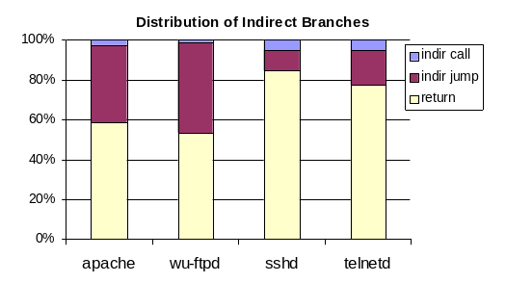
- : the percentage of different type of indirect branches: Four server-type applications, namely telnetd (from the Redhat 6.2), wu-ftpd 2.6.0, apache 2.2.2, OpenSSH 3.0p1, are tested on a full-system x86 emulator. First two have notorious vulnerabilities that can be exploited to launch a control data attack while the latter two are recently released. The apache server hosts static html files, several popular large files for download (50MB each), and contains several CGI programs in C, perl and php. It had run as a “field” web server for about 7 days, approximately receiving 1500 hits per day. Synthetic input scripts are employed to exercise t For ftpd, ssh, and telnetd,.

At machine architecture level, an execution of indirect branch provides a desirable sampling point for validating program behavior. It provides a natural epoch to check whether a control datum, the target for an indirect branch, has been overwritten maliciously or not. Moreover, our solution also considers the conditional branches close to the indirect branch instance and has taken the outcomes of those conditional branches into consideration to detect possible compromises in the directions of the conditional branches to reach the particular indirect branch instance.
Our scheme obtains the normal behavior of indirect branches and the conditional branches nearby through training. The signature is extracted directly from control flow transfer instructions thereby representative( this sentence doesn't make sense... once again i dont' understan teh topic so i can't change it, but you probably want to rethink this one). The amount of information for the signatures is expected to be limited because the number of different targets for indirect branches is bounded and predictive correlations exist among the direct branches. This motivates us to build a hardware table containing control flow objects of all indirect branches. At run-time each indirect branch instance is validated against its legitimate control flow objects in the table before the program control flow transfer is made. A failed validation indicates that the current indirect branch is either with a compromised target or on a compromised execution path. A hardware interrupt is then triggered and the operating system can take over the execution to determine the response procedure. This finer-granularity validation can prevent a malicious control transfer attempt from even updating the machines state and is effective against not only control data attacks but also many non-control data attacks that aim to compromise the predicate data for conditional branches. It is tightly incorporated with processor pipeline and works in tandem with processor core, resulting in a short validation delay.
It is noteworthy that the experiments reported in this paper are from complete running of full-scale applications under a live operating system. To have a better understanding on the behavior of the real applications running in a live operating system, we mainly utilize the Bochs-2.2.6[3], a full-system Intel Pentium emulator, for our profiling study. All programs are compiled and targeted to dynamically linked x86 binaries and run under Redhat Linux OS over Bochs. The Linux kernel is modified also so that the hardware emulator becomes aware of process information. All instructions from the same process images, not a “representative” process, are tracked so that complete run-time information can be collected even for multi-threaded applications. Focusing only on process ID (PID) is problematic in Unix/Linux system because the vfork() in Unix and the fork()+execv() system call in Linux can replace the execution image without changing the PID. Our experiment overcomes the above problem and obtains complete and accurate behavior information. In addition, by using the Bochs, we are able observe the behavior of the dynamically linked library code that is otherwise hard to acquire. In addition, the results from SPEC2000 integer benchmarks are reported; they are compiled and tested with the reference inputs on the x86 emulator and run to complete. Floating-point benchmarks typically have less diversity in terms of control flow transfer, and thereby are ignored in this work.
The next section describes the program behavior signatures chosen for our study of validating control flow transfers at run time. Section 3 shows how to extract the interested control flow related objects for the signature. It also depicts the architectural modifications of augmenting branch predictor in details and describes using Bloom filter for saving the extracted behavior signatures. Section 4 evaluates the performance impact. Section 5 presents related works and comparisons with other solutions and we conclude the paper in section 6.

- : The number of Target PC and BPC||TPC: gcc has relatively more target PCs probably because of the large number of call sites by recursive function calls in syntax analysis; eon, a C++ program, invokes many virtual function calls.
Benchmark | Target PC# | BPC||TPC # | Benchmark | Target PC# | BPC||TPC #
gcc | 8218 | 8592 | eon | 5980 | 6396
crafty | 2652 | 3162 | gap | 2965 | 4480
vpr | 1288 | 1429 | gzip | 548 | 616
parser | 2121 | 2306 | vortex | 4261 | 4420
mcf | 739 | 836 | perl | 3050 | 3327
twolf | 2670 | 2980 | bzip2 | 807 | 890
apache | 2526 | 6055 | sshd | 2016 | 5593
ftpd | 1224 | 3003 | telnetd | 1127 | 2247
2. Program Behavior Signature
For program behavior signature, various control flow related objects can be collected, from branch targets to complete execution paths. Depending on the scope of the objects collected, protection efficacy and overhead will be different. This section considers the objects our schemes collect for program behavior signature.
2.1. Objects for Behavior Signature
Although validating the target PC (TPC) of each indirect branch instance can prevent attacks that introduce a new execution code, some adversary might utilize a legitimate target to do malicious operations such as in return-to-libc attacks: For example, consider a simple code in Figure-2. System() is the target for a normal function call through a function pointer, funcptr. With a simple stack smashing attack, the return address of the vulnerable function, fun(), could be overwritten to be the entry address of system(), which is perfectly legitimate. This would result an execution path oblivious of detection, but unexpected control flow transfer from the return of fun to the call of system().

vuln_fun ( char *input)
{
int buf[];
//buffer overflow
strcpy(buf, input);...
}
main(argc, argv)
{
func * funcptr;
...
//the return can be compromised to
//be the entry address of system()
fun(argv)
...
if () //root user
{
funcptr = system();
...
//address of system() is legitimate, //only for the following function call through a function pointer.
* funcptr ();
}
}

- : The example showing that the only protecting target is not sufficient.

With the branch’s PC always associated with each legitimate target for the behavior signature, any control flow transfers invoked by indirect branches are guaranteed to be from an intended branch site to a validated destination. As a result, the attacks mentioned above can be detected since the return of fun() should never return to the entry address of system(). One may concatenate the branch PC, a new object, with each one of its legitimate targets (denoted as BPC||TPC) for behavior signature as in previous studies [1][22][24]. Our experiments on SPEC2000 shows (see the shadowed columns in Table-2) that monitoring BPC||TPC only increases the number of objects that need to be monitored by an insignificant account (13.5% on average). However, the signature table size increases considerably (2× to 3×) for server-type applications, although still remains modest, because of more dynamic behavior of general indirect branches in such applications. Although validating both the branch PC and target PC guarantees an individual indirect branch always branches to a predefined address, one critical issue is that it samples program behavior only at isolated program execution points, i.e. at the indirect branches, without considering dynamic execution path reaching to the indirect branches. Therefore, it could miss elaborate attacks that alter the control flow but still using a legitimate indirect branch to jump to a legitimate target. Figure-3 illustrates such a scenario, in which the indirect function call of poutputfun() (an indirect branch in machine code level) passes the BPC||TPC validation even when the attack is underway.

state_transfer(int input)
{
int state;
char buf[];
function pointer *poutputfun;

if (input<0) --1
state = REGULAR;
else if (input <10) --2
state = PRIVILEGED;
else --3
state = UNKNOWN
f1(buf);
if state = = REGULAR --4
poutputfun = g1;
else
if state = PRIVILEGED --5
poutputfun = g2;
else
poutputfun = g3;

(*poutputfun)();
}

f1(buf) { memory corruption bugs}
g2() { privileged operations}

- : Example codes that shows protecting BPC||TPC is not sufficient: The output function is invoked through a function pointer dynamically. Suppose f1() contains a memory corruption bug, e.g. format string vulnerabilities such that a call of f1() might result in an overwrite over the variable of state. Now assume the input is 5 and state is REGULAR originally. Then, a malicious party may invoke the f1(), explore the bugs and change the value of state into PRIVILEGED. Consequently, the privileged function, g2(), is called by the indirect branch unexpectedly. Note that the source PC and the target of the indirect branch are both legitimate since such a control flow transfer is possible in a normal execution. The indirect function call of poutputfun() passes the BPC||TPC validation even when the attack is under the way.

We observe that although the branch PCs and the targets might be legal ones, the control flow might have followed an unintended execution path to reach that branch, possibly through non-control data attack. However, such an execution path is typically unexpected and/or impossible due to a well-known fact that the outcomes of consecutive branches are strongly correlated in many cases. In our example code in Figure-3, only if the conditions at branch site 2 and 5 are both satisfied could the control flow reach the call of the privileged subroutine, g2(). However, non control data attack that aims to alter the predicate values of the conditional branches destructs the correlation abruptly. In our example, if a memory corruption bug in f1() overwrites the state variable in the middle, then outcomes of branches at site 1 and 5 would have an abnormal combination or the correlation between the two has been violated. This suggests that we include the execution path besides the indirect branch and its target into the objects being monitored: Only if the BPC||TPC of an indirect branch and the execution path that leads to the branch have been validated, the program is allowed to make control flow transfer. In this study, we define the execution path of an indirect branch as the sequence of the direction outcomes of the preceding conditional branches that reaches a particular instance of the indirect branch and denote it as EP (execution path). Now three objects are extracted and validated, namely the branch PC, the target PC, and the execution path, and they are simply concatenated together to form a behavior signature. We denote it as BPC||TPC||EP and monitor the triplet at run-time. Validating BPC||TPC||EP not only guarantees that a jump by an indirect branch is with legal source and target but also on a legitimate execution path to make the jump.
Our behavior signature of BPC||TPC||EP is effective against a wide range of attacks. It is able to protect many control data attacks that introduce foreign code in heap or stack, such as stack smashing, since any legitimate target addresses (TPC) is ensured to have been seen. Branch site information is necessary to prevent an adversary from compromising an indirect branch and redirecting the control flow to existing code such as in return-to-libc attacks. Including path information is a general protection measure to validate dynamic execution path based on the existing correlations among branch instructions. This can detect many non-control data attacks that aim to change the decision-making data. There are certain chances that an adversary exploits vulnerabilities without invoking indirect branches. However, as mentioned in [14], system calls and library calls in many cases are indispensable for an adversary to introduce malicious operations. Fortunately, many realistic run-time systems do invoke library calls through indirect branches using a system function pointer table, such as PLT (procedure linkage table) and GOT (global offset table). In such a system, checking execution path before every indirect branch is sufficient to thwart most attacks.
One complication that arises in any control flow monitoring scheme is the use of dynamically linked library because the addresses are determined at run-time. There can be control flow transfers between the executable and the entry address of a function in dynamic libraries, called as executable-library jumps. Another type of relevant jumps occurs within the same library code, called internal jumps. Our experiment shows 21.3% (ssh) to 30.4% (apache) indirect jumps related to dynamic libraries are executable-library jumps. FSA[22] simplifies their solution by traversing the stack back to the static-linked part only. It does not track the states when program is executing the library code. CFI[1] also limits its validation to static linked calls. VtPath[13]and N-jump[30] only track the internal jumps and ignore the executable-library jumps. We address this issue of dynamically linked targets by seeking helps from the linker. A target address for the indirect library call could be resolved with only two address values. One is the entry address of the linker, which is always fixed for a given operating system (installation???). The other is the actual address patched by the linker for the library routine invoked, which is always fixed in each run. When constructing a signature of BPC||TPC||EP for an indirect branch for a library call, the TPC is initialized as the address of the linker for executable-library jumps (e.g. PLT0 in PLT). When the linker solves the address at run-time, it patches both the function pointer table (e.g. GOT) for dynamic linking and the TPC in the corresponding signature. By moving the patched signature into a read-only hardware table, such an update is guaranteed to happen only once. Thus, a later compromise of function pointers for dynamically linked libraries can be detected.
2.2. Extracting Program Behavior Signature
For hardware table of the legitimate behavior signatures, i.e. the legitimate BPC||TPC||EPs, there are many ways to fill it up depending on several factors such as the availability of source code, the accuracy to achieve, and the size of program’s control flow graph. Many static analysis methods can be utilized as only indirect branches and the conditional branches nearby are interested. It may be feasible to extract the legitimate branch PCs and their targets from the existing execution trace of legacy code offline. In addition, during software testing in its development phase, test cases should cover most, if not all, possible execution paths for each branch; therefore a behavior signature table can be generated as a side product. This paper uses training, a widely adopted method in many behavior-based protections [11][13][14][17][24][29][14][16][22][29], to collect security signatures in studying the effectiveness and feasibility of the proposed validation. That is, we train the application in a particular time frame or until the number of the interested objects of BPC||TPC||EPs converges.
We define the number of conditional branch outcomes preceding to an indirect branch as the length of the execution path, or EP length. As architectural solution, the execution paths saved in the hardware signature table can only have a limited length. A larger EP length certainly improves the detection accuracy and provides a stronger protection. However, it comes at the cost of larger storage overhead as well as slowing down the validation. Furthermore, an excessively long execution path may include unrelated behavior, resulting in either a longer training time or a high false positive rate. Therefore, we must trade the EP length off the overall efficiency. We have profiled indirect branch’s PC and target PC (BPC||TPC) as complete as possible and tested the convergence of BPC||TPC||EP with the different EP length. The goal is to have the “truncated” execution path be as informative as possible and reflect the program behavior as close as possible. Our study suggests that the EP of a short length would be sufficient.

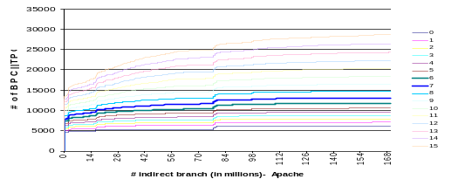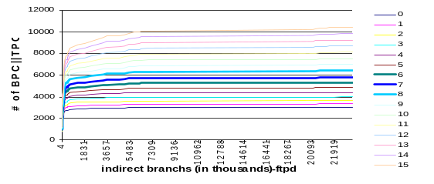
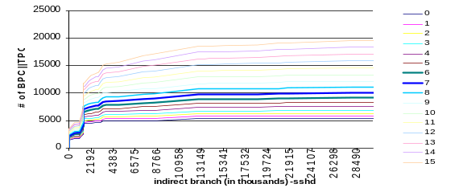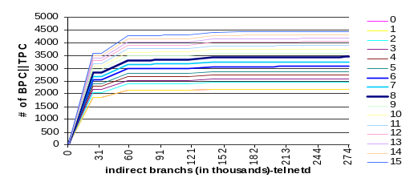
- : The number of BPC||TPC||EP for apache, sshd, ftpd, and telnetd against the indirect branches that have been executed. Each diagram also shows the results with different EP length from 0 to 15.

Figure-4 shows the number of BPC||TPC||EP and its convergence speed with respect to the EP length from 0 to 15, i.e. up to 15 conditional branches prior to each indirect branch, over four server-type applications. Apache is trained in the field while others use synthetic inputs. The resultant trends of all four applications have shown that the behavior signature is limited indeed over different input data. And after a reasonable time of training, the number of BPC||TPC||EP does converge. For apache, the number of BPC||TPC||EP increases very slowly as the EP length ranges from one to four. Also the curves are closer to each other than other cases. However, when more than ten branch outcomes are included in EP, the distance between two adjacent curves becomes larger. This probably means the additional path information is less informative and is unlikely to be relevant to the indirect branches. In addition, these curves have a greater slope, indicating a slower convergence speed. Similar results can be found for other applications.

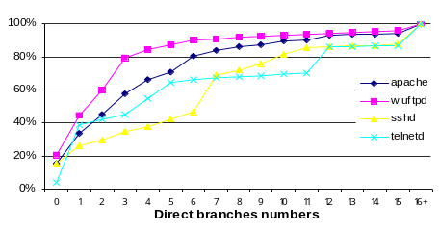
We have also profiled the numbers of the conditional branches that appear between any two consecutively executed indirect branches at run-time (Figure-5). Notice that we do not use the average number of branches between two indirect branches because there may be loops that iterate a large number of times, resulting a biased average of a large number. We instead measure the accumulative distribution of the number of conditional branches that are dynamically executed between the two indirect branches.

- : The accumulative distribution of the number of conditional branches between two consecutively executed indirect branches.
Based on the experiments shown in Figure-4 and Figure-5, six to eight branch history outcomes might be a reasonable length as they have 60% to 80% coverage over the whole execution path between any two indirect branches. With an execution path length of eight, BPC||TPC||EP has a similar converging speed as the cases with a shorter execution path, while the total number of the signature remains still moderate. Table-3 shows the number of BPC||TPC||EP with different the EP length. Nevertheless, one should note that the length of the execution path is a design option and its value depends more upon the cost one can tolerate to collect and to store legitimate BPC||TPC||EPs, because the protection efficacy does not improve proportional to the EP length. As noted in[8], non control data attacks attempt to compromise predicate data near to indirect function calls: the EP length of six to eight seems sufficient. Typically the direct branches that are closer to the indirect branches are more important since closer branches have more correlations while remote branch outcomes likely to add less relevant information.
- :The number of behavior signature (BPC||TPC||EP) with different EP length. Most benchmarks have a modest number, less than 15000 BPC||TPC||EPs except the gcc, which has a significantly larger dynamic run-time behavior signatures. /* you may want to add data for shorter EPs like 3-bits 4 bits */
Application | # of BPC||TPC||EP
 | 6 bits | 7 bits | 8 bits
eon | 11684 | 12812 | 12943
crafty | 8580 | 10578 | 13209
Gap | 11102 | 12892 | 14919
Gcc | 25091 | 29184 | 33687
mcf | 1442 | 1659 | 1971
gzip | 1233 | 1442 | 1731
parser | 7404 | 9094 | 11259
Vpr | 2561 | 2845 | 3207
perl | 8330 | 9144 | 10729
vortex | 6834 | 7347 | 7995
twolf | 5255 | 5976 | 6812
bzip2 | 1428 | 1604 | 1848
apache | 11749 | 13133 | 14788
ftpd | 5320 | 5816 | 6418
sshd | 9063 | 9973 | 11006
telnetd | 3173 | 3352 | 3546
3. Augmenting Branch Predictor to Retrieve and Validate Behavior Signature
For efficient implementation of the proposed validation, it is critical to minimize the overhead both for capturing the objects of behavior signature for monitoring at run-time and checking against the legitimate signatures.

3.1 Capturing Run-Time Behavior Information
Our hardware solution takes an advantage of the fact that the objects for the behavior signature, namely the branch PC, the target PC and the execution path, are readily available in modern processors. Based on the observation that a branch outcome typically depends not only on its local history but also on its global history, correlation/two-level branch predictors[11] were proposed and have been implemented in many commercial processors. A common component in such predictors is the branch history shift register (BHSR) that records the outcomes of recently executed conditional branches. The BHSR provides history information for prediction as well as of the current execution path for our monitoring of program behavior. Specifically, several popular predictors such as correlation predictor, Gas/Gap/Gag two-level predictor, and g-share predictor contain a global BHSR which we can utilize directly. For per branch BHSR, an additional register can be incorporated and updated with branch outcomes on each write of per branch BHSRs. If the BHSR is updated speculatively, it is necessary to maintain a shadow copy of non-speculative branch outcomes to store the committed results. Notice that our architectural level solution avoids reading run-time information from memory. This is because memory access is not only slow but also consumes extra memory bandwidth. In addition, virtual address mechanisms make it harder for hardware to distinguish the meaning of the memory objects, making it a potential vulnerability.

3.2 Augmenting the Branch Predictor for Validation
The validation involves comparing the retrieved BPC||TPC||EP at run-time with the legitimate signatures that have been collected in the signature table. Interestingly, the branch predictor together with the prediction verification mechanism is already doing a large portion of the validation work. Thus, the frequency of validating against the signature table can be reduced. With the validation in place prior to that an indirect branch instruction commits its result into machine state, the history information buffered in the branch predictor is the one that has been committed before, and has thereby been validated also. While an adversary can exploit software vulnerability to overwrite critical data in memory, it cannot compromise the history information stored in the branch predictor, a software transparent component.
In particular, the branch target buffer (BTB) and Return address stack (RAS) are two buffer units that store the targets from the branch history. Each entry in the BTB contains both the PC of a branch and its target that has been used recently. At the fetch stage, a branch instruction uses its PC to locate an entry in the BTB and obtain the speculated target. At the branch verification stage, the speculated target is checked to see if it is the correct one. A successful prediction means both the final PC and its target are from the BTB, thereby are validated already. Therefore, if the behavior signature only consists of the branch PC and the target PC (or BPC||TPC), a correct prediction is sufficient to ensure a secure execution: Validation against the complete signature table (discussed in Section 3.5) is only needed on indirect branch mis-predictions.
However, our protection scheme also requires validating the execution path proceeding to each indirect branch. We propose to append a small bit vector recording the execution paths (outcomes in conditional branch history) along with the Branch PC and its target PC in each BTB entry (see Figure-6). This bit vector, called EP bit vector, effectively caches the execution paths that have been seen before. Accordingly, besides the verification of the target PC, the hardware does an additional comparison between the current execution path from BHSR and the buffered execution paths in the EP bit vector stored in BTB. Only when the indirect branch is correctly predicted and the run-time EP from BHSR matches the buffered path in EP bit vector (an EP bit vector hit), would the processor view the control flow transfer legitimate. Otherwise, a checking against the complete security signature table is enforced.

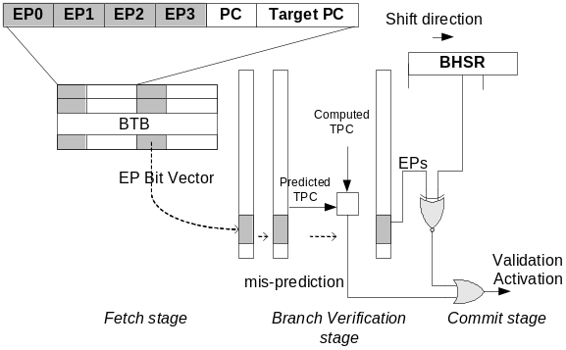
- : BTB and pipeline enhancement to support execution path validation. Each BTB entry contains extra EP information and current execution path is extracted from BHSR. The comparison of the two, together with the target verification, equivalently performs a validation.
Figure-6 shows the modifications to each BTB entry and processor pipeline in order to support the EP validation. To improve the hit rate of the EP bit vector, multiple EPs are buffered for each BTB entry since multiple paths can reach the same branch. They are organized in a fully associative way in each BTB entry. At run-time, the EP bit vector is fetched along with target address from BTB at the fetch stage. And it is carried along with the instruction in the pipeline registers or in the reorder buffer. A mis-prediction at branch verification stage or an EP bit vector miss on a correct prediction at the commit stage will trigger a validation. If an EP bit vector miss does occur, the bit vector is updated when the indirect branch is committed: The current execution path that has been validated with the complete signature table replaces one of the execution paths in the bit vector. Although a carefully chosen policy can be adopted, an execution path to be replaced in the EP bit vector is randomly chosen for simplicity in this work.

3.3 Evaluating EP bit Vector Hit Rate
The extra checking on the EP bit vector lowers the chance that the branch predictor alone does the validation and incurs more validations against the complete signature table. Therefore a high hit rate of the EP bit vector is desirable. We have experimented the SPEC2000 CPUinteger benchmarks with different numbers of the execution paths stored in each BTB entry as shown in Figure-7. Each path consists of eight branch outcomes, which suggests 128 different EPs possible in theory. However, with four to eight paths the EP bit vector yields a hit rate as high as 85% to 91% on average. This is not surprising since the number of execution path to each indirect branch is limited because of the correlations of branches instructions and the execution path has temporal localities similar to instruction cache (this whole sentence needs to be rewritten, or break it up in separate sentences). More importantly, the execution path history in the BHSR is used to make a prediction at the fetch stage and is likely to remain the same on a successful prediction.
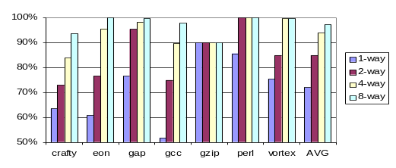
- : The hit rate of the EP bit-vector with different number of buffered execution path. (n-way here means n paths are stored in the EP bit vector). Only the benchmarks that execute considerable number of general indirect branches are shown. Refer section 4 for other simulation configuration and architecture parameters.

3.4 Overall Validation Rate
For a return address, a validation against the signature table is triggered only on RAS misses. This is because the targets, i.e. return addresses, are pushed into and popped out of stack in a strict first-in-last-out order. Successful pushing and popping of an address on RAS hits indicate the call and return follow the call sequence chain as specified (this is not grammatical). However, on an RAS miss, we perform a strict BPC||TPC||EP validation against the complete signature table. In fact, many hard-to-detect explorations such as impossible path exploration [16][28] are likely to trigger a RAS miss first. This is because although the return address may have been seen before, the access order of the return address stack is corrupted in such an exploration. Thereby our scheme is able to catch the exploration and detect such an intrusion.
Figure-8 shows the overall rate of the validation done by the augmented branch predictor alone for SPEC2000 integer benchmarks when the execution path is also checked with the EP bit vector. Eon, crafty, gcc have a considerable number of general indirect branches and thereby are affected by the validation of the EP information. The indirect branches of the rest of the benchmarks exhibit no noticeably different behaviors regarding the number of the EPs since the general indirect branches are rare or they have an accurate prediction rate already. Gap has only slightly above 50% validation rate due to the low success of indirect branch predictions. However, with around 80% rate on average, extra validation frequency beyond the branch prediction drops dramatically by about 5 fold less than when every indirect branch must be validated. In addition, adding extra validation of the execute paths only incurs a minor increment to the validation frequency beyond the branch prediction. (8.5%, 6%, 1.6% for the cases of the EP bit vector holding 2, 4, and 8 EPs, respectively).
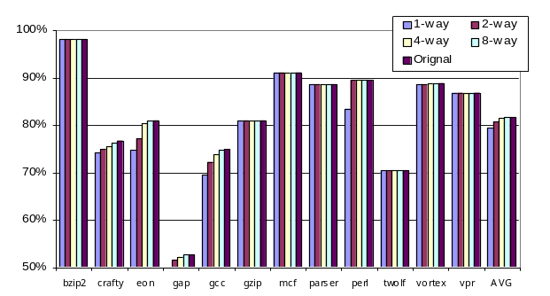
- :The rate that no activation of the complete security signature table access is needed with the augmented branch predictor (n-way here means n paths are stored in the EP bit vector).

3.5. Building Signature Table using a Bloom Filter
With a miss-prediction of indirect branch or an EP bit vector miss, a validation against the complete signature table becomes necessary. We use a Bloom filter[4] for the signature table to store the legitimate BPC||TPC||EPs. A Bloom filter is a space-efficient set representation that answers a membership query with a small false positive possibility but with no false negative. It is implemented as an m-bit vector, using k independent hashing functions that map set elements onto the bit vector to record their existence, which facilitates time and space efficient hardware implementation of the signature table with multiple parallel hashing hardware units.
Each signature of BPC||TPC||EP is fed into the multiple hashing units to generate vector indices for the signature table initialization at training and for membership query at validation later (see Figure-9). We use for hashing SHA-1 algorithm implemented in hardware. Multiple SHA-1 hashing units with permuted BPC||TPC||EP are utilized to index the bit vector. Note that many viable alternatives for hashing exist including a single cycle exclusive-OR function. We use the SHA-1 not only for excellent randomness but also mainly to have a very conservative performance evaluation (in Section 4).
The false positive of a bloom filter means a case of undetected execution path, i.e. system false negative, thus must be minimized. It is determined by three filter parameters: the number of hashes (k), the size of bit vector (m), and the size of the set represented (n). The probability of a false positive or false positive rate (FPR) for a Bloom filter is
(1 – (1 – 1/m)^{kn})^{k} ≈ ( 1 – e ^{-kn/m})^{k} (1)
With a basic bloom filter with m = 256K bits and k = 4, the corresponding false positive rates for n of 1400 and 15000 (which are the number of BPC||TPC||EPs for most benchmarks except gcc) are 2.2e-7 to 0.19%, respectively. With k=4, we provide four read/write ports for the bit vector. The k can effectively be increased by allowing the bit vector be accessed multiple times for different hash results. The FPR is reduced to 0.038% and 0.027% with k of 8 and 12, respectively. To lower the FPR further, multiple basic Bloom filters can be connected together and the outputs are ANDed to decide the final result. The overall FPR is approximately the product of the FPRs of participated basic Bloom filters. For example, assume three basic Bloom filters are activated and with n of 15000, the FPR drops to 6.9e-10 and even for gcc with n of 33000, the FPR is 1.8e-5.

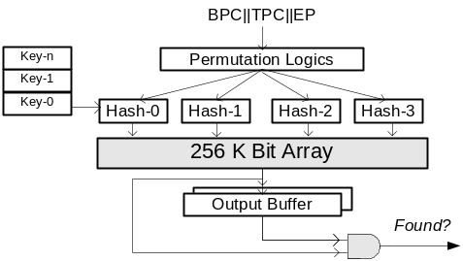

- : A basic validation unit that incorporates a 256K-bit Bloom filter as the security signature table.

We may also cache the behavior signatures of BPC||TPC||EPs that must reside in the on-chip hardware table to reduce the FPR. Our experiment shows that a considerable number of BPC||TPC||EPs are accessed rarely. Figure-10 depicts the percentage of BPC||TPC||EPs that are accessed less than five times throughout the program execution. They account for 17%, 20%, 38%, 45% of the signatures being monitored for ftpd, apache, gcc, eon, respectively, but only for 0.0086%, 0.0024%, 0.0001% and 0.0058%, respectively, of the ones that have been executed at run-time. These signatures therefore consume the corresponding amount of space in the Bloom Filter with little utilization. If they are filtered out of the Bloom filter and stored in memory rather than the on-chip table, we can reduce the FPR further (because of the smaller n) without compromising the performance.
To exploit the inherent false positives in the Bloom filter to launch a successful attack, the attacker has to construct three proper values that conform to the false positive pattern, the branch PC that the attacker can succeed to compromise and the target address where the attacker can succeed to put or utilize malicious code as well as an legitimate branch outcome sequence (EP). Given a program, the number of the useful targets for the attacker that might lead to a successful exploitation is limited. For a sufficiently low false positive rate, it is impractical for an attacker to try many BPC||TPC||EP in order to find one that happens to be able to skip the check through a bloom filter.
Generally, by using Bloom filters, we provide a mechanism that users can customize it (i.e. changing the effective Bloom filter parameters) according to the security requirements, performance degradation tolerance, and hardware budget. Similar to encryption algorithms, the chance to break the protection is determined by the filter’s parameters and is mathematically predictable.
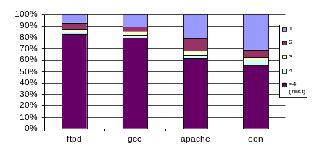
- :The percentage of the BPC||TPC||EP that are referenced only for one, two, three, and four times and more.
4. Performance Evaluation
The performance impact comes from the extra cycles needed to validate the BPC||TPC||EP on an indirect branch mis-prediction or an EP bit-vector miss. We assume the validation unit is non-pipelined for conservative evaluation, and thereby can serve only one instruction each time. Also, only the validated indirect branches are allowed to commit the result and update the machine state. Consequently, an indirect branch in the commit queue may stall the pipeline either because it is still being validated or because the validation unit is busy in servicing other branches, thus deferring all its successors to commit. However, these stalls due to the validation do not always result in observable performance degradation. As shown in Figure-8, the majority of the validations are due to indirect branch mis-predictions per se. Thus, the processor must do mis-prediction recovery work such as flushing the pipeline, restoring the renaming table, and redirecting the fetch point. These would introduce stalls at the front end of the pipeline. As a result, a later committed indirect branch in the backend does not necessarily affect the overall instruction commit speed. In other words, the recovery action needed from branch mis-predictions masks off some of the validation delay. Only the EP bit-vector miss would actually delay the commit. However, with a moderate hardware enhancement of the EP bit vector, we have a fairly high hit rate as shown in Figure-7. In summary, the rarity and high prediction accuracy for indirect branches, and high hit rate of the EP bit vector on BTB hits make the validation infrequent. As such, it is expected to incur little performance overhead. /* how many EPs in EP bit vector for simulation? It’s also not clear why adding EPbit vector to the BTB does not increase time for branch prediction. And also the hardware cost for the EPB bit vector not mentioned*/
The access latency of the validation unit mainly consists of the delay of hashing functions and the bit array access as well as other glue logics (see Table-4). The delay for accessing a 256K-bit array is measured by a simulation with CACTI 3.2 [5] under the technology of .09um. The storage structure is assumed to have four read ports and one write port. The delay of hashing logics (SHA-1) and the glue logics are estimated by a Verilog implementation and a synthesis with TSMC’s 0.09um library. Note that the delay of SHA-1 dominates the total delay, which is intended to have a conservative performance evaluation.
- : Access Delay of the validation unit
Permutation Logic | SHA-1 Hash Function | 256K-bit array with 4 read ports | 6-64MUX & Select logics | Total delay
0.49 ns | 6.92 ns | 1.062 ns | 0.79 ns | 9.262 ns
Assuming a processor runs at a clock rate of 2 GHz, the delay of the validation unit will be 19 cycles. If the bit vector needs to be accessed twice for twice more hashing to reduce the false positive rate, the delay is about 22 cycles assuming eight SHA-1 units are available. In the simulation, we estimate the validation delay ranges from 20 cycles to 40 cycles. The simulation runs the SPEC2000 CPU integer benchmarks on the Simplescalar simulator [2] that models an out-of-order 4-issue superscalar processor. The reference input is used and the number of instructions specified by SimPoint[23] is skipped. Architectural parameters for our simulations are shown in Table-5.
- :Architecture Parameters
Parameter | Value
BTB | 512 set, 4-way set associative
RAS | 8 entries
Branch miss penalty | 7 cycles
Pipeline stage | 9
Branch Predictor | g-share, 12 bits history, 2048 entries
Fetch/dispatch/issue width | 4
RUU size | 64 entries
Load/Store Queue | 32 entries
I-cache | 64K, 2 way set-asso., 2 cc hit time, LRU
D-cache | 64K, 2 way set-asso., 2 cc hit time, LRU
L2 cache | Unified, 512KB, 4 way set-associative,
L2 access time | 10 cycles
Memory | 100 cycles access time, 2 memory ports
Function unit | 4 Int ALUs, 1 Int MUL/DIV, 4 FP Adder, 1 FP MUL/DIV

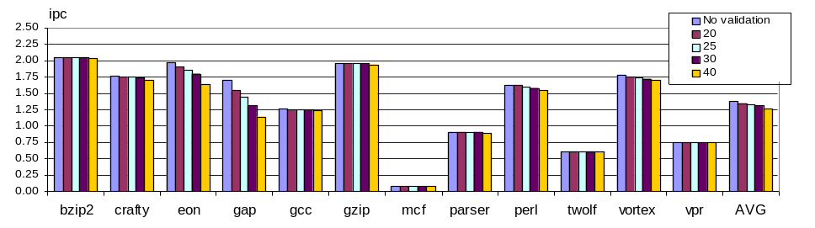
As shown in the Figure-11, more than half of the benchmarks do not have a measurable performance impact due to the reasons mentioned above. Gap has is apparently sensitive to the validation delays as it has a very low indirect branch prediction accuracy (only about 50% see Figure-8). Similar results can be observed for eon because of the presence of extensive virtual function pointers. The performance degradation of eon is still within 10% when the delays are less than 30 cycles. It reaches 16% only when 40-cycle validation delay is assumed. Gcc, perl, and crafty also have noticeable performance degradation but within the bound of 5% even in the worst case. Rest benchmarks can hide the validation delays almost completely, resulting in a negligible performance reduction. Overall, the average degradations are 1.7%, 3.0%, 4.5%, and 7.3% for a validation delay of 20 cycles, 25 cycles, 30-cycles, and 40 cycles, respectively. The relatively severe performance impact from 30 to 40 cycles implies that it might be the upper bound for the validation delays that a 9-stage pipeline processor can hide: this can be used to guide the Bloom filter design for less performance impact. Note again that this is a very conservative estimation by using overly complex hashing function and non-pipelined validation unit.
5. Related work
There is numerous software and hardware proposals to restrain the control flow transfer to secure program execution. Most measurements to prevent control data attacks typically involve identifying, encrypting, and/or tracking the control data [9][26][19][29][20][25][8]. However, in the current program model, it is not always possible to distinguish and trace the interested control data accurately, especially the general indirect branches’ target. Moreover, non-control-data attacks [8]open new doors for an adversary to compromise the direct branches.
Behavior-based schemes, on the other hand, monitor the execution behavior and detect any deviations on some interested event, thereby independent on the specific exploits. Forrest[14] observed that short-term system call sequence could be viewed as “a sense of self” for a program. Any deviation from the trained sequence database captured at run-time is treated as anomaly. Wagner[28] found an adversary could mix malicious code with nullified system calls to mimic a valid system calls sequence. They find that impossible path exploration can circumvent the check but still abides by the valid system call sequence. They[27] also propose static analysis to build an intrusion model that was later refined by [16]. Seker’s finite state automaton proposal associates the system call with the PC[22]. Their recent work further tries to capture the relationships between parameter of system calls[3]. Their coverage depends upon the actual relationships existed in the system call parameters and how effective the solution can extract and construct them. VtPath[13] by Feng is an effort that also includes additional information, specifically the return address sequence, into the objects being monitored. The new run-time information from stack on system call event helps to detect more intrusions but still miss others [29]. Gao[17] generalized VtPath by introducing a concept of execution graph to infer sequence of calls, returns and intra-procedural transition. All methods above work at the granularity of system calls and may miss the attacks that alter program behavior between system calls.
Down to the machine instruction trace level, program shepherding[18] employs a binary code interpreter to enforce security policies. It constrains the control flow transfer when constructing execution traces. The complicated implementation and performance/memory overhead may affect its adoption. CFI[1] is a software measure that marks and validates targets for indirect calls and returns through binary rewriting. It is equivalent to collecting validated targets statically. A weakness is that an adversary may exploit arbitrary write flaws, e.g. format string vulnerability, to write the actual target for the indirect branch, skipping the ID-check code. The paper also does not discuss indirect jump. N-jump[30] by Zhang also works on machine-code level and is based on observations similar to ours about branch behaviors. Their work mainly focuses on direct branches and treats the indirect branches as special cases. Compared to their work, ours provides a clear checking boundary, i.e. indirect branches. In addition, we incorporate the behavior signature tightly into the pipeline by a Bloom filter and perform the validation only on branch mis-prediction and EP bit vector miss. To contrast, the N-jump solution checks each jump (one every five instructions) therefore must rely on a sophisticated co-processor running in a secure environment.

6. Conclusion
Current processor architecture is vulnerable to control flow altering attacks because it lacks a validation mechanism to check the legitimacy of its target address and the execution path leading to it. We have shown that validation of branch behavior, specifically an indirect branch’s PC, its target, and execution path preceding it, (BPC||TPC||EP), is effective in securing program execution even when some non-control-data attacks are presented. Checking the target can prevent a compromised indirect branch from jumping to foreign code that an advisory has implanted. Validating the branch PC guarantees that a legal target is always used by an intended indirect branch, which many attacks, e.g., return-to-libc attack, violate. Our scheme goes further with the additional validation of the execution path, to guarantee that the program follows a legitimate path to arrive at the control flow transfer by any indirect branch. Our experimental study has shown that the number of the behavior signatures of (BPC||TPC||EP) is limited. This is because programs in general generate a limited number of target addresses per indirect branch and correlation existing among nearby conditional branches limits the number of possible execution paths.
To incorporate the validation into the processor's pipeline, two enhancements were made to the branch predictor: (1) enhancement of a branch target buffer (BTB) entry with an execution path (EP) bit-vector for storing the execution paths that have been followed previously, and (2) hardware table of the behavior signatures in the form of a Bloom filter because of its compactness and uniform access time. A correctly predicted branch with an EP bit vector hit can be safely filtered from the validation, which dramatically reduces the validation frequency. A small amount of extra hardware storage for the EP bit vector of four paths proves to be effective with an average hit rate of above 95%. With branch mis-prediction or EP bit vector miss, the Bloom filter of the signature table is accessed for validation. After accommodating the validation scheme with these hardware enhancements into a superscalar processor, we have found that performance degradation caused by the validation is small and controllable.
There are a few interesting directions for further study, including further optimization of the proposed validation per program characteristics. The direction outcomes of conditional branches serve as the path information between two indirect branches in the current work. However, the address outcomes of the branches might be a more precise measure and need a further investigation. We also expect that using the execution path information related to branch prediction, such as trace cache, could further reduce the validation frequency beyond the branch predictor. Moreover, currently only the execution paths close to the indirect branches are thoroughly checked. Some direct branches may also be security sensitive, for example, system calls and/or library calls invoked by a direct branch. How to identify these critical direct branches is also an interesting topic.
References
- M. Abadi, M. Budiu, U. Erlingsson and J. Ligatti, “Control_flow Integrity”, ACM CSS05, Nov, 2005
- T. Austin and D. Burger, “The SimpleScalar Tool Set”. Univ. of Wisconsin CS Dept. Technical Report, No. 1342, June 1997.
- Bochs, “The Open Source IA-32 Emulation Project”, http://bochs.sourceforge.net/
- S. Bhatkar, A. Chaturvedi, and R. Sekar, “Dataflow Anomaly Detection”, IEEE Symposium on Security & Privacy, May 2006
- B. Bloom, “Space/Time Tradeoffs in Hash Coding with Allowable Errors”, In Communications of the ACM 13:7, 1970
- Cacti3.2. http://research.compaq.com/wrl/people/jouppi/CACTI.html.
- CERT Security Advisories. http://www.cert.org/advisories/
- S. Chen, Jun Xu, Emre C. Sezer, Prachi Gauriar, and Ravi Iyer.“Non-Control-Data Attacks Are Realistic Threats”. In Proceedings of USENIX Security Symposium, Aug. 2005.
- S. Chen, Jun Xu, N. Nakka, Z. Kalbarczyk, R. Iyer. “Defeating Memory Corruption Attacks via Pointer Taintedness Detection”.In Proceedings of IEEE International Conference on Dependable Systems and Networks (DSN), June, 2005.
- C. Cowan, C. Pu, D Maier, J. Walphole, P Bakke, S. Beattie, A. Grier, P Wagle, Q. Zhang, and H. Hinton, “StackGuard: Automatic adaptive detection and prevention of buffer-overflow attacks”, In Proc. 7th USENIX Security Symposium, Jan 1998.
- P. Chang, E Hao, Y. Patt, “Target prediction for indirect branches”. Proc. of the 24th ISCA, 1997.
- J. Crandall and F. Chong, “Minos: Control Data Attack Prevention Orthogonal To Memory Model”, Proc. of the 37th Int’l Symp. on Microarchitecture, Dec. 2004.
- H. Feng, O. Kolesnikov, P. Fogla, W. Lee, W. Gong, “Anomaly Detection Using Call Stack Information”, IEEE Symposium on Security and Privacy, May, 2003.
- S. Forrest, S. Hofmeyr, A. Somayajo and T. Longstaff, “A Sense of Self for Unix Processes”, in Proc. of the 2000 IEEE Symp.on Security and Privacy, 1996.
- M Frantzen and M. Shuey. “Stackghost: Hardware facilitated stack protection”, In 10th USENIX Security Symposium, August 2001
- J. Giffin, S. Jha, B. Miller, “Efficient Context-Sensitive Intrusion Detection”, In 11th Annual Network and Distributed Systems Security Symposium, February 2004.
- D. Gao, M. K. Reiter and D. Song, “Gray-Box Extraction of Execution Graphs for Anomaly Detection”, the 11th ACM CCS conf,, Oct. 2004.
- V. Kiriansky, D Bruening, S. Amarasinghe, “Secure Execution via Program Shepherding”, In Proc. of the 11th Usenix Security Symp, 2002.
- G. Lee and A. Tyagi, “Encoded Program Counter: Self-Protection from Buffer Overflow Attacks”, Proc. of the First Int’l Conference on Internet Computing, June, 2000
- J. Newsome and D. Song, “Dynamic taint analysis for automatic detection, analysis, and signature generation of exploits on commodity software”, In Proceedings of the 12th Annual Network and Distributed System Security Symp. (NDSS 05), February 2005.
- Y. J Park, Z. Zhang, and G. Lee, "Microarchitectural Protection Against Buffer Overflow Attack", IEEE Micro, July-Aug., 2006.
- R. Sekar, M. Bendre, P. Bollineni, D. Dhurjati, “A fast Automaton-Based Method for Detecting Anomalous Program Behaviors”, in Proc. of IEEE Symp.on Security & Privacy, 2001.
- T. Sherwood, E. Perelman, G. Hamerly and B. Calder, “Automatically Characterizing Large Scale Program Behavior”, In Proc. of the 10th Int’l Conf. on ASPLOS, Oct. 2002.
- Y. Shi, S. Dempsey, G. Lee, "Architectural Support for Run-Time Validation of Control Flow Transfer", IEEE ICCD 2006, Oct. 2005
- G. Suh, J. Lee, S Devadas, D. Zhang, “Secure program execution via dynamic information flow tracking”. In Proc. of the 12th Int’l Conf. on ASPLOS, 2004.
- N. Tuck, B. Calder, G. Varghese, “Hardware and Binary Modification Support for Code Pointer Protection from Buffer Overflow”, Proc. of the 37th Int’l Symp. on Microarchitecture, 2004.
- D. Wagner and D. Dean, “intrusion detection via Static Analysis”, in Proc. of the IEEE Symp.on Security and Privacy, 2001.
- D. Wagner and P. Soto, “Mimicry Attack on Host-based Intrusion detection system”, ACM CSS 02, Nov. 2002.
- J. Xu, Z. Kalbarczyk, R. Iyer. “Transparent runtime randomization for security”, in Proc. Of the Symp. On Reliable and Distribution System, 2003
- T. Zhang, X. Zhuang, W. Lee, S. Pande, "Anomalous Path Detection with Hardware Support," in Proc. of CASES, 2005.

