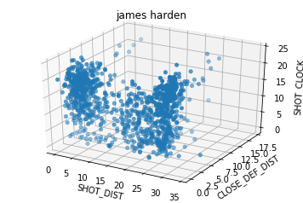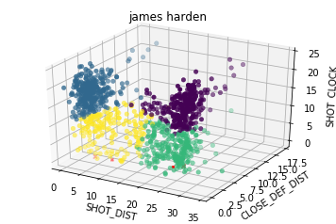

array(

'SHOT_DIST', 'CLOSE_DEF_DIST', 'SHOT_CLOCK'

[[23.81888112, 5.04020979, 16.26643357],

[ 4.01733333, 2.768 , 17.891 ],

[22.12163265, 4.24489796, 5.47795918],

[ 8.30971429, 2.836 , 8.56971429]])

|  |  |
| --- | --- |
|  | Hit_Rate |
| 0 | 0.335664336 |
| 1 | 0.563333333 |
| 2 | 0.428571429 |
| 3 | 0.462857143 |

kmeans.cluster_centers_

'SHOT_DIST', 'CLOSE_DEF_DIST', 'SHOT_CLOCK'

array([[23.81888112, 5.04020979, 16.26643357],

[ 4.01733333, 2.768 , 17.891 ],

[22.12163265, 4.24489796, 5.47795918],

[ 8.30971429, 2.836 , 8.56971429]])

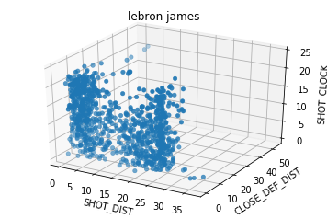

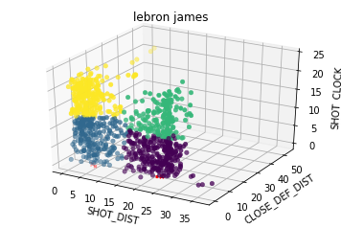

|  |  |
| --- | --- |
|  | Hit_Rate |
| 0 | 0.359259259 |
| 1 | 0.535087719 |
| 2 | 0.396648045 |
| 3 | 0.659259259 |

kmeans.cluster_centers_

Out[45]:

'SHOT_DIST', 'CLOSE_DEF_DIST', 'SHOT_CLOCK'

array(

[[22.42037037, 4.6662963 , 5.73777778],

[ 6.44912281, 2.71140351, 8.09035088],

[23.29106145, 5.59664804, 15.7150838 ],

[ 5.11148148, 4.0237037 , 18.63740741]])

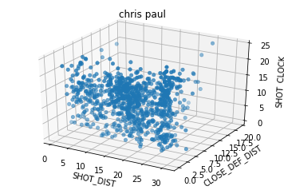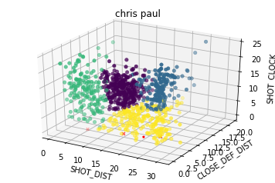

|  |  |
| --- | --- |
|  | Hit_Rate |
| 0 | 0.547619048 |
| 1 | 0.441717791 |
| 2 | 0.514450867 |
| 3 | 0.407239819 |

shot_df_clean['cluster'] = kmeans.labels_

'SHOT_DIST', 'CLOSE_DEF_DIST', 'SHOT_CLOCK'

[[15.52040816 4.41292517 14.99013605]

[24.1 6.2006135 16.4196319 ]

[ 6.39075145 3.36300578 13.17572254]

[20.79230769 4.73393665 5.5479638 ]]

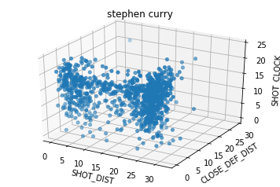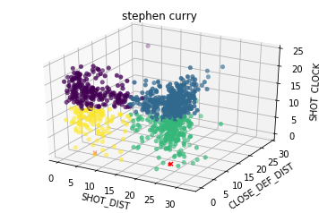

|  |  |
| --- | --- |
|  | Hit_Rate |
| 0 | 0.61965812 |
| 1 | 0.444444444 |
| 2 | 0.389140271 |
| 3 | 0.601851852 |

shot_df_clean['cluster'] = kmeans.labels_

'SHOT_DIST', 'CLOSE_DEF_DIST', 'SHOT_CLOCK'

[[ 5.85384615 3.33504274 17.80811966]

[23.75529101 5.41798942 18.05582011]

[23.64886878 5.01040724 9.45294118]

[ 6.27407407 2.75185185 9.22777778]]