Chapter 2: Installing Scala
Exercises :
- Figure out how to install Scala on Linux in an offline setting (e.g., on a system that’s not connected to the Internet). You will encounter such scenarios extensively in professional environments due to security controls.
- Type scala -help at the command prompt and familiarize yourself with as many options available as possible.
- Try installing multiple versions of Scala on your system and investigate if there are any challenges.
- Research the latest versions of Scala available on the website and make a habit of going through the release notes to understand the latest enhancements in the new releases.

Answers :
- Installing Scala on Linux
before installing scala you have to make sure that java is well installed and if it is not the case do it first before continuing
type java -version to check it
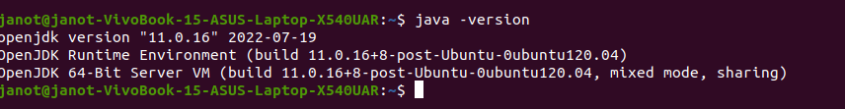
First, download from the Scala website the archive file (in .tgz format) of the latest version of the language: http://www.scala-lang.org/downloads.
Here is how to get it via the command line :
$ wget http://www.scala-lang.org/downloads/distrib/files/scala-2.10.0.tgz
Then we extract the content of the archive file: $ tar xvfz scala-2.10.0.tgz
The files are extracted to the scala-2.10.0 folder. The following output of the tree command shows the file structure.
cd scala-2.10.0
$ tree -L 1
.
├── bin
├── doc
├── examples
├── lib
├── man
├── misc
└── src
The executables are in the bin folder and the libraries in the lib folder. On my computer the files are in ~/tools/scala-2.10.0 on which I created the symbolic link /opt/scala since I want to be able to easily change Scala version.
sudo ln -s ~/tools/scala/scala-2.10.0 /opt/scala
Let's check the installation by displaying the Scala version:
$ /opt/scala/bin/scala -version

It works but it's not convenient to type the full path of the command each time the Scala interpreter is launched. To fix this I add the /opt/scala/bin folder to the system path with the following command:
$ export PATH=$PATH:/opt/scala/bin
By putting the previous line in the .bashrc file the executables in /opt/scala/bin will be added to the system path when logging in.
$ scala

