Chapter 3: Using the Scala Shell
Exercises :
- Create a variable of type Int, assign a value, and then see what methods are available for that type. Repeat the same process for the String variable.ls.
- Explore other options that are available in Scala REPL and research how you can use them (e.g., :sh, :save, :load, etc.).
- Research the spark-shell and see if the same commands and features are available there as well.
- Try increasing the memory used by the Scala shell.

Answers :

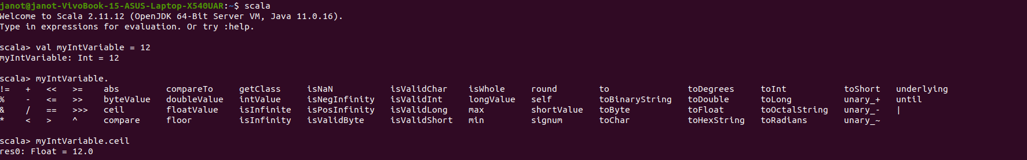
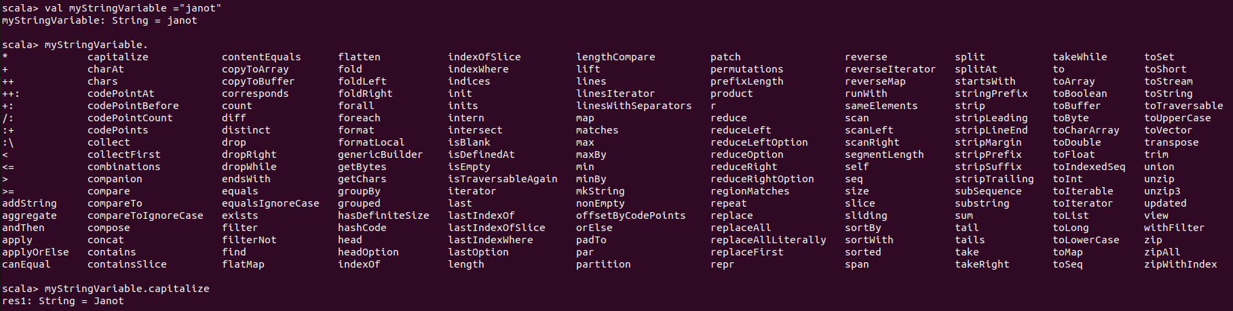

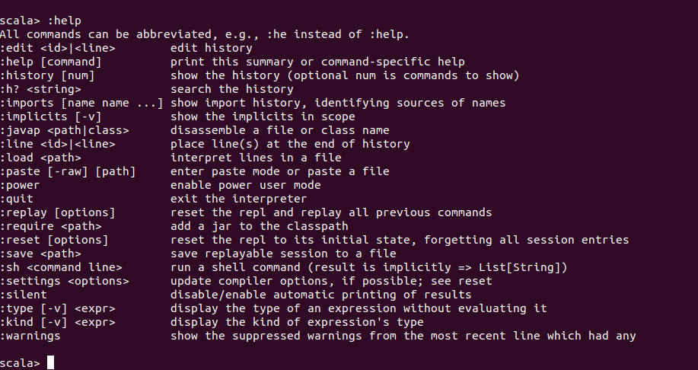

- Spark-shell reuses the latest Scala REPL to reduce code maintenance; the REPL made some changes to how snippets are wrapped to accommodate Spark.

