Chapter 5: Data Types
Exercise1:
- Understand the difference, also in the context of memory footprint and range, between different numeric types in Scala. What are the limitations of each and when does it make sense to use one over the other?
- Research what functions are available in the integer data type, i.e. addition, subtraction, multiplication, and division. Use them in Scala REPL.
- Research which operators on numeric types have precedence, i.e., in an expression, which operation will be executed before the other. Understand these basic concepts on your own.

Answer1 :

Sr.No | Data Type & Description
1 | Byte 8 bit signed value. Range from -128 to 127
2 | Short 16 bit signed value. Range -32768 to 32767
3 | Int 32 bit signed value. Range -2147483648 to 2147483647
4 | Long 64 bit signed value. -9223372036854775808 to 9223372036854775807
5 | Float 32 bit IEEE 754 single-precision float
6 | Double 64 bit IEEE 754 double-precision float

2.
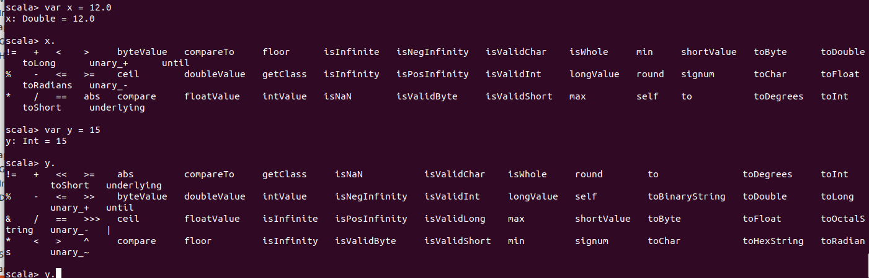

3. Operators Precedence in Scala
Operator precedence determines the grouping of terms in an expression. This affects how an expression is evaluated. Certain operators have higher precedence than others; for example, the multiplication operator has higher precedence than the addition operator −
For example, x = 7 + 3 * 2; here, x is assigned 13, not 20 because operator * has higher precedence than +, so it first gets multiplied with 3*2 and then adds into 7.
Take a look at the following table. Operators with the highest precedence appear at the top of the table and those with the lowest precedence appear at the bottom. Within an expression, higher precedence operators will be evaluated first.
Category | Operator | Associativity
Postfix | () [] | Left to right
Unary | ! ~ | Right to left
Multiplicative | * / % | Left to right
Additive | + - | Left to right
Shift | >> >>> << | Left to right
Relational | > >= < <= | Left to right
Equality | == != | Left to right
Bitwise AND | & | Left to right
Bitwise XOR | ^ | Left to right
Bitwise OR | | | Left to right
Logical AND | && | Left to right
Logical OR | || | Left to right
Assignment | = += -= *= /= %= >>= <<= &= ^= |= | Right to left
Comma | ,

Exercise2:
- Research the different types of logical operators available in Scala. Try to use them in Scala REPL.
- Try assigning a Boolean variable to an Integer variable. What do you get? Research whether you can do this in other languages.
- Try adding two Boolean values. What do you get?

Answer 2:

Logical Operators
The following logical operators are supported by Scala language. For example, assume variable A holds 1 and variable B holds 0, then −
Show Examples
Operator | Description | Example
&& | It is called Logical AND operator. If both the operands are non zero then condition becomes true. | (A && B) is false.
|| | It is called Logical OR Operator. If any of the two operands is non zero then condition becomes true. | (A || B) is true.
! | It is called Logical NOT Operator. Use to reverses the logical state of its operand. If a condition is true then Logical NOT operator will make false. | !(A && B) is true.

2.
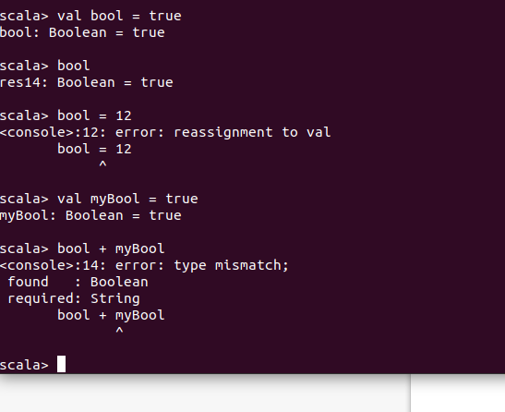

Exercise3:
- Create a string variable and then type . (the dot character) and press Tab. You will see a list of functions. Many of them are covered in this book; however, explore them and learn what they do. The more you know about them, the better.
- Try converting numeric types and Boolean types to String types. Did you have any issue in doing so? You shouldn’t.

Answer 3:
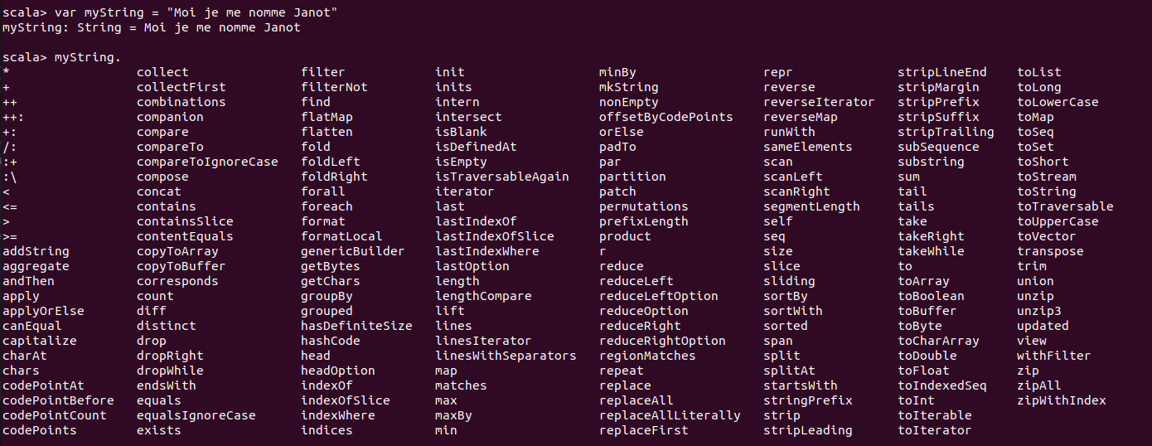

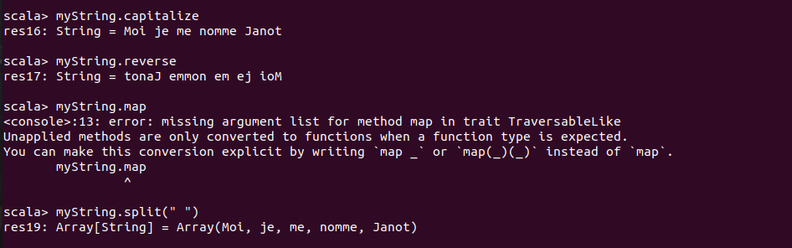

Exercise4:
- Try converting a Double (e.g., 10.5) to Int. What happens? It will drop the portion of number after the decimal. Beware of such nuances.
- Try running "10".toInt. Does it work? It should. Try to convert "two".toInt. Does it work? It shouldn’t. You can’t type cast all the time.
- Research how you generally work with nulls in Scala. You will find specific types, such as Option and its concrete subtypes (Some, None). Research them and make sure you understand their use.

Answer 4:
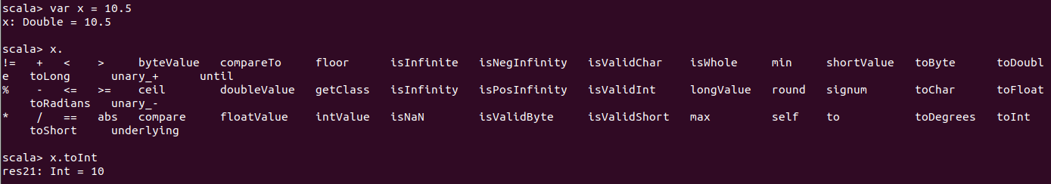

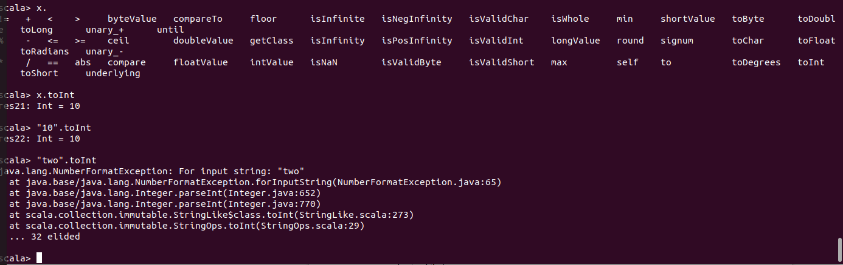
The Empty values in Scala are represented by Null, null, Nil, Nothing, None, and Unit. The explication of these empty values are as follows:
- null:
The reference types such as Objects, and Strings can be nulland the value types such as Int, Double, Long, etc, cannot be null, the null in Scala is analogous to the null in Java.
- Null:
It is a Trait, which is a subset of each of the reference types but is not at all a sub-type of value types and a single instance of Null is null. The reference types can be assigned null but the value types cannot be assigned null.
- Nothing:
Nothing is also a Trait, which has no instances. It is a subset of each of the distinct types. The major motive of this Trait is to supply a return type for the methods which consistently throws an exception i.e, not even a single time returns generally. It is also helpful in providing a type for Nil.
- Unit:
The Unit is Scala is analogous to the void in Java, which is utilized as a return type of a functions that is used with a function when the stated function does not returns anything.
- Nil:
Nil is Considered as a List which has zero elements in it. The type of Nil is List[Nothing] and as stated above, that Nothing has no instances, we can have a List which is confirmed to be desolated.

