Chapter 6: Conditional Statements
Exercise1:
- First, create a decision tree indicating a different series of conditions to be checked. Then use the if/else condition statements based on this decision tree in your program.
- Try assigning the whole if/else blocks to a variable and seeing what value is returned.
- Try nesting different case statements in pattern matching. See how it works.
- Explore other use cases of pattern matching. Explore how it can be used with regular expressions, type checks, and for catching exceptions.

Answer1 :



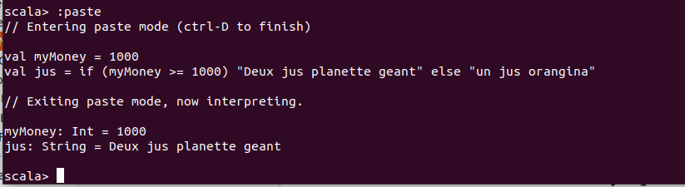

Pattern matching is used to determine whether source files of high-level languages are syntactically correct. It is also used to find and replace a matching pattern in a text or code with another text/code. Any application that supports search functionality uses pattern matching in one way or another.

