**FLORY ANNE CAMILLE, CARLOS**

School Coordinator

Trent Information First Technical Career Institute, Inc. Taytay Rizal

**Dear Ms. Carlos.,**

We, at L. A Voyage Travel and Tours Services is thrilled to extend a warm invitation to you all to join us on our 2-day and 1-night trip capitalizing on the Beauty of Antipolo, Morong, and Tanay Rizal. wherein some exhilarating and enriching tours are waiting to be discovered. Our company is dedicated to providing exceptional travel experiences that not only broaden your horizons but also create memories that will last a lifetime. We look forward to the opportunity to collaborate and achieve remarkable results together.

Thank you for considering our proposal, we are eager to discuss how we can contribute to your success.

For more clarification in detail and inquiries, please do contact Mr. Ariel Curiano on these platforms.

FB: Ariel Curiano #:09294600456

_____________

ARIEL CURIANO

Chief Executive Officer

**COMPANY PROFILE**

The brief history of our business, L.A Tour Service Voyage, is named after our first initials L for Luigi and A for Ariel. The term "voyage" originates from the French language, meaning a long journey. The owners chose this name because it perfectly reflects the nature of our business, which is to provide our clients with an unforgettable travel experience. The Business was founded to provide more job opportunities and offer its clients the best of the best products and services that they may not met in their past company

L.A Travel Voyage is a Travel Business who are committed to provide exceptional Travel experiences for its clients with the product and services that it offers. We are in L. A Travel Voyage also desires to provide a job opportunity in inclined with the industry that we are in.

Our Advantage against our Competitors is that we ensure transparent pricing in every product and service that we offer to our clients. Thus, We also provide flexible and customizable travel packages that allow customers to modify their itineraries according to their preferences.

Day 1 in Antipolo,Rizal

|  |  |
| --- | --- |
| 5:00 am | Meet up at TIFTCI |
| 6:00 am | ETD |
| 8:00 am | arrival at Antipolo |
| 9:00 am | Breakfast at Café Lupe |
| 10:00 am | Visit Antipolo Cathedral |
| 11:00 am | Going to Cloud 9 Antipolo 360 view |
| 11:30 am | Arrival at Cloud 9 Antipolo |
| 12:00 am | Lunch at a Local restaurant inside Cloud 9 Antipolo |
| 1:00 pm | Going to Hinulugang Taktak |
| 2:00 pm | Arrival at Hinulugang Taktak |
| 3:00 pm to 4:30 pm | Enjoy the refreshing waters of Hinulugang Taktak falls |
| 5:00 pm | Going to Bumble Bee Inns |
| 5:30 pm | Arrival at Bumble Bee Inns |
| 6:00 pm | Dinner |

Day 2 in Antipolo,Rizal

|  |  |
| --- | --- |
| 6:00 am | Breakfast at Bumble Bee Inns |
| 7:00 am | Prepare for the Pinto Art Museum Tour |
| 8:00 am | Going to the Antipolo Art Museum |
| 9:00 am | Arrival at Antipolo Museum |
| 9:30 am | Enjoy the view of different Art in frames inside that can be seen in Antipolo Art Museum |
| 10:30 am | Call time for Early Lunch at Perot Resto Bar and Grill |
| 11:30 am | Arrival at Perot Resto Bar and Grill |
| 12:00 nn | Lunch |
| 1:00 pm | Going back TIFTCI |
| 4:00 pm | ETA at TIFTCI |

|  |
| --- |
| END OF TOUR |

**Budget Breakdown for Antipolo Trip**

|  |  |  |  |
| --- | --- | --- | --- |
| Category | Quantity | Per head Per head | Amount |
| Antipolo Cathedral | 100 | 0 | 0 |
| Hinulugang Taktak | 100 | 100 | 10,000 |
| Pinto Art Museum | 100 | 100 | 10,000 |
| Bumble Bee Inns | 100 | 1,000 | 100,000 |
| Cafe Lupe | 100 | 400 | 40,000 |
| Pero't Resto Bar and Grill | 100 | 400 | 40,000 |
| Transportation | 100 | 200 | 20,000 |
| Travel Insurance | 100 | 400 | 40,000 |
| **TOTAL** |  | 2,600 | 260,000 |

**Profit percentage formula**

|  |  |  |  |
| --- | --- | --- | --- |
| **Percentage Profit** | **Selling Price** | **Total Cost** | **Total Profit** |
| 15% | ₱ 2, 990.00 | ₱ 2, 660.00 | ₱ 390.00 |



Day 1 IN PILLILA RIZAL

|  |  |
| --- | --- |
| 5:00 am | Meet up at TIFTCI |
| 6:00 am | ETD |
| 9:00 am | Arrival at Pililla Rizal |
| 10:00 am | Going to Winds Cape Nature Park for sightseeing of the view of mountains near the area. |
| 11:00 am | Going to Raski’s Kainan for Lunch |
| 11:30 am | Arrival at Raski’s Kainan |
| 12:00 nn | Lunch |
| 1:00 pm | Going to Masungi Georeserve for sightseeing and light hike activities with the guide of staffs to ensure the safety of the students |
| 2:00 pm | Arrival at Masungi Georeserve |
| 3:00 pm to 4:00 pm | Enjoy the Light hike activities and relaxation in a hammock with a view of nature at the peak of Masungi |
| 5:00 pm | Call time for Hotel Check in at Camp Ula |
| 5:30 pm | Going to Camp Ula |
| 6:00 pm | Arrival and Dinner at Camp Ula |

Day 2 In PILILLA Rizal

|  |  |
| --- | --- |
| 6:00 am | Breakfast at Camp Ula |
| 7:00 am | Call time for Windmill Farm in Pillila |
| 8:00 am | Going to Windmill Farm |
| 10:00 am | Arrival at Windmill Farm and start Sightseeing and picture taking with the view of nature and the gigantic windmill of Pililla |
| 11:00 am | Going to La Luna Sa Hungry local restaurant for Lunch |
| 11:40 am | Arrival at La Luna Sa Hungry restaurant |
| 12:00 nn | Lunch |
| 1:00 pm | Going to the famous Old Church in Pillila |
| 1:20 pm | Arrival at Old Church and start sightseeing and learning about its history |
| 2:30 pm | Call time for departure |
| 3:00 pm | Going back to TIFTCI |
| 7:00 pm | ETA |

|  |
| --- |
| END OF TOUR |

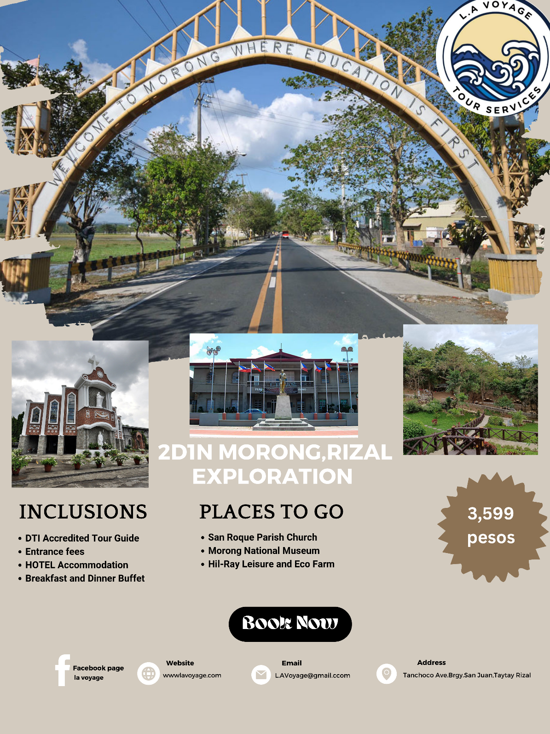

Day 1 In Morong Rizal

|  |  |
| --- | --- |
| 5:00 am | Meet at TIFTCI |
| 6:00 am | ETD |
| 7:00 am | Arrival at Morong Rizal |
| 8:00 am | Breakfast at Zeplong Siblings Kitchen and Cafe |
| 9:00 am | Going to San Roque Parish Church |
| 9:30 am | Arrival at San Roque Parish Church and sightseeing at its Western-inspired Church |
| 10:30 am | Going to Morong National Museum |
| 11:00 am | Arrival and sightseeing of Local Art displayed in the frames inside Morong National Museum |
| 12:00 nn | Lunch at Filomena’s local restaurant,1street far from the Museum |
| 1:00 pm | Going to St. Jerome Parish Church |
| 2:20 pm | Arrival and start of Tour in St. Jerome Parish Church |
| 3:30 pm | Going to Alamaris Resort Red, Panther for check-in |
| 4:10 pm | Arrival and check-in at Alamaris Resort Red, Panther |
| 6:00 pm | Dinner |

Day 2 In Morong Rizal

|  |  |
| --- | --- |
| 6:00 am | Breakfast |
| 7:00 am | Going to Hil-Ray Leisure and Eco Farm |
| 8:30 am | Arrival and sightseeing of botanic gardens and leisure activities at Hil-Ray Leisure and Eco Farm |
| 12:00 nn | Lunch at Hil-Ray |
| 1:00 pm | Going back to TIFTCI for the end of Tour |
| 4:00 pm | ETA |
| END OF TOUR |  |