In The Partial Fulfilment Of

Master Science (Information Technology)

**Sem-8**



L.J Institute of Computer Applications

L.J University, Ahmedabad

**Skill-Swap: Skills Exchange Platform**

Developed By: Guided By:

1. Name: Yash Shah Prof. Ananya Yaduvanshi

Enrollment: 21004500210160

1. Name: Arnold Macwan

Enrollment: 21004500210065

1. Name: Nandini Bhavsar

Enrollment: 21004500210016

L.J Institute of Computer Applications

Near Nagdev Kalyan Mandir, Near Sanand Cross Roads,

Sarkhej-Gandhinagar Highway, Ahmedabad – 382210

Phone No: 9099063417



**CERTIFICATE**

Enrollment No: 21004500210160 Seat No: ­_________

This is to certify that **Yash Shah** of Master of Science (MSc.IT), Semester - **8**, Roll No-**60(B)** has satisfactorily completed his project titled **SkillSwap-Skill Exchange Platform** in Web Application Development using MEAN stack.

Internal Guide: HOD:

Date of Submission:

L.J Institute of Computer Applications

Near Nagdev Kalyan Mandir, Near Sanand Cross Roads,

Sarkhej-Gandhinagar Highway, Ahmedabad – 382210

Phone No: 9099063417



**CERTIFICATE**

Enrollment No: 21004500210065 Seat No: ­_________

This is to certify that **Arnold Macwan** of Master of Science (MSc.IT), Semester - **8**, Roll No-**28(B)** has satisfactorily completed his project titled **SkillSwap-Skill Exchange Platform** in Web Application Development using MEAN stack.

Internal Guide: HOD:

Date of Submission:

L.J Institute of Computer Applications

Near Nagdev Kalyan Mandir, Near Sanand Cross Roads,

Sarkhej-Gandhinagar Highway, Ahmedabad – 382210

Phone No: 9099063417



**CERTIFICATE**

Enrollment No: 21004500210016 Seat No: ­_________

This is to certify that **Nandini Bhavsar** of Master of Science (MSc.IT), Semester - **8**, Roll No-**06(B)** has satisfactorily completed his project titled **SkillSwap- Skill Exchange Platform** in Web Application Development using MEAN stack.

Internal Guide: HOD:

Date of Submission:

|  |  |  |
| --- | --- | --- |
| **Sr.**  **No.** | **TABLE OF CONTENT** | **Page No.** |
| **1.** | **INTRODUCTION** | **06** |
|  | 1.1 Existing System | **06** |
|  | 1.2 Need for the New System | **06** |
|  | 1.3 Objectives of the New System | **07** |
|  | 1.4 Problem Definition | **07** |
|  | 1.5 Core Components | **07** |
|  | 1.6 Project Profile | **08** |
|  | 1.7 Assumptions and Constraints | **08** |
|  | 1.8 Advantages and Limitations of the Proposed System | **09** |
| **2.** | **REQUIREMENT DETERMINATION & ANALYSIS** | **10** |
|  | 2.1 Requirement Determination | **10** |
|  | 2.2 Targeted Users | **10** |
| **3.** | **SYSTEM DESIGN** | **11** |
|  | 3.1 Use Case Diagram | **11** |
|  | 3.2 Class Diagram |  |
|  | 3.3 Activity Diagram |  |
|  | 3.4 Sequence Diagram |  |
|  | 3.4 Data Dictionary |  |
| **4.** | **DEVELOPMENT** |  |
|  | 4.1 Coding Standard |  |
|  | 4.2 Screenshots |  |
| **5.** | **AGILE DOCUMENTATION** |  |
|  | 5.1 Agile Project Charter |  |
|  | 5.2 Agile User Story |  |
|  | 5.3 Agile Release Plan |  |
| **6.** | **PROPOSED ENHANCEMENTS** |  |
| **7.** | **CONCLUSION** |  |
| **8.** | **BIBLIOGRAPHY** |  |

**1. INTRODUCTION**

* The new currency in today's fast-paced, constantly-changing world is talents. But not everyone can afford professional instruction, and not everyone has equal access to high-quality learning materials. This is the role of SkillSwap, a peer-to-peer collaborative network that allows people to share talents and information without exchanging money.
* Using the MEAN (MongoDB, Express.js, Angular, and Node.js), SkillSwap is a full-stack online application that enables users to teach others new skills. People from different backgrounds may interact, teach, and learn according to their areas of expertise in this community-driven setting.

**1.1 Existing System**

* In today’s digital learning landscape, people primarily rely on **paid platforms**, online courses, and traditional coaching institutes to acquire new skills. While these methods provide structured learning, they often come with significant drawbacks that make them inaccessible or ineffective for a large section of learners.
* Affordable, participatory, and community-driven learning opportunities are not offered by the present systems. Individuals are either unable to obtain value for their money or are overly dependent on pricey platforms. This emphasizes the need for a different approach to learning that is economical, individualized, and collaborative.

**1.2 Need for The New System**

* SkillSwap addresses these needs by introducing a skill-exchange-based learning model, allowing users to both teach and learn through direct interaction and provide centralized collaborative platform. By providing cost effective learning or gather various SkillSwappers across the globe. Such kind of platform that allows people to **exchange skills**, **build networks**, and **grow together**—without the barriers of medium and trust or location. It’s more than a platform — it’s a **movement for democratized learning**.

**1.3 Objective of the System**

* The objective of SkillSwap is to create a collaborative, peer-to-peer platform where users can exchange skills and knowledge. The system aims to connect individuals based on their teachable and learnable skills, enabling them to grow personally and professionally through mutual learning, interactive sessions, and a community-driven environment. It promotes affordable, accessible, and personalized education by facilitating skill listings, search, filtering, and request-based exchange workflows — all built on a secure and user-friendly MEAN stack infrastructure.

**1.4 Problem Definition**

* In the current digital age, acquiring new skills often requires enrolling in expensive courses, relying on static self-learning resources, or struggling to find personalized guidance. These traditional methods create **financial, geographical, and accessibility barriers**, especially for learners who seek affordable and collaborative learning opportunities. By overcoming these issues, the system provides centralized platform which enables users to interact with each other exchange their skills and thoughts by promoting community-based skill learning

.

**1.5 Core Components**

**1.6 Project Profile**

|  |  |
| --- | --- |
| Project Title | Skill-Swap |
| Frontend | HTML5, SCSS, JavaScript, Angular |
| Libraries | Angular Material, Tailwind CSS |
| Back-end | NodeJS, ExpressJS |
| Database | MongoDB Cluster |
| Tools | MS-OFFICE, Visual Studio Code, Draw.io |

**1.7 Assumption and Constraints**

**Assumption**

* Users have access to the internet and a modern web browser to use the application effectively**.**
* Users will have to provide accurate information when signing up and listing their skills.
* Each user has at least one skill they can teach and one they want to learn.
* The platform will initially target **individual learners and educators**, not organizations.

**Constraints**

* The platform currently supports only English for content and communication.
* OAuth login is limited to selected provider (Google).
* Real-time communication or chat features may not scale efficiently in the early stages of the platform.

**1.8 Advantages and Limitations**

**2. REQUIREMENT DETERMINATION**

**AND ANALYSIS**

**2.1 Requirement Determination**

* Requirement determination for task management involves gathering, Analysing, and documenting the needs and expectations of stakeholders.
* Requirements were identified through a combination of user research, brainstorming, and analysis of similar platforms.

• This phase is consisting of:

* + Surveys & sampling
  + Stockholders’ requirements & analysis
  + Review existing system if available
  + Competitive analysis
  + Planned or hypothetical interviews
  + Mock-up

**2.2 Targeted users**

* Admin
* User

**3. System Design**

**3.1 Use Case Diagram**

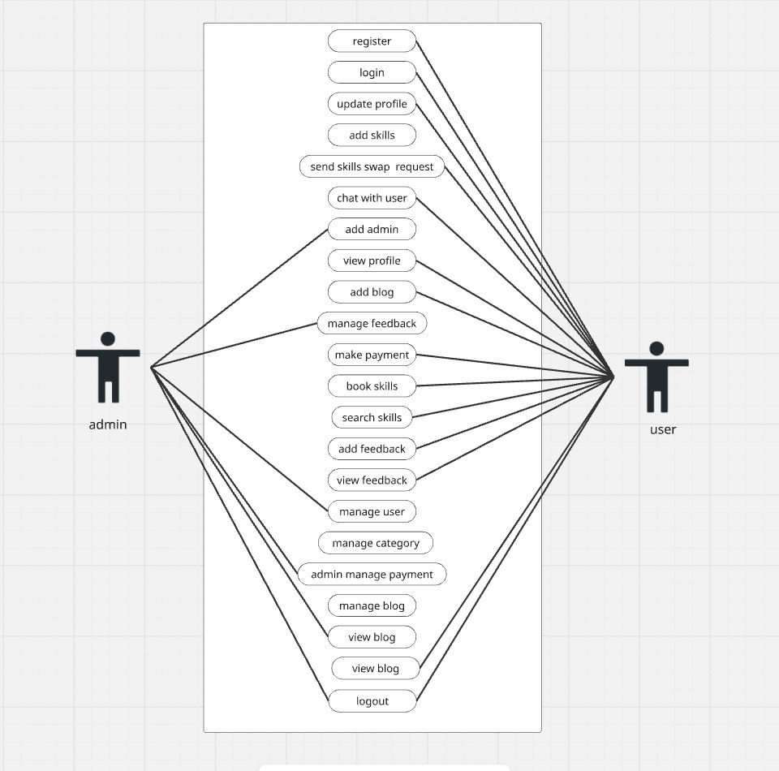

**3.2 Class Diagram**

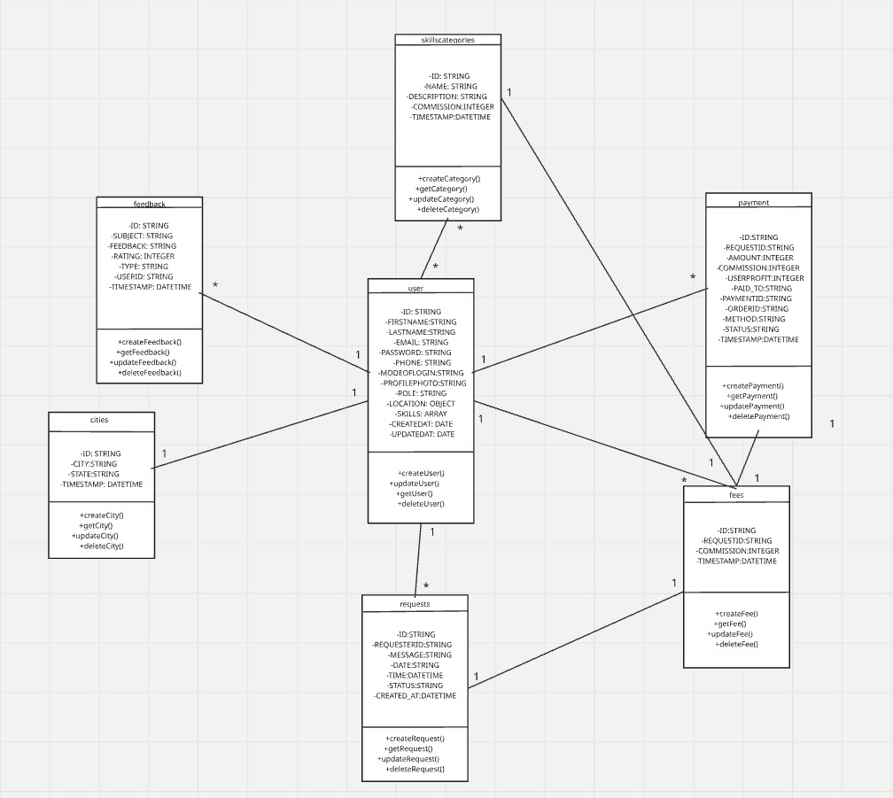

**3.3 Activity Diagram**

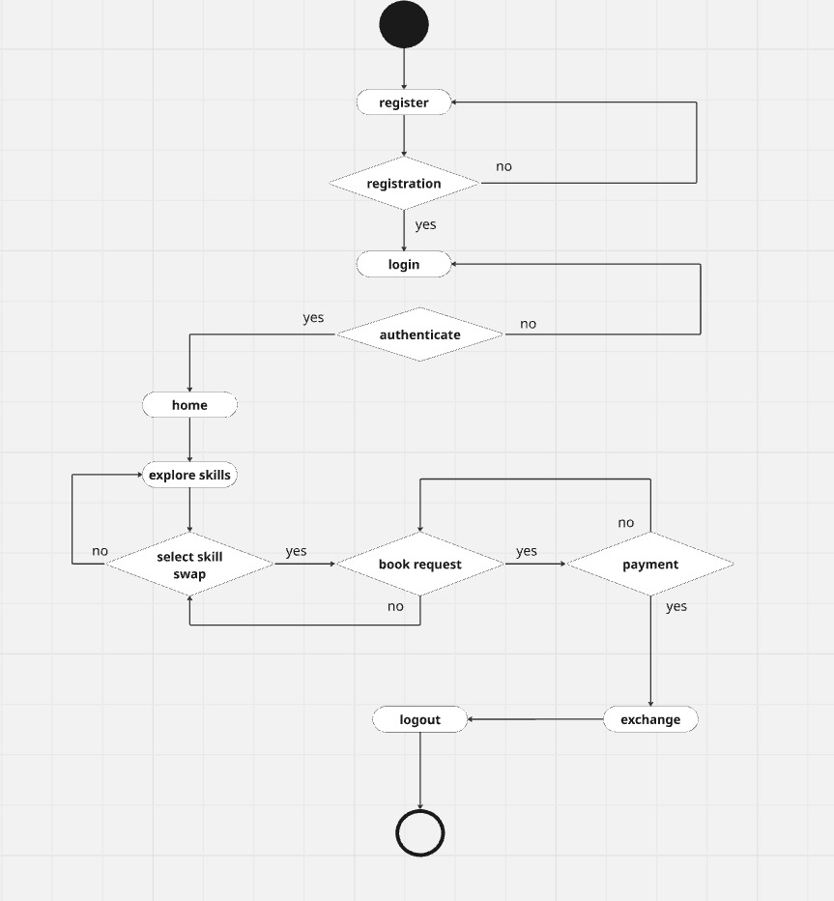

**3.4 Sequence Diagram**

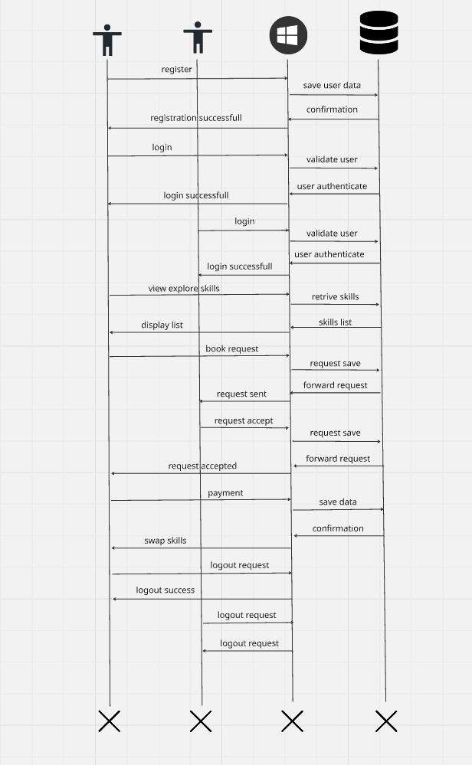

**3.5 Data Dictionary**

1. **User**

|  |  |  |  |  |
| --- | --- | --- | --- | --- |
| Fieldname | Datatype | Field Size | Constraint | Example |
| ID | STRING | 50 | NOT NULL | 67f6c02dc5a0504124894dc6 |
| FIRSTNAME | STRING | 50 | NOT NULL | Yash |
| LASTNAME | STRING | 50 | NOT NULL | Shah |
| EMAIL | STRING | 100 | NOT NULL | [2106450211600@jku.edu.in](mailto:2106450211600@jku.edu.in) |
| PASSWORD | STRING | 50 | NOT NULL | $2a$10$cDNC5bxYUeBB1bqWBvmfDeEnchiSjThVnrRHLbc.kHYlsany2x5u2 |
| PHONE | STRING | 15 | NOT NULL | 1234567890 |
| MODEOFLOGIN | STRING | 50 | NOT NULL | google |
| PROFILEPHOTO | STRING | 100 | NOT NULL | 1744224697311.jpg |
| ROLE | STRING | 20 | NOT NULL | user |
| LOCATION | OBJECT | - | NOTNULL | - |
| LOCATION.HOUSE | STRING | 100 | NOT NULL | Sweetal appartment |
| LOCATION.AREA | STRING | 100 | NOT NULL | shapur |
| LOCATION.STATE | STRING | 100 | NOT NULL | gujarat |
| LOCATION.CITY | STRING | 100 | NOT NULL | ahmedabad |
| LOCATION.PINCODE | INTEGER | 6 | NOT NULL | 380001 |
| SKILLS | ARRAY | - | NOT NULL | - |
| SKILLS.CATEGORYID | STRING | 50 | REFERENCE KEY | 67ea79b253d89517f16bd0a4 |
| SKILLS.CERTIFICATE | STRING | 100 | NOT NULL | uploads/documents/1744224534634.pdf |
| SKILLS. CREATEDAT | DATE | 50 | NOT NULL | 2025-04-09T18:48:52.452+00:00 |
| SKILLS.ID | STRING | 50 | NOT NULL |  |
| CREATEDAT | DATE | 50 | NOT NULL | 2025-04-09 |

1. **Feedback**

|  |  |  |  |  |
| --- | --- | --- | --- | --- |
| Fieldname | Datatype | Field Size | Constraint | Example |
| ID | STRING | 50 | NOT NULL | 67f4f4dd8a819d3b2f06fbb |
| SUBJECT | STRING | 100 | NOT NULL | User interface |
| FEEDBACK | STRING | 100 | NOT NULL | nice |
| RATING | INTEGER | 5 | NOT NULL | 5 |
| TYPE | STRING | 50 | NOT NULL | Feedback |
| USERID | STRING | 50 | REFERENCE KEY | 67f6c92dc5a85094124894dc6 |
| TIMESTAMP | DATETIME | 50 | NOT NULL | 2025-04-12T11:32:29.597+00:00 |

1. **Cities**

|  |  |  |  |  |
| --- | --- | --- | --- | --- |
| Fieldname | Datatype | Field Size | Constraint | Example |
| ID | STRING | 50 | NOT NULL | 67f4f4dd8a819d3b2f06fbb |
| CITY | STRING | 100 | NOT NULL | ahmedabad |
| STATE | STRING | 100 | NOT NULL | gujarat |
| TIMESTAMP | DATETIME | 50 | NOT NULL | 2025-04-12T11:32:29.597+00:00 |

1. **Requests**

|  |  |  |  |  |
| --- | --- | --- | --- | --- |
| Fieldname | Datatype | Field Size | Constraint | Example |
| ID | STRING | 50 | NOT NULL | 67fd2bae6e6bba7a45d3787b |
| REQUESTERID | STRING | 50 | REFERENCE KEY | 67f6c02dc5a0504124894dc |
| MESSAGE | STRING | 100 | NOT NULL | I want to swap this skills |
| DATE | STRING | 100 | NOT NULL | 2025-04-17T00:00:00.000+00:00 |
| TIME | DATETIME | 50 | NOT NULL | NIGHT |
| STATUS | STRING | 50 | NOT NULL | PENDING |
| CREATED_AT | DATETIME | 50 | NOT NULL | 2025-04-14T15:37:18.703+00:00 |

1. **Fees**

|  |  |  |  |  |
| --- | --- | --- | --- | --- |
| Fieldname | Datatype | Field Size | Constraint | Example |
| ID | STRING | 50 | NOT NULL | 67fe8e83037b27ddf67114ca |
| REQUESTID | STRING | 100 | REFERENCE KEY | 67fe1df1e8fed1e45a4b0109 |
| commission | INTEGER | 100 | NOT NULL | 75 |
| TIMESTAMP | DATETIME | 50 | NOT NULL | 2025-04-15T17:08:56.401+00:00 |

1. **Payment**

|  |  |  |  |  |
| --- | --- | --- | --- | --- |
| Fieldname | Datatype | Field Size | Constraint | Example |
| ID | STRING | 50 | NOT NULL | 67fe8e83037b27ddf67114cd |
| REQUESTID | STRING | 100 | REFERENCE KEY | 67fe1df1e8fed1e45a4b0109 |
| AMOUNT | INTEGER | 100 | NOT NULL | 500 |
| commission | INTEGER | 100 | NOT NULL | 75 |
| USERPROFIT | INTEGER | 100 | REFERENCE KEY | 425 |
| PAID_TO | STRING | 100 | NOT NULL | 67f69b7a7b65f87cac357fd1 |
| PAYMENTID | STRING | 50 | REFERENCE KEY | pay_QJPCXQULGicAi5 |
| ORDERID | STRING | 50 | REFERENCE KEY | order_QJPBxFG2efteCz |
| METHOD | STRING | 50 | NOT NULL | Razorpay |
| STATUS | STRING | 50 | NOT NULL | Success |
| TIMESTAMP | DATETIME | 50 | NOT NULL | 2025-04-15T17:08:56.401+00:00 |

1. **Skill Category**

|  |  |  |  |  |
| --- | --- | --- | --- | --- |
| Fieldname | Datatype | Field Size | Constraint | Example |
| ID | STRING | 50 | NOT NULL | 67ea79b253d89517f16bd0a4 |
| NAME | STRING | 100 | NOT NULL | Health, Wellness & Fitness |
| DESCRIPTION | STRING | 100 | NOT NULL | They are crucial for both personal and professional growth |
| COMMISSION | INTEGER | 100 | NOT NULL | 10 |
| TIMESTAMP | DATETIME | 50 | NOT NULL | 2025-04-12T11:32:29.597+00:00 |

1. **Development**

**4.1 Coding Standard**

• **Project structure:**

* Use clear, descriptive names for directories, reflecting different modules.
* Name source code files meaningfully to indicate their function.

• **Code-version management:**

* Write detailed and meaningful commit messages that summarize changes
* Organize the repository with well-defined branches.

• **Error handling:**

* Implement comprehensive error handling for user input validation, skill matching conflicts, and payment processing failures.
* Ensure error messages are user-friendly and informative, without exposing internal system details.

• **Further development:**

* Conduct regular code reviews to maintain code quality, promote best practices, and detect bugs or inefficiencies early.
* Keep documentation up-to-date, especially when new features are added or existing features are changed.

**4.2 Screenshot’s**

**Home Page:**

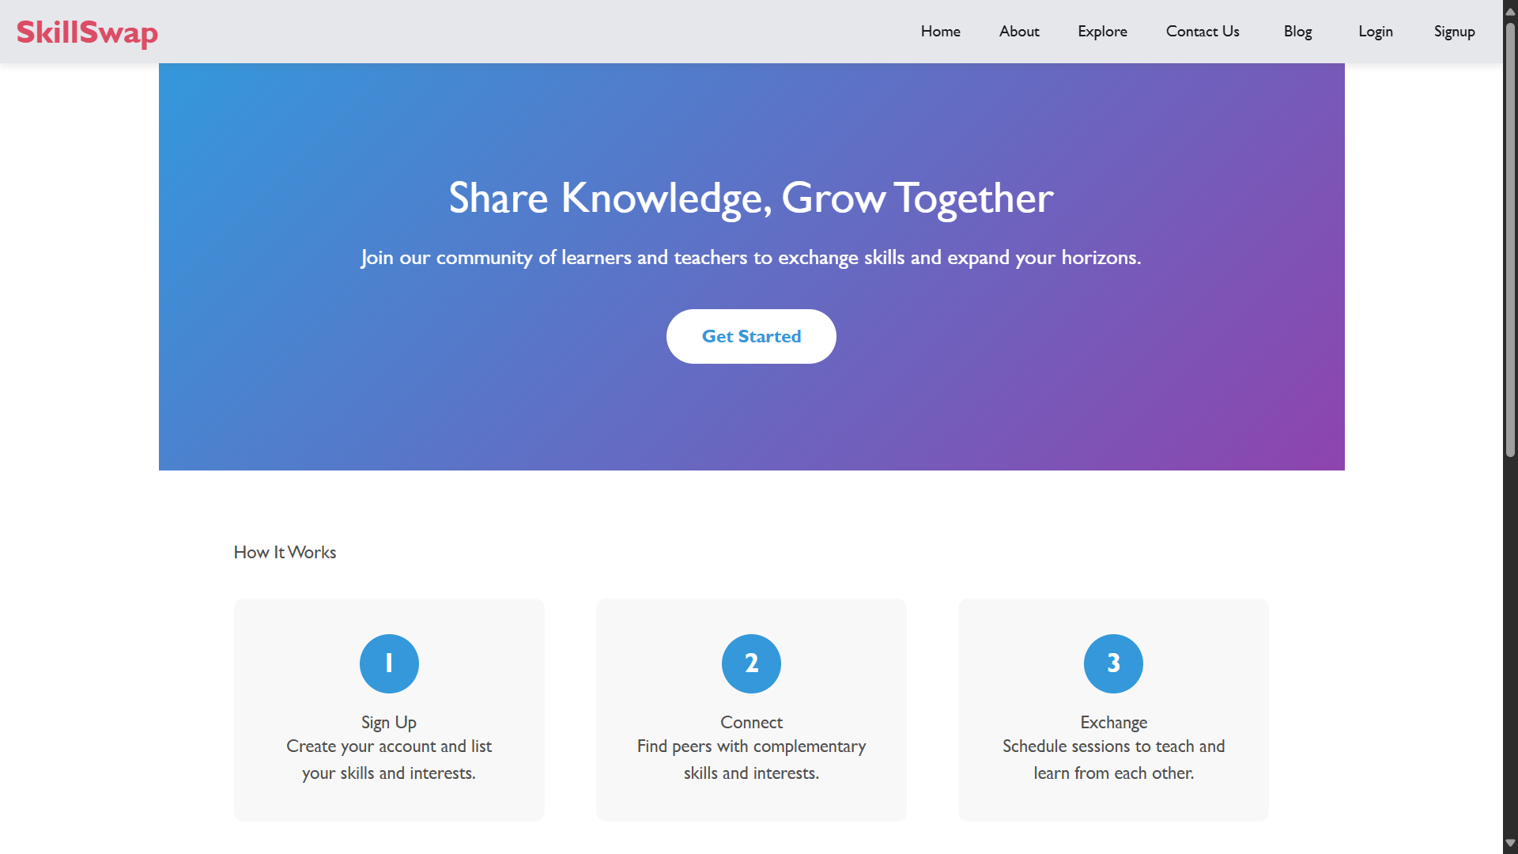

**Login Page:**

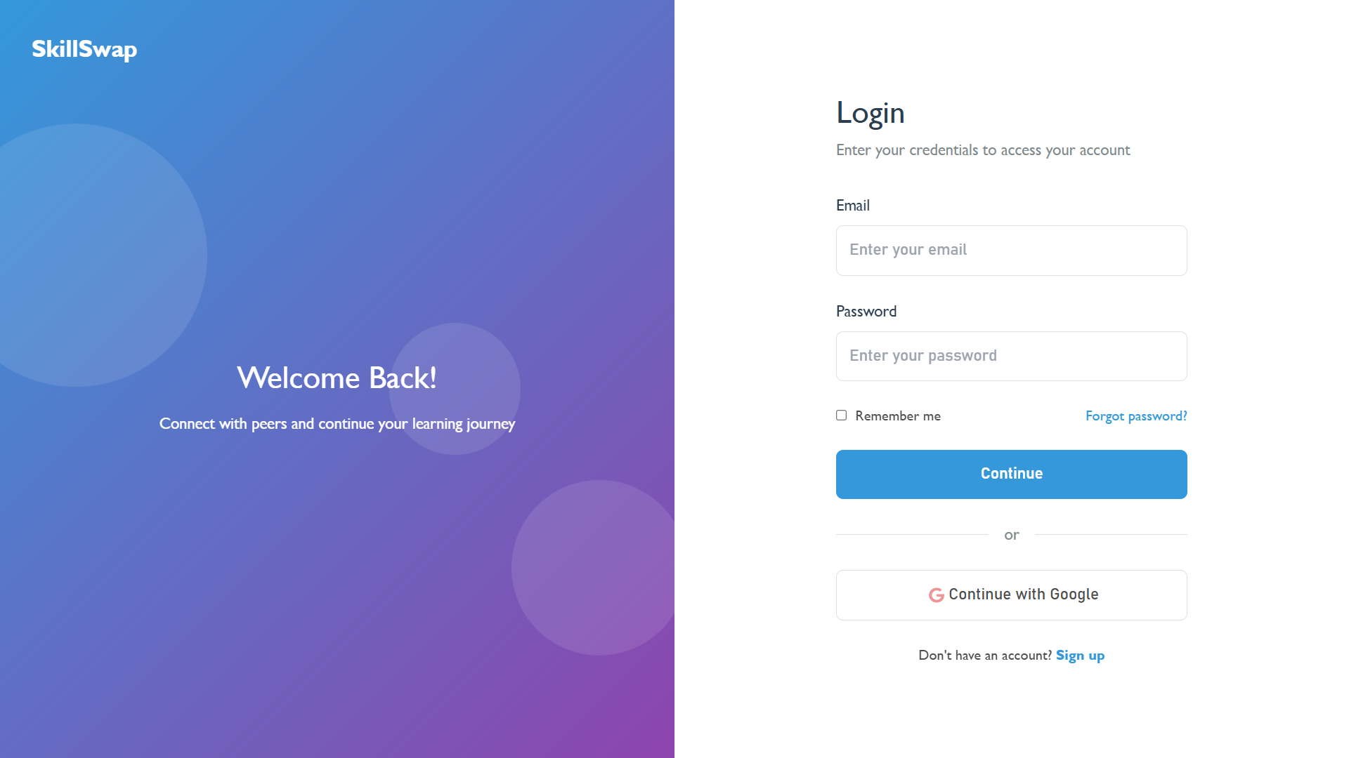

**Register Page:**

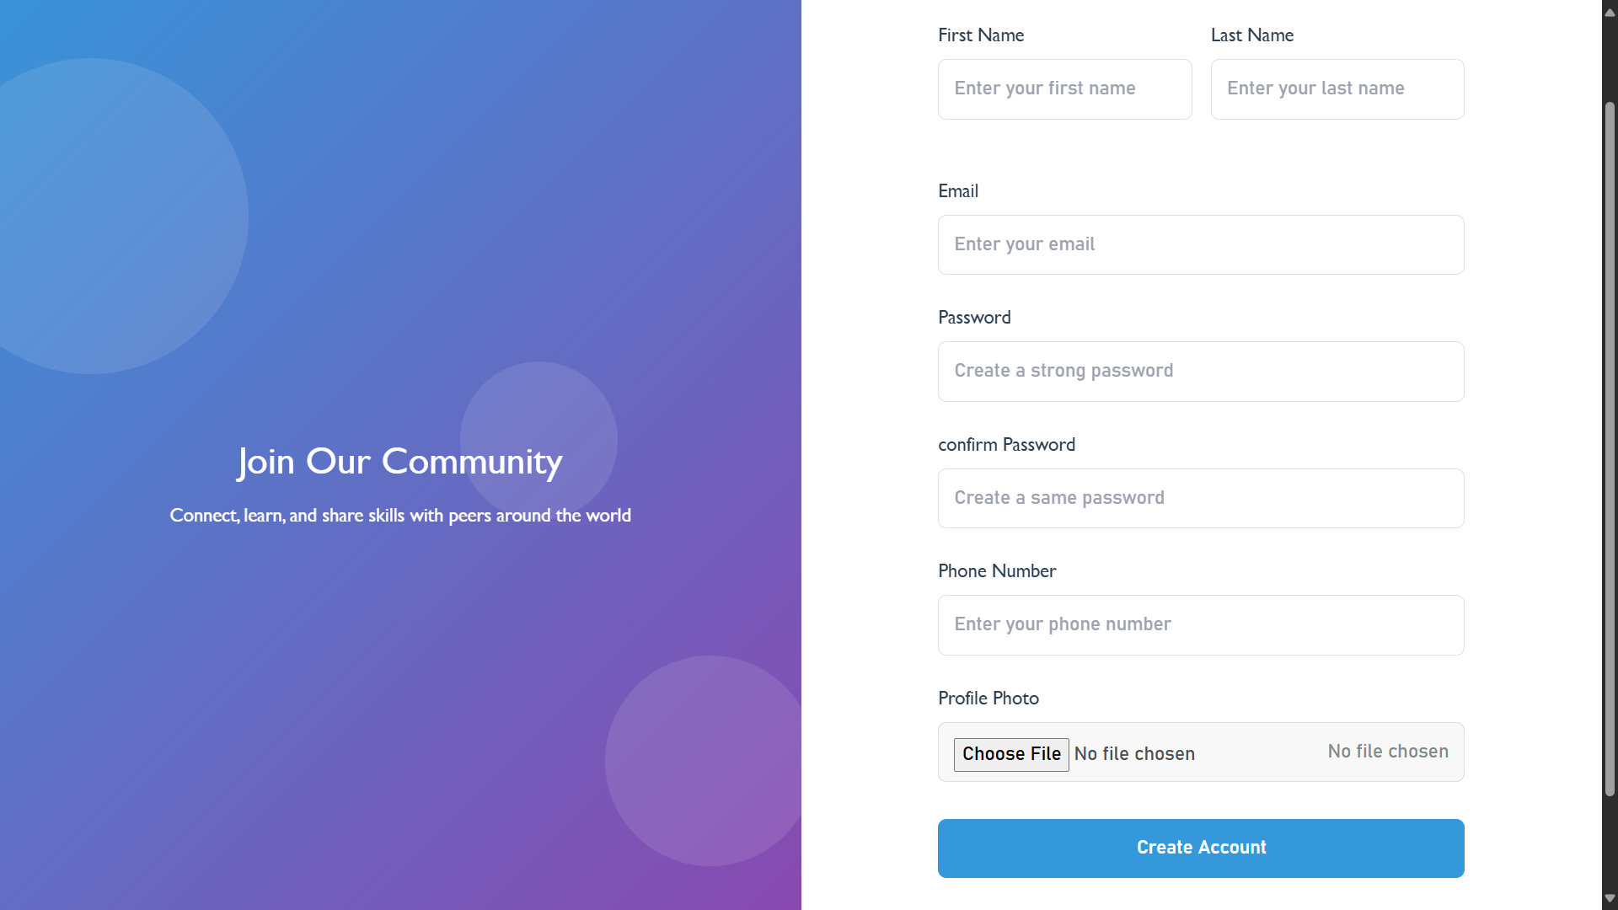

**Contact us:**

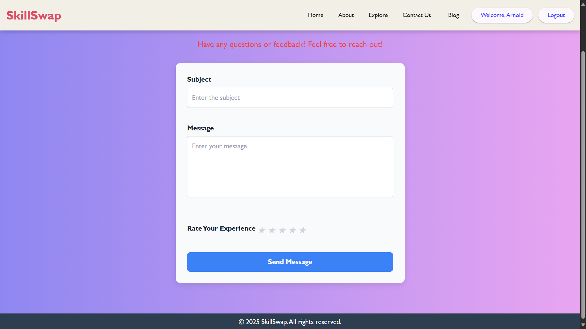

**Explore page**

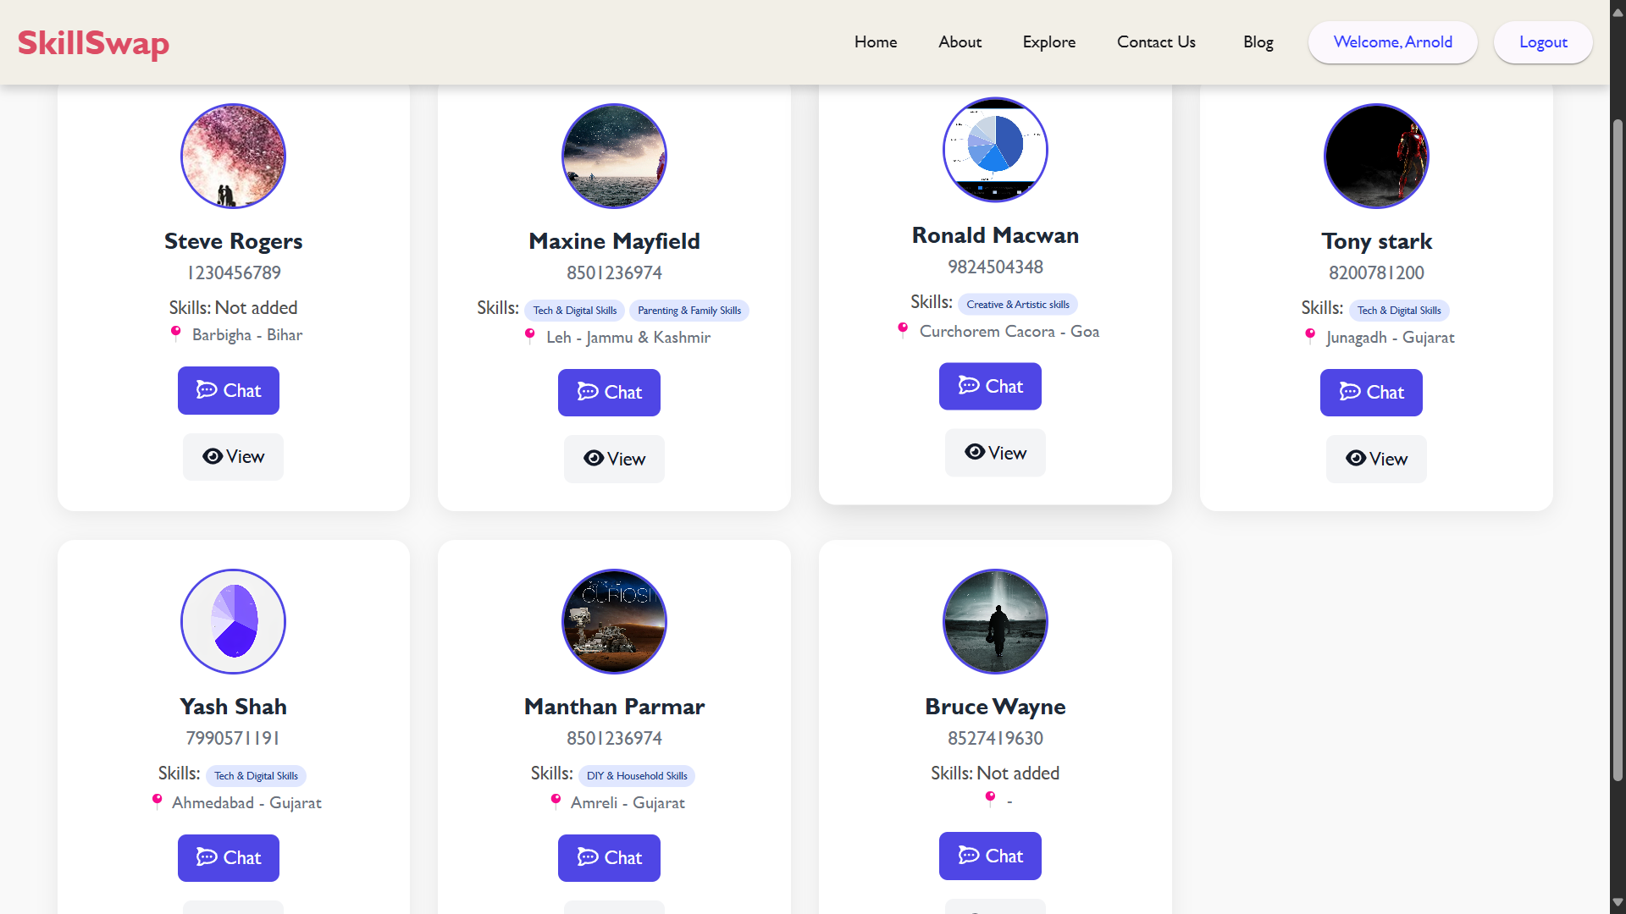

**Profile page**

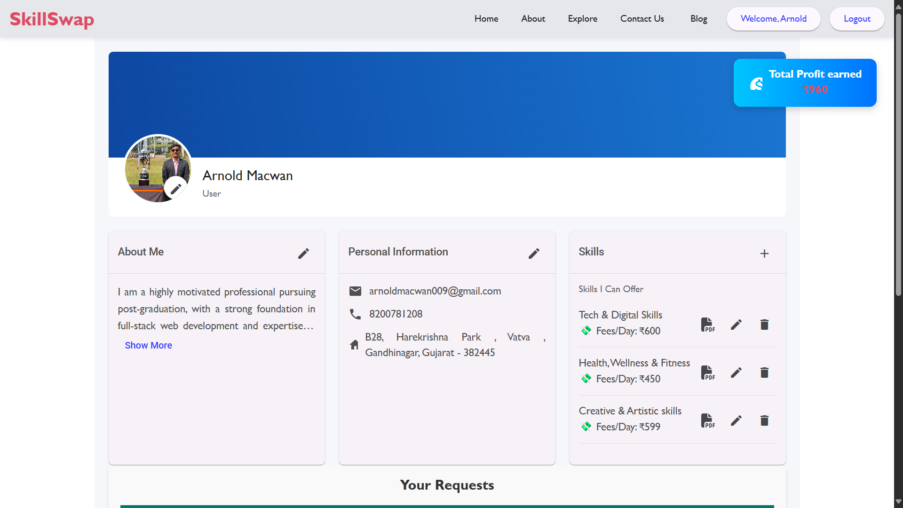

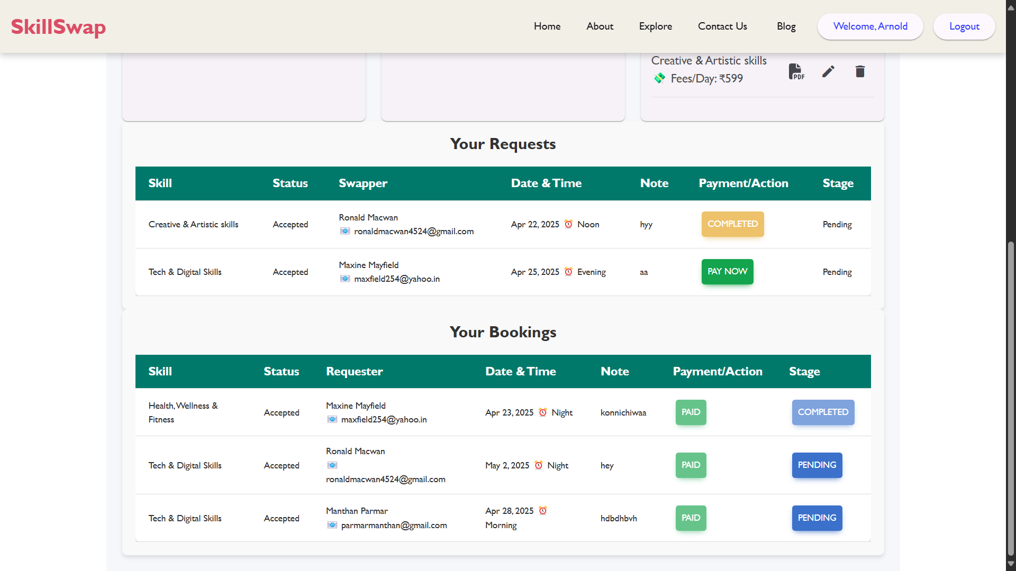

**User detail page**

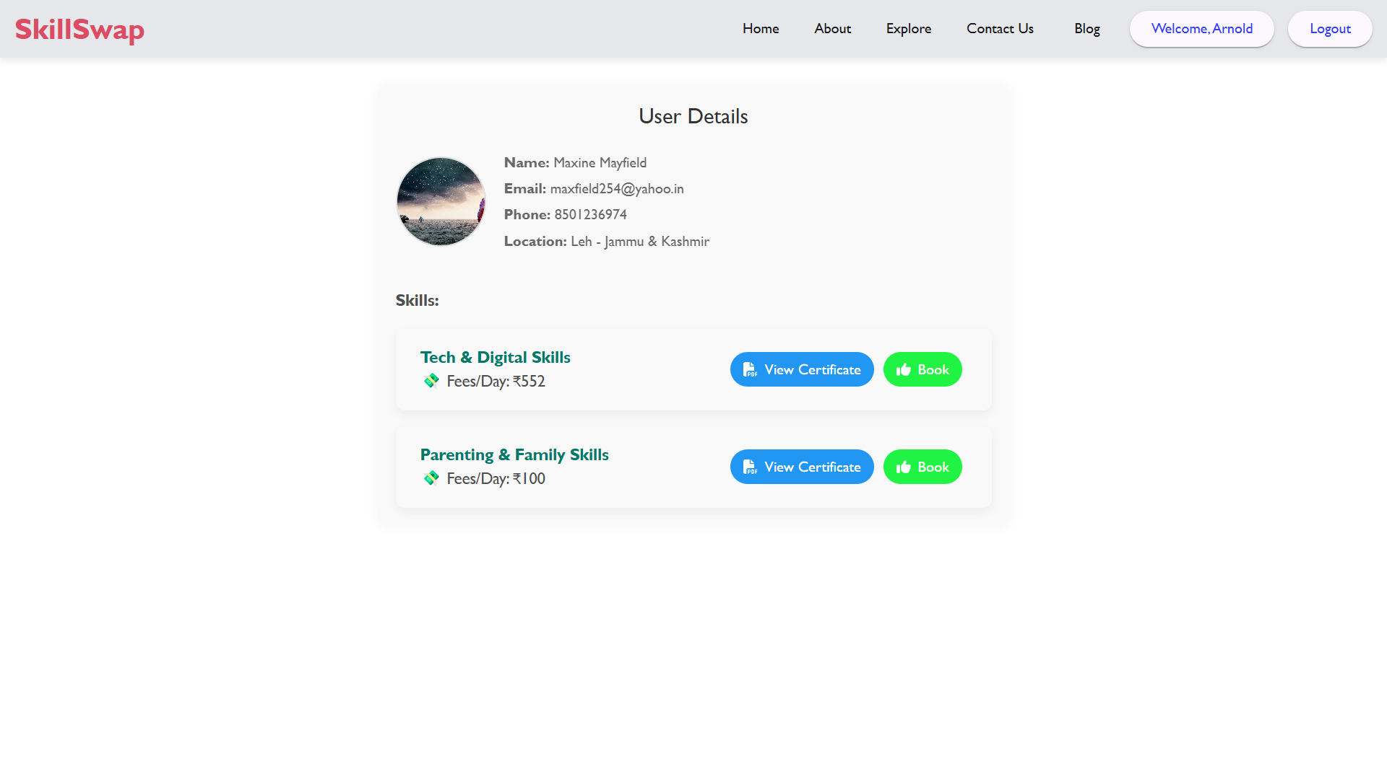

**Admin Dashboard**

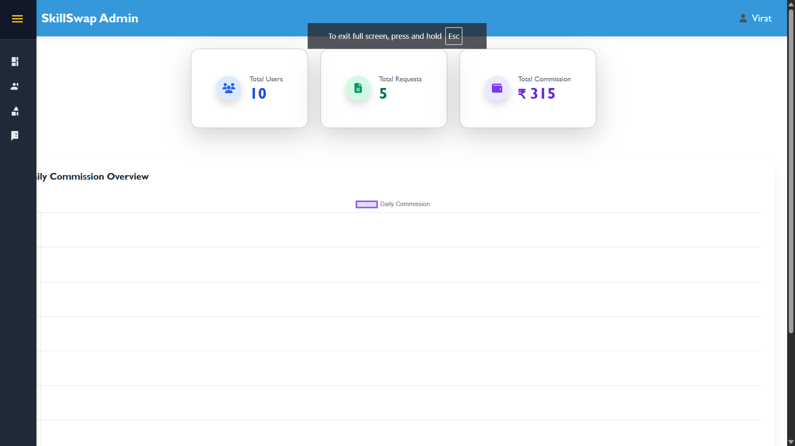

**Users List**

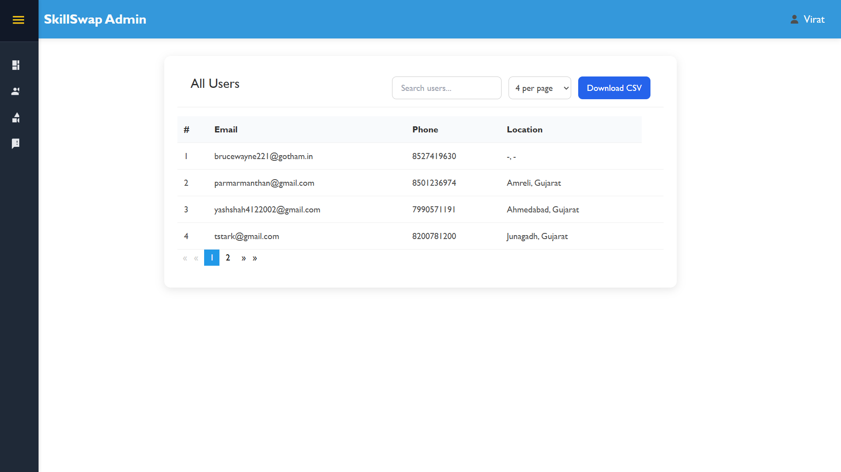

**Add skill category**

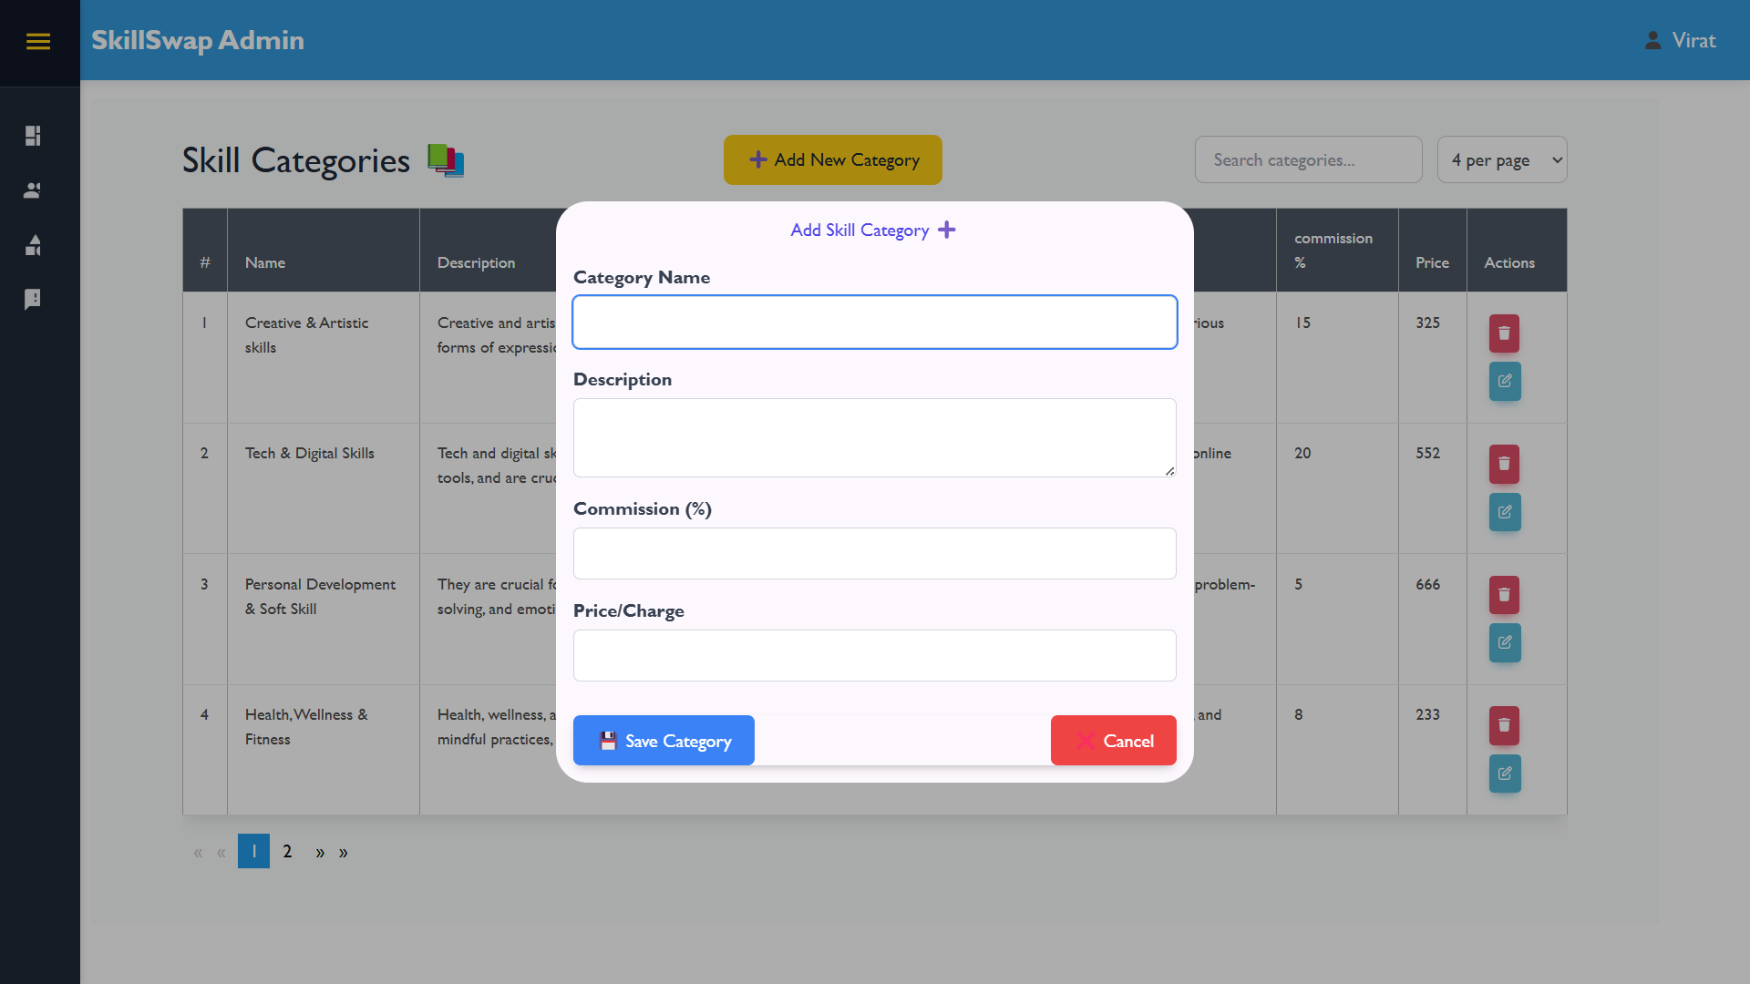

**Admin profile**

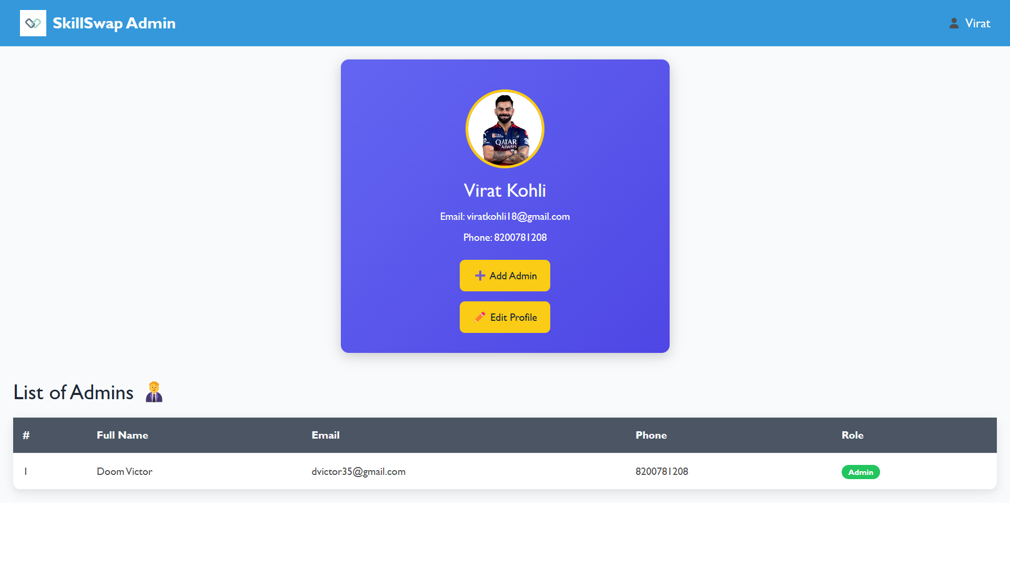

1. **Agile Documentation**

**5.1 Project Charter**

|  |  |
| --- | --- |
| Project Name | Skill Swap |
| Guide | Ananya Yaduvanshi |
| Project expected Start date | 02-01-2025 |
| Project expected end date | 17-04-2025 |
| Project Scope | Skill Swap is a platform where people can exchange skills with each other. Users can offer a skill they know like cooking, coding, or painting and find others who can teach them something new in return. The system helps match users based on skills, set up sessions, and manage bookings. It also includes features like messaging, reviews, and payments if needed. |
| Project mission | The mission of Skill Swap is to create a user-friendly platform that connects people who want to learn new skills with those who are willing to teach, through a simple and fair skill exchange system. Instead of using money, users trade their knowledge, making learning more accessible and community-driven. Skill Swap aims to empower individuals by helping them share what they know, discover new talents, and build meaningful connections through learning. |
| Project vision | Our vision is to build a global community where everyone can learn, grow, and share their skills freely. We imagine a world where skill-sharing is easy, accessible, and empowering for all—regardless of background or income. Skill Swap strives to become the go-to platform for exchanging knowledge, fostering personal growth, and building strong human connections through learning. |

**5.2 Project Roadmap**

**5.3 Sprint Table**

|  |  |  |  |  |  |
| --- | --- | --- | --- | --- | --- |
| Id # | Task/Module | Assigned to | Status | Estimated time (hours) | Story points |
| 1 | Authentication | Arnold | Completed | 2.5 | 6 |
| 2 | Password reset & Email Verification | Yash | Completed | 2 | 5 |
| 3 | Feedback & Ratings | Nandini | Completed | 4.5 | 5 |
| 4 | Profile Management | Arnold | Completed | 6 | **7** |
| 5 | Admin Dashboard UI | Nandini | Completed | 4 | 7 |
| 6 | Admin Dashboard Management | Arnold | Completed | 5 | 7 |
| 7 | Skills Listing | Yash | Completed | 2.5 | 8 |
| 8 | Skills Filter & Search | Arnold | Completed | 2.5 | 8 |
| 9 | Skills explorer | Nandini | Completed | 2 | 7 |
| 10 | Skill exchange | Arnold, Yash | Completed | 7.5 | 9 |
| 11 | Chat Module | Yash | Completed | 8 | 7 |
| 12 | Blogs Module | Nandini | Not Completed | 8 | 6 |
| 13 | Payment Module | Yash | Completed | 4 | 8 |

**5.4 User Story**

|  |  |  |  |
| --- | --- | --- | --- |
| Sr. | As a <user> | Want to <task> | So that <goal> |
| 1 | Admin | Login | Admin login to access the system dashboard. |
| 2 | Admin | Logout | Admin logout securely from the system. |
| 3 | Admin | View User | Admin view users |
| 4 | Admin | Generates reports | Admin can view or generate reports to gain system’s useful insights |
| 5 | Admin | Manage Skills | Admin can add, update or delete available skills. |
| 6 | Admin | Manage Transactions | Admin can monitor user payments. |
| 7 | User | Login | User logs in to access their account. |
| 8 | User | Logout | User logs out to securely end the session. |
| 9 | User | Edit Profile | Users can update or edit their profiles. |
| 10 | User | Exchange Skills | User finds and connects with others to exchange skills. |
| 11 | User | Filter & Search Skills | User easily finds matching skills or users. |
| 12 | User | Provide Feedback | User shares feedback after a skill exchange. |
| 14 | User | Get Reminders | User receives notifications or reminders for scheduled sessions. |
| 15 | User | Create Blog Posts | |  | | --- | |  |   User shares their experience or knowledge with the community. |
| 16 | User | Manage Payment | User completes or reviews payments for premium exchanges or services. |
| 17 | User | Communication | User chats or messages other users to plan skill exchanges. |

**5.5 Release Plan**

|  |  |  |  |  |
| --- | --- | --- | --- | --- |
| Task | Start Date | End Date | Status | Release date |
| Database connection & Initial setup | 02-01-2025 | 02-01-2025 | Released | 03-01-2025 |
| Authentication | 03-01-2025 | 05-01-2025 | Released | 06-01-2025 |
| Password reset & Email Verification | 05-01-2025 | 09-01-2025 | Released | 12-01-2025 |
| Feedback & Ratings | 07-01-2025 | 08-01-2025 | Released | 12-01-2025 |
| Profile Management | 12-01-2025 | 15-01-2025 | Released | 15-01-2025 |
| Admin Dashboard UI | 30-01-2025 | 03-02-2025 | Released | 05-02-2025 |
| Admin Dashboard Management | 05-02-2025 | 09-02-2025 | Not Released | - |
| Skills Listing | 16-02-2025 | 21-02-2025 | Released | 23-02-2025 |
| Skills Filter & Search | 25-02-2025 | 01-03-2025 | Released | 05-03-2025 |
| Skills explorer | 03-03-2025 | 09-03-2025 | Released | 15-03-2025 |
| Skill exchange | 10-03-2025 | 19-03-2025 | Released | 22-03-2025 |
| Chat Module | 21-03-2025 | 26-03-2025 | Released | 01-04-2025 |

**5.6 Test Plan**

|  |  |  |  |
| --- | --- | --- | --- |
| Project Name | SkillSwap | Browser: | Chrome |
| Tested on: | 16-04-2025 | Device: | Ryzen 5 Laptop |

|  |  |  |  |  |
| --- | --- | --- | --- | --- |
| Test# | Action | Expected Result | Actual Result | Status |
| 1 | User Authentication | Redirect to home screen | Redirect to home screen | Pass |
| 2 | Staff Authentication | Redirect to staff home screen | Redirect to staff home screen | Pass |
| 3 | Admin Authentication | Redirect to admin screen | Redirect to admin screen | Pass |
| 4 | Reset password using Email | Password reset by sending email | Password reset by sending email | Pass |
| 5 | Feedback section | Feedbacks should be displayed on user screen | Feedbacks is displayed on user screen | Pass |
| 6 | Book Appointment | Appointment should be booked | Appointment is booked | Pass |
| 7 | View and accept Appointment (staff) | Appointment should be view and manage by staff | Appointment is viewed and getting manage | PASS |
| 8 | Edit Profile (user) | Profile should be Update | Profile is being updated | Pass |
| 9 | Blog Section | Blogs Should be posted and displayed | Blogs are being posted but not getting read | FAIL |
| 10 | Service Module | Service can be booked and viewed | It’s working Good | PASS |
| 11 | Manage Tasks | Tasks can be managed by staff | Tasks are getting managed | PASS |

**5.7 Sprint Burn Chart**

1. **Proposed Enhancement**

* The proposed enhancements for the SkillSwap platform aim to take the system beyond its basic functionality and transform it into a highly scalable, feature-rich and user-centric application. The system also proposed the implementing a **skill rating** and **review system**, allowing users to provide feedback on the quality of the sessions they attend. This would increase trust and credibility across the community. Additionally, introducing a smart **skill-matching** algorithm that uses AI or machine learning to **recommend** relevant connections based on user interests, location, skill level, and availability could greatly improve engagement and help users find the right learning partners more efficiently.

1. **Conclusion**

The Skill Swap platform offers a smart way for people to share and learn skills from each other. It helps users connect based on their interests, making learning more flexible, affordable, and community-driven. By allowing skill exchange, the platform encourages personal growth and builds a helpful network of learners and teachers. With planned improvements and user-friendly features, Skill Swap has the potential to become a valuable tool for lifelong learning and collaboration.