**Master of Science (IT) Sem – 05**



Lj School Of Computer Applications

**Healthcare Management system**

Guided by:

Dr. Jignesh Doshi

Developed by:

|  |  |
| --- | --- |
| Name | Enrollment |
| Arnold Macwan | 21004500210065 |
| Dharmik Halani | 21004500210046 |
| Tirth Panchal | 21004500210086 |

**Lj School Of Computer Applications**

Near Nagdev Kalyan Mandir, Near Sanand Cross Roads,

SG Highway Ahmedabad – 382210

Ph. No.: 9099063417



Enrollment No: 21004500210065

This is certified that **Arnold Macwan** of Master of science (IT), Semester 05, Roll no **28** has satisfactorily completed his project titled **Healthcare Management system** under the supervision of internal guide.

Internal guide: HOD:

Dr. Jignesh Doshi Dr. Jignesh Doshi

**Lj School Of Computer Applications**

Near Nagdev Kalyan Mandir, Near Sanand Cross Roads,

SG Highway Ahmedabad – 382210

Ph. No.: 9099063417



Enrollment No: 21004500210086

This is certified that **Tirth Panchal** of Master of science (IT), Semester 05, Roll no **38** has satisfactorily completed his project titled **Healthcare Management system** under the supervision of internal guide.

Internal guide: HOD:

Dr. Jignesh Doshi Dr. Jignesh Doshi

**Lj School Of Computer Applications**

Near Nagdev Kalyan Mandir, Near Sanand Cross Roads,

SG Highway Ahmedabad – 382210

Ph. No.: 9099063417



Enrollment No: 21004500210046

This is certified that **Dharmik Halani** of Master of science (IT), Semester 05, Roll no **18** has satisfactorily completed his project titled **Healthcare Management system** under the supervision of internal guide.

Internal guide: HOD:

Dr. Jignesh Doshi Dr. Jignesh Doshi

1. Introduction

* System is built to connect and provide a medium so that users can get the services from them palm
* A healthcare management system is a software solution designed to optimize various aspects of healthcare delivery and administration. It encompasses tools and processes for managing patient records, scheduling appointments, manage staff tasks…
* This system is instrumental in improving healthcare efficiency, reducing errors, and enhancing the overall quality of patient care.

1.1 Existing System

* The existing systems have not features like generate reports through the system quickly, store medical history of patients by having medical reports, etc.
* The Health Care Management System software helps healthcare institutions manage daily operations including appointment scheduling, patient reminders, insurance claims, billing, and payments.

1.2 Need for New System

* A new healthcare management system is needed for data security, patient participation, appointment scheduling and sophisticated analytics.
* System will provide the report generating , manage tasks for staff , store medical history and analysis and many more functionalities.

1.3 Objective for New System

* A healthcare management system aims to enhance patient care, streamline administrative processes and privacy, and facilitate for reports analysis.
* Also connect the patients from anywhere by using system

1.4 Problem Definition

* A healthcare management system aims to enhance patient care, increase efficiency, and ensure data security and privacy. Providing prompt access to correct patient information, administrative processes can improve diagnosis, treatment, and follow-up care. Implementing strong security measures. Patients should be empowered to take part actively.

1.5 Core components

1.6 Project Profile

|  |  |  |
| --- | --- | --- |
| Project name | | Healthcare |
| **Front-end** | | HTML5, CSS3, JavaScript, Bootstrap |
| **Back-end** | **Database** | Mongo dB |
| **Framework** | Django |

1.7 Assumptions & Constraints

* Assumptions:  
    
  - We assume that sources or patients provide reliable and trustable health information.  
  - We also assume that sources follow regulations & protection laws on website.
* Constraints

- No Backup services

- Supported English language only

1.8 Advantages & Limitations

2.1 Requirement Determination

* Requirement determination for healthcare project involves gathering, analyzing, and documenting the needs and expectations of stakeholders.
* This phase is consisting of:
  + Surveys & sampling
  + Client’s requirements
  + Identifying the non-functional requirements
  + Review existing system if available
  + References
    - https://www.indimac.in/
    - https://www.advinohealthcare.com/

2.2 Targeted Users

* Admin
* User
* Staff

3.0 System Design

**3.1 Use case diagram** 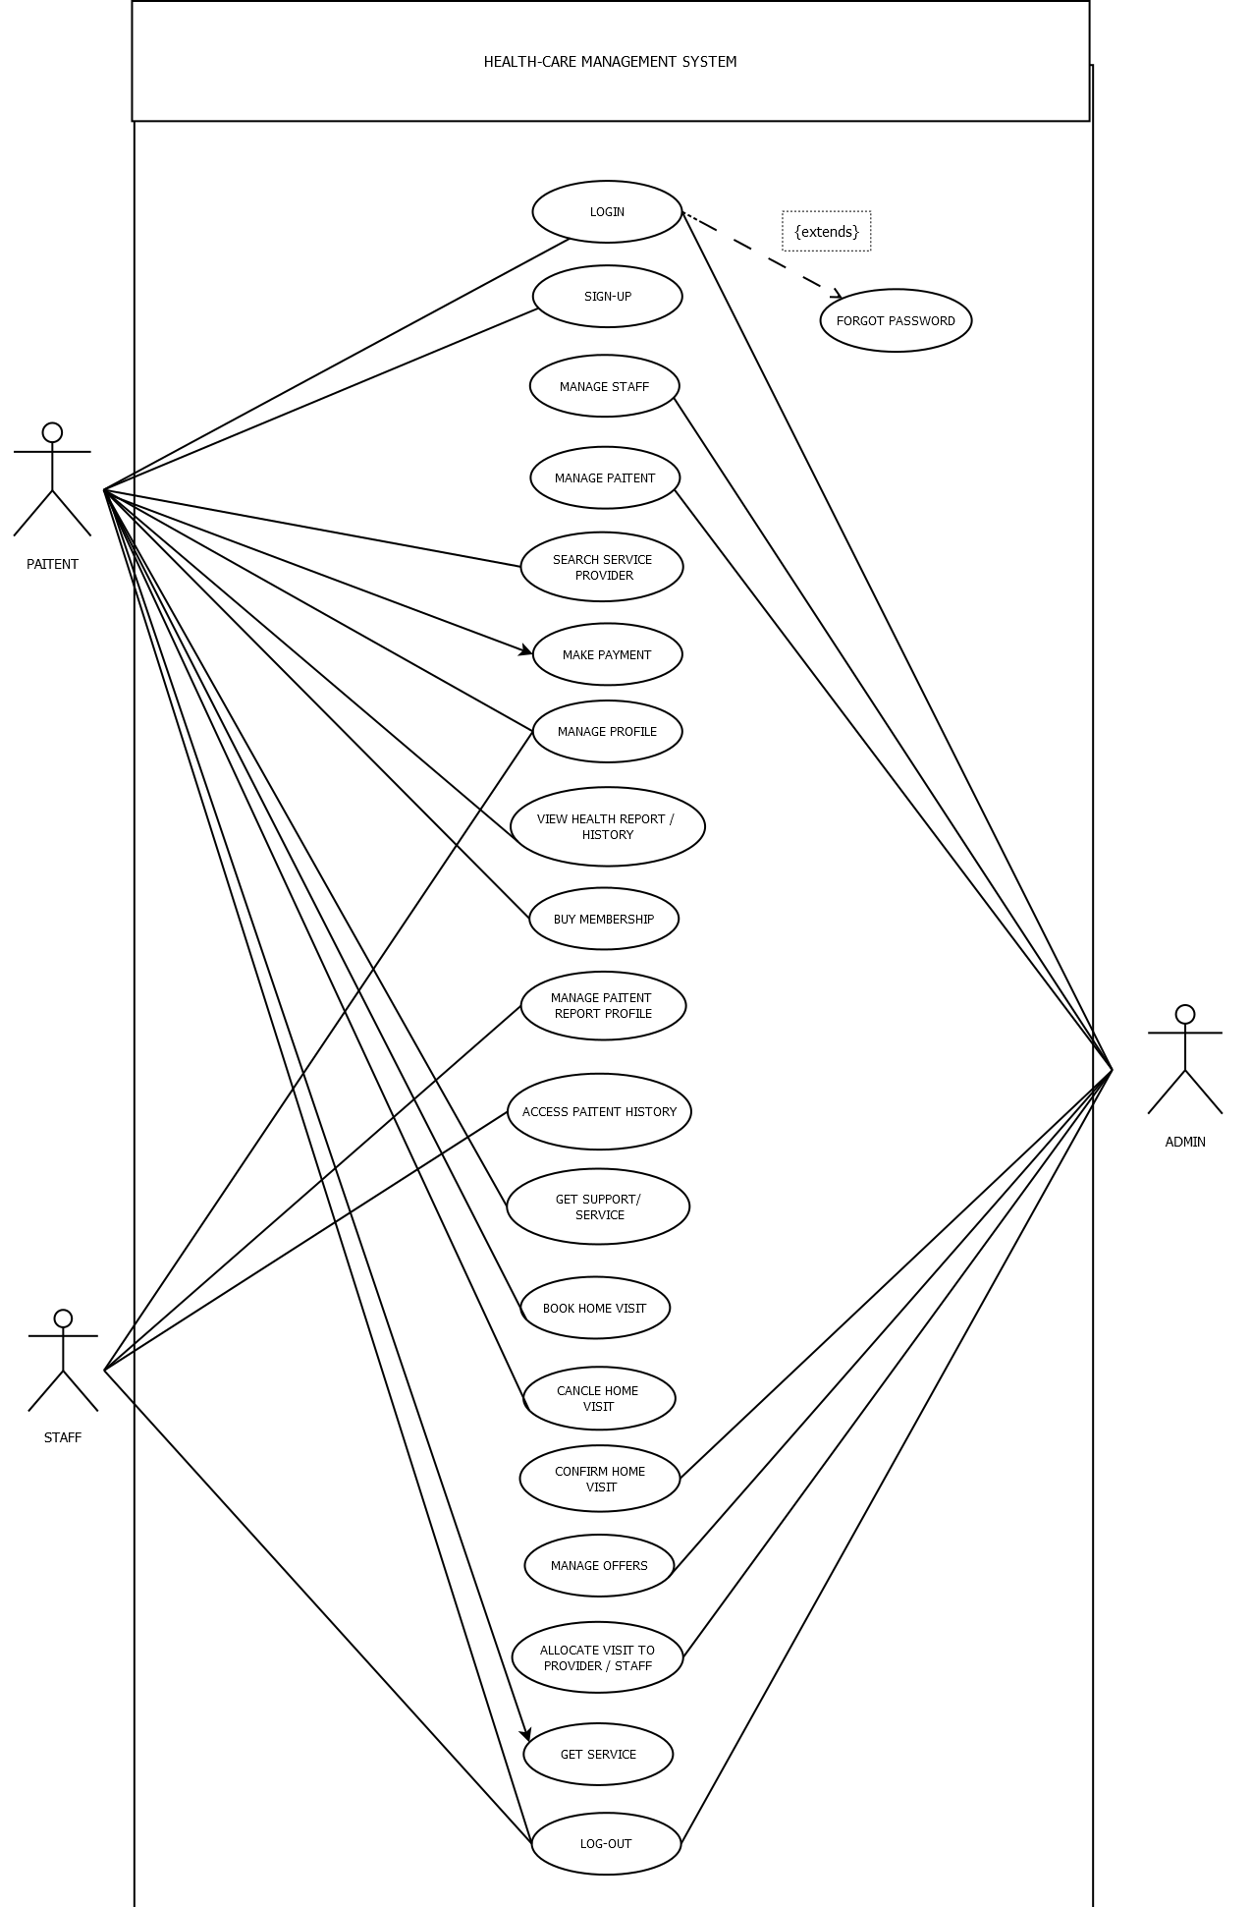

**3.2 Class Diagram**

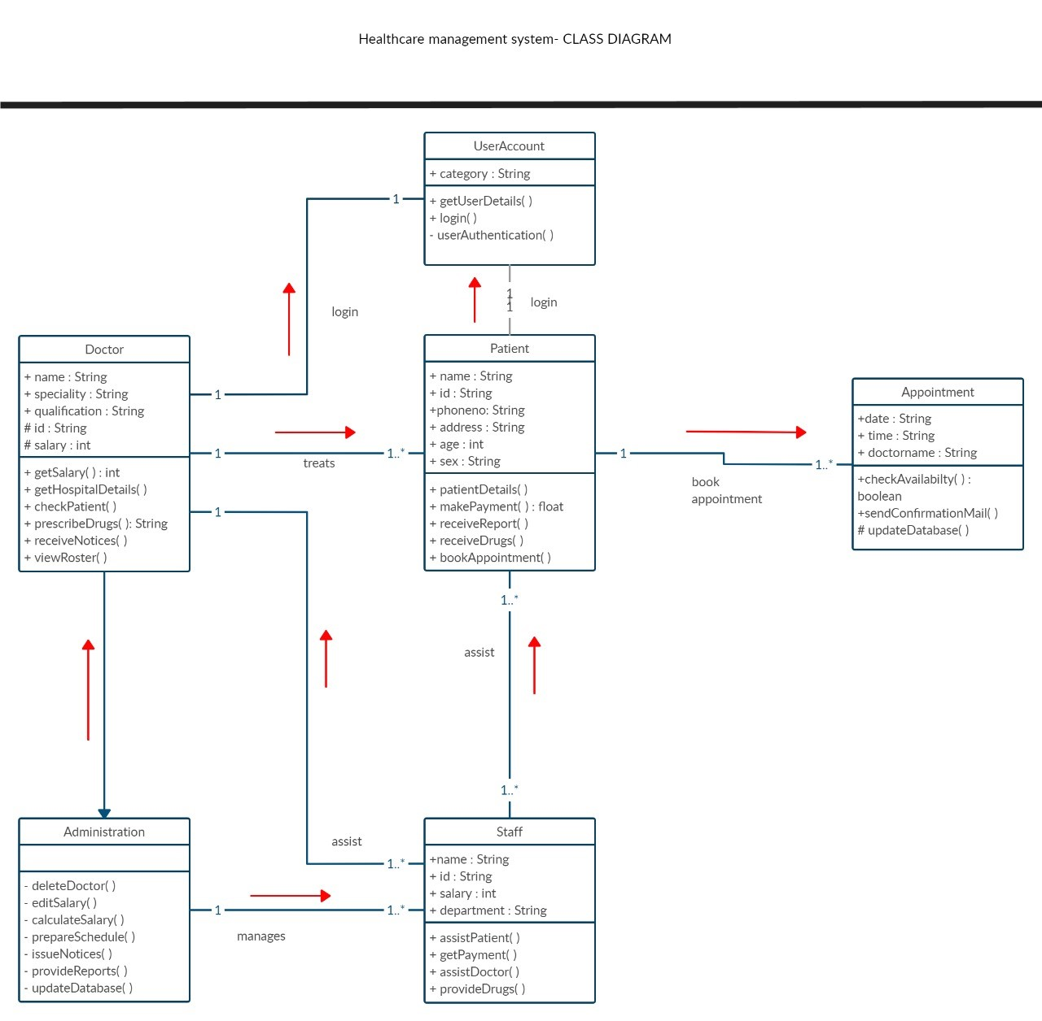

**3.4 Activity Diagram**

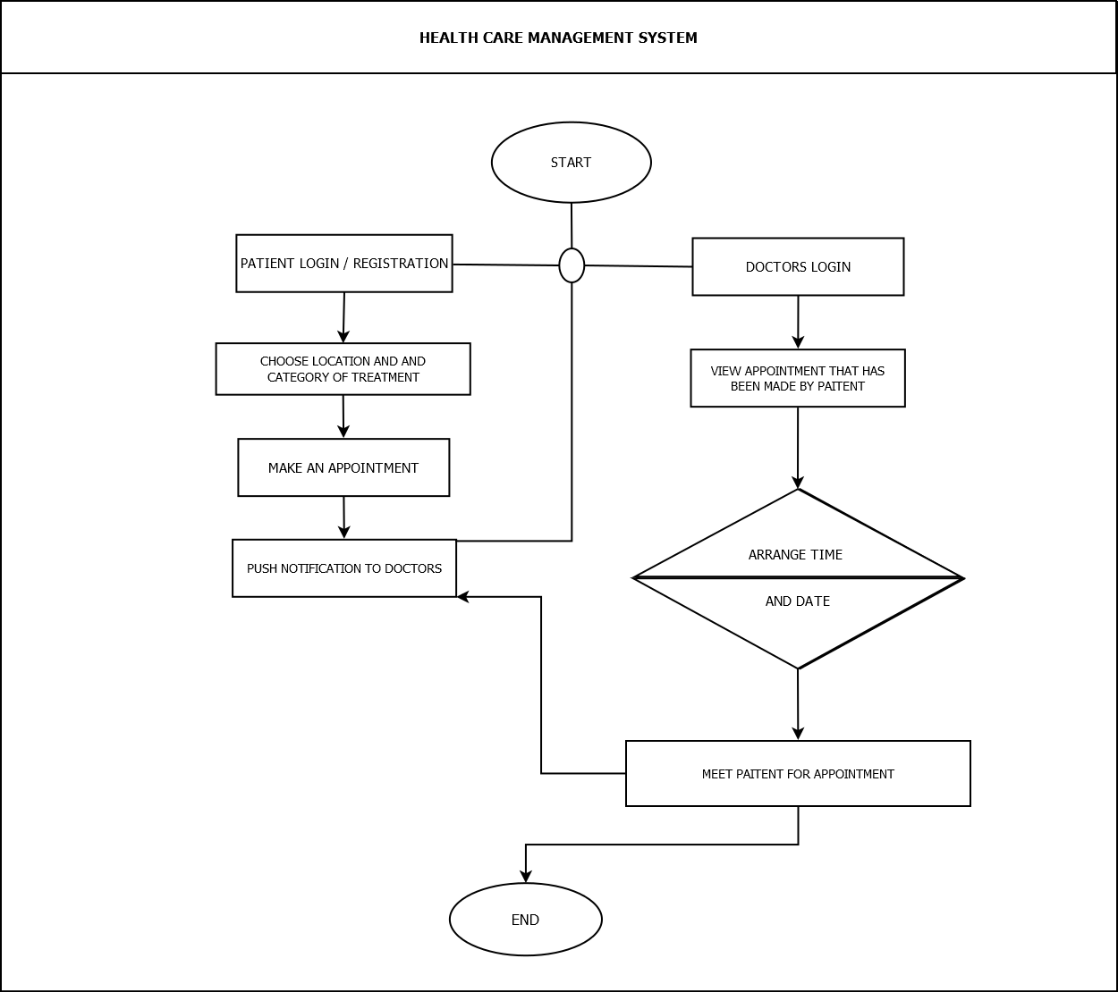

3.5 Data Dictionary

|  |  |  |  |  |
| --- | --- | --- | --- | --- |
| Field | Datatype | Constraints | Description | Sample |
| Id | Int(4) | primary key | Table id | 1 |
| First name | Varchar2(25) | Not null | Firstname of the user | Arnold |
| Last name | Varchar2(25) | Not null | Lastname of the user | Macwan |
| Email | Varchar2(25) | Unique | Email of the user | [abc@gmail.com](mailto:abc@gmail.com) |
| Password | Varchar2(10) | Not null | Password | abc@123 |
| DOB | Date | Not null | Date of birth | 20-03-1969 |
| Role | Varchar2(15) | Not null | Role of the user | Doctor |
| State | Varchar2(15) | Not null | State of user | Karnataka |
| City | Varchar2(15) | Not null | City of user | Pune |
| Pincode | Int(6) | Not null | Pincode of area | 382440 |
| Apartment_no_nm | Varchar2(25) | Not null | Apartment no & name | B2 , harekrishna park |
| Userprofile | Varchar2(50) | Not null | Path of image of the user | pics/img.png |

**User table**

|  |  |  |  |  |
| --- | --- | --- | --- | --- |
| Field | Datatype | Constraints | Description | Sample |
| Id | Int(4) | primary key | Table id | 1 |
| Qualification_doc | Varchar2(50) | Not null | Image path for Document of the qualification | doc/img.jpeg |
| Profilephoto | Varchar2(50) | Not null | Photo of the staff | pic/photo.png |
| Total_visit_done | Int(3) | Not null | No. of visit taken by staff | 12 |
| Experience | Int(3) | Not null | Experience of the staff | 25 years |
| Joined_date | date | Not null | Date of joining | 20-09-2002 |
| About | Varchar2(100) | Not null | About the staff | A supportive caretaker |
| Availability | Varchar2(10) | Not null | Status for staff Availability | Not available |

**Staff Profile table**

|  |  |  |  |  |
| --- | --- | --- | --- | --- |
| Field | Datatype | Constraints | Description | Sample |
| Id | Int(4) | primary key | Table id | 1 |
| Firstname | Varchar2 | Not null | First name of staff | John |
| Lastname | Varchar2 | Not null | Last name of staff | Smith |
| Email | Varchar2 | Unique | Email of staff | [abc@gmail.com](mailto:abc@gmail.com) |
| DOB | Date | Not null | Date of birth | 20-05-1996 |
| Category | Varchar2 | Not null | Category of staff | Care taker |

**Staff table**

**Services table**

|  |  |  |  |  |
| --- | --- | --- | --- | --- |
| Field | Datatype | Constraints | Description | Sample |
| Id | Int(4) | primary key | Table id | 1 |
| Staffid | Int(4) | Foreign key references staff table | Staff id | 11 |
| Name | Varchar2(25) | Not null | Title of the service | Lab test |
| Status | Varchar2(15) | Not null | Status of service | Pending |
| Cost | Decimal (4,2) | Not null | Cost of the service | 499/- |

**Test table**

|  |  |  |  |  |
| --- | --- | --- | --- | --- |
| Field | Datatype | Constraints | Description | Sample |
| Id | Int(4) | primary key | Table id | 1 |
| Category | Int(4) | Not null | Category of test | Full body |
| Cost | Decimal(4,2) | Not null | Cost for the service | 699 |
| Dur | Int(3) | Not null | Result duration of the test In hours | 36 |

|  |  |  |  |  |
| --- | --- | --- | --- | --- |
| Field | Datatype | Constraints | Description | Sample |
| Id | Int(4) | primary key | Table id | 1 |
| Userid | Int(4) | Foreign key references user table | Id of the user | 2 |
| Date | Date | Not null | Date of the visit | 15-10-2023 |
| Status | Varchar2(10) | Not null | Status of the visit | Pending |
| Staffid | Int(4) | Foreign key references staff table | Visit allocate to the staff | 2 |
| Reason | Varchar2(25) | Not null | Reason for visit | Blood report |

**Homevisit table**

|  |  |  |  |  |
| --- | --- | --- | --- | --- |
| Field | Datatype | Constraints | Description | Sample |
| Id | Int(4) | primary key | Table id | 1 |
| Userid | Int(4) | Foreign key references user table | Id of the user | 2 |
| Membership_holder | Boolean | Not null | If the user is membership holder | TRUE |
| no_of_visits | Int(3) | Not null | No. of visits to patient | 5 |
| Height | Int(4) | Not null | Height of the patient | 165cm |
| Weight | Int(4) | Not null | Weight of the patient | 56kg |
| Blood_group | Varchar2(4) | Not null | Blood group of the user | O+ |
| BMI | Int(5) | Not null | Body-mass index of the user | 23.6% |
| Date_joined | Date | Not null | Date of the joining organization | 20-03-2005 |

**Patient_history table**

|  |  |  |  |  |
| --- | --- | --- | --- | --- |
| Field | Datatype | Constraints | Description | Sample |
| Id | Int(4) | primary key | Table id | 1 |
| Userid | Int(4) | Foreign key references user table | Id of the user | 2 |
| Date | Date | Not null | Date of the bill | 20-04-2024 |
| Discount | Decimal(6,2) | Not null | Discount price on bill | 2500/- |
| Total_amount | Decimal(6,2) | Not null | Amount of the bill | 9980/- |
| Payment_id | Int(10) | Foreign key references payment table | Payment id | 15002693 |

**Billing table**

**Payment table**

|  |  |  |  |  |
| --- | --- | --- | --- | --- |
| Field | Datatype | Constraints | Description | Sample |
| Id | Int(4) | primary key | Table id | 1 |
| Userid | Int(4) | Foreign key references user table | Id of the user | 2 |
| Date | Date | Not null | Date of the payment | 20-04-2024 |
| Status | Varchar2(15) | Not null | Status of the payment | Pending |
| Payment_method | Varchar2(10) | Not null | Method of the payment | Cash |

**Premium_user table**

|  |  |  |  |  |
| --- | --- | --- | --- | --- |
| Field | Datatype | Constraints | Description | Sample |
| Id | Int(4) | primary key | Table id | 1 |
| Userid | Int(4) | Foreign key references user table | Id of the user | 11 |
| Startdate | Date | Not null | Date of buying the premium | 12-12-2022 |
| Expirydate | Date | Not null | Date of expiry of premium | 10-11-2023 |
| Renewal_option | Varchar(10) | Not null | Option to renew the premium | Manual |

**Feedback table**

|  |  |  |  |  |
| --- | --- | --- | --- | --- |
| Field | Datatype | Constraints | Description | Sample |
| Id | Int(4) | primary key | Table id | 1 |
| Userid | Int(4) | Foreign key references user table | Id of the user | 2 |
| Date | Date | Not null | Date of the feedback received | 20-04-2024 |
| Message | Varchar2(250) | Not null | Message for feedback | It was good |

**Blog table**

|  |  |  |  |  |
| --- | --- | --- | --- | --- |
| Field | Datatype | Constraints | Description | Sample |
| Id | Int(4) | primary key | Table id | 1 |
| Userid | Int(4) | Foreign key references user table | Id of the user | 2 |
| Date | Date | Not null | Date of the feedback received | 20-04-2024 |
| Message | Varchar2(250) | Not null | Message description | It was good |

4. Development

4.1 Screenshots

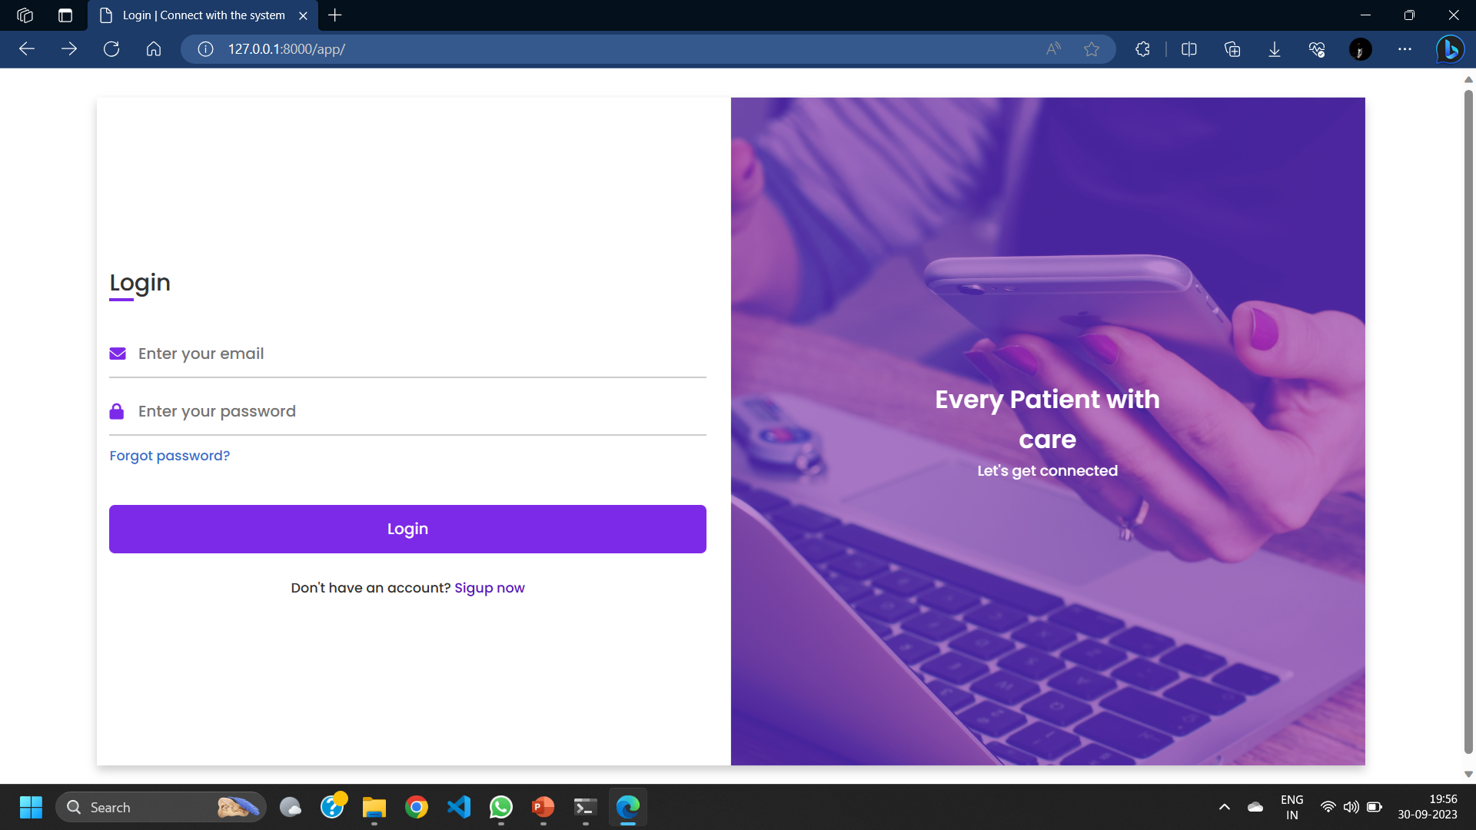

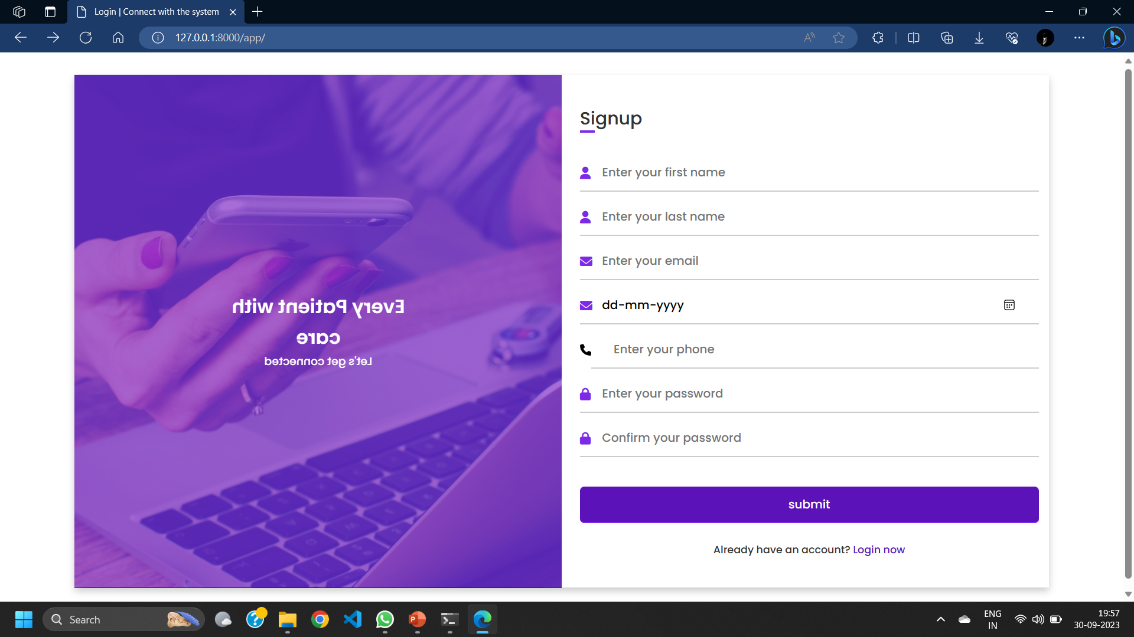

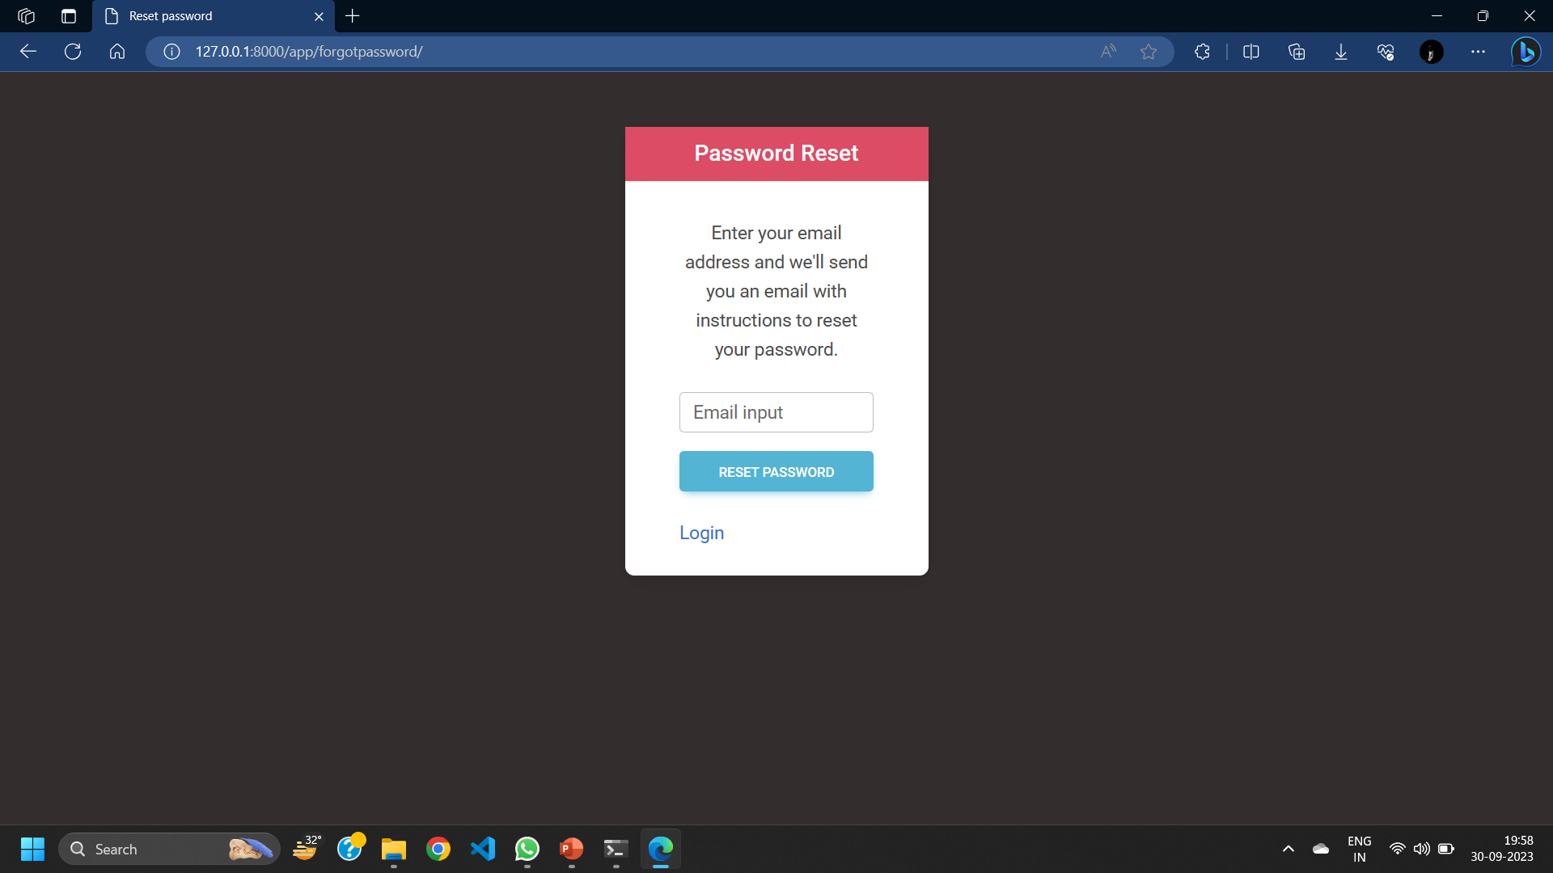

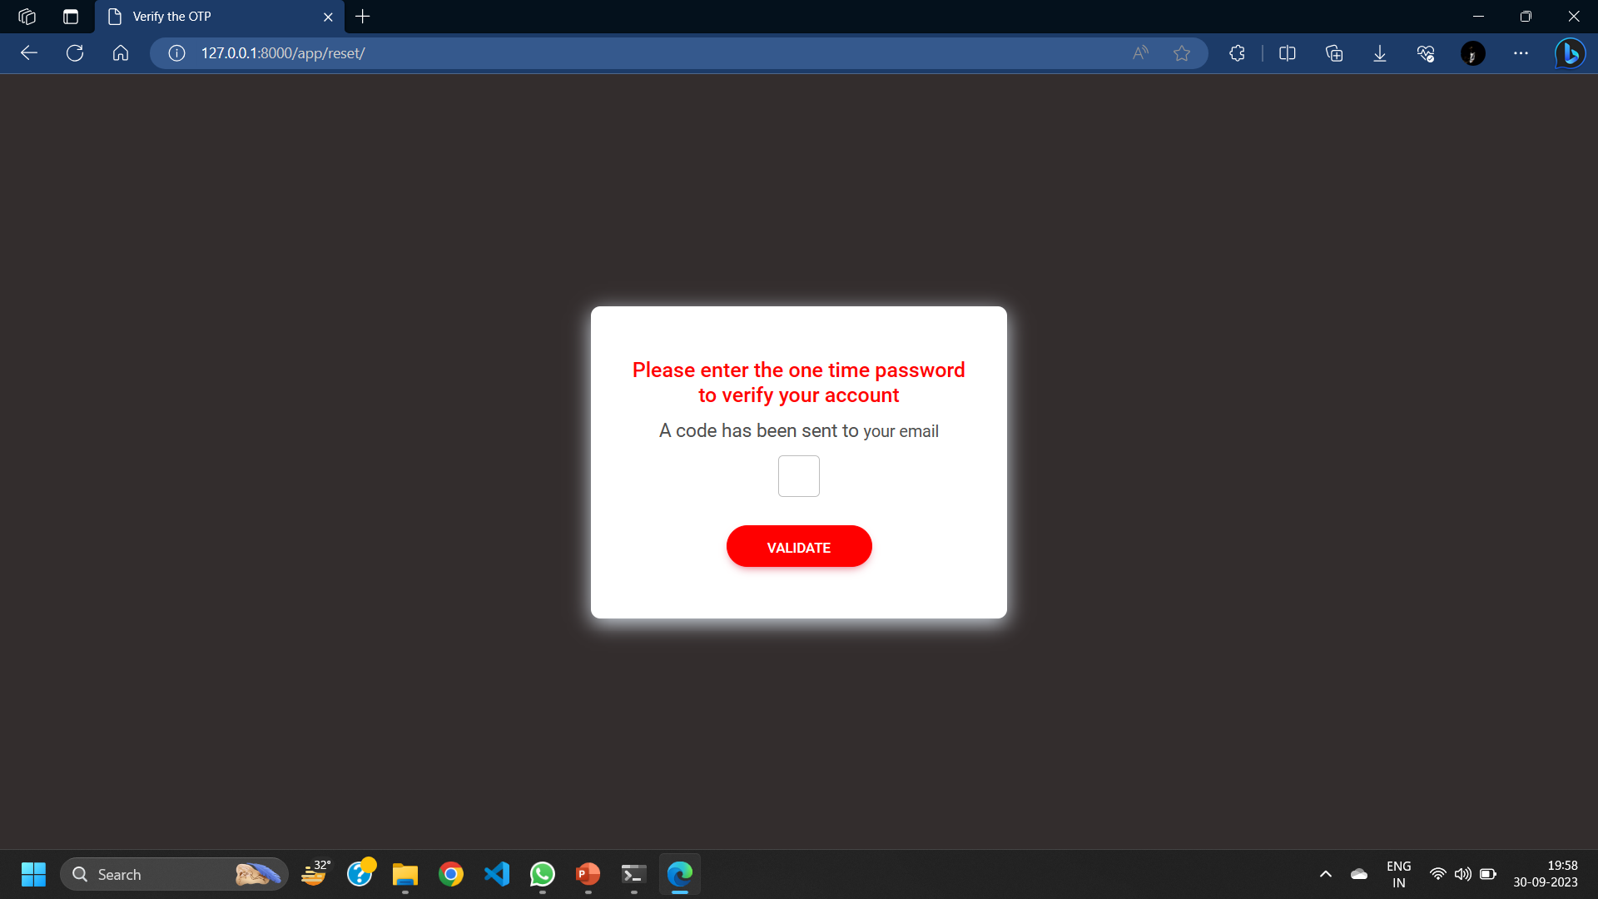

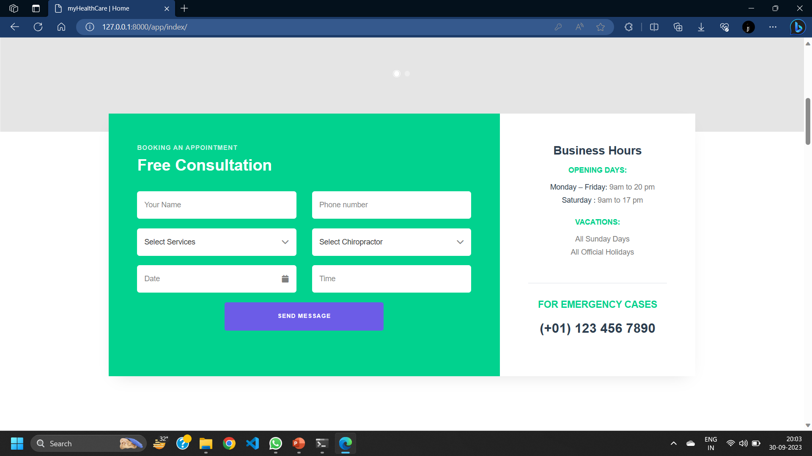

AGILE DOCUMENTATION

|  |  |
| --- | --- |
| Project name | Healthcare web Application |
| **Guide** | Dr Jignesh Doshi |
| **Project expected start date** | 14-08-2023 |
| **Project expected end date** | 30-11-2023 |
| **Project Scope** | * Integration of Booking health service * Custom Admin UI deployment * Report and documentation download * Safe & secure storing patient information and medical history |
| **Project mission** | Our mission is to provide such a platform so that every customer using the system will get the enhanced online service for their health accordingly their customization. |
| **Project vision** | Our vision is to reach every person who is not able to take even primary healthcare services and provide them services at doorstep by using their phones. |

**Project charter**

|  |  |  |  |
| --- | --- | --- | --- |
| **Sr.** | **As a <user>** | **Want to <task>** | **So that <goal>** |
| 1 | Admin | Login | I can manage flow and activities as administrator |
| 2 | Admin | Manage users / patient | I can control user activities & account related issues |
| 3 | Admin | Manage staff | I can control & review staff activities |
| 4 | Admin | Confirm home-visit request | I can verify & accept user’s request for home visit |
| 5 | Admin | Allocate service to staff | Staff can handle service for patient |
| 6 | Admin | Generate report | Insights can be visualized |
| 7 | Admin | Manage lab test | Let the Lab tester know about it & patients can use |
| 8 | Admin | Manage services | User can request for service provider accordingly |
| 9 | Admin | Access medical history | Health reports can be made |
| 10 | Admin | Post a blog | Article & blogs can be read |
| 11 | Admin | Logout | No one can access system except me |

**User Story**

|  |  |  |  |
| --- | --- | --- | --- |
| **Sr.** | **As a <user>** | **I Want to <task>** | **So that <goal>** |
| 1 | Patient | Login | I can use the system as existing user |
| 2 | Patient | Sign up | I can use the system as new user |
| 3 | Patient | Manage profile | I can edit or delete my profile account & review profile |
| 4 | Patient | Buy premium | I can use extra benefits of system |
| 5 | Patient | Search service provider | I can spectate particular provider |
| 6 | Patient | Browse services | I can search & view services accordingly |
| 7 | Patient | Give feedback | I can give feedback of system & enhancement can be done |

|  |  |  |  |
| --- | --- | --- | --- |
| **Sr.** | **As a <user>** | **I Want to <task>** | **So that <goal>** |
| 1 | Staff | Sign up | I can join system as service provider |
| 2 | Staff | Login | I can use system as existing user |
| 3 | Staff | Manage patient profile | I can update patient profile after providing service |
| 4 | Staff | Manage profile | I can edit or remove personal profile from system |
| 5 | Staff | Access patient medical history | I can provide service accordingly |
| 6 | Staff | Post blog | I can publish articles |
| 7 | Staff | Update Availability | I can take leave accordingly |
| 8 | Staff | Manage tasks/appointments | I can review or update all pending tasks allocated |
| 9 | Staff | Delete account | I can remove my self as a service provider from system |
| 10 | Staff | Logout | No one can access my data |

|  |  |  |  |  |  |
| --- | --- | --- | --- | --- | --- |
| **Task** | **Start date** | **End date** | **Duration(hrs.)** | **Status** | **Release date** |
| Database connection | 21-08-2023 | 22-08-2023 |  | Released | 22-08-2023 |
| Login & signup | 25-08-2023 | 28-08-2023 |  | Released | 30-08-2023 |
| User Crud on Dashboard | 1-09-2023 | 3-09-2023 |  | Released | 4-09-2023 |
| Staff Crud on Dashboard | 2-09-2023 | 6-09-2023 |  | Released | 7-09-2023 |
| Reset password on User Side | 10-09-2023 | 13-09-2023 |  | Released | 14-09-2023 |
| Staff Screen Creation | 21-09-2023 | 25-09-2023 |  | Planned | 26-09-2023 |
| Excel upload for add staff | 30-09-2023 | 02-10-2023 |  | Planned | 3-09-2023 |

**Release plan**

Proposed Enhancements

* Healthcare management systems should focus on resolving current issues and enhancing functionality. Improvements include integrating with EHR systems, improving data security, using machine learning and AI, and integrating telemedicine. Access control and advanced encryption techniques can protect patient data. Mobile applications can help monitor patients remotely and communicate with them in real time.

Conclusion

* A healthcare management system is essential for improving patient care, operational effectiveness, data security, and regulatory compliance. It promotes the implementation of cutting-edge technologies, facilitates the seamless sharing of patient data, and helps with cost management.