**Master of Science (IT) Sem – 05**



Lj School of computer applications

**Healthcare Management system**

Developed by:

|  |  |
| --- | --- |
| Name | Enrollment |
| Arnold Macwan | 21004500210065 |
| Dharmik Halani | 21004500210046 |
| Tirth Panchal | 21004500210086 |

Guided by:

Dr. Jignesh Doshi

**Lj School Of Computer Applications**

Near Nagdev Kalyan Mandir, Near Sanand Cross Roads,

SG Highway Ahmedabad – 382210

Ph. No.: 9099063417



Enrollment No: 21004500210065

This is certified that **Arnold Macwan**  of Master of science(IT) , Semester 05 , Roll no **28** has satisfactorily completed his project titled **Healthcare Management system**  under the supervision of internal guide.

Internal guide: HOD:

Dr. Jignesh Doshi Dr. Jignesh Doshi

**Lj School Of Computer Applications**

Near Nagdev Kalyan Mandir, Near Sanand Cross Roads,

SG Highway Ahmedabad – 382210

Ph. No.: 9099063417



Enrollment No: 21004500210086

This is certified that **Tirth Panchal** of Master of science(IT) , Semester 05 , Roll no **38** has satisfactorily completed his project titled **Healthcare Management system**  under the supervision of internal guide.

Internal guide: HOD:

Dr. Jignesh Doshi Dr. Jignesh Doshi

**Lj School Of Computer Applications**

Near Nagdev Kalyan Mandir, Near Sanand Cross Roads,

SG Highway Ahmedabad – 382210

Ph. No.: 9099063417



Enrollment No: 21004500210046

This is certified that **Dharmik Halani** of Master of science(IT) , Semester 05 , Roll no **18** has satisfactorily completed his project titled **Healthcare Management system**  under the supervision of internal guide.

Internal guide: HOD:

Dr. Jignesh Doshi Dr. Jignesh Doshi

**Introduction**

* A healthcare management system is a software solution designed to optimize various aspects of healthcare delivery and administration. It encompasses tools and processes for managing patient records, scheduling appointments, etc.
* This system is instrumental in improving healthcare efficiency, reducing errors, and enhancing the overall quality of patient care.

**Problem statement**

* A web-based Healthcare Management System , which allows healthcare providers to efficiently manage patient records, appointments, and medical history and also it enables patients to access and interact with their health information.

**Objective**

* Main goal of the project is to provide a primary healthcare services and reliable health information to the patients by anywhere at doorstep

**Core components**

**Advantages & Limitations**

**Assumptions & constraints**

* Assumptions:  
    
  - we assume that sources or patients provide reliable and trustable health information.  
  - We also assume that sources follow regulations & protection laws on website.
* Constraints

- No Backup services

- Supported English language only

**Project Profile**

|  |  |  |
| --- | --- | --- |
| Project name | | Healthcare |
| **Front-end** | | HTML5, CSS3, JavaScript, Bootstrap |
| **Back-end** | **Database** | Mongodb |
| **Framework** | Django |

**Requirement determination**

* Requirement determination for healthcare project involves gathering, analyzing, and documenting the needs and expectations of stakeholders.
* This phase is consists of:
  + Surveys & sampling
  + Client’s requirements
  + Identifying the non-functional requirements
  + Review existing system if available
  + References
    - https://www.indimac.in/
    - https://www.advinohealthcare.com/

**Targeted Users**

* Admin
* User
* Staff

**System Design**

**Use case diagram** 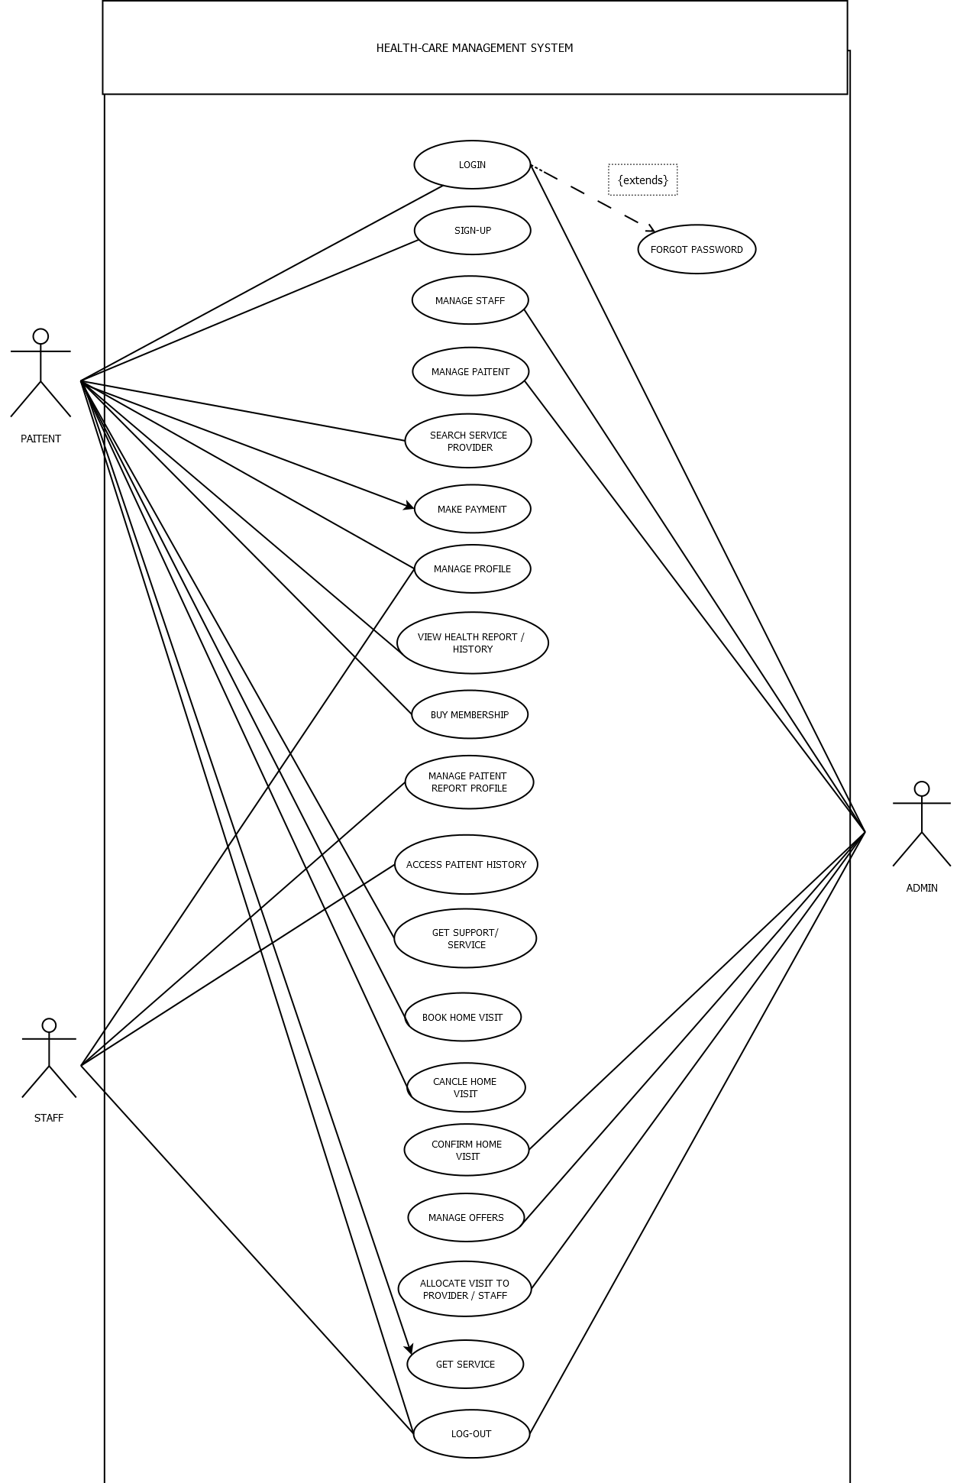

**Class Diagram**

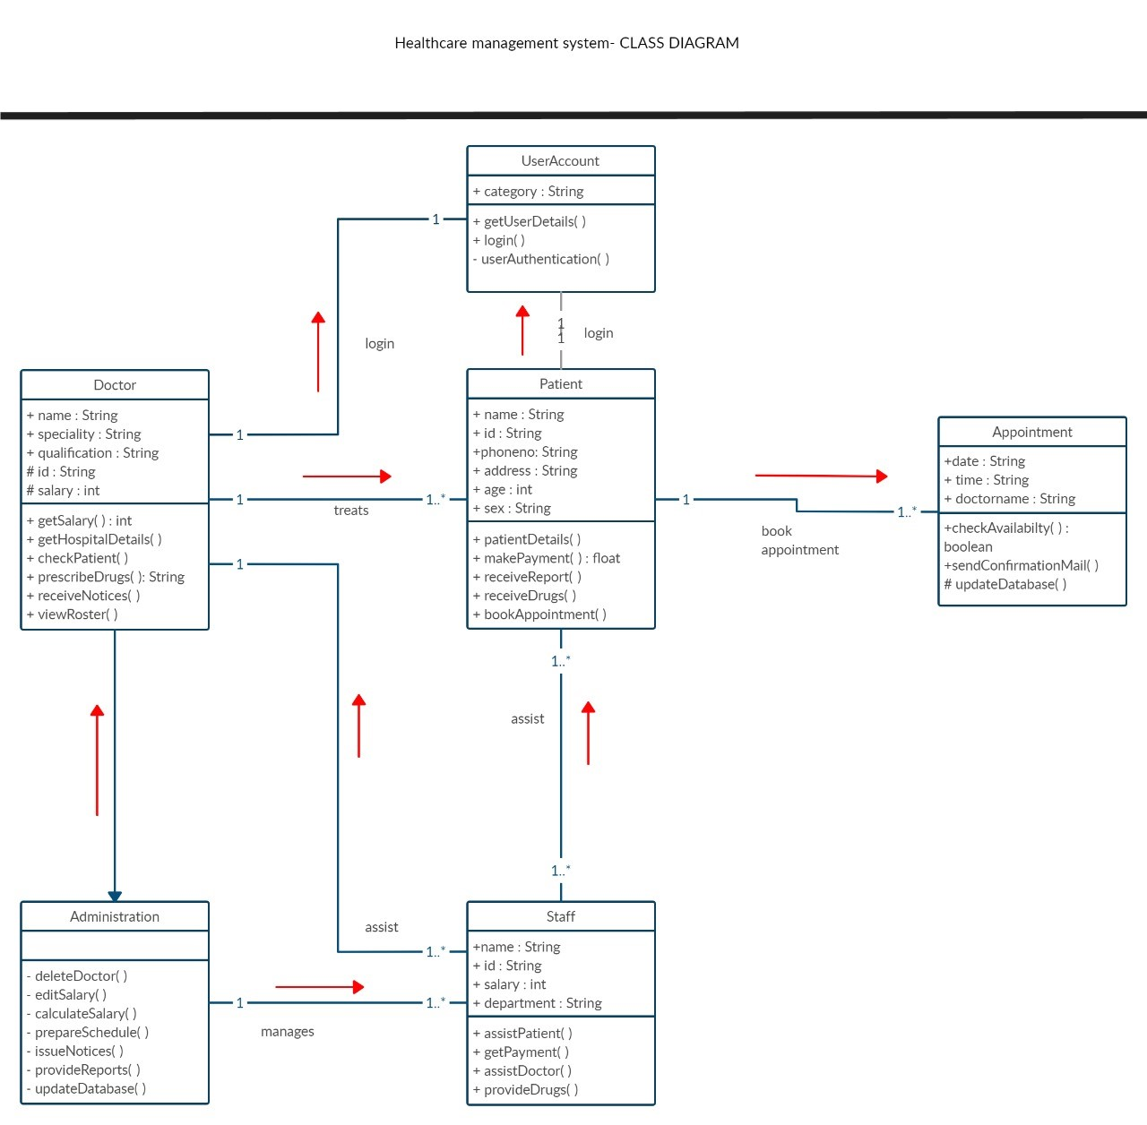

**Activity Diagram**

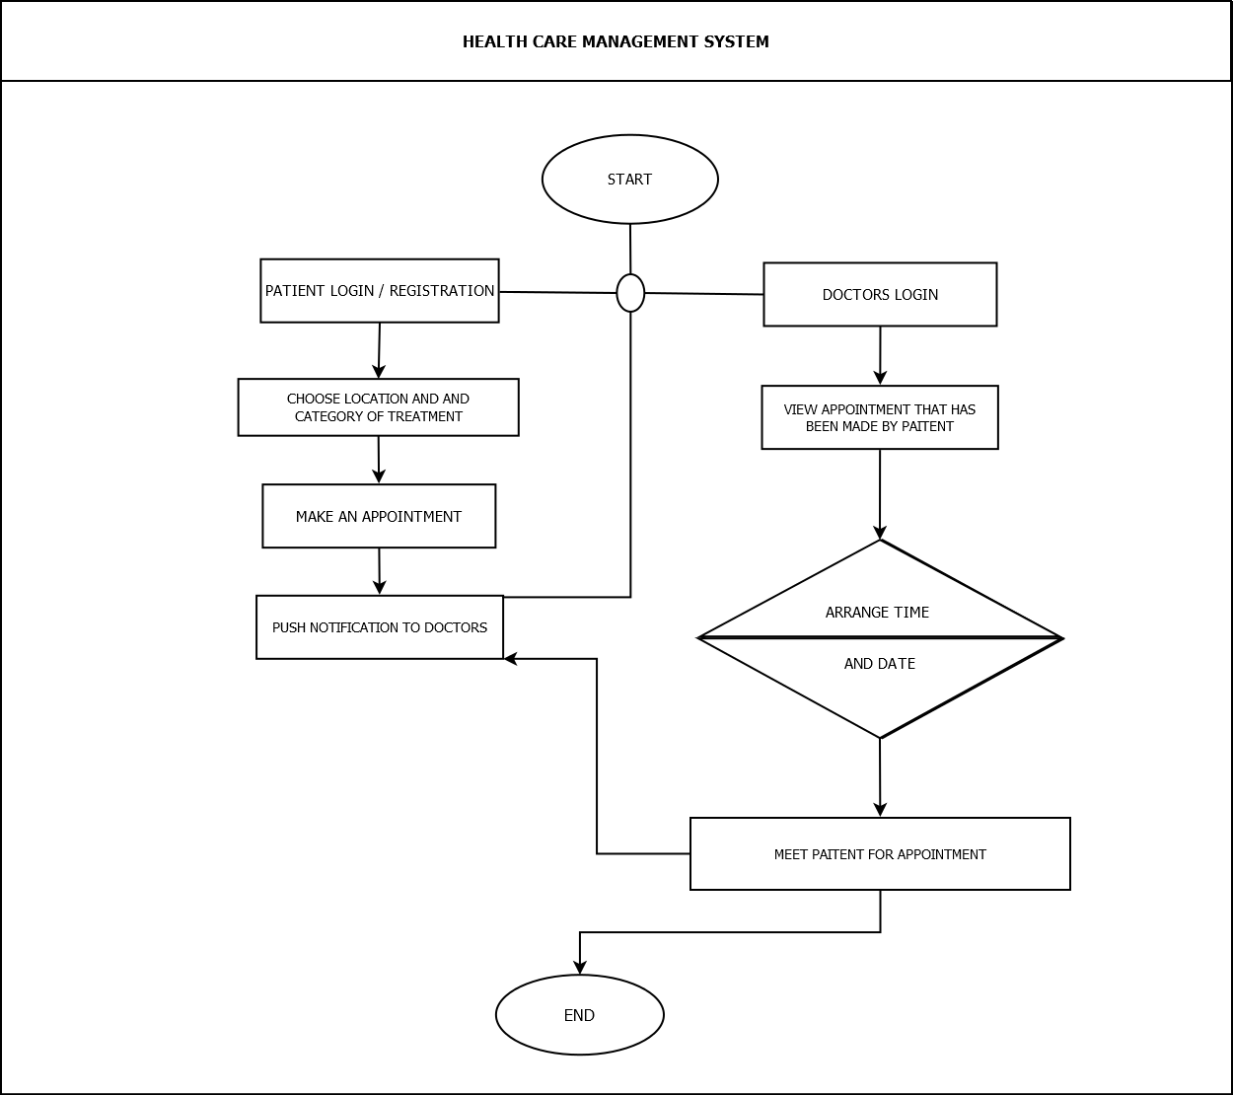

**Data Dictionary**

|  |  |  |  |  |
| --- | --- | --- | --- | --- |
| Field | Datatype | Constraints | Description | Sample |
| Id | Int(4) | primary key | Table id | 1 |
| First name | Varchar2(25) | Not null | Firstname of the user | Arnold |
| Last name | Varchar2(25) | Not null | Lastname of the user | Macwan |
| Email | Varchar2(25) | Unique | Email of the user | [abc@gmail.com](mailto:abc@gmail.com) |
| Password | Varchar2(10) | Not null | Password | abc@123 |
| DOB | Date | Not null | Date of birth | 20-03-1969 |
| Role | Varchar2(15) | Not null | Role of the user | Doctor |
| State | Varchar2(15) | Not null | State of user | Karnataka |
| City | Varchar2(15) | Not null | City of user | Pune |
| Pincode | Int(6) | Not null | Pincode of area | 382440 |
| Apartment_no_nm | Varchar2(25) | Not null | Apartment no & name | B2 , harekrishna park |
| Userprofile | Varchar2(50) | Not null | Path of image of the user | pics/img.png |

**User table**

|  |  |  |  |  |
| --- | --- | --- | --- | --- |
| **Field** | Datatype | Constraints | Description | Sample |
| Id | Int(4) | primary key | Table id | 1 |
| Qualification_doc | Varchar2(50) | Not null | Image path for Document of the qualification | doc/img.jpeg |
| Profilephoto | Varchar2(50) | Not null | Photo of the staff | pic/photo.png |
| Total_visit_done | Int(3) | Not null | No. of visit taken by staff | 12 |
| Experience | Int(3) | Not null | Experience of the staff | 25 years |
| Joined_date | date | Not null | Date of joining | 20-09-2002 |
| About | Varchar2(100) | Not null | About the staff | A supportive caretaker |
| Availability | Varchar2(10) | Not null | Status for staff Availability | Not available |

**Staff Profile table**

|  |  |  |  |  |
| --- | --- | --- | --- | --- |
| **Field** | Datatype | Constraints | Description | Sample |
| Id | Int(4) | primary key | Table id | 1 |
| Firstname | Varchar2 | Not null | First name of staff | John |
| Lastname | Varchar2 | Not null | Last name of staff | Smith |
| Email | Varchar2 | Unique | Email of staff | [abc@gmail.com](mailto:abc@gmail.com) |
| DOB | Date | Not null | Date of birth | 20-05-1996 |
| Category | Varchar2 | Not null | Category of staff | Care taker |

**Staff table**

**Services table**

|  |  |  |  |  |
| --- | --- | --- | --- | --- |
| **Field** | Datatype | Constraints | Description | Sample |
| Id | Int(4) | primary key | Table id | 1 |
| Staffid | Int(4) | Foreign key references staff table | Staff id | 11 |
| Name | Varchar2(25) | Not null | Title of the service | Lab test |
| Status | Varchar2(15) | Not null | Status of service | Pending |
| Cost | Decimal (4,2) | Not null | Cost of the service | 499/- |

**Test table**

|  |  |  |  |  |
| --- | --- | --- | --- | --- |
| Field | Datatype | Constraints | Description | Sample |
| Id | Int(4) | primary key | Table id | 1 |
| Category | Int(4) | Not null | Category of test | Full body |
| Cost | Decimal(4,2) | Not null | Cost for the service | 699 |
| Dur | Int(3) | Not null | Result duration of the test In hours | 36 |

|  |  |  |  |  |
| --- | --- | --- | --- | --- |
| Field | Datatype | Constraints | Description | Sample |
| Id | Int(4) | primary key | Table id | 1 |
| Userid | Int(4) | Foreign key references user table | Id of the user | 2 |
| Date | Date | Not null | Date of the visit | 15-10-2023 |
| Status | Varchar2(10) | Not null | Status of the visit | Pending |
| Staffid | Int(4) | Foreign key references staff table | Visit allocate to the staff | 2 |
| Reason | Varchar2(25) | Not null | Reason for visit | Blood report |

**Homevisit table**

|  |  |  |  |  |
| --- | --- | --- | --- | --- |
| Field | Datatype | Constraints | Description | Sample |
| Id | Int(4) | primary key | Table id | 1 |
| Userid | Int(4) | Foreign key references user table | Id of the user | 2 |
| Membership_holder | Boolean | Not null | If the user is membership holder | TRUE |
| no_of_visits | Int(3) | Not null | No. of visits to patient | 5 |
| Height | Int(4) | Not null | Height of the patient | 165cm |
| Weight | Int(4) | Not null | Weight of the patient | 56kg |
| Blood_group | Varchar2(4) | Not null | Blood group of the user | O+ |
| BMI | Int(5) | Not null | Body-mass index of the user | 23.6% |
| Date_joined | Date | Not null | Date of the joining organization | 20-03-2005 |

**Patient_history table**

|  |  |  |  |  |
| --- | --- | --- | --- | --- |
| Field | Datatype | Constraints | Description | Sample |
| Id | Int(4) | primary key | Table id | 1 |
| Userid | Int(4) | Foreign key references user table | Id of the user | 2 |
| Date | Date | Not null | Date of the bill | 20-04-2024 |
| Discount | Decimal(6,2) | Not null | Discount price on bill | 2500/- |
| Total_amount | Decimal(6,2) | Not null | Amount of the bill | 9980/- |
| Payment_id | Int(10) | Foreign key references payment table | Payment id | 15002693 |

**Billing table**

**Payment table**

|  |  |  |  |  |
| --- | --- | --- | --- | --- |
| Field | Datatype | Constraints | Description | Sample |
| Id | Int(4) | primary key | Table id | 1 |
| Userid | Int(4) | Foreign key references user table | Id of the user | 2 |
| Date | Date | Not null | Date of the payment | 20-04-2024 |
| Status | Varchar2(15) | Not null | Status of the payment | Pending |
| Payment_method | Varchar2(10) | Not null | Method of the payment | Cash |

**Premium_user table**

|  |  |  |  |  |
| --- | --- | --- | --- | --- |
| Field | Datatype | Constraints | Description | Sample |
| Id | Int(4) | primary key | Table id | 1 |
| Userid | Int(4) | Foreign key references user table | Id of the user | 11 |
| Startdate | Date | Not null | Date of buying the premium | 12-12-2022 |
| Expirydate | Date | Not null | Date of expiry of premium | 10-11-2023 |
| Renewal_option | Varchar(10) | Not null | Option to renew the premium | Manual |

**Feedback table**

|  |  |  |  |  |
| --- | --- | --- | --- | --- |
| Field | Datatype | Constraints | Description | Sample |
| Id | Int(4) | primary key | Table id | 1 |
| Userid | Int(4) | Foreign key references user table | Id of the user | 2 |
| Date | Date | Not null | Date of the feedback received | 20-04-2024 |
| Message | Varchar2(250) | Not null | Message for feedback | It was good |

**Blog table**

|  |  |  |  |  |
| --- | --- | --- | --- | --- |
| Field | Datatype | Constraints | Description | Sample |
| Id | Int(4) | primary key | Table id | 1 |
| Userid | Int(4) | Foreign key references user table | Id of the user | 2 |
| Date | Date | Not null | Date of the feedback received | 20-04-2024 |
| Message | Varchar2(250) | Not null | Message description | It was good |

**AGILE DOCUMENTATION**