Master of Science (IT) Sem – 09



Lj School Of Computer Applications

Wristified – Online Watch Store

Guided by:

Prof. Virendra Ingle

Developed by:

|  |  |
| --- | --- |
| Name | Enrollment |
| Arnold Macwan | 21004500210065 |
| Manthan Parmar | 21004500210094 |
| Monil Jain | 210045002100 |

Lj School Of Computer Applications

Near Nagdev Kalyan Mandir, Near Sanand Cross Roads,

SG Highway Ahmedabad – 382210

Ph. No.: 9099063417



Enrollment No: 21004500210065

This is certified that Arnold Macwan of Master of science (IT), Semester 09, Roll no B28 has satisfactorily completed his project titled Wristified under the supervision of internal guide.

Internal guide: HOD:

Prof. Virendra Ingle Dr. Jignesh Doshi

Lj School Of Computer Applications

Near Nagdev Kalyan Mandir, Near Sanand Cross Roads,

SG Highway Ahmedabad – 382210

Ph. No.: 9099063417



Enrollment No: 21004500210094

This is certified that Mathan Parmar of Master of science (IT), Semester 09, Roll no B43 has satisfactorily completed his project titled Wristified under the supervision of internal guide.

Internal guide: HOD:

Prof. Virendra Ingle Dr. Jignesh Doshi

Lj School Of Computer Applications

Near Nagdev Kalyan Mandir, Near Sanand Cross Roads,

SG Highway Ahmedabad – 382210

Ph. No.: 9099063417



Enrollment No: 21004500210

This is certified that Monil Jain of Master of science (IT), Semester 09, Roll no B20 has satisfactorily completed his project titled Wristified under the supervision of internal guide.

Internal guide: HOD:

Prof. Virendra Ingle Dr. Jignesh Doshi

|  |  |
| --- | --- |
| Sr.  No. | TABLE OF CONTENTS |
| 1. | INTRODUCTION |
|  | 1.1 Existing System |
|  | 1.2 Need for the New System |
|  | 1.3 Objective of the New System |
|  | 1.4 Problem Definition |
|  | 1.5 Core Components |
|  | 1.6 Project Profile |
|  | 1.7 Assumptions and Constraints |
|  | 1.8 Advantages and Limitations of the Proposed System |
| 2. | REQUIREMENT DETERMINATION & ANALYSIS |
|  | 2.1 Requirement Determination |
|  | 2.2 Targeted Users |
| 3. | SYSTEM DESIGN |
|  | 3.1 Use Case Diagram |
|  | 3.2 Class Diagram |
|  | 3.3 Sequence Diagram |
|  | 3.4 Activity Diagram |
|  | 3.5 Data Dictionary |
| 4. | DEVELOPMENT |
|  | 4.1 Coding Standard |
|  | 4.2 Screenshots |
| 5. | AGILE DOCUMENTATION |
|  | 5.1 Agile Project Charter |
|  | 5.2 Agile Roadmap / Schedule |
|  | 5.3 Agile User Story |
|  | 5.4 Agile Release Plan |
|  | 5.5 Agile Sprint Backlog |
|  | 5.6 Agile Test Plan |
| 6. | PROPOSED ENHANCEMENTS |
| 7. | CONCLUSION |
| 8. | BIBLIOGRAPHY |

1. Introduction

Wristified is a modern and user-friendly e-commerce application designed specifically for wristwatch enthusiasts. Built using Flutter for a cross-platform mobile experience and powered by a scalable Express.js + MySQL backend. the application provides a seamless platform for users to browse, explore, and purchase watches. *Wristified* is not just to act as an e-commerce platform but to provide a **luxury digital shopping experience**, combining technology with the elegance of timepieces.

* 1. Existing System

Currently, most e-commerce applications and websites provide a wide range of products, including watches, but they often lack **specialization** and a **personalized shopping experience** for watch enthusiasts. Moreover, many existing systems suffer from limitations such as outdated or non-responsive user interfaces, poor navigation, minimal use of modern design features like animations, and inconsistent user experience across devices. In addition, personalized features such as customer reviews, product recommendations, and interactive layouts are either limited or not effectively implemented, leaving users with a less engaging shopping experience.

* 1. Need for New System

Users today expect more than just product listings; they seek a modern, responsive, and visually appealing interface that reflects the elegance of luxury timepieces. A new system is required to overcome issues such as poor categorization, lack of personalization, and restricted brand exploration. By introducing features like smooth navigation, interactive product displays, personalized recommendations, and a cross-platform experience, the new system can bridge the gap between traditional e-commerce solutions and the expectations of modern users.

* 1. Objective

The main objective of *Wristified* is to develop a modern, user-friendly, and specialized e-commerce platform exclusively for wristwatches. The system aims to provide users with a seamless shopping experience through an elegant interface, smooth animations, and responsive design. *Wristified* strives to enhance user engagement with features like personalized product suggestions, customer reviews, and intuitive navigation, ultimately bridging the gap between luxury retail and digital convenience.

* 1. Problem Definition

In the current digital marketplace, customers looking for wristwatches face several challenges that hinder their overall shopping experience. Lack of specialization, personalization, and seamless design highlights the need for a dedicated system like *Wristified*, which is built to overcome these shortcomings and provide an enhanced shopping journey tailored specifically for watch enthusiasts.

* 1. Core components
  2. Project Profile

|  |  |
| --- | --- |
| Project Name | TaskQuest |
| Front-end | Flutter, Dart |
| Back-end | ExpressJS, NodeJS |
| Database | MySQL |
| Tools | MS-OFFICE, MySQL workbench, Android Studio, VS Code |

* 1. Assumptions & Constraints
* Assumptions:
  + Users will have access to a stable internet connection for smooth app functionality.
  + Customers are familiar with basic e-commerce features such as login, signup, product browsing, and cart management.
  + Payment gateway integration (if added later) will rely on third-party services for secure transactions.
* Constraints:
  + Lack of Backup services
  + Performance depends on device specifications — lower-end smartphones may experience minor lags with heavy animations.
  + The system will initially support only English language and INR currency (extendable later for internationalization).
  1. Advantages & Limitations

1. Requirement Determination

* Requirement determination for task management involves gathering, analyzing, and documenting the needs and expectations of stakeholders.
* This phase is consisting of:
  + Surveys & sampling
  + Client’s requirements
  + Identifying the non-functional requirements
  + Review existing system if available
  1. Targeted Users
* Customer
* Admin

1. System Design

3.1 Use case diagram

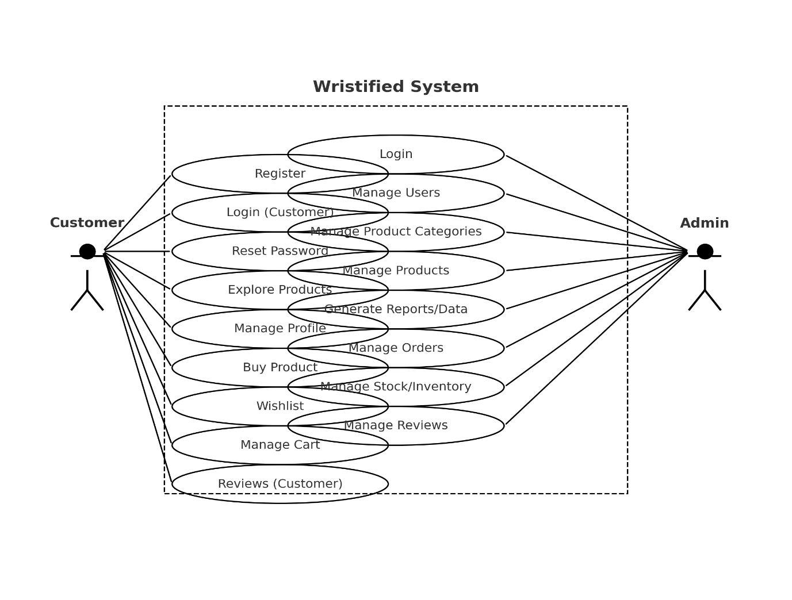

3.2 Class Diagram

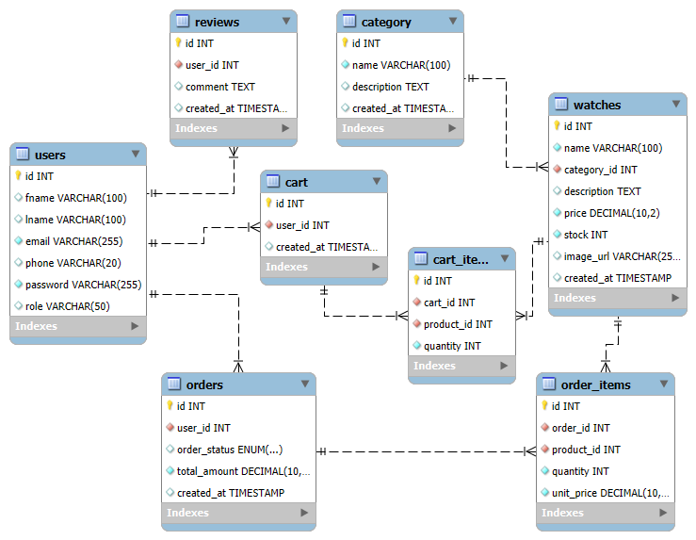

3.4 Activity Diagram

3.5 Sequence diagram

3.6 Data Dictionary

### 4. Development

4.1. Coding standard

* Project structure:
* Use clear and descriptive names for the whole directory of the project and also recommend the naming conventions rules for the variables and functions names.
* Code-version management:
  + Use a version control system (i.e., GitHub) for the project to collaborate effectively.
* UI design:
  + Design a user-friendly interface so that user can use the system and understand it easily.
* Error handling:
  + Implement an error free code and use error handling mechanism for user interactions.
* Further development:
  + Maintain the system as well conduct regular reviews that genuine feedback for the system.
  + Always look for the further improvement of the system that can make the system work more accurate and reliable

4.2. Screenshots

AGILE DOCUMENTATION

|  |  |
| --- | --- |
| Project name | Wristified – Watch Store |
| Guide | Prof. Virendra Ingle |
| Project expected start date | 15-07-2025 |
| Project expected end date | 10-10-2025 |
| Project Scope | * Development of mobile and web interfaces. * Custom Admin UI deployment * Secure authentication and authorization. * Role Based Access control * Safe & secure storing user information |
| Project mission | * to create an easy-to-use online store for watches that offers safe transactions, customized features like order tracking, ratings, and Wishlist, and seamless navigation. * to provide effective product, inventory, and user management capabilities to administrators and merchants. * to provide a cross-platform shopping experience by integrating a strong backend with Express.js and MongoDB and leveraging Flutter (web & mobile). |
| Project vision | To develop into a high-end online marketplace for watch lovers that provides a smooth, contemporary, and customized purchasing experience that combines convenience, style, and technology. |

1. Project charter
2. Project Roadmap
3. Sprint table

|  |  |  |  |  |  |
| --- | --- | --- | --- | --- | --- |
| Id # | Task | Assigned to | Status | Estimated time(hours) | Story points |
| 1. | Database setup | Mathan | Completed | 3 | 5 |
| 2. | Authentication | Arnold | Completed | 8 | 8 |
| 3. | Admin Dashboard UI | Manthan | Completed | 6 | 7 |
| 4. | Forgot password | Arnold | Completed | 2 | 6 |
| 5. | Leader Dashboard UI | Arnold | Completed | 4 | 7 |
| 6. | Member Dashboard UI | Manthan | Completed | 6 | 8 |
| 7. | Profile management | Arnold | Delayed | 3 | 4 |
| 8. | Task module | Arnold & Manthan | Delayed | 9 | 8 |
| 9. | Generate report | Arnold | Ongoing | 2 | 6 |
| 10. | Deadline management | Arnold | Delayed | 3 | 7 |
| 11. | Reminder/notification | Manthan | Delayed | 4 | 7 |

Proposed Enhancements

* System is focusing on resolving current issues and enhancing functionality.
* Improvements include more data security, efficient analytics using machine learning.
* Implement Role based access control.
* Going to add basic real time chat in the system.

Conclusion

* A task management system is essential for improving product development, data security, and real time collaborations. we aim to deliver a more efficient, user-friendly, and scalable solution.