Minkowski metric
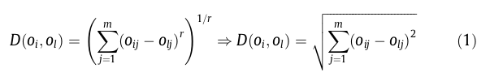

Mathematical formulation of the clustering problem
