Appendix B: Synthetic illustration of rolling-sum correlations

B0: Purpose
This appendix uses an idealised synthetic experiment to clarify the statistical interpretation of finite-window rolling-sum correlations. It distinguishes a trailing 9-month sum from a cumulative target, explains the leave-one-component-out calculation, and shows how nine lag-specific covariance contributions form each endpoint-month Pearson correlation. The experiment is methodological and is not intended to identify physical periodicities in the model simulations.
All synthetic quantities are expressed in arbitrary units, and one time step represents one synthetic month. No physical heat-flux or temperature units are assigned.

B1: Synthetic construction and the 9-month window
The synthetic signal contains oscillatory components with periods of 12, 40 and 55 months. The 12-month component represents a prescribed annual cycle, while the 40- and 55-month components introduce variability at longer, distinct timescales.
$$Q_{full}(t)=8sin\left(\frac{2πt}{40}\right)+5sin\left(\frac{2πt}{12}\right)+3sin\left(\frac{2πt}{55}\right)+ϵ(t)+0.15.$$
(B1)
The random component is
$$ϵ(t)∼N(0,3^{2}).$$
(B2)
It represents independent Gaussian noise with zero mean and a standard deviation of 3. The record contains 360 monthly samples, with a fixed random seed for reproducibility. The complete cumulative target is
$$S_{full}(t)=\sum_{τ=0}^{t}{Q_{full}}(τ).$$
(B3)
Here, $Q_{full}$ is a monthly synthetic increment, whereas $S_{full}$ is its cumulative state. These quantities are related but are not the same time series.
The 9-month window is prescribed to mirror the finite-window diagnostic used in the main analysis; it is not selected as an optimum from the synthetic experiment. No calendar-month climatology or anomaly is removed from the synthetic signal. The raw trailing 9-month rolling sum is
$$I_{9}(t)=\sum_{k=0}^{8}{Q}(t-k).$$
(B4)
For an endpoint in May, the window contains the endpoint month and the preceding eight months:
$$I_{9}({May}_{y})=Q({Sep}_{y-1})+Q({Oct}_{y-1})+⋯+Q({Apr}_{y})+Q({May}_{y}).$$
(B5)
It is a lagging window, not a forward-looking window. Moving the endpoint from May to June removes the oldest value and adds the new endpoint value:
$$I_{9}(June)-I_{9}(May)=Q(June)-Q({September}_{-1}).$$
(B6)
The cumulative target contains the complete history of $Q$, whereas $I_{9}$ retains only the most recent nine values. Their correlation is therefore not expected to equal one.
For each endpoint calendar month $m$, the correlation is calculated across years:
$$r_{m}={corr}_{y}\left[I_{9}(y,m),S_{full}(y,m)\right].$$
(B7)
For example, the May coefficient correlates one September-to-May rolling sum from each year with $S_{full}$ evaluated in May of the same year.

B2: Leave-one-component-out correlation
The synthetic construction contains three known periodic components. One component is removed from the predictor at a time, while the complete cumulative target $S_{full}$ remains unchanged:
$$Q_{-12}(t)=Q_{full}(t)-5sin\left(\frac{2πt}{12}\right),$$
(B8)
$$Q_{-40}(t)=Q_{full}(t)-8sin\left(\frac{2πt}{40}\right),$$
(B9)
and
$$Q_{-55}(t)=Q_{full}(t)-3sin\left(\frac{2πt}{55}\right).$$
(B10)
For each case, the raw trailing 9-month rolling sum is
$$I_{i,9}(t)=\sum_{k=0}^{8}{Q_{i}}(t-k), i∈\{full,-12,-40,-55\}.$$
(B11)
Every predictor is correlated with the same complete cumulative target:
$$r_{i}=corr\left[I_{i,9}(t),S_{full}(t)\right].$$
(B12)
This is leave-one-component-out, not leave-one-observation-out cross-validation. The predictor changes, but the target is never reconstructed after a component is removed.
Predictor | Correlation with fixed $S_{full}$ | Change from full predictor
Full-$Q$ 9-month rolling sum | 0.5114 | –
Without 12-month component | 0.4998 | -0.0116
Without 40-month component | 0.2952 | -0.2162
Without 55-month component | 0.4361 | -0.0753
The numerical differences quantify sensitivity to omission of each imposed component. They are not evidence that the corresponding periods constitute physical modes in the model simulations.
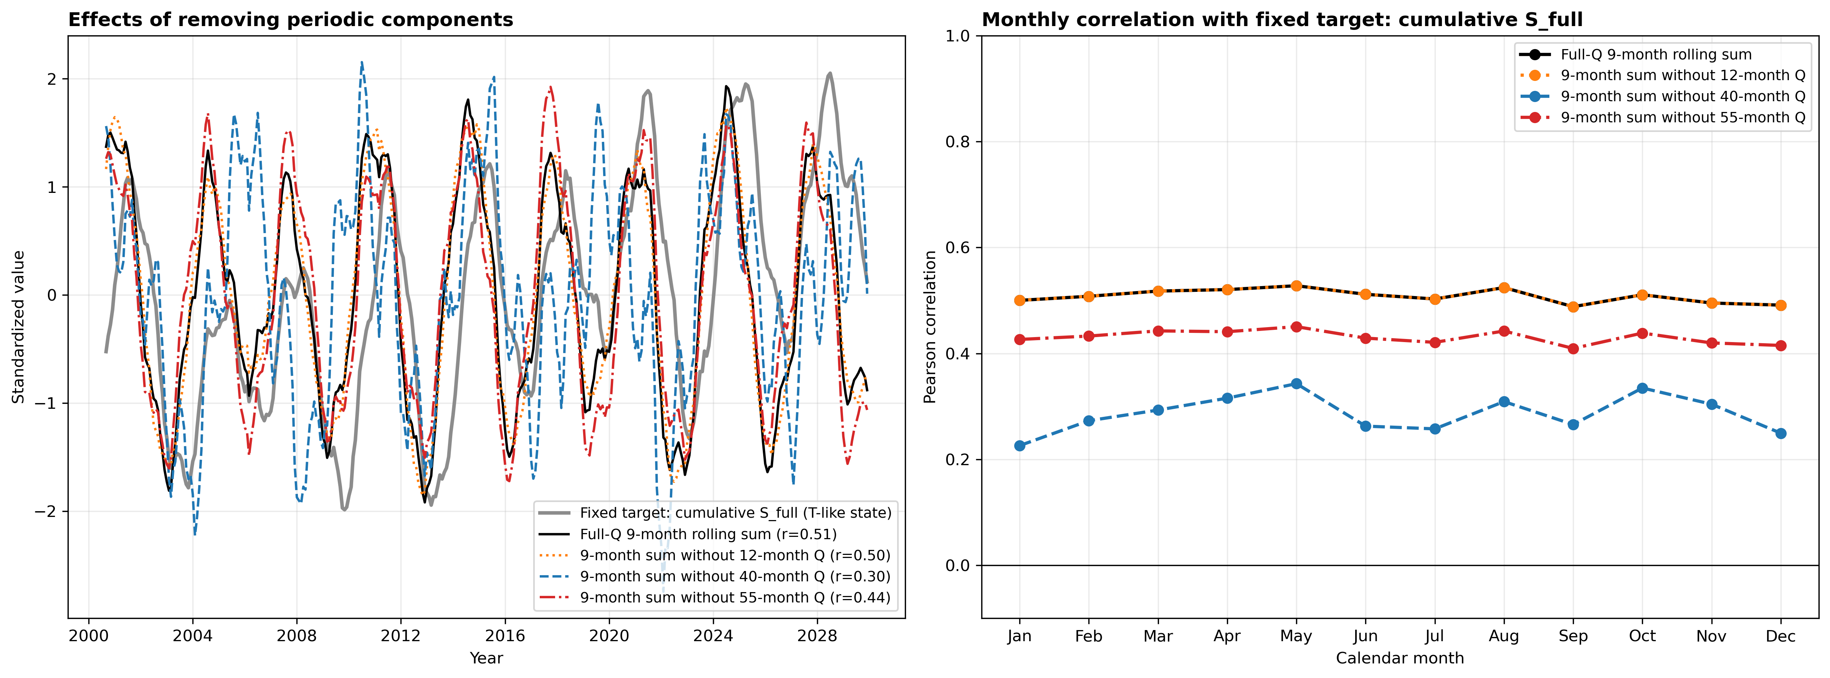
Figure B1. Leave-one-component-out comparison for the synthetic 9-month rolling-sum experiment. The grey line is the complete cumulative target $S_{full}$. The black line is the raw 9-month rolling sum of the complete $Q_{full}$, and the coloured lines are rolling sums after one imposed component is removed. Time series are standardised separately for display; correlations use unstandardised values. The target remains unchanged.
The complete-$Q$ and without-12 curves overlap in the calendar-month panel even though raw $Q$ is used. Within a fixed calendar month across years, the perfectly repeating 12-month component contributes a constant offset. Pearson correlation is invariant to a constant offset. This does not mean that an anomaly was removed.

B3: How the nine monthly contributions form the endpoint correlation
Because covariance is linear, the endpoint-month covariance can be separated into contributions from the endpoint value and the preceding eight values:
$$Cov\left[S_{m},\sum_{k=0}^{8}{Q_{m-k}}\right]=\sum_{k=0}^{8}{Cov}\left[S_{m},Q_{m-k}\right].$$
(B13)
Define the contribution of lag $k$ for endpoint month $m$ as
$$C_{m,k}=\frac{Cov\left[S_{m},Q_{m-k}\right]}{σ(S_{m}) σ(I_{9,m})}.$$
(B14)
The nine contributions sum exactly to the Pearson correlation for that endpoint month:
$$r_{m}=\sum_{k=0}^{8}{C_{m,k}}.$$
(B15)
Each vertical heat-map column in Figure B2 corresponds to one endpoint calendar month. The bottom cell is the endpoint contribution, and the remaining cells represent one to eight months before the endpoint. Red cells contribute positively, while blue cells contribute negatively. The algebraic sum of all nine cells in a column equals the correlation plotted above that column.
An individual cell is not an independent Pearson correlation. Every cell within a column uses the standard deviation of the complete 9-month rolling sum in the denominator. This common normalization permits the contributions to sum exactly to $r_{m}$.
The lag labels are relative to the endpoint. For example,
$$C_{Jan,0}=\frac{Cov[S(Jan),Q(Jan)]}{σ[S(Jan)],σ[I_{9}(Jan)]},$$
(B16)
whereas
$$C_{Feb,1}=\frac{Cov[S(Feb),Q(Jan)]}{σ[S(Feb)],σ[I_{9}(Feb)]}.$$
(B17)
Both cells use January $Q$, but the first compares it with January $S$, whereas the second compares it with February $S$. Their target months and normalizations differ, so the contributions need not be equal.
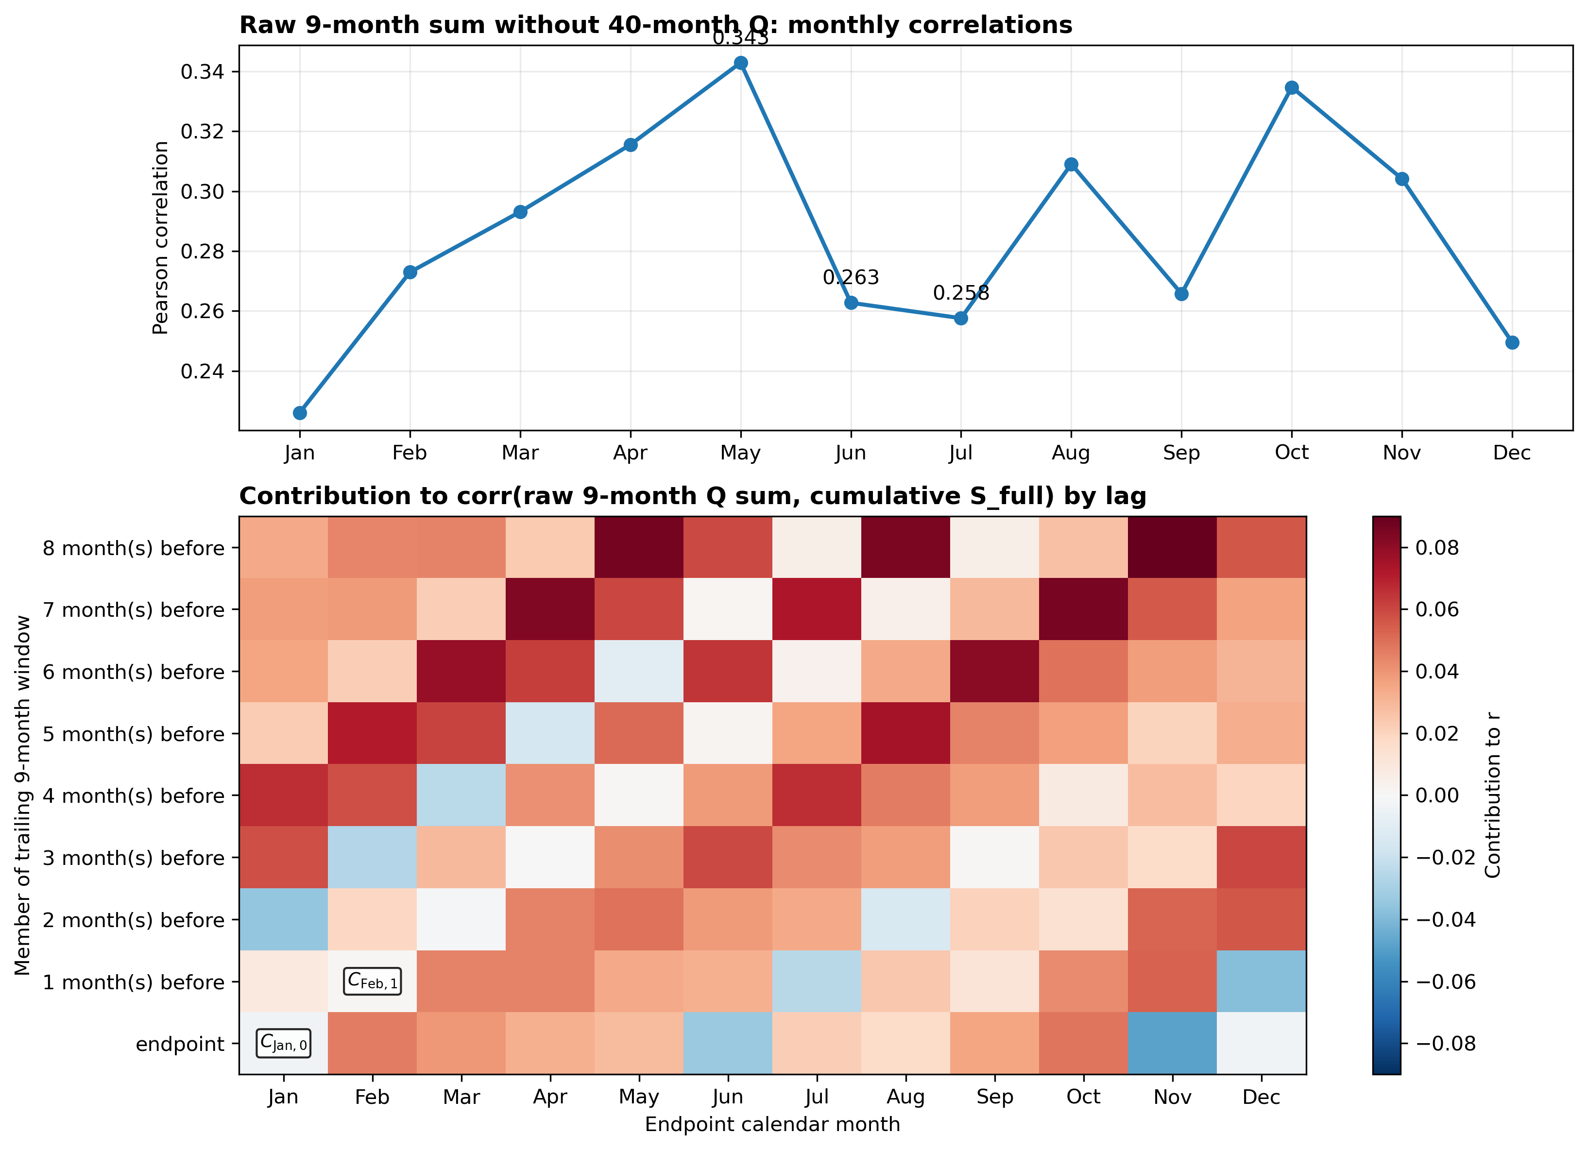
Figure B2. Lag-by-lag covariance decomposition for the raw 9-month rolling-sum predictor without the imposed 40-month component. The upper panel shows the endpoint-month Pearson correlations. The lower panel decomposes each coefficient into contributions from the endpoint month and preceding eight months. The nine cells in each vertical column sum exactly to the corresponding correlation above. Individual cells are covariance contributions, not independent Pearson correlations.

B4: Summary
The synthetic experiment shows how a prescribed trailing 9-month window is constructed and why it differs from the complete cumulative target. The leave-one-component-out test changes one predictor component at a time while preserving a common target. The covariance decomposition shows how the endpoint month and preceding eight months combine to form each endpoint-month Pearson correlation.

