Reconstruction Report

## Name

Student ID

[e-mail@shanghaitech.edu.cn](mailto:e-mail@shanghaitech.edu.cn)

# Q1

## Results

Show the screenshots of mesh result.

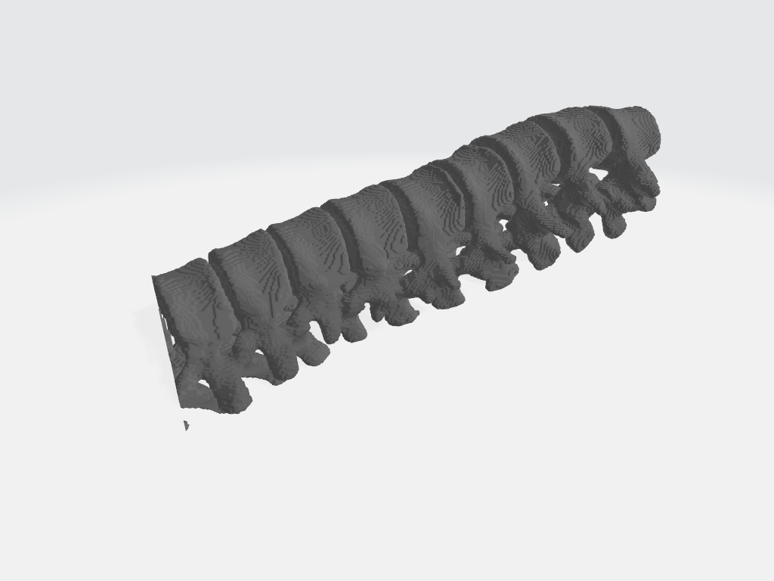交通信号灯

AI 生成的内容可能不正确。

Table 1: Q1 Hausdorff Distance result

|  |  |  |  |
| --- | --- | --- | --- |
| Method | HD Min | HD Max | HD Mean |
| Marching Cubes | 0.01314 | 28.25020 | 2.15914 |

* 1. **Discussion**

1. **Implementation Steps of the Marching Cubes Algorithm**
2. **Input Preparation**  
   Input a 3D volumetric data (3D numpy array), typically obtained from medical images such as those read from NIfTI format, and a threshold value, which represents the isosurface extraction threshold.
3. **Isosurface Extraction (Using skimage.measure.marching_cubes)**
   * Use measure.marching_cubes(volume, level=threshold) to perform the Marching Cubes algorithm on the volumetric data.
   * This function scans the voxel cubes of the entire 3D volume, determines whether the scalar values at the vertices of the cube are above the threshold, and identifies the isosurface positions on the cube edges.
   * Based on these positions, it uses a lookup table (Marching Cubes lookup table) to generate triangular facets, which are combined to form the complete isosurface.
4. **Obtain Output Results**
   * Obtain the vertex coordinates verts, triangle facet indices faces, as well as vertex normals normals and corresponding values values of the isosurface.
5. **Create Open3D Triangle Mesh Object**
   * Create an empty TriangleMesh object using Open3D.
   * Import the corresponding vertices, triangle facet indices, and normals into this object to construct the mesh.
6. **Visualization**
   * Use Open3D's visualization function o3d.visualization.draw_geometries([mesh]) to display the extracted isosurface mesh.
7. **Export**
   * The generated triangular mesh can be exported to formats like OBJ for further use or sharing.

**II. Why Can Hausdorff Distance Evaluate Reconstruction Quality?**

1. **Understanding Basic Requirements of Reconstruction Quality**
   * The core of reconstruction quality is to measure the similarity between the reconstructed model and the true model.
   * Ideally, the smaller the spatial error between the two, the better the reconstruction quality.
2. **Definition of Hausdorff Distance**
   * The Hausdorff distance measures the maximum distance between two point sets, specifically, the maximum of the minimum distances from each point in one set to the closest point in the other set.
   * Formally, the Hausdorff distance between set A and set B is: 
3. **Advantages in Evaluating Reconstruction Quality**
   * Directly quantifies maximum deviation: It accurately captures the point on the reconstructed model that is farthest from the true model, reflecting the worst reconstruction area.
   * Comprehensive error distribution characterization: By considering the distances from both point sets, it ensures not only overall model matching but also avoids missing parts of the structure.
   * Matches the requirements of medical image reconstruction and 3D reconstruction: It focuses on the precise conformity of model boundaries and shapes.
4. **Summary**
   * Hausdorff distance can measure both detail deviation (maximum error) and ensure overall model consistency, making it an effective metric for assessing the distance between a model and a reference standard.
   * Therefore, using the Hausdorff distance allows for a scientific and objective evaluation of the quality of 3D reconstructed models.

# Q2

## Results

Show the screenshots of mesh result.

灰色的鸟

AI 生成的内容可能不正确。

图表 1 Poisson Surface Reconstruction

动物的雕塑

AI 生成的内容可能不正确。

图表 2Alpha Shape Reconstruction when alpha=0.1

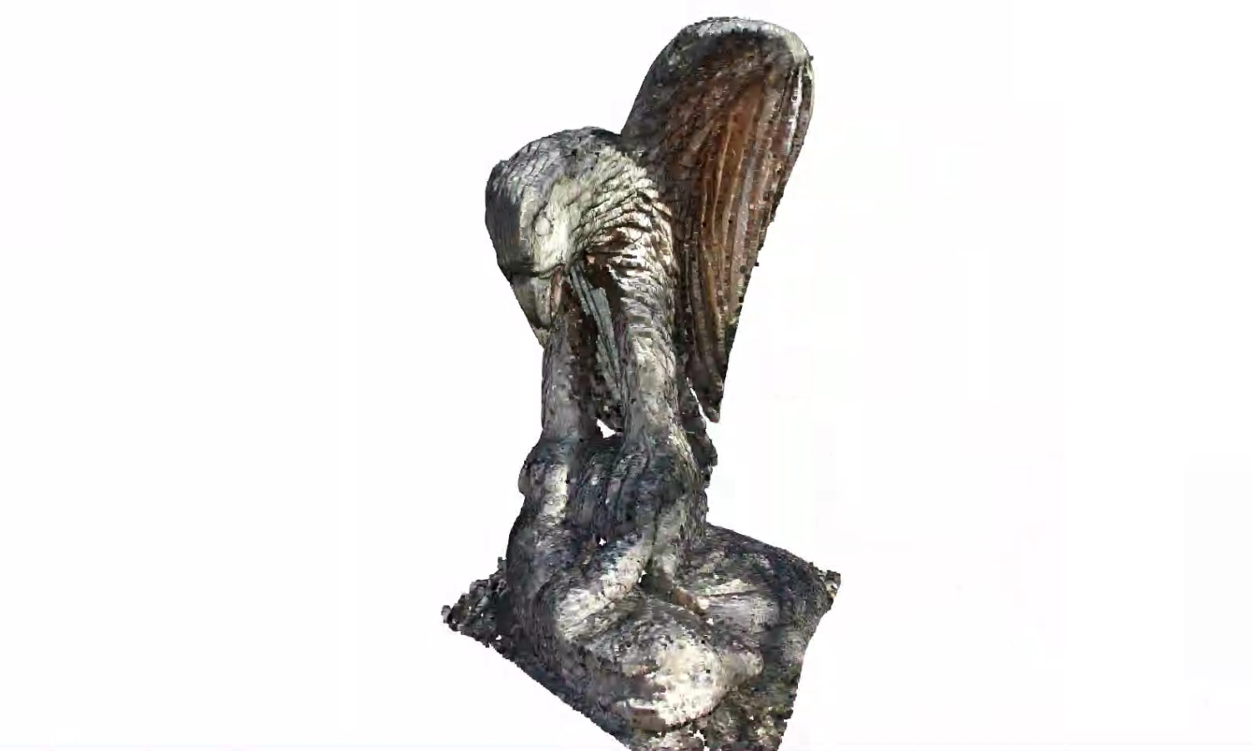

图表 3 Ball Pivoting Reconstruction when radii = [0.005, 0.01, 0.02, 0.04]

Table 2: Q2 Hausdorff Distance result

|  |  |  |  |
| --- | --- | --- | --- |
| **Method** | **HD Min** | **HD Max** | **HD Mean** |
| Poisson | 0.0005810094014416832 | 0.19123249997678987 | 0.06164615267981447 |
| Alpha Shape | 0.0027112700583508346 | 0.2116086206589997 | 0.06364499245886879 |
| Ball Pivoting | 0.0010917599321975083 | 0.21373294918659846 | 0.06130900422275048 |

* 1. **Discussion**

1. Principles, Strengths, and Weaknesses of Each Reconstruction Method:

**(a) Poisson Surface Reconstruction**

**Principle:**

* Poisson reconstruction formulates surface reconstruction as solving a Poisson equation. Given a point cloud with associated normal vectors, it computes a scalar function whose gradient best matches the given normals. The implicit surface is then extracted as an iso-surface from this scalar field using an algorithm like Marching Cubes.

**Strengths:**

* Robust to noise and incomplete data.
* Produces smooth, watertight surfaces.
* Good at filling small holes and gaps.

**Weaknesses:**

* Requires accurate normal estimation.
* May overly smooth sharp features and edges.
* Sensitive to incorrect normal orientations.

**Best Performance:**

* Smooth, organic shapes or noisy point clouds requiring robustness.

**(b) Alpha Shape Reconstruction**

**Principle:**

* Alpha shapes generalize convex hulls by introducing a parameter α that controls the level of detail. They are based on Delaunay triangulations and Voronoi diagrams. Smaller α values capture finer details, while larger α values produce simpler, more convex shapes.

**Strengths:**

* Flexible control over detail level.
* Good at capturing concave features.
* Simple and intuitive parameterization.

**Weaknesses:**

* Sensitive to noise and outliers.
* Difficulty in choosing optimal α parameter.
* May produce non-watertight meshes or holes.

**Best Performance:**

* Concave shapes or structures where detail control is critical and noise is minimal.

**(c) Ball Pivoting Reconstruction**

**Principle:**

* Simulates rolling a virtual ball of fixed radius over the surface points. A triangle is formed when the ball touches three points simultaneously. The process continues until the mesh covers the entire surface.

**Strengths:**

* Intuitive and straightforward physical interpretation.
* Good at preserving sharp features and edges.
* Fast and efficient for dense, uniformly sampled point clouds.

**Weaknesses:**

* Sensitive to sampling density and noise.
* Requires uniform sampling; gaps or sparse regions may cause incomplete meshes.
* Difficult to handle large holes or irregularly sampled data.

**Best Performance:**

* Uniformly sampled, dense point clouds with minimal noise and clearly defined surfaces.

**2. Mesh Quality and Processing Time Comparison (Based on Provided Results):**

| **Method** | **HD Min (Lower is better)** | **HD Max (Lower is better)** | **HD Mean (Lower is better)** |
| --- | --- | --- | --- |
| **Poisson** | **0.00058** | **0.19123** | 0.06165 |
| **Alpha Shape** | 0.00271 | 0.21161 | 0.06364 |
| **Ball Pivoting** | 0.00109 | 0.21373 | **0.06131** |

**Interpretation:**

* **Poisson** reconstruction generally provides the lowest maximum Hausdorff distance, indicating a smoother and more robust reconstruction, especially effective in noisy scenarios.
* **Ball Pivoting** has the lowest mean distance, suggesting good average accuracy, but slightly higher maximum error, indicating possible local inaccuracies or gaps.
* **Alpha Shape** generally performs worse in terms of accuracy metrics, likely due to sensitivity to parameter choice and noise.

**Processing Time (General Expectation):**

* **Poisson**: Typically moderate to high computational cost due to solving a large linear system.
* **Alpha Shape**: Usually fast, as it relies on geometric computations (Delaunay triangulation), but can become slow for large datasets.
* **Ball Pivoting**: Often fastest for dense, uniform datasets, as it is a local method without global optimization.

**3. Main Parameters and Their Effects on Reconstruction Performance:**

| **Method** | **Main Parameters** | **Effects on Performance** |
| --- | --- | --- |
| **Poisson Reconstruction** | - **Octree Depth (resolution)** - **Iso-value threshold** - **Normal estimation accuracy** | - Higher octree depth increases mesh detail and processing time. - Iso-value affects surface tightness and smoothness. - Poor normal estimation significantly reduces reconstruction quality. |
| **Alpha Shape Reconstruction** | - **Alpha (α) parameter** | - Small α captures fine details but is sensitive to noise and may create holes. - Large α produces smoother, simpler shapes but loses detail. |
| **Ball Pivoting Reconstruction** | - **Ball radius** - **Point cloud density** | - Smaller ball radius captures finer details but is sensitive to noise and gaps. - Larger ball radius smooths out details and may skip fine features. - Non-uniform sampling density severely affects reconstruction completeness. |

**Summary of Recommendations:**

* **Poisson Reconstruction** is generally robust and suitable for noisy or incomplete data, especially when smoothness and watertightness are important.
* **Alpha Shape Reconstruction** is best for controlled, noise-free environments where detail level must be explicitly managed.
* **Ball Pivoting Reconstruction** is ideal for dense, uniformly sampled point clouds, especially when preserving sharp features and computational efficiency are priorities.

**References**