SNA 2018 - HW1

Einav Ram - Ziv Levi - Arnon Kahani

203546445 – 304974645- 305509556

# Data structure and clustering coefficient algorithm logic

## Data structure

1. To represent the input network, we choose a combination of a HashMap and ArrayList. Each vertex is an entry (key) in the HashMap and the adjacent vertices (neighbors) are kept in an ArrayList as the value of the vertex key.
2. The decision for this data structure was due to several considerations:
   1. Finding the adjacent vertices quickly
   2. The amount of the neighbors is given by the size of the ArrayList
   3. Counting the number of “mutual-friends” required only checking if they exist in both lists.
   4. Relativity to adjacency matrix (AM) this data structure is small in memory, we considered large network such as Facebook were the AM will be very sparse and will require large amount storage.

## Logic

1. The full algorithm can be seen in the implementation but the high level idea of the algorithm is to iterate over all nodes i.e. entries in the HashMap and for each “neighbor” in the ArrayList (value of the entry) go over the node neighbors and count how many “mutual-friends” they have.
2. Pseudo code for section 2.a
   1. graph = HashMap<Integer,ArrayList<Integer>>
   2. for node in graph:
      1. counter ← 0
      2. k = node.value.length
      3. for neighbor_outer in node.value:
         1. neighbor_of_neighbors ← graph.get(neighbor)
         2. for neighbor in node.value:
            1. If neighbor_of_neighbors.contains(neighbor):

counter ← counter + 1

* + 1. coefficients ← $\frac{counter}{k*(k-1)}$

# Networks

The network images were crated in Neo4J.

ACC - The average clustering coefficient

Colors = Green(High CC) 🡪 Purple(Low CC)

Size = Large (High CC) 🡪 Small (Low CC)

## Egonets-Facebook

URL: <https://snap.stanford.edu/data/egonets-Facebook.html>

Description: Dataset from Facebook collected from survey participants, the data contains friend list and features per node i.e. Facebook account that are encoded to anonymized

the data and the participants account is also encoded as a number for the same reason.

Nodes: 4039

Edges: 88234

ACC: 0.6055467186200871

|  |  |
| --- | --- |
| Node ID | Clustering coefficient |
| 71 | 1 |
| 70 | 1 |
| 63 | 1 |
| 52 | 1 |
| 47 | 1 |
| 46 | 1 |
| 44 | 1 |
| 42 | 1 |
| 35 | 1 |
| 33 | 1 |

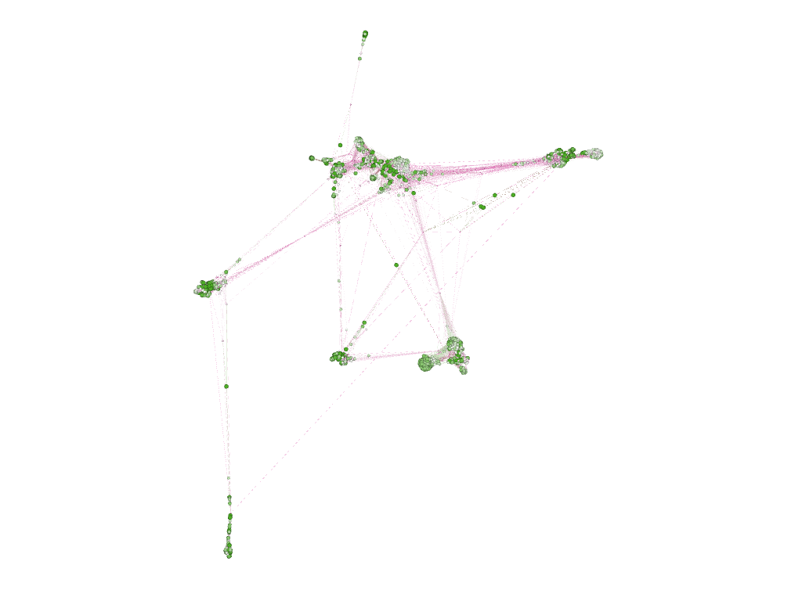

## Karate

Nodes: 34

Edges: 78

ACC: 0.5706384782076823

|  |  |
| --- | --- |
| Node ID | Clustering coefficient |
| 27 | 1 |
| 23 | 1 |
| 22 | 1 |
| 21 | 1 |
| 19 | 1 |
| 18 | 1 |
| 17 | 1 |
| 16 | 1 |
| 15 | 1 |
| 13 | 1 |

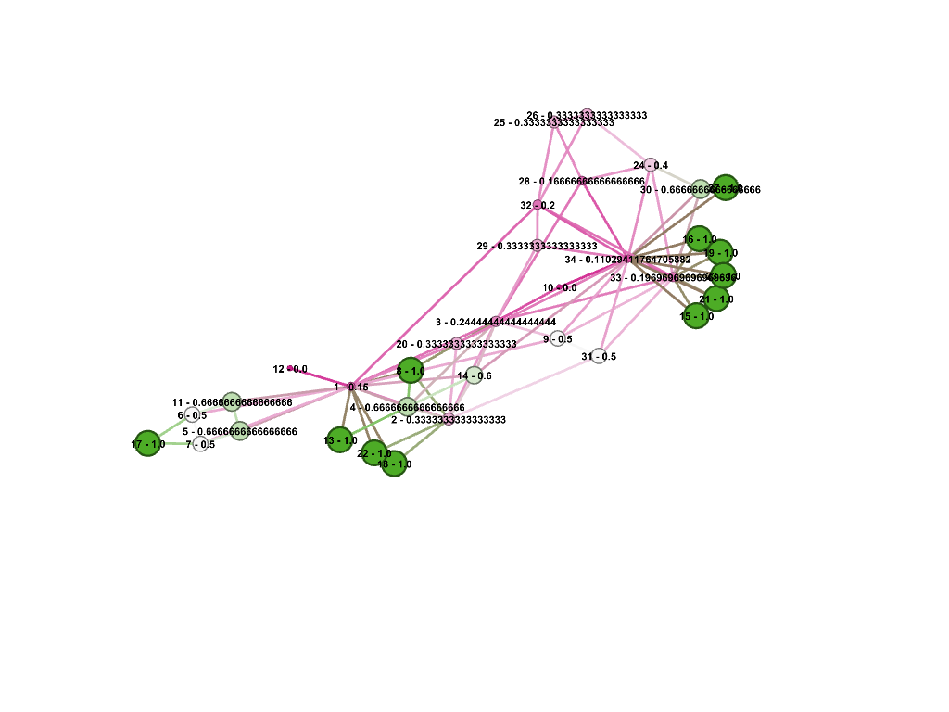

## Les Mesrables

URL: <https://github.com/gephi/gephi/wiki/Datasets>

Description: Dataset from coappearance weighted network of characters in the novel Les Miserables

the data and the participants account is also encoded as a number for the same reason.

Nodes: 77

Edges: 254

ACC: 0.5731367499320134

|  |  |
| --- | --- |
| Node ID | Clustering coefficient |
| 33 | 1 |
| 30 | 1 |
| 22 | 1 |
| 21 | 1 |
| 20 | 1 |
| 19 | 1 |
| 18 | 1 |
| 17 | 1 |
| 12 | 1 |
| 3 | 1 |

