Preliminary Design Review

Vehicle ad-hoc network simulation

June 19, 2013

Course 371-1-1691

Department of Communication System Engineering

Ben Gurion University

Presented by: Slava Ustinov 309930006

Arnon Shimoni 032491821

Contents

Preface 1

June 19, 2013 2

Course 371-1-1691 2

Department of Communication System Engineering 2

Ben Gurion University 2

Contents 2

1. Introduction 1-1

1.1 Definitions and abbreviations 1-1

1.2 Overview 1-1

2. Design and Flow 2-2

2.1 Overview 2-2

2.2 Modules overview 2-2

2.3 Erlang Nodes 2-3

2.4 The actual simulation 2-4

3. Bibliography 3-4

# Introduction

## Definitions and abbreviations

**Abbreviations**:

VANET - Vehicular Ad hoc Network – The network type this article deals with

RV - Relay Vehicle – An infrastructure related vehicle

AV - Ancillary Vehicles – Regular vehicles on the road that use the infrastructure

BS - Base Stations – backhaul connections to the network infrastructure.

## Overview

Our proposed Erlang simulation program is based on the article "Communication framework for vehicle ad hoc network on freeways" (Kuan-Lin & Hwang, 2012).

The article suggests a new scheme for vehicular ad-hoc communication on freeways, with emphasis on a safety feature in the form of Flood messages.

Out of the entire suggested scheme at this article, we'll focus mainly on simulating and displaying vehicle motion along the freeway, when vehicle will have the ability to switch lanes and crash into each other, and handling crash events, on which a Flood message should be broadcasted across the network, telling all vehicles behind the crash's location to slow down immediately.

In regards to the Core Network, we'll only implement the Guard server.

Our freeway will have multiple lanes, all in the same direction, as seen in Figure 1 - Freeway schematic (Kuan-Lin & Hwang, 2012).

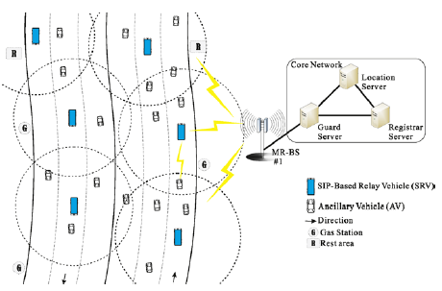

Figure 1 - Freeway schematic (Kuan-Lin & Hwang, 2012)

# Design and Flow

## Overview

As described the system is built of the following components:

**AVs, RVs, two BSs, two Display units, one Control unit and one Guard server**.

The basic modules and network topology are described below:

* **AV –** A regular vehicle on the road (can be considered as an End Device). Such vehicle can ask to register to the network through the RV. On registration success, it'll be able to send and receive emergency Flood messages that originate from other vehicles.
* **RV** – Relay vehicle. It relays all data traffic between the AVs and the rest of the network, via a BS. On reception of a Flood message, it relays it to all connected devices.
* **BS** – A static base station alongside the road. It's responsible for connecting between RVs and the Guard server.
* **Guard server** – Receives messages from the Base Stations and forwards them if necessary.
* **Control Unit –** Controls the changes in the network's topology, responds to network topology queries and so on.

## Modules overview

**AV**

**Variables:**

* RV_ID – The ID of the RV that this AV is currently connected to.
* Last_Event_Time – The time at the last Flood or crash event.
* Is_crazy – Indicates the possible variation in this vehicle's speed.

**Description:** The AV is an ordinary car on the freeway that uses the network.

An AV can communicate with the rest of the network through a single RV at a time. If an AV goes out of an RV's range, it'll notify that RV and will try to reconnect to another RV in range. Information about RVs in its range will be obtained by querying the Control unit.

After every pre-defined time it'll contact the Control unit to ask for relocation along the road.

Normal vehicle will travel at 110 KMH with a fluctuation of +/- 5 KMH.

Crazy vehicle will travel at 110 KMH with a fluctuation of +/- 15 KMH.

**RV**

**Variables:**

* Number_of_supported_AVs – The maximum number of clients this RV can support.

**Description:** Relays messages from and to AVs.

Sends a flood message to all stations upon any of the following events:

- Flood message reception from an AV

- Crash event

In case of a Flood message from the BS, the RV will broadcast it only if its range covers an area relevant to the Flood message.

A Flood message will contain an event_id, vehicle_id and location coordinates.

**BS**

**Variables:** none.

**Description:** Relays messages from the Guard server to the RVs.

- Upon reception of a Flood message, it'll broadcast it to all connections.

**Control Unit**

**Variables:**

* RV_transmission_range – Will be used to calculate whether an AV can communicate with an RV.
* Number_of_lanes – the number of lanes on the freeway.

**Description:** Control the changes in the network's topology:

- Replies vehicle relocation requests – calculates their new position considering their speed and lane switch probability, lets them know if they’ve crashed into another vehicle or that they're out of their current RV's range.

- It'll notify RVs if they have to switch a BS.

- Replies AV queries for the nearest RV to connect to.

**Guard Server**

**Variables:** none.

**Description:** Will receive all Flood message across the network and route them between BSs if necessary.

**Display Unit 1, 2**

**Variables:** none.

**Description:** Will use the Control unit's data of the network topology and display the 1st/2nd half of the road using WxWidgets.

## Erlang Nodes

Here is our proposed layout of Erlang nodes.

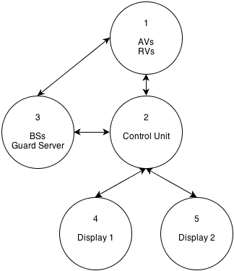

Figure 2 - Proposed Erlang node layout

## The actual simulation

Our plan is to simulate the flow of vehicles on the road with elements of speed changing among the vehicles.

The network structure is dynamic – AVs will exchange their RVs, depending on the range to the next RV. RV will swap their base stations also according to range.

Naturally, different types of driving will cause messages to be sent over the network.

Our result from this simulation will be a graphic representation of the vehicles on the road, with their different roles – and messages passing between them. Naturally, the vehicles react to the different types of messages received.

# Bibliography­

Kuan-Lin, C., & Hwang, R.-H. (2012, August 01). Communication framework for vehicle ad hoc network on freeways. *Telecommunication Systems, 50*(4). doi:10.1007/s11235-010-9401-4