

Program Basics:

- 5-year residency
  - PGY-1 year 6 months general surgery + 6 months urology
  - PGY2-5 urology
- Call schedule
  - Primary call split between Uro2 and Uro3
  - Uro2: 1-2 nights/week, 2 weekends/month
  - Uro3: 0-1 nights/week backup call, 1 weekend/month primary
  - Uro4: 0-1 nights/week backup call, 1 weekend chief call/month
  - Uro5: 1 weekend chief call/month
- Didactics
  - Wednesday 7-8 AM conference: dedicated educational time for AUA core curriculum/Campbell's chapters with faculty proctor. Year-long didactic program covering all of AUA core curriculum topics
  - Friday AM conference: grand rounds, guest speakers, AUA updates/guidelines, Morbidity and Mortality Conference ("M+M"), Indications

Rotation Sites:

Montefiore Moses Campus:
-Largest medical center in Bronx – 726 beds
-Residents: PGY2, PGY3, PGY5
-Busy consult service for Uro2
-Majority of Onc/Robotic Cases: RALP, partial nephrectomy, cystectomy, simple prostatectomy
-Da Vinci Xi robot and Si robot with a dual console for resident teaching and simulator

CHAM - Children's hospital at Montefiore:
-PGY2/PGY3 rotation (dedicated 4 months on pediatric service)
-3 full-time pediatric Urology Attendings
-OR Monday-Tuesday, Thursday-Friday
-Clinic Wednesday

Montefiore Weiler Campus:
-421 bed hospital
-Residents: PGY2, PGY3, PGY4, PGY5
-Cases: open oncology (kidney, prostate), robotic onc (partial nephrectomy and RALP), complex stones (PCNL), complex endoscopic cases (TURP, complicated TURBT)
-Da Vinci Xi robot and Si robot with a dual console for resident teaching and simulator

Montefiore Wakefield Campus
-321 bed hospital
-Residents PGY1, PGY2
-Clinic, consults, and general urology cases

Hutchinson Metro Center ("The Hutch"):
-State of the art ambulatory surgery center and clinic
-Residents: PGY2, PGY3, PGY4, PGY5
-Majority of endoscopic stone cases, "bread and butter Urology cases", prosthetics, female urology (scrotal/penile surgery, TURBT, ureteroscopy)
-Clinic is built into each year and rotation
-Robust outpatient clinic in general urology, oncology, sexual medicine, female urology, pediatric urology
-Office procedures: flexible cystoscopy, TRUS prostate biopsies, vasectomy, bladder botox, PTNS, PNE, urethral bulking injection

Memorial Sloan Kettering Cancer Center
-One of the world’s most respected comprehensive cancer center
-Residents: PGY3 (2 months)
  - Clinical experience in comprehensive, multidisciplinary, hands-on training in all aspects of the surgical management of GU cancers as well as interaction with medical and radiation oncologists
  - Educational experience in weekly didactics and grand rounds lead by world-renown experts in GU malignancies

Breakdown of Resident Duties by Level

Urology 1 (PGY1):
-Spend 6 months on General Surgery and 6 months on Urology
-General Surgery rotations include: Acute Care, Colorectal, Surgical Intensive Care Unit, Surgical Oncology and Transplant
-Locations of rotations are at Weiler/Hutch, Moses, Wakefield, and Jacobi

Urology 2 (PGY2):
-Spend 4 months at Moses, 4 months at Wakefield, and 4 months at Weiler
-Moses: busy consult service, where you learn basic of managing consults in setting of complicated and complex medical patients
-Weiler: learn basics of Urologic surgery at Hutch (busy endoscopic service)
-Wakefield: high volume exposure to clinic-based urology with time spent seeing inpatient consults and in OR for general urology cases

Urology 3 (PGY3):
-Spend 6 months at Moses, 4 months at CHAM, and 2 months at MSKCC
-CHAM: Dedicated pediatrics resident, operate 4 days a week (Mo-Thursday) and clinic Friday, handle all pediatric consults/inpatients
-Moses: Learn basics of bedside assisting robotic cases, first introduction on Robot; complicated endoscopic cases (TURP, TURBT, complex stones)

Urology 4 (PGY4):
-Year is split between Weiler and Hutch
-Complex stones (PCNL's), robotic experience at Weiler, master bread and butter Urologic procedures
-Begin to take Chief call

Urology 5 (PGY5)
-Chief Year
-6 months at Moses and 6 months at Weiler
-Master Robotic procedures, open oncologic procedures

Case log data 2022 – 2023

 | Uro-2 | Uro-3 | Uro-4 | Uro-5 | Minimum
General Urology | 147 | 415 | 474 | 398 | 250
Transurethral | 76 | 240 | 262 | 202 | 100
TRUS/prostate biopsy | 15 | 59 | 68 | 80 | 25
Fusion | 0 | 19 | 29 | 19 | 0
Scrotal/inguinal surgery | 48 | 106 | 104 | 102 | 60
Urodynamics | 8 | 9 | 35 | 12 | 10
Endourology/Stone Disease | 133 | 302 | 349 | 263 | 150
Ureteroscopy | 125 | 265 | 303 | 228 | 90
Percutaneous procedures | 5 | 32 | 38 | 30 | 10
Reconstructive Surgery | 45 | 233 | 391 | 290 | 100
Male | 26 | 122 | 200 | 185 | 30
Male penis/incontinence | 23 | 112 | 188 | 166 | 15
Male urethra | 3 | 10 | 12 | 19 | 5
Female | 12 | 65 | 134 | 58 | 15
Intestinal diversion | 0 | 9 | 2 | 10 | 10
Oncology | 49 | 155 | 174 | 224 | 130
Pelvic | 34 | 89 | 100 | 121 | 50
Pelvic – bladder | 0 | 23 | 15 | 13 | 10
Pelvic – prostate | 34 | 63 | 84 | 108 | 30
Retroperitoneal | 15 | 66 | 74 | 103 | 50
Retroperitoneal – kidney | 14 | 56 | 72 | 96 | 40
Pediatric-Minor | 58 | 103 | 97 | 134 | 30
Endoscopy | 7 | 27 | 27 | 31 | 5
Hydrocele/hernia | 9 | 29 | 18 | 21 | 10
Orchiopexy | 36 | 44 | 48 | 73 | 10
Pediatric-Major | 28 | 31 | 33 | 59 | 15
Hypospadias | 22 | 21 | 24 | 34 | 5
Ureter | 2 | 9 | 5 | 17 | 5
Robotic | 57 | 104 | 169 | 192 | 80

Montefiore Urology Department Current Residents

Chiefs/ PGY – 5
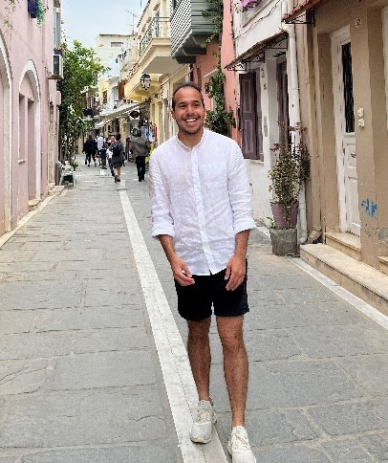
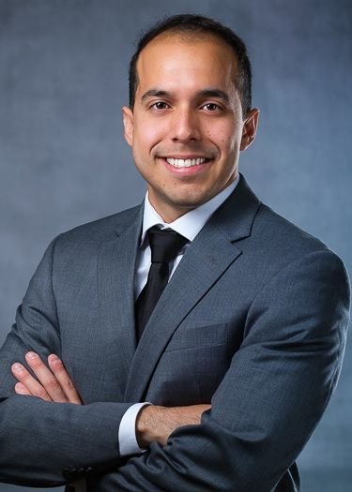

John Hill, MD johill@montefiore.org Hometown: Guayaquil, Ecuador Nickname: JP
Undergrad: Virginia Commonwealth University, Richmond, VA Medical School: Renaissance School of Medicine at Stony Brook University
Favorite Case: hydrocelectomy, IPP, mid urethral sling
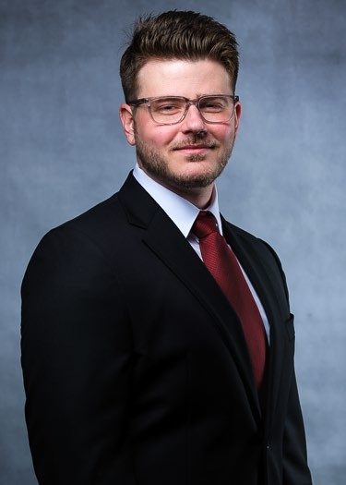
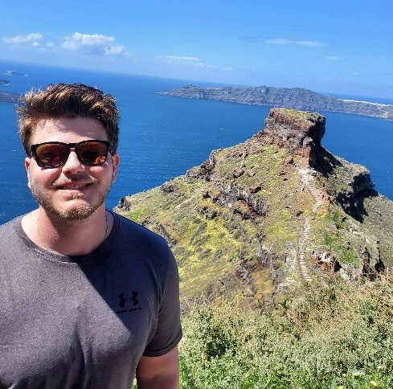
Extracurricular Interests: hiking, camping, nature activities, visiting national parks, and dining around the city

John Hordines, MD johordines@montefiore.org Hometown: New Windsor, NY
Undergraduate: Rensselaer Polytechnic Institute, Troy, NY
Medical School: State University of NY Downstate Medical Center College of Med Favorite Case: RALP
Extracurricular Interests: Whiskey collecting: Special interest in Scotch and Irish whisky. Travelling began in 2014. Favorite locations: Rome, Italy, Speyside region of Scotland , Rioja, Spain. Computer building: first computer constructed in 2014 with continuous upgrades. Bass guitar: Private lessons from 2013-2015. Special interest in classic rock. Reading: Interest in fiction and non-fiction. Running: former high school cross-country runner, currently as a recreational activity. NBA basketball.

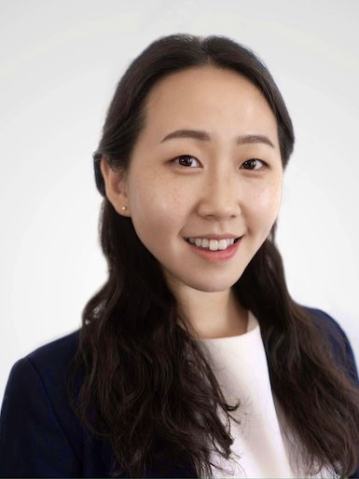
So Yeon Pak, MD 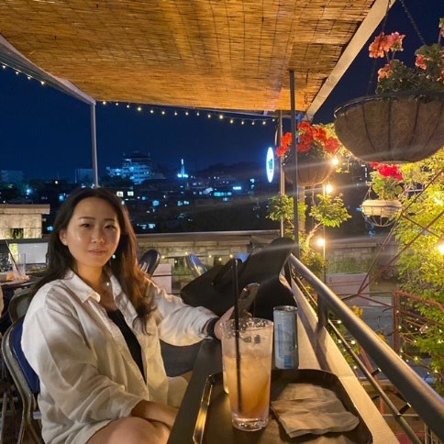
sopak@montefiore.org
Hometowns: Brooklyn, New Hyde Park Nickname: Jen, JPak
Undergraduate: Cornell University, Ithaca, NY
Medical School: State University of NY Downstate Medical Center College of Med Favorite Case: TURP
Extracurricular Interests: Yelp Elite member (I review restaurants and get invited to food- related social events). New York Times crossword puzzles (especially Sunday ones).
Wineries, cooking

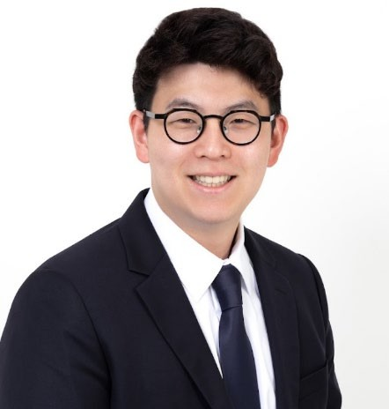
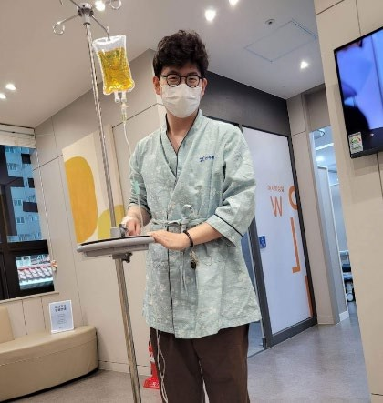
PGY – 4

Joseph Kim, MD jkim28@montefiore.org Hometown: Seoul, Korea Nickname: Joe
Undergrad: University of Pennsylvania, PA Medical School: Albert Einstein College of Medicine
Favorite Case: Ureteral stents
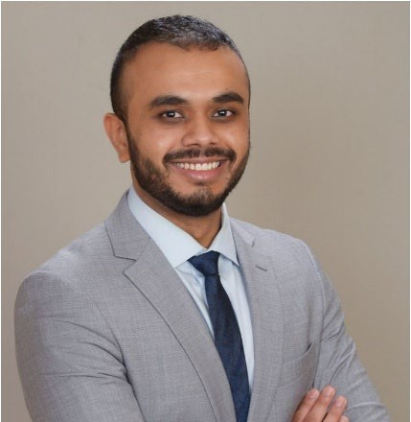
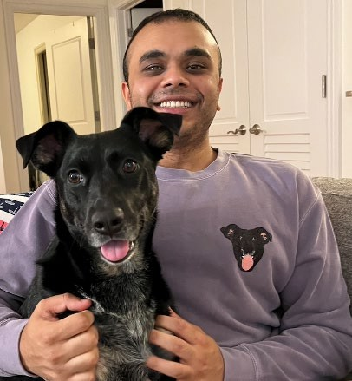
Extracurricular Interests: Exploring new restaurants in NYC, Animes, Kdramas, Games – League of Legends, Teamfight Tactics

Rutul Patel, DO Rutupatel@montefiore.org Hometown: Boston, MA Nickname: Ruty
Undergrad: University of Massachusetts Amherst
Medical School: New York Institute of Technology College of Osteopathic Medicine Favorite Case: IPP
Extracurricular Interests: Hiking with my dog, Cooking, Fantasy Football, League of Legends (psst: I’m better than Joe)

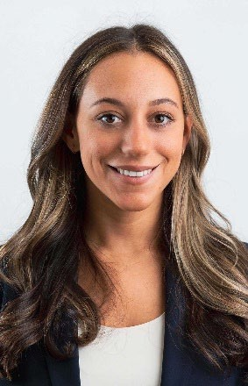
Kelli Aibel, MD Kaibel@montefiore.org Hometown: Jericho, NY Nickname: KAibel Undergrad: Duke University
Medical School: Zucker School of Medicine at Hofstra/Northwell Favorite Case: Sacrocolpopexy
Extracurricular Interests: Hanging with my dogs, travel, photography, trying new restaurants

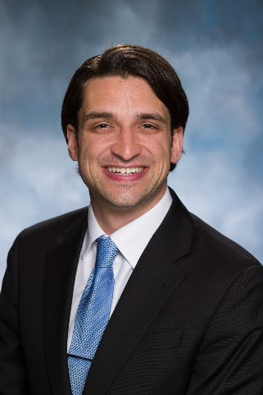
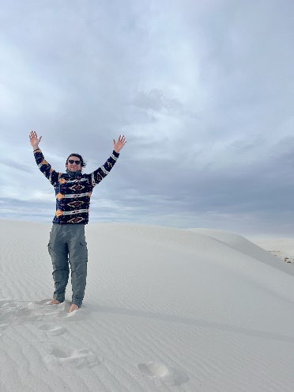
PGY – 3

Jake Drobner, MD jdrobner@montefiore.org Hometown: Englewood, NJ Nickname: Jake
Undergrad: Columbia University
Medical School: Rutgers Robert Wood Johnson Medical School Favorite Case: Vasectomy
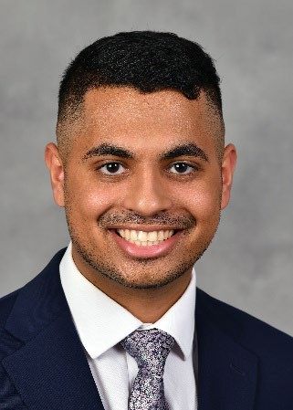
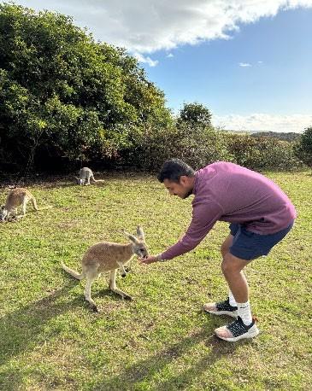
Extracurricular Interests: Snowboarding, traveling, going to the movies, doing crossword puzzles, and exploring NYC’s restaurants, running

Valmic Patel, MD valpatel@montefiore.org Hometown: Goshen, NY Nickname: Val
Undergrad: Binghamton University
University Medical School: SUNY Upstate Medical University
Favorite Case: TURP
Extracurricular Interests: Soccer, Golf, Pickleball, NY Jets, eating (sometimes cooking)

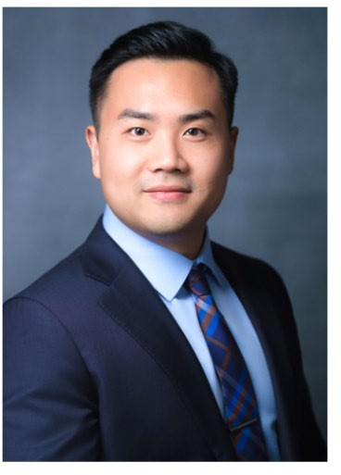
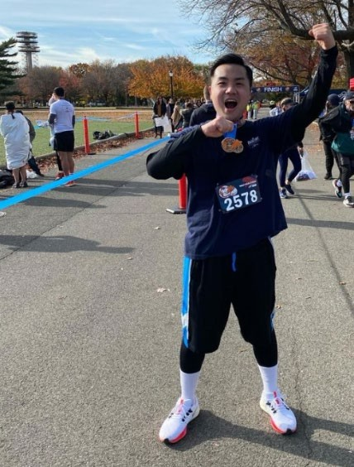
Samuel Yim, MD syim@montefiore.org Hometown: Great Neck, NY Nickname: Sam
Undergrad: Cornell University Medical School: SUNY Downstate Favorite Case: PCNL
Extracurricular Interests: Running, weightlifting, going to parks, trying new restaurants, exploring NYC, finding the best views.

PGY-2
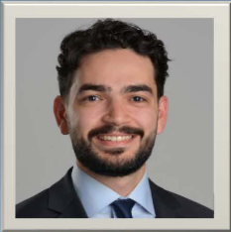

Nate Iskhakov, MD Hometown: Queens, NY Nickname: Nate, Nate dogg, Nate the Great
Undergrad: Stony Brook
Medical School: University of Buffalo
Favorite Case: Orchiectomy
Extracurricular Interests: Basketball, pickleball, ping pong, video games, NY Knicks, traveling, very amateur chess player

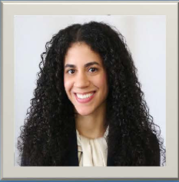

Jasmin Capellan, MD Hometown: Bronx, NY
Nickname: Jas
Undergrad: Princeton University
Medical School: Rutgers Robert Wood Johnson
Favorite Case: Ureteral reimplant
Extracurricular Interests: dancing, crocheting, weight-lifting, traveling

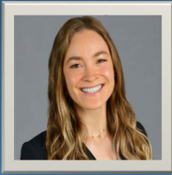

Dinora Murato, MD Hometown: Berkeley, California
Nickname: Nor
Undergrad: Washington University in St Louis
Medical School: New York Medical College
Favorite Case: MLD Phalloplasty
Extracurricular Interests: Climbing (mostly sport climbing, some trad and bouldering), backpacking, soccer (I played competitive soccer through high school and club/rec in college), reading (I was a comparative literature major), cooking

PGY-1/Interns

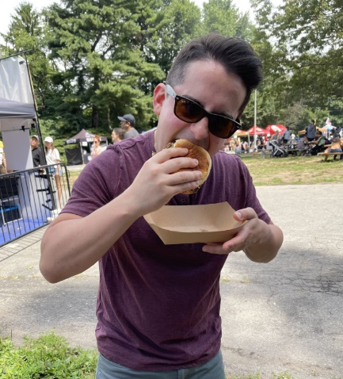
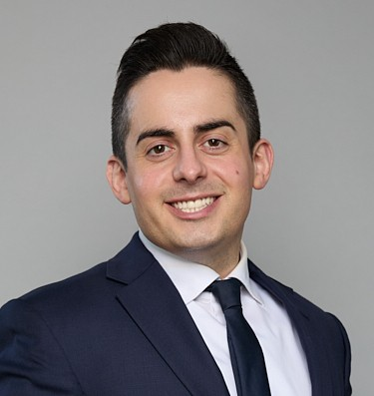
Matthew Antonellis, MD Hometown: Stoneham, Massachusetts
Undergrad: Salem State University, Salem, MA
Medical School: SUNY Downstate College of Medicine
Favorite Case: IPP
Extracurricular Interests: Weightlifting, cycling, bouldering, exploring New York City’s amazing food and wine scene, reading, and relaxing with video games and movies.

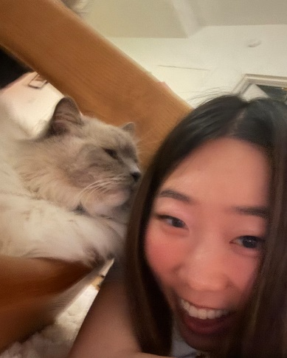
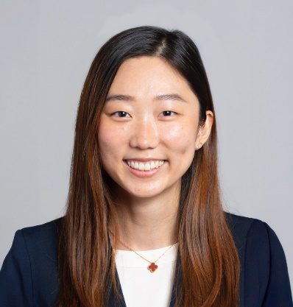
Esther Kim, MD
Hometown: Queens, NY

Nickname: dur

Undergrad: Carnegie Mellon University

Medical School: Icahn School of Medicine at Mount Sinai

Fav Cases: hydrocelectomy, IPP (plus if it’s with Dr. Maria), ureteral reimplant
Extracurricular Activities: documentaries, board games, traveling (my fav spots: Hawaii, Korea, Switzerland, Costa Rica), trying to get glass skin with Korean skincare, trying new restaurants and cafes (I love noodles, Sichuan food, and hot pot!!!), cooking (Korean and Japanese foods), music festivals, yoga

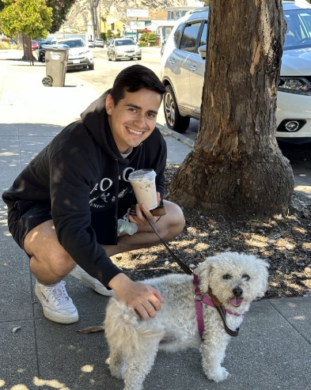
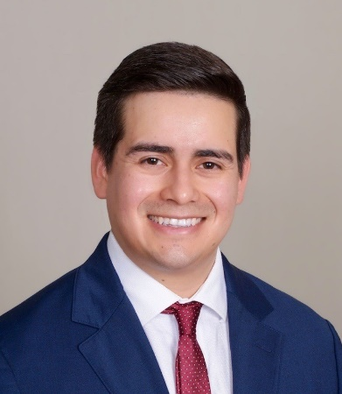

Luis Santos Molina MD
Hometown: Arlington, VA

Nickname: Lulu

Undergrad: Florida State University - Tallahassee, FL

Medical School: Keck School of Medicine of USC

Favorite case: Radical cystectomy with neobladder, IPP
Extracurricular interests: Playing and watching soccer (big Barcelona fan), trying new cuisines and restaurants, cooking, working out, and spending time outdoors

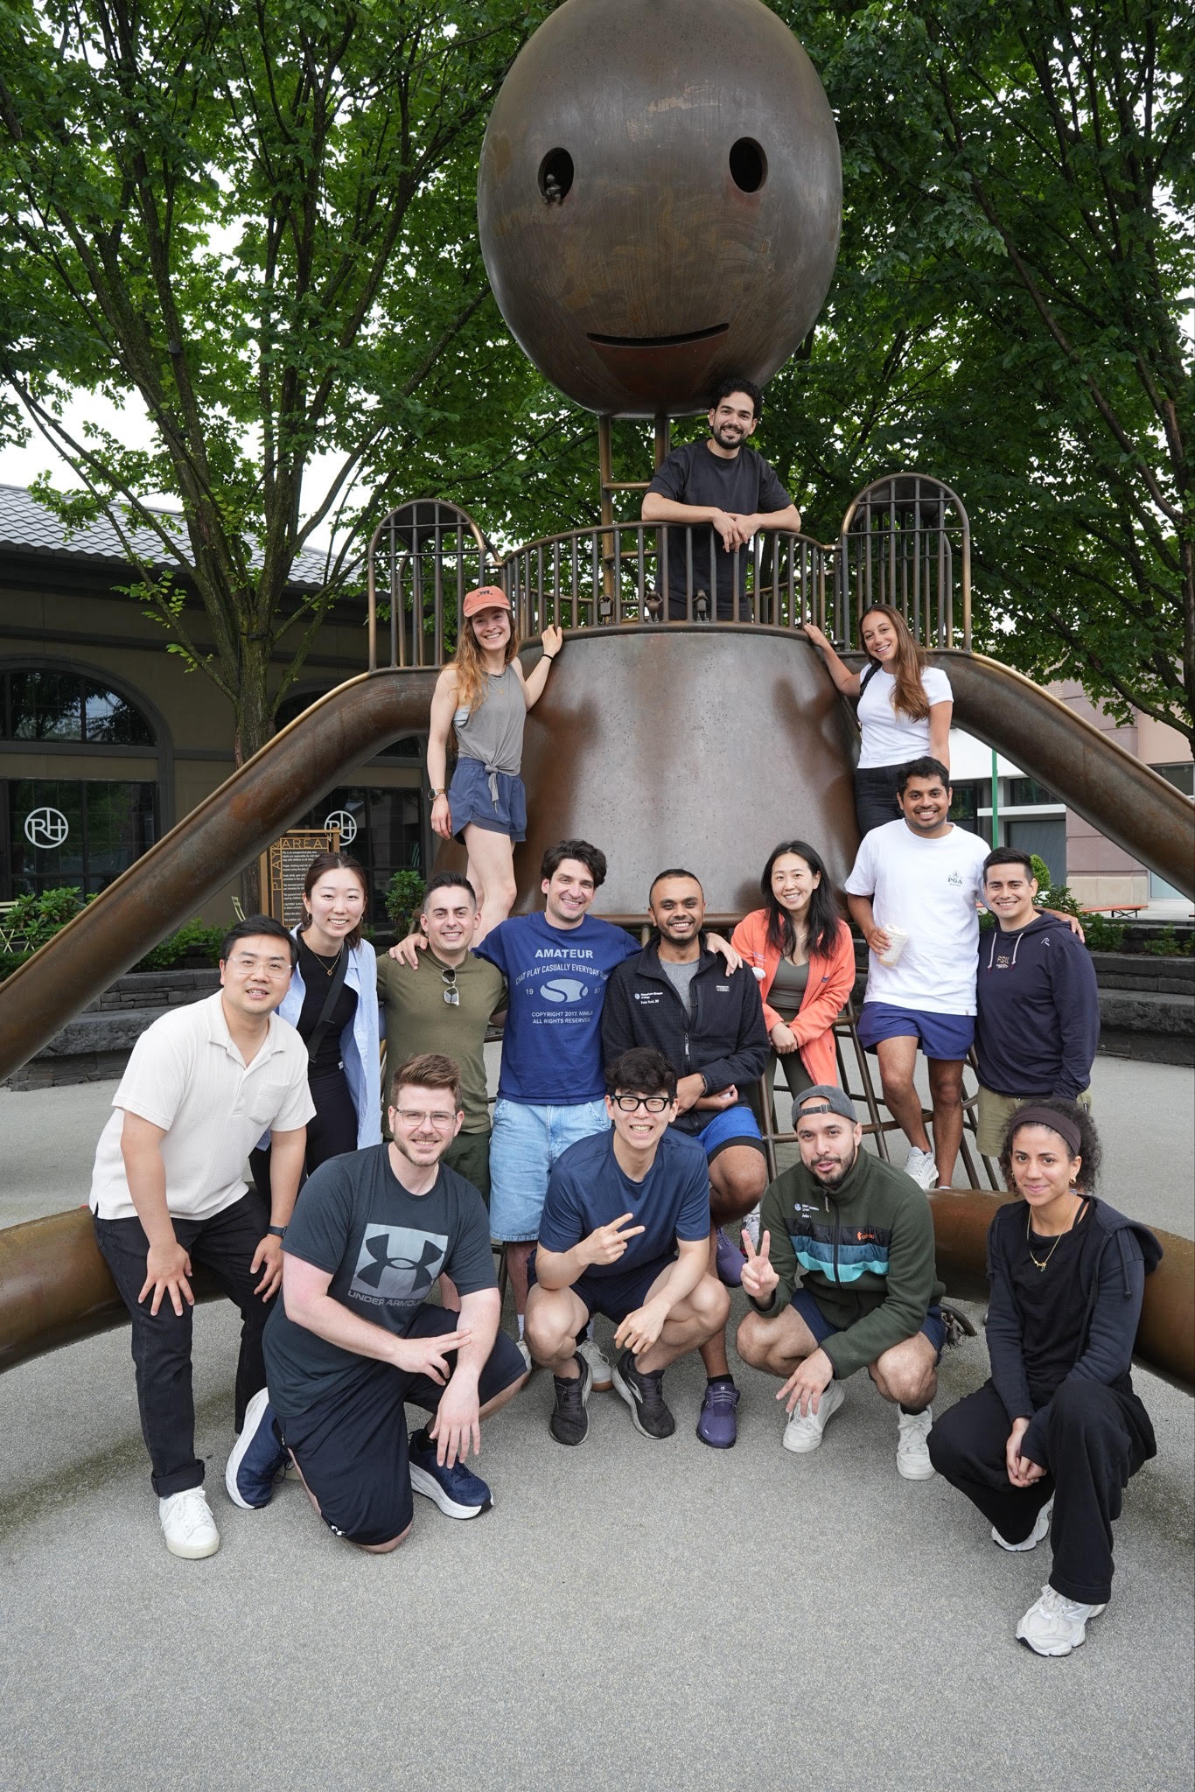
Recent Program Graduates

2026

Ari Allen – URPS Fellowship at Montefiore

Dimindra Karki – Private Practice

Farzaan Kassam – Reconstructive Urology at Cleveland Clinic

2025

Priya Dave –Oncology Fellowship at Cornell

Justin Loloi –Male Reproductive Medicine at Stony Brook

2024
Jennifer Nauheim –Faculty in General Urology at NYU
Jubin Matloubieh –Reconstructive Urology at Columbia

2023
Kavita Gupta – Endourology Fellowship at Mt Sinai Daniel Illinsky – Private practice California

2022
Jonathan Davila – The Independent Clinical Fellowship in Men’s Health & Andrology North Shore University Hospital & Long Island Jewish Medical Ctr
Josh Gottlieb – Saint John's Cancer Institute, Santa Monica, California

2021
Ethan Fram – Private practice, Oregon Evan Shreck – Private practice, Connecticut

2020
Meenakshi Davuluri –Urologic Health Outcomes & Research Fellowship, NYP Cornell
- Faculty at NYP Cornell
Richard Maiman – Private Practice, Long Island, NY

2019
Laura Douglass – Reconstructive Urology Fellowship, Temple University
- Faculty at Temple University, Philadelphia, PA
Tian Zhou – Private Practice, Advanced Urology Rockland County, NY

2018
Abhishek Srivastata – Urologic Oncology Fellowship, Fox Chase Cancer Center
- Private Practice, Atlantic Urology Clinics, Myrtle Beach, South Carolina Saman Moazami – Private Practice, Garden State Urology, NJ

2017
Aryeh Keehn – Minimally Invasive Urology fellowship, Temple University Hospital.
- Now in Private Practice at New Jersey Urology

Where should I Live?!?!
Your two main options are to live in Manhattan or the Bronx; however, we have had residents live in Queens and New Jersey also. Here’s a breakdown.
Manhattan

  - The two most popular neighborhoods that residents live in are the Upper East Side (UES) and Upper West side (UWS)
  - However, there are many other neighborhoods that offer a different feel and require a longer commute
  - PROS:
    - Both are quick, easy drives to work (15-20 minutes in morning) but can hit traffic on the way home, especially when driving back home in the morning after overnight shifts
    - Both are easily accessible by subway, about a 40+ minute subway ride to work
    - Living the city life! Great location for food, bars, culture, and entertainment
    - Great outdoor spaces including Central Park and running/bike paths on both the East Side River and Hudson River
  - CONS:
    - Price $$$- expect a 1 bedroom in both UES and UWS to run you about
$3000+/month
      - Cheaper neighborhoods to consider are Harlem and Morningside Heights
    - Parking- street parking is doable depending on exact location but may require you driving around looking for a spot, garages will cost
$300+/month

The Bronx

  - Two main options are resident housing and to find a place on your own
  - Riverdale is a popular neighborhood and is family friendly, expect to pay more for rent here
  - Resident housing locations are across the street from Moses Campus (Wayne Avenue) and Riverdale (Waldo Avenue)
  - PROS:
    - Convenience- walk across the street to work!
    - Price- very affordable: Studio around $800, 1 bedroom is about
$1000/month at Wayne Avenue and $1300 at Waldo Avenue
    - Camaraderie- a lot of other residents live in the housing
    - Bronx Botanical Gardens, Bronx Zoo, Van Cortlandt Park, Arthur Avenue, Yankee stadium
  - CONS:
    - It’s not Manhattan
    - Not convenient for fun nights in the city, going out drinking, etc.
    - Have to drive to most places (restaurants, grocery stores, shopping, etc.

BOTTOM LINE: Ultimately, it’s about cost and location- what you can afford and where you want to live. As a compromise, many of us have lived both in the city and in housing to get the best of both worlds.

Things to Do in New York City – The greatest City in the World

Bronx


- Yankees!!
  - Home of one of the best baseball teams in the
country, find yourself cheering on the yanks
any evening. Not a Yankee fan? That’s okay,
you can still go to the stadium and root for the opposing team (although we don’t recommend it).
- Botanical Gardens
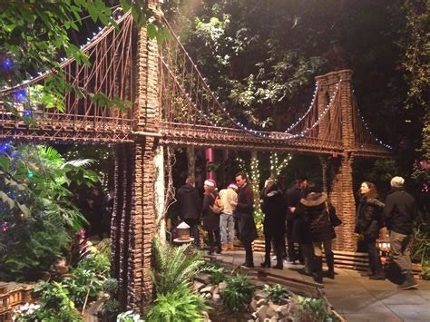
  - Beautiful all year around
with much greenery and
activities. The Winter
Train show is a must go
showing wintry
landscape of NYBG sets the
scene for festive outdoor
adventures, with an after-
dark viewing of
the Holiday Train Show
- Bronx Zoo
  - The animals at the Bronx Zoo represent species from all over the world. This summer, experience the music, food, dance, and culture of those places without leaving the Bronx Zoo. From the jungles of Asia to the heart of Latin America, we'll take you on a trip around the world.

- Arthur Avenue
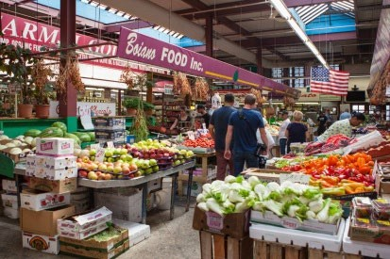
  - The actual original little of NYC, just minutes away from our hospital, you can get the best Italian food, fresh Italian groceries, and wine that this city has to offer



ALL BOROUGHS
    - Madison Square Garden
      - From Bruce Springstein to Phish to Justin Beiber this venue hosts some of the world’s best events. Of course, it is the home to the New York Knicks and Rangers too
    - Upper East Side/Upper West side
      - Great area of restaurants, bars, comedy clubs, central park access, access to rivers
    - Central Park
      - One of the best parts of living in NYC is having this greenery in the middle of the chaos. Great place to go for a run, bike ride, picnic, enjoy the sun. It is also full of history and new parts of the park can always be discovered
      - In the summers, they feature Shakespeare in the Park which is one of the best experiences and free concerts
    - Shopping
      - Shopping in NYC is second to none. Don’t believe us? Just take a stroll down Madison and 5th Avenues
    - Music
      - There is a ton of live music to be seen in NYC, whether you prefer giant stadium venues, small clubs on the lower east side, warehouses in Brooklyn or multi-day music festival NYC has it all
    - Museums
      - Between The Met, Natural History, MOMA, Guggenheim, The Frick, and the list continues – you will never be able to satiate your desire for culture

    - Foodies
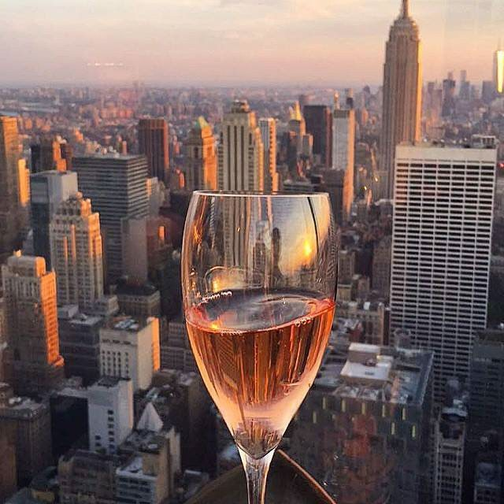
      - The raging food scene in New York can be seen across the Bronx, Queens, Manhattan, Brooklyn
and Staten Island. The best is that you often don’t even need to break the bank to find these amazing places
    - Cocktails
      - New York will revolutionize your cocktail game. From speakeasies, to upscale cocktail bars, to mixeries there is so much to try. Even better when you pair it with a rooftop view.
    - Comedy Clubs
      - It’s easy to stumble into a show and find world class comedians performing including people like Jerry Seinfield. It is known that they are regulars at great comedy clubs like the Comedy Cellar
    - Smorgasboard open air food market in Brooklyn
    - Coney Island
    - New York Sports
      - Between the NY giants, the Mets, Knicks, Rangers, Jets, Nets…you will never have a dull moment.
    - The U.S. Open
      - There is nothing better than seeing world class tennis on a weekend, weeknight, and definitely no better way to spend a post call day

