Montefiore Urology Faculty Profiles

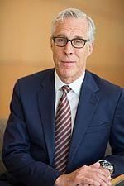
Mark P. Schoenberg, MD
University Professor and Chairman
Training:
Medical School: University of Texas Houston
Residency: University of Pennsylvania
Fellowship: Urologic Oncology, Johns Hopkins
Clinical & Research Focus: Bladder cancer with a particular emphasis on muscle-invasive tumors.

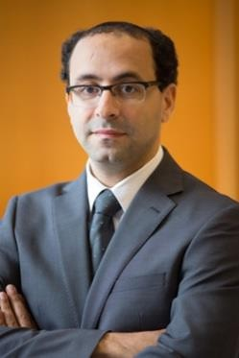
Ahmed A. Aboumohamed, MD
Associate Professor, Attending
Training:
Medical School: Cairo University Residency: Cairo University Hospital Fellowships: Urologic Oncology, Cleveland Clinic. Minimally Invasive Surgery
Montefiore Medical Center: Minimally Invasive Surgery, Wake Forest

Clinical & Research Focus: Urologic Oncology reconstructive urethral surgery; robotics and minimally invasive surgery.

Stanley H. Boczko, MD
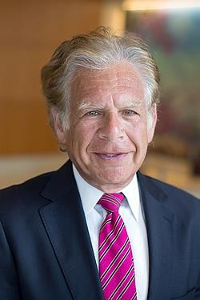
Instructor, Attending
Training:
Medical School: Albert Einstein College of Medicine
Residency: Montefiore Medical Ctr Fellowship: Renal Transplant, American Cancer Society
Clinical Focus: Bladder outlet obstructions.

Melissa A. Laudano, MD
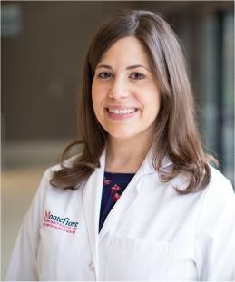
Assistant Professor, Attending
Training:
Medical School: Columbia University
Residency: NY Presbyterian Columbia
Fellowship: FPRMS, Montefiore
Clinical & Research Focus: Urinary incontinence, voiding dysfunction, pelvic organ prolapse, urethral reconstruction; treatment for urinary continence, and utility of urodynamics.

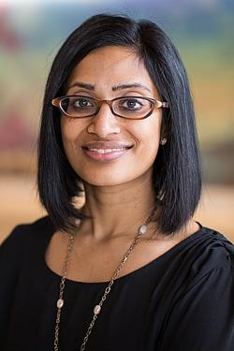
Nitya E. Abraham, MD Associate Professor, Attending,
Training:
Medical School: New York University Residency: New York University Fellowship: FPRMS, Cleveland Clinic
Clinical & Research Focus: Urinary incontinence, voiding dysfunction, pelvic organ prolapse, urethral
reconstruction; patterns and disparities in FPMRS care including opioid use after urogynecologic surgery, variation in treatment for urinary incontinence, and utility of urodynamics.

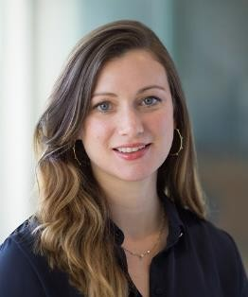
Whitney Clearwater, MD
Associate Professor, Attending

Training:
Medical School: Kansas University Medical Center School of Medicine Residency: Montefiore Medical Center
Fellowship: Montefiore Medical Center
Clinical & Research Focus: Urinary incontinence, pelvic organ prolapse, painful bladder syndrome, mesh complications, fistula; global health, medical education, health disparities and equity.

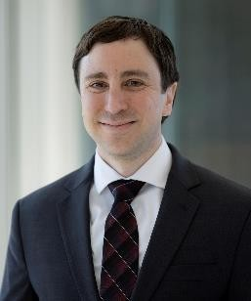
Matthew Danzig, MD
Assistant Professor, Attending
Training:
Medical School: Icahn School of Medicine at Mount Sinai Residency: University of Colorado Fellowship: Medical College of Wisconsin
Clinical & Research Focus: Congenital and functional problems of the genitourinary tract in children of all ages; minimally invasive surgery and genitourinary reconstruction; medical education and surgical training in pediatric urology.

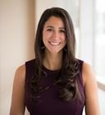
Jillian Donnelly, DO
Assistant Professor, Attending
Training:
Medical School: New York College of Osteopathic Medicine Residency: Cook County Health and Hospital System
Clinical & Research Focus: Stone disease, benign prostatic hypertrophy, urologic oncology, and men’s health

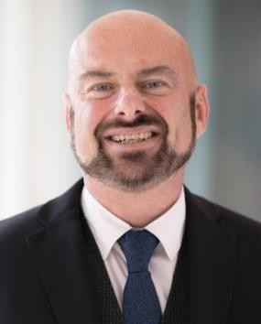
Kelvin P. Davies, PhD
Professor of Urology; Professor of Physiology and Biophysics
Training:
Medical School: University of Zurich, Switzerland (PhD, Biochemistry)
Research Focus: Erectile dysfunction (ED), priapism,
diabetic ED and bladder dysfunction, nerve regeneration following radical prostatectomy or spinal cord injury to improve urogenital function outcomes, nanotechnology to treat urogenital disease, opiorphins role in prostate cancer, kidney stone disease, sperm motility/male infertility, urogenital smooth muscle biology.

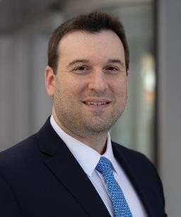
Michael Lipsky, MD
Assistant Professor, Attending

Training:
Medical School: Albert Einstein College of Medicine
Residency: New York-Presbyterian Hospital/Columbia University Medical Center

Clinical & Research Focus: Kidney Stones, Medical and surgical treatments for BPH, vasectomy, general urology.

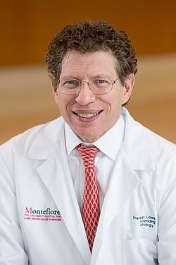
Franklin C. Lowe, MD, MPH University Professor, Director of Urologic Services at Weiler Hospital
Training:
Medical School: Columbia University Residency: Johns Hopkins
Clinical & Research Focus: BPH, Genitalia infections, hormonal therapy of ED; Genital reconstruction, meds for BPH.

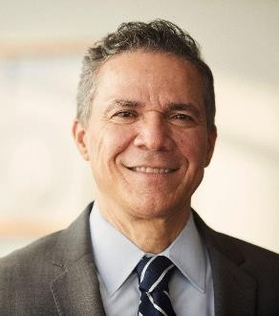
Pedro P. Maria, DO
Associate Professor, Attending

Training:
Medical School: Philadelphia College of Osteopathic Medicine Residency: Albert Einstein Medical Ctr – Philadelphia Fellowship: Minimally Invasive Surgery, Montefiore Medical Ctr

Clinical & Research Focus: Men’s Health sexual dysfunction
and minimally invasive robotic surgery.

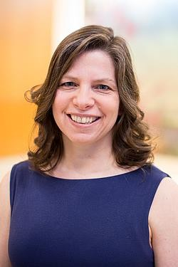
Amanda C. North, MD
Associate Professor, Attending
Training:
Medical School: Albert Einstein College of Medicine
Residency: Montefiore Medical Ctr Fellowship: Pediatric Urology, Johns Hopkins
Clinical & Research Focus: Physician burnout and addressing work force
issues in urology; Prenatal hydronephrosis; general pediatric urology.

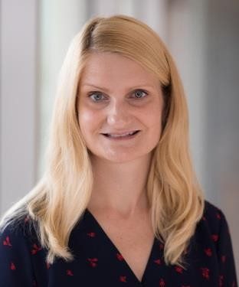
Erin L. Ohmann, MD
Assistant Professor, Attending
Training:
Medical School: University of Pittsburgh School of Medicine Residency: New York University School of Medicine
Clinical & Research Focus: Male voiding dysfunction - BPH, retention, overactive bladder;
open and robotic simple prostatectomy and advanced therapies for OAB (Botox, Interstim, PTNS); non-PCNL stones, stress urinary incontinence and general Urology gamut.

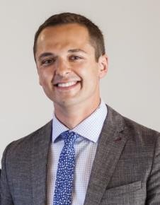
Dima Raskolnikov, MD
Associate Professor, Attending
Training:
Medical School: SUNY Downstate Medical Center
Residency: University of Washington
Clinical & Research Focus: Minimally invasive surgery with a focus on
complex kidney stone disease, robotic urinary tract reconstruction and kidney cancer; quality improvement programs that make urological care more effective and efficient; reducing patients’ exposure to imaging-generated radiation.
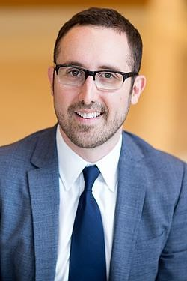
Alexander I. Sankin, MD Associate Professor, Attending, Residency Program Director
Training:
Medical School: New York University Residency: SUNY Downstate Fellowship: Urologic Oncology, Mem Sloan Kettering Cancer Ctr
Clinical & Research Focus: Urologic malignancies, immunotherapy for bladder cancer, advances in treatment of renal cell carcinoma.

Alexander C. Small, MD Assistant Professor, Attending
Associate Program Director
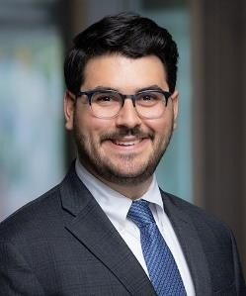
Training:
Medical School: Icahn School of Medicine at Mount Sinai Fellowship: Advanced Minimally Invasive Urology, Mount Sinai
Clinical & Research Focus: Urological diseases, cancer and kidney stones through the use of minimally invasive, robotic and endoscopic surgery.

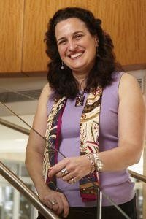
Sylvia O. Suadicani, PhD
Associate Professor of Urology; Assistant Professor of Neurosciences
Training:
Medical School: Universidade de São Paulo
Research Focus: Urogenital Dysfunction in Diabetes, Multiple Sclerosis, Spinal Cord Injury, Estrogen Deficiency, Aging,
Overactive & Underactive Bladder, Female Sexual Dysfunction; Chronic Pelvic Pain; Interstitial Cystitis; Bladder Cancer.
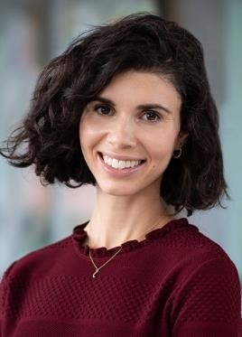
Marissa C. Theofanides, MD Assistant Professor, Attending
Training:
Medical School: Weill Cornell Medical College
Residency: Columbia Presbyterian
Clinical & Research Focus: Minimally invasive treatments for benign prostatic enlargement,
kidney stones, male and female sexual health, no scalpel vasectomy and wide range of general urologic and voiding conditions.

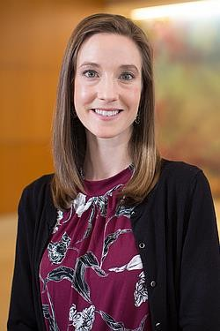
Kara L. Watts, MD
Associate Professor, Attending
Training:
Medical School: University of Connecticut
Residency: Montefiore Medical Ctr Fellowship: Healthcare, Patient and Quality Improvement, Institute for Healthcare Improvement, Albert Einstein College of Medicine
Clinical & Research Focus: Focal ablation of renal and prostate cancer; multi-parametric MRI for prostate cancer.

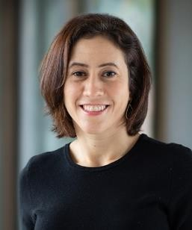
Miriam Harel, MD Assistant Professor, Attending
Training:
Medical School: SUNY Downstate
Residency: SUNY Downstate
Fellowship: Pediatric Urology,
Connecticut Children’s Med Ctr
Clinical & Research Focus: Pediatric urologic care, with a interest in reconstructive surgery, neurogenic and non-neurogenic voiding dysfunction, prenatal PUV

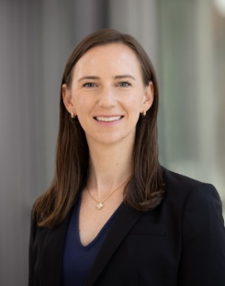
Clare Mallahan, MD Assistant Professor, Attending
Training:
Medical School: Georgetown University School of Medicine
Residency: University of Pennsylvania
Clinical & Research Focus: Male voiding dysfunction - BPH medical and surgical treatments including robotic simple prostatectomy, male overactive bladder, general urology, medical student and resident education

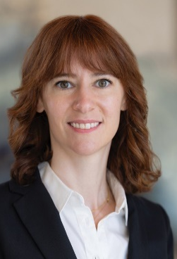
Beth Edelblute, MD
Assistant Professor, Attending
Subinternship Clerkship Director

Training:
Medical School: Columbia University Residency: Mount Sinai
Fellowship: Endourology, Montefiore Medical Center
Clinical & Research Focus: Minimally invasive surgery, PCNL, complex stone surgery, robotic surgery, BPH, resident education

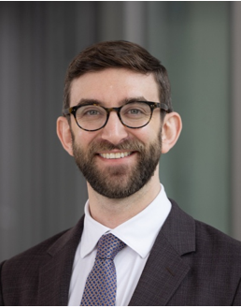
Benjamin Cedars, MD
Assistant Professor, Attending

Training: Medical School: SKMC, Thomas Jefferson University
Residency: UC San Diego
Fellowship: Genitourinary Reconstruction, SUNY Upstate

Clinical & Research Focus: Reconstruction and trauma, urethral stricture, fistula, upper tract robotics, prosthetics, urinary diversion

