PLM Adoption in the Automotive Sector: Processes, Impact, and Future Directions

Shubham Kumar Goswami
(2210992366)
Chitkara University

Arnav Gupta
(2211981092)
Chitkara University

Abstract
Product Lifecycle Management (PLM) is a strategic approach to managing product’s entire lifecycle from initial concept through design, production, services and eventual retirement integrating people processes and technology. In automotive industry, the modern vehicles has many complex interconnections of mechanical, electrical and other software components, managing thousand of parts and their data presents many operational challenges. PLM take care of those challenges by creating a single source of product information enabling seamless cross-functional and ensuring consistency throughout development process

For automotive manufacturers, PLM implementation helps reduce expensive rework cycles and facilitate more informed decision making through real-time, reliable data. It also helps companies to take care of their regulatory requirements, maintaining quality and responding effectively to market demands. This paper examines how PLM is utilized across the automotive industry showing how PLM is implemented and effects the development timelines, cost efficiency and product quality with revenue. Research approach – industry reports and real-world company case studies – the finding will tell the PLM adoption provides significant improvements in performance, collaboration and technological advancements

1. Introduction.
Automotive Industry has seen a great structural shift over decades, shaped by technological breakthroughs, rising consumer demands and increasing competition in market. Where vehicles were once a mechanical artifact, they evolved into integrated platforms combining mechanics, electronics and real time software systems

As its core, PLM is strategic approach to consolidate all products related knowledge – design, engineering specifications, manufacturing instructions, and maintenance records – within a single, dynamically updating environment. Rather than maintaining disconnected databases across departments, PLM creates a shared digital workspace that eliminates redundant data, preventing version conflicts and closes communication gaps between departments that increases the productivity of the employees in different departments.

Among PLM’s most recognized strengths is its capacity to unite engineering teams worldwide around single source of truth. As automotive development is introduced to multiple nations, the ability to synchronize information in real time becomes impossible at first look. PLM platforms facilitate this by ensuring that every contributor, regardless of location, operates from consistent, up-to-date data – reducing manual error and cross regional coordination.

PLM also strengthens the quality of products and other technical decisions. Engineers and program managers can leverage real-time product analytics to detect anomalies early, anticipate risks before materializing and refine strategies without waiting for physical prototypes. We will Primarily work on Teamcenter as our PLM tool.

2. Objectives
Aim of this research is to exam how PLM is implemented in automotive organizations and how it affects the product and product lifecycles. As vehicle Architectures grow increasingly complicated, the value of well implemented PLM systems becomes even more important.
The study is guided by following objectives
- To examine the typical approaches and frameworks used when integrating PLM into automotive organizations
- To investigate how PLM adoption influences product development velocity and inter-departmental collaboration
- To evaluate the tangible advantages as well as the organizational difficulties that accompany PLM rollouts
- To determine how PLM contributes to leaner cost structures, higher quality outcomes, and improved operational throughput
- To assess the potential role of PLM in supporting next-generation automotive technologies such as electrification and autonomous driving

3. Methodology

This investigation adopts a secondary research design, synthesizing existing knowledge from a range of established sources: peer-reviewed academic journals, technical white papers, analyst reports from automotive consultancies, and documented case studies from major vehicle manufacturers. Source selection prioritized credibility, recency, and direct applicability to the research questions.

An extensive literature review was undertaken to map the conceptual landscape of PLM and trace its evolution within the automotive context. By examining multiple independent studies, common themes, recurring benefits, and persistent implementation challenges were identified and cross-validated. Real-world deployment experiences at organizations such as BMW Group, Tesla, and Ford Motor Company were analyzed to ground the theoretical findings in practical evidence.

To interpret the gathered data, a comparative analytical approach was employed, contrasting key performance indicators — including product development timelines, unit cost trajectories, and quality defect rates — both prior to and following PLM implementation. Graphical tools were utilized to present these performance shifts in a clear and accessible format.

4. Results and Findings

The evidence gathered through this study consistently points to substantial performance gains following PLM adoption across automotive firms. The availability of a centralized data management infrastructure proved instrumental in elevating operational productivity, curtailing process inefficiencies, and strengthening collaboration across engineering and manufacturing divisions.

Graphical Analysis – Automotive Industry: Before and After PLM

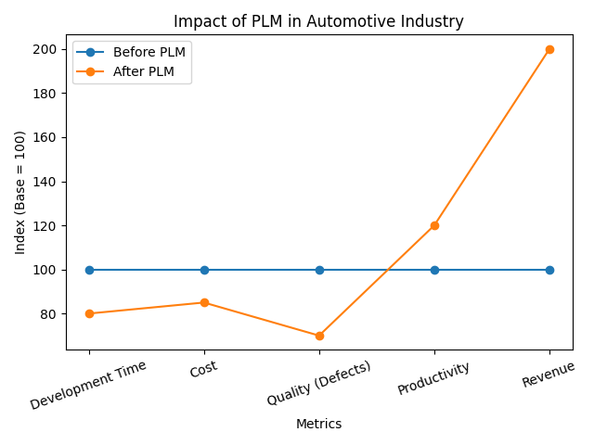
Fig 1. Automotive Industry Before and After Implementing PLM

Key Observations
Analysis of the graphical data reveals a reduction of roughly 20% in product development timelines post-PLM deployment. This compression is primarily attributable to enhanced parallelization of engineering tasks and the ability of distributed teams to work concurrently on shared, live data rather than waiting for sequential information handoffs.

Financial performance also showed meaningful improvement. Total development and production costs declined by approximately 15%, driven by reduced engineering rework, more accurate digital prototyping, and optimized allocation of both human and material resources throughout the product lifecycle.

5. Case Studies
5.1 BMW Group

BMW Group stands as a prominent example of PLM-driven manufacturing transformation. The company has integrated enterprise-grade tools including Teamcenter and Tecnomatix to construct a fully digital manufacturing ecosystem. Virtual simulation environments allow BMW to model, validate, and refine production processes before any physical investment is committed.
The outcomes of this approach have been substantial: production planning cycles have shortened meaningfully, and the company’s ability to manage multinational manufacturing networks has improved. These efficiencies have translated into measurable reductions in operating costs and a faster cadence for bringing new models to market.

5.2 Tesla

Tesla’s application of PLM principles reflects a distinctly forward-looking philosophy. Rather than confining lifecycle management to the development phase, Tesla has built a tightly coupled digital architecture that spans design, engineering, production, and active vehicle use. This interconnected system enables rapid iteration and continuous product refinement at a pace that is unusual in traditional automotive development.

A particularly innovative dimension of Tesla’s model is the deployment of over-the-air (OTA) software updates, which effectively extend the concept of lifecycle management into the ownership experience. This capability allows Tesla to enhance vehicle performance, add features, and resolve software issues remotely, transforming PLM from a factory-oriented tool into a customer-facing value proposition.

5.3 Ford Motor Company

Ford has leveraged PLM to tackle the dual challenge of managing complex, high-variation product portfolios while maintaining consistency across a globally dispersed engineering workforce. By establishing a unified data environment, the company ensures that every team — from design studios to assembly plants — is operating from verified, current information.

The results have been evident across multiple dimensions: engineering error rates have declined, product quality has risen, and development model programs have progressed more efficiently. PLM has also enabled Ford to manage vehicle variants and derivatives more effectively, a critical capability in a marketplace that demands extensive customization.

6. Discussion
Taken together, the findings of this research underscore the far-reaching impact that PLM can exert on automotive enterprises. The ability to centralize product knowledge and facilitate seamless information exchange positions PLM as a foundational capability for organizations seeking to thrive in an era of increasing complexity and market volatility.

Real-time data access emerged as one of the most consistently cited benefits, as it both accelerates decision cycles and substantially reduces the likelihood of error propagation across development stages. The enforcement of data consistency further reinforces quality by ensuring that design intent is faithfully preserved as information flows through the organization.
Nevertheless, PLM adoption is not without its difficulties. Upfront capital requirements can be considerable, and many organizations underestimate the organizational change management effort required to achieve meaningful adoption. Integrating PLM with legacy enterprise systems — such as ERP and MES platforms — often introduces additional technical complexity. Even so, the cumulative long-term returns documented across the case studies surveyed in this research suggest that these initial hurdles represent worthwhile investments for manufacturers committed to sustained competitiveness.

7. Conclusion
This study affirms that the strategic integration of PLM represents a pivotal advancement for automotive manufacturers navigating the demands of modern product development. By consolidating product data management under a single framework, PLM drives measurable improvements across collaboration, cost control, and quality assurance — three dimensions that are central to automotive competitiveness.

Organizations that embrace PLM are demonstrably better positioned to navigate the complexities inherent in contemporary vehicle development programs and to respond to the accelerating pace of industry transformation. As the automotive sector continues to evolve — driven by electrification, connectivity, and automation — PLM’s role as an enabling infrastructure is likely to grow in both scope and strategic importance.

8. Future Scope
Looking ahead, the trajectory of PLM in the automotive industry is increasingly intertwined with a cluster of transformative technologies: Artificial Intelligence (AI), Digital Twin simulation, and the Internet of Things (IoT). Each of these innovations holds the potential to augment PLM capabilities in distinct and complementary ways, making lifecycle management more predictive, autonomous, and customer-integrated.

AI-powered analytics can process vast engineering datasets to surface hidden patterns, forecast potential failures before they occur, and recommend design optimizations with minimal human intervention. Digital Twin technology extends this further by enabling the construction of high-fidelity virtual replicas of physical products, allowing teams to run sophisticated performance simulations in real time — without the cost and delay of physical testing.

IoT connectivity adds yet another dimension by enabling continuous telemetry from deployed vehicles, feeding operational data back into PLM systems to inform iterative design improvements and predictive maintenance strategies. As these technologies converge, PLM platforms are expected to become significantly more intelligent, adaptive, and scalable — empowering automakers to innovate at greater speed and deliver more personalized, higher-quality products to a rapidly changing global customer base.

Evaluation Work
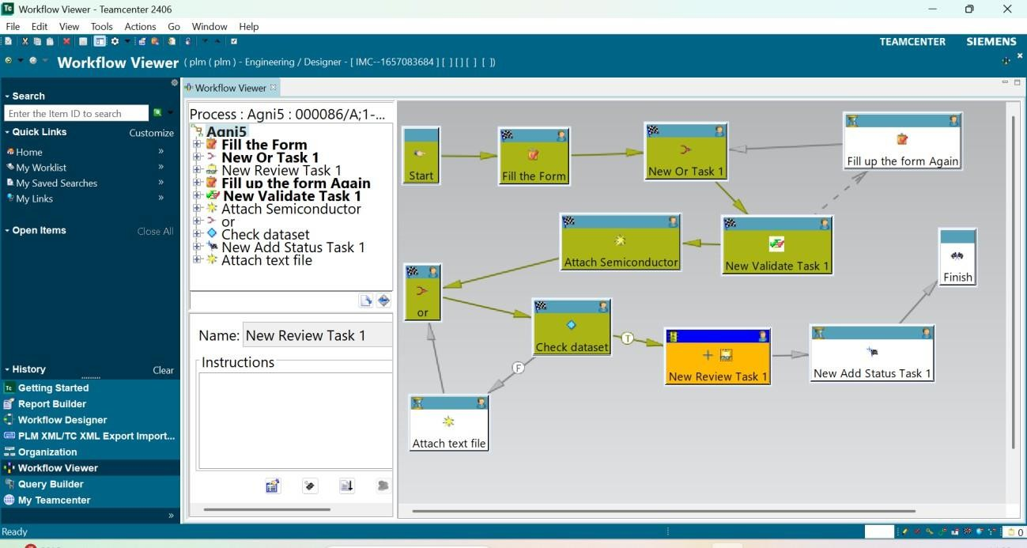

Fig 2. Assigning Workflow to the Item

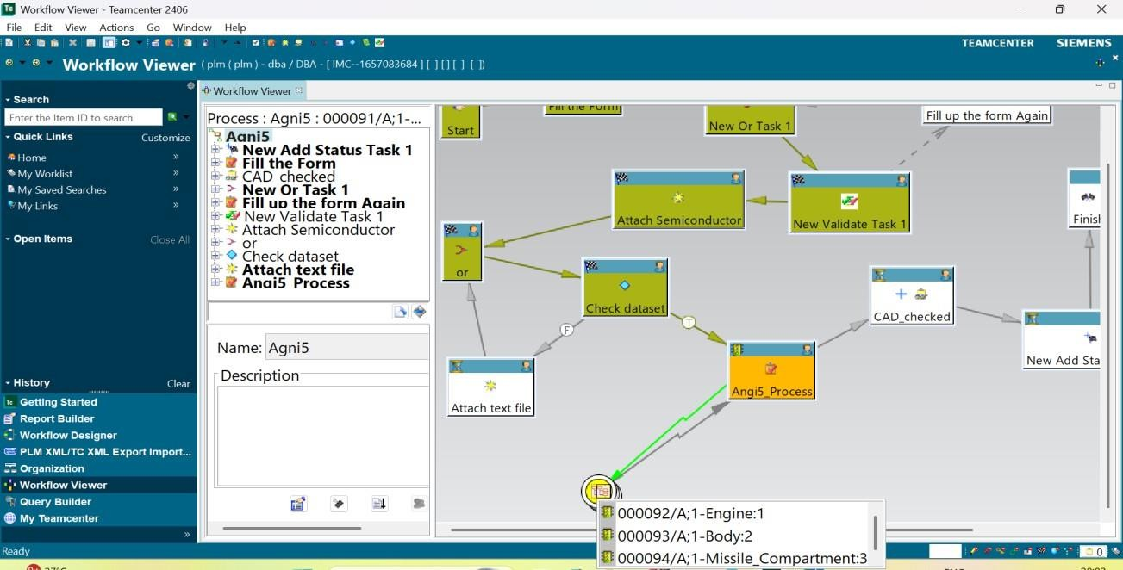
Fig 3. Adding Subprocess to the Workflow

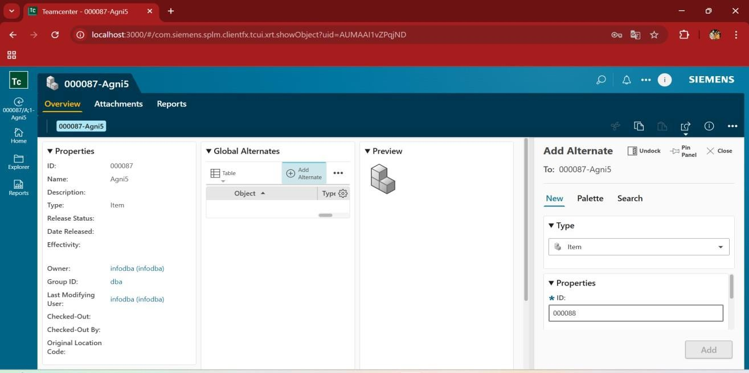

Fig 4. Creating Item Named Agni and Adding Alternates

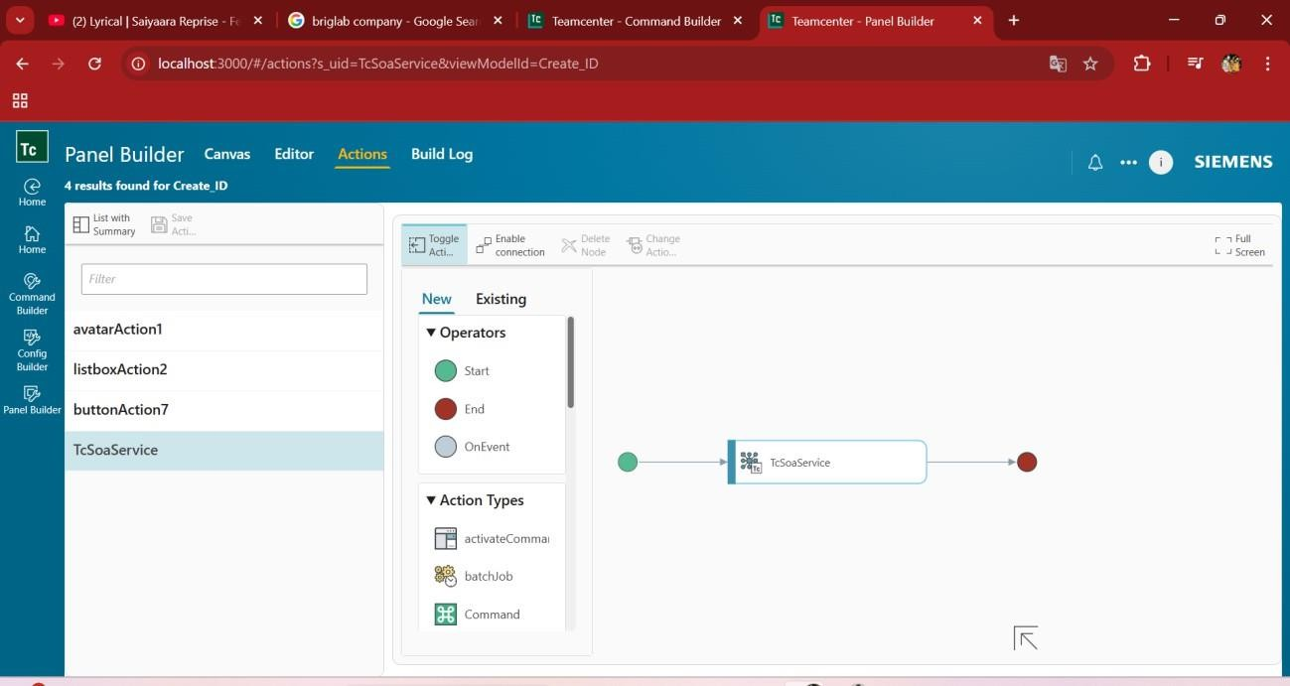

Fig 5. Adding TcSOA Services Through Panel Builder

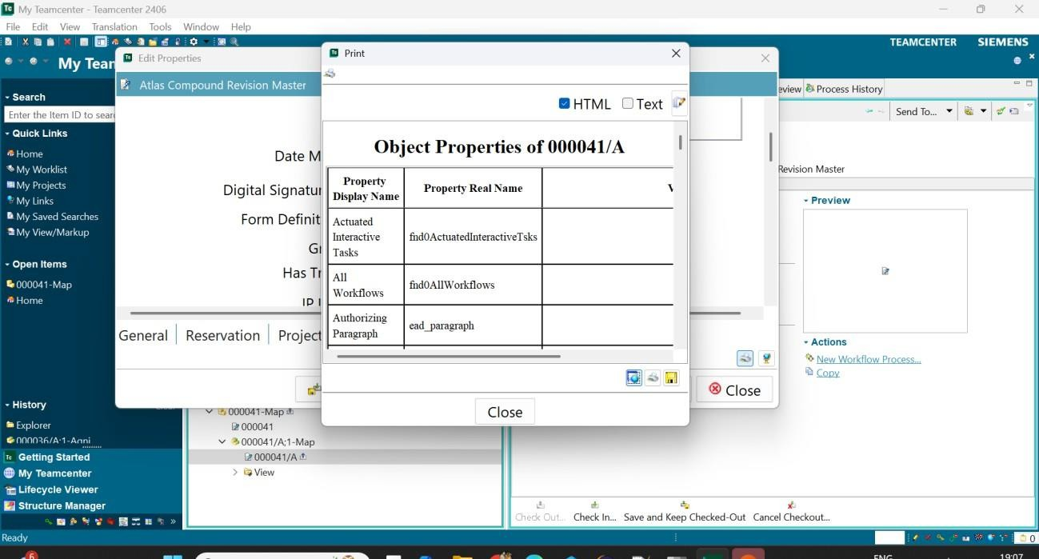

Fig 6. Retrieving Information Through Report Builder

