Software Requirements Specification

for

InSemi TimeSheet

Prepared by Arnav Sampigethaya

InSemi Technology

16.04.2020

Table of Contents

Contents

1. Introduction 1

1.1 Purpose 1

1.2 Project Scope 1

2. Overall Description 2

2.1 Product Features 2

2.2 User Classes and Characteristics 2

2.3 Operating Environment 2

3. System Features 3

3.1 Login Service 3

3.1.1 Description and Priority 3

3.1.2 Stimulus/Response Sequences 3

3.1.3 Functional Requirements 3

3.2 TimeSheet – Employee Level 3

3.2.1 Description and Priority 3

3.2.2 Stimulus/Response Sequences 3

3.2.3 Functional Requirements 3

3.3 TimeSheet – Supervisor Level 4

3.3.1 Description and Priority 4

3.3.2 Stimulus/Response Sequences 4

3.3.3 Functional Requirements 4

3.4 TimeSheet – Admin Level 4

3.4.1 Description and Priority 4

3.4.2 Stimulus/Response Sequences 4

3.4.3 Functional Requirements 4

Revision History

|  |  |  |  |
| --- | --- | --- | --- |
| **Name** | **Date** | **Reason For Changes** | **Version** |
| SRS1_Arnav | 16/04/20 | N/A | 1.0 |
|  |  |  |  |

# Introduction

## Purpose

The purpose of this program is to create a tool for employees to maintain their office timesheet, and for employers to check attendance and maintain employee records.

## Project Scope

The program can be used on the desktop internally in the company and can be scaled for larger entities as well.

# Overall Description

## Product Features

## 

TIMESHEET

- Calendar based TimeSheet

- Using .xlsx files

- Python – Pandas, Seaborn and Kivy libraries mainly to be used.

- Checkbox style attendance marking

- Dropdown list style leave marking

## User Classes and Characteristics

## Operating Environment

It can operate across all platforms using Kivy library of Python.

# System Features

## Login Service

### Description and Priority

Login using predetermined usernames (company e-mail) and password (can be changed by each user).

Priority – MAIN

### Stimulus/Response Sequences

User will need to enter email and password to login.

Optional – Captcha can be added.

### Functional Requirements

REQ-1: Emails must be matched with Database

REQ-2: Passwords must be hidden while typing

REQ-3: User-account type must be determined

## TimeSheet – Employee Level

### Description and Priority

Employee should mark attendance and leaves.

Priority - MAIN

### Stimulus/Response Sequences

User will need to use checkbox based system to mark their attendance on calendar-based timesheet. Or will have to mark leave, if taken.

### Functional Requirements

REQ-1: Calendar based Database using Pandas DF and Excel

REQ-2: Checkbox and Leave Drop-down GUI components

## TimeSheet – Supervisor Level

Mgr1 – emp1, emp2, mgr2

Mgr2 – emp 3

### Description and Priority

Supervisor should be able to see attendance of all employees registered under them.

*Optional – Statistical data can be shown for each employee*

Priority – MAIN

### Stimulus/Response Sequences

Supervisor will be able to choose employee and see attendance data as well as mark their own attendance. Supervisor will also be able to verify and confirm employee attendance as well as edit if required to ensure accuracy of data.

### Functional Requirements

REQ-1: Calendar based Database using Pandas DF and Excel

REQ-2: Checkbox and Leave Drop-down GUI components

REQ-3: Pandas-based Data Analysis

REQ-4: Seaborn based Data Visualisation

REQ-5: Verification system

## TimeSheet – Human Resources Level

[Hr1@insemitech.in](mailto:Hr1@insemitech.in)

[Hr2@insemitech.in](mailto:Hr2@insemitech.in)

## TimeSheet – Admin Level

[Admin1@insemitech.in](mailto:Admin1@insemitech.in)

Admin2

### Description and Priority

Admin should be able to control all aspects of program.

Priority – MAIN

### Stimulus/Response Sequences

#### Add User

* Backup the data
* First Name
* Last Name
* Employee ID
* Email
* Password
* Type of User
* Define the Hierarchy (from XLSX)
* Enable unlock of restricted features
* Backup the data

1. Remove User
   1. Backup the data
   2. Update the hierarchy
   3. Delete the user
   4. Backup the data
2. Edit the User
   1. Backup the data
   2. First Name
   3. Last Name
   4. Employee ID
   5. Email
   6. Password
   7. Type of User
   8. Define the Hierarchy (from XLSX)
   9. Enable unlock of restricted features
   10. Backup the data
3. Employee Database(Hierarchy) Management
4. TimeSheet Database Management
   1. Holiday Management (Disabling timesheets for Non-Working days)

Features of TimeSheet –

1. Calendar (Can View Month, Days)
2. Restriction – Only Last Two Months (for User)
3. View Hierarchically – Reportees
4. Search – Employees(First Name, Last Name, Email, Employee ID) –( Date Range )
   1. Restrictions - Hierarchical
5. Edit
6. Save (locally – Employee, Admin)
7. Submit for Approval
8. Export (.xlsx) – (Date Range)

Implementation –

HR is an employee (separate login)

Person X is HR. Person X will have one HR login and one Employee login.

2 HR Logins will be created.

2 Admin Logins will be created.

Features unique to Admin -

Add/Remove Employees

Edit Hierarchies

Manually edit employee data

Features shared with Supervisor –

Admin will be able to choose employee and see attendance data as well as mark their own attendance. Admin will also be able to verify and confirm employee attendance as well as edit if required to ensure accuracy of data.

### Functional Requirements

REQ-1: Calendar based Database using Pandas DF and Excel

REQ-2: Checkbox and Leave Drop-down GUI components

REQ-3: Pandas-based Data Analysis

REQ-4: Seaborn based Data Visualisation

REQ-5: Verification system

REQ-6 : Manual editing of employee database

REQ-7: Manual editing of hierarchical structures internally

REQ-8: Ability to export Excel-based data

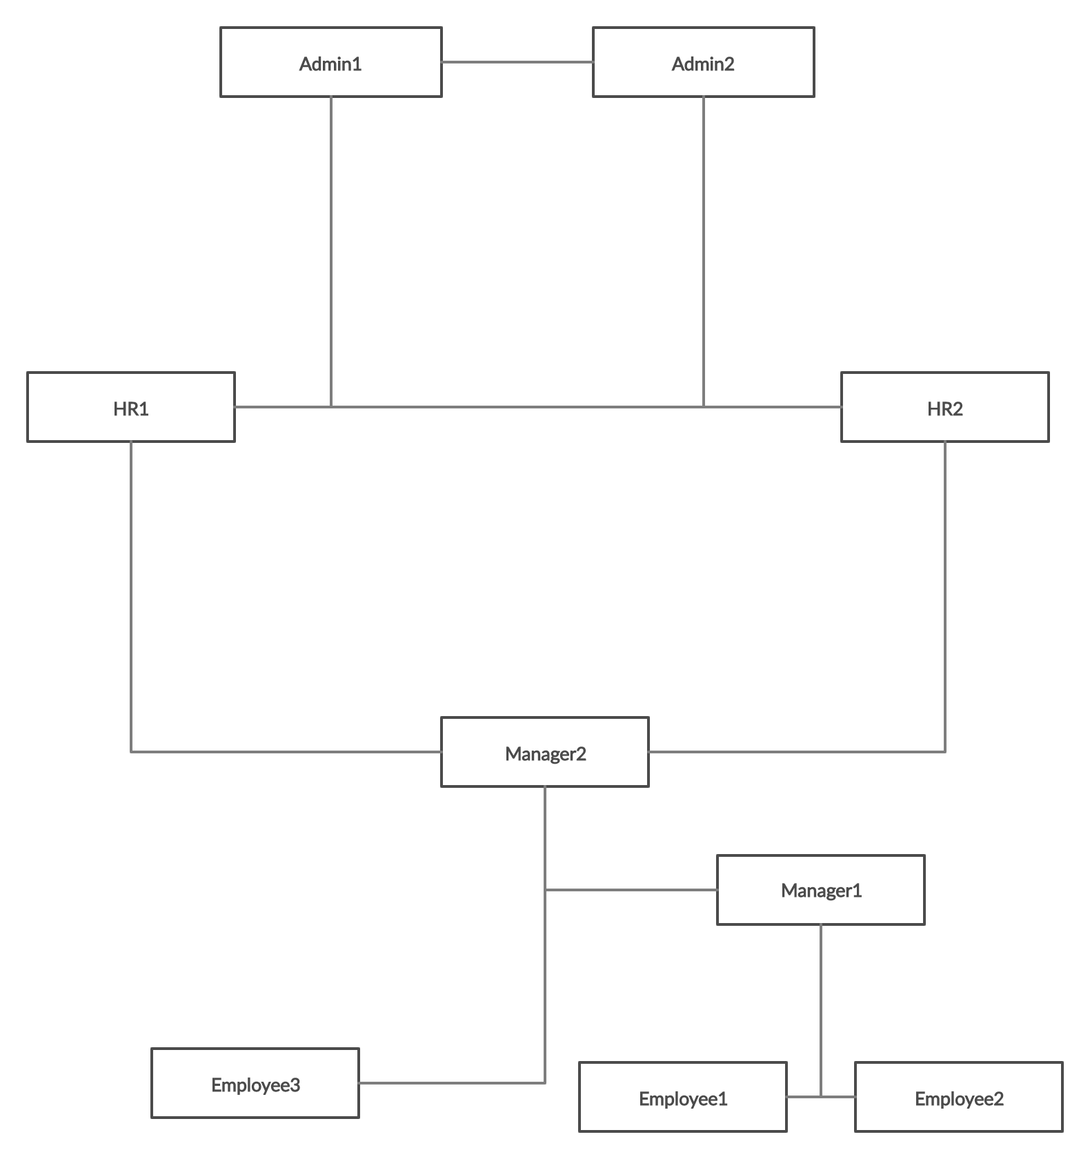



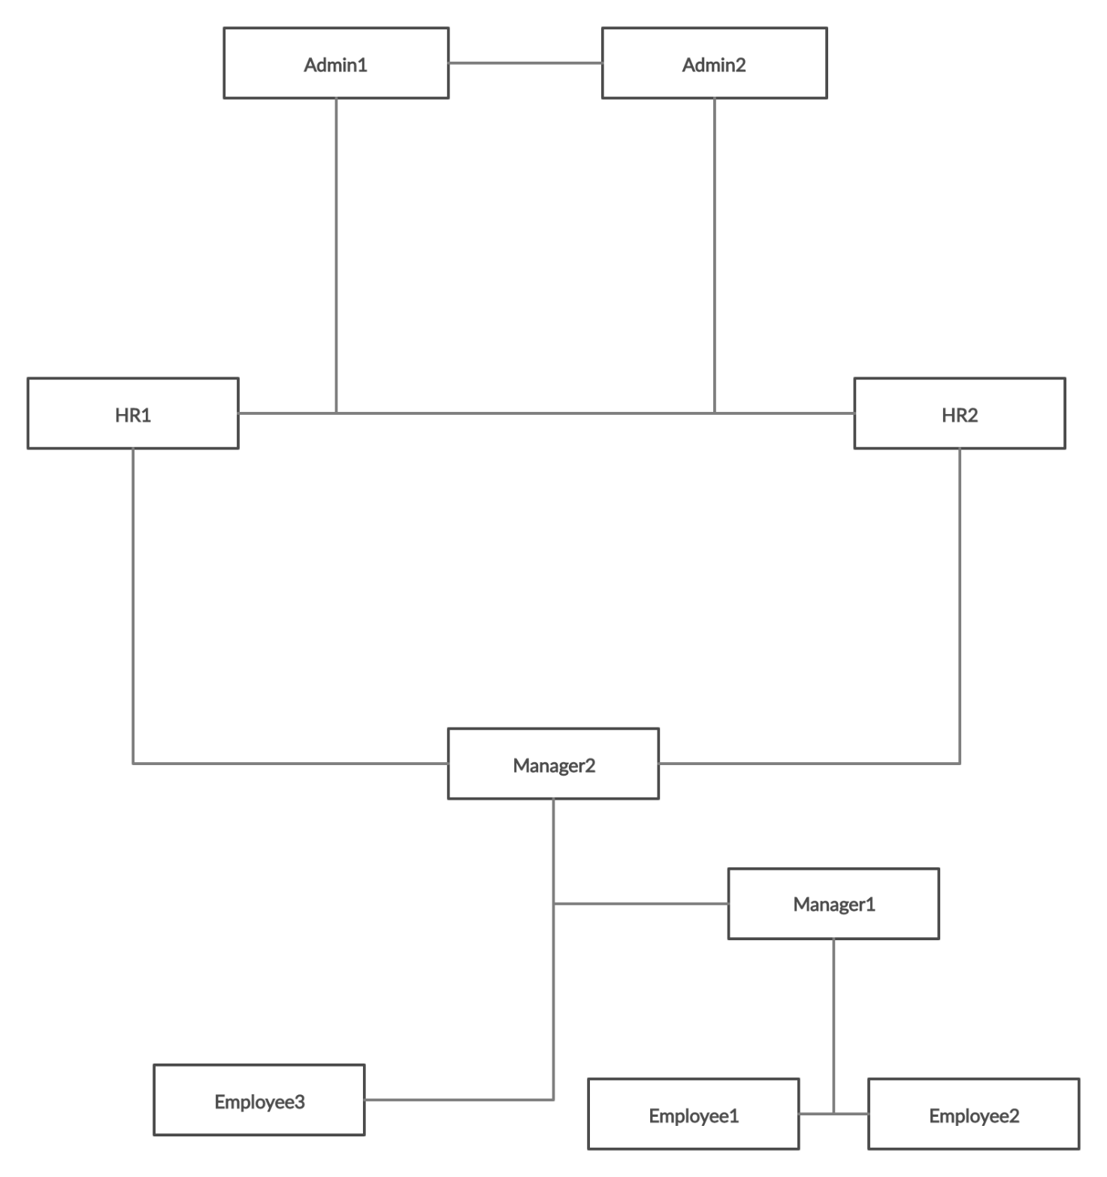

a

