The Duke Depot
CS 347 Revised Site Proposal
Team 3: Aaron Zamecnik, Chris Brinkmann, Charles Humphries, and Michael Smith
10/13/2014

- Overview
We are proposing a web-based e-commerce store. Our store is called The Duke Depot. This store sells JMU memorabilia and apparel (mostly clothing). There is a nationwide market for JMU memorabilia, particularly current, future and past students and their families and our e-commerce store has the potential to serve them all. Users will be able to browse the store’s catalog, add and remove items from their shopping cart easily, make purchases via credit/debit cards and maintain a secure customer profile. This profile contains their payment information, billing and shipping addresses, order history, and personal data. A person is not required to have an account to place an order, but anonymous order information is still saved and can be retrieved.
- Pages and Content
Our site will rely heavily on dynamic content. There will be a sign-in button located at the top of each page that will be displayed if an anonymous user is browsing the catalog or a welcome message, a “View Profile” button, and a shopping cart indicator if they are signed in. The site content will also be dynamic. Each product category page will pull from a table of products that contains a description, title, price, sizing options, and category; each product detail page will also be a template with interchangeable product information fields. This will allow site administrators to add and remove content through a GUI rather than interacting with the database or HTML pages directly, and will reduce the amount of time and resources needed to edit the product manifest. User profile pages will also be dynamically generated with specific profile information. The shopping cart will also be dynamically generated since it can change at any point in time.
Page | Dynamic? | Description
Index.jsp | Yes | Homepage. Will be primary navigation source
CreateAccount.jsp | Yes | Page for unregistered users to create a new account.
PasswordReset.jsp | Yes | A page for resetting the user's password with a security question.
Category.jsp | Yes | A page to display all items that are members of a certain category, i.e. “Men’s Clothing”.
Product.jsp | Yes | Will display individual product details when a user chooses to view an item
Profile.jsp | Yes | Allows user to view & edit personal information . Users can delete their account from this page.
Cart.jsp | Yes | Contains items in the user’s shopping cart; allows them to delete items or checkout
Checkout.jsp | Yes | Processing view for completing transactions
AccountList.jsp | Yes | Allows administrators to view, add and delete accounts. Available only to users with administrator privileges.
EditProduct.jsp | Yes | Allows administrator to edit and add product information to database. Available only to users with administrator privileges.
OrderList.jsp | Yes | Provides information on all open and closed orders. Allows administrator to close and edit orders. Available only to users with administrator privileges.

- Database Tables
There are two categories of database tables that our application requires: Product information and user data. There will be a “Products” table that contains information on individual products such as name, description, category, sizes, price, and an image. There will also be a product category table that contains information about each grouping of products. User information is more complicated, since users can have multiple forms of payment and there are security concerns with storing personal data. There will be a payment information table that will encrypt and contain credit card information. There will also be a username/password table that will encrypt and keep track of a user’s username, password, and security questions. The third profile table will contain other relevant personal information.

Table | Description
Products | Contains information about individual products, including their category, sizing, price, description, and image
Product Category | Contains product categories to allow better display, searching, and organization of products
Users | Contains user’s profile information, such as name, DOB, address, sex, age, link to payment info. Also identifies user as customer or administrator.
Payment Information | Contains payment information, since a user can have multiple methods of payment. Each method of payment is linked to one specific user only. Contains credit card data and billing addresses. Must be encrypted (AES-256).
Shibboleth | Links to one specific user. Maps passwords, secret questions and answers to each user. Must be encrypted (AES-256).

- Use Cases

- Reset Password:
Abstract: A registered user will be able to reset the password to their account by answering security questions which they have previously set.
Precondition: The user has previously registered and knows their account name, and the answer to their account's security question.
Postcondition: The user's account password is reset to a new value. Users and shibboleth databases are updated.
Steps:
  - The user navigates to the password reset page (PasswordReset.jsp), by clicking a link from the main page (index.jsp).
  - PasswordReset.jsp displays a field for entering the account name.
  - The user enters the account name that they want to reset the password for.
  - The security question set up for that account is displayed, and the user must type the correct answer into the field.
  - PasswordReset.jsp displays a field for entering the new desired password.
  - The user enters their new desired password, and clicks a submit button, causing the password to be reset to the new value.
Alternatives:
cc1. The user enters an account name that does not match any in the database. Return to step b.
dd1. The user enters an incorrect answer to the security question. Repeat step d.
- Delete Account:
Abstract: A registered user or administrator will be able to remove their account (or another's account if the user is an administrator) from the system.
Precondition: The user is registered and logged in to their account
Postcondition: A user's account is removed from the Users, Payment Info, and Shibboleth databases.

Steps:
  - The user clicks on the Profile link (profile.jsp) from the main page (index.jsp).
  - The user clicks on the Delete Account link on their profile page.
  - The page displays a message prompting the user to confirm or cancel their action.
  - The user confirms, and they are returned to index.jsp, logged out, and their account is deleted from the user databases.
Alternatives:
aa1. The user is an administrator and is deleting another user's account.
aa2. The user clicks on the UserList (userList.jsp) link from the main page (index.jsp).
aa3. The user locates the account to be deleted and clicks on the Delete Account link.
aa4. The account is removed from all user Database's and the user remains on UserList.jsp.
- Change Account Information:
Abstract: A registered user will be able to change any profile information.
Precondition: The user is registered and logged in to their account
Postcondition: Some of the user's profile information has been changed
Steps:
  - The user clicks on the Profile link (profile.jsp) from the main page (index.jsp).
  - The user clicks on any of the edit links for payment information, billing and shipping addresses, personal information (name, age, gender).
  - The is presented with a blank text field to enter the appropriate information.
  - The user clicks a submit field and the information is updated in the User databases and displayed in the profile page.
Alternatives:

- View Account List:
Abstract: An administrator will be able to view the list of accounts registered to Duke Depot.
Precondition: The user is logged in to an administrator account.
Postcondition: The user can view a list of all registered accounts.
Steps:
  - The user clicks on the AccountList link (accountList.jsp) from the main page (index.jsp).
  - The user is taken to the account list page and can view all registered accounts.
Alternatives:
aa1. The user is not logged in or is not an administrator. In this case clicking the AccountList link will redirect back to the homepage (index.jsp).
- Browse Products:
Abstract: Any site visitor will be able to view the product catalog.
Precondition: The user has a working internet connection and web browser.
Postcondition:The user can browse available products on the Duke Depot website.
Steps:
  - The user navigates to www.DukeDepot.com on their web browser.
  - The user clicks on the products link (products.jsp).
  - The available products are displayed for the user to browse on products.jsp.
Alternatives:
- Place Order:
Abstract: Any site visitor will be able to place an order.
Precondition: The user has a working internet connection, web browser, and valid credit card information.
Postcondition: The user place's an order on the site, and the databases reflect that the user's are to be charged, and shipped the items that they ordered.
Steps:
  - The user navigates to www.DukeDepot.com on their web browser.
  - The user clicks on the link for the category they want to shop in (i.e. men's clothes, women's clothes, accessories, etc.) (category.jsp).
  - The user clicks on a specific product that they want to buy.(product.jsp)
  - The user selects any options available (size, color)
  - The user clicks "Add to Cart" button.
  - The user clicks on the "Checkout" link (checkout.jsp)
  - The user enters their shipping, billing, and credit card information.
  - The user clicks on the submit order button.
  - The databases are updated with the users orders.
Alternatives:
gg1. The user has a registered account and is logged in. They can select their saved shipping, billing, and credit card information from a drop down menu rather than re entering it.
gh1: The user enters invalid credit card information (incorrect number of characters [actual account information will not be validated until later]).
gh2: They are redirected to checkout.jsp.
- Create Account:
Abstract: Anonymous visitors will be able to create an account.
Precondition: The user has navigated to the main page of our website (www.DukeDepot.com).
Postcondition: The user has created an account that is recorded in our User database.
Steps:
  - The user clicks on the Create Account link (CreateAccount.jsp)
  - The user is taken to CreateAccount.jsp where they are presented with fields for account name, password, secret question, and answer to secret question.
  - The user fills in all of the necessary fields and clicks the submit button.
  - The account is created in the database and can be logged into using the credentials provided in step b.
Alternatives:
- View Account:
Abstract: Users can view their account information: name, age, gender, billing, shipping, and payment information.
Precondition: The user is registered and logged in to their account.
Postcondition: The user is able to see their account information.
Steps:
  - The user clicks on the Profile link (Profile.jsp) from the main page (index.jsp).
  - The user can see their profile information.
Alternatives:
aa1. The user is not logged in when they click on the Profile link.
aa2. The user is redirected back to index.jsp
- Add/Remove Content:
Abstract: Administrators will be able to add new product categories and products without having to edit raw HTML or interact directly with the database.
Precondition: The user is logged in to a registered administrator account.
Postcondition: The user has edited the content by adding, removing, or changing certain objects contained in the database.
Steps:
  - The user clicks on the Edit Products link (EditProducts.jsp) from the main page (index.jsp).
  - The user can edit any text field that describes any product. They can click on a link to remove a product from display and from the database.
  - The user can click on an Add link which will create a new set of fields to describe a new product which they can fill in (name, price, sizes, picture [jpeg], description, category)
Alternatives:
- View Orders:
Abstract: An administrator is able to view a list of all current and past orders contained in the order database.
Precondition: The user is logged in to a registered administrator account.
Postcondition: The administrator can see a list of the orders.
Steps:
  - The user clicks on the View Orders link (orderList.jsp) from the main page (index.jsp)
  - The user can see a list of all current and past orders contained in the order database.
Alternatives:
aa1. The user is not logged in or is not an administrator account when they click View Orders.
aa2. They are redirected back to the main page (index.jsp).
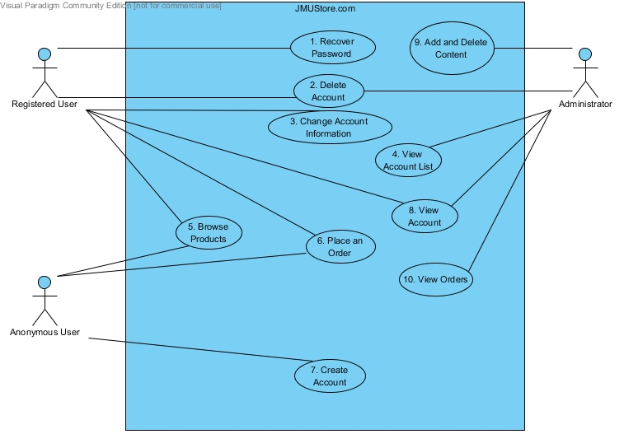
Figure : Use-Case Diagram for JMUStore.com

