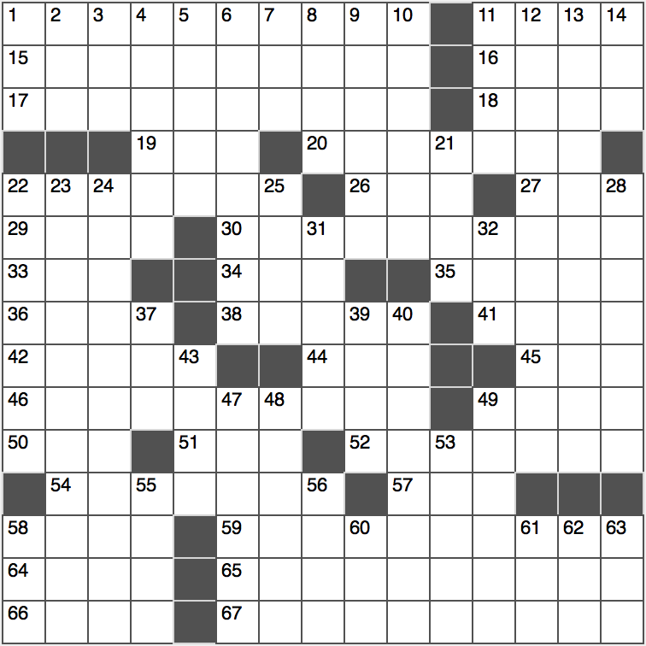**Across**

1. Wile E. Coyote’s nemesis

11. Genesis vessel, in 22-Across

15. Non-mainstream social group

16. Land along the Mekong

17. Get closer to home?

18. ____ Mode, of “The Incredibles”

19. Camping gear retailer

20. Sesame pastes used in Middle Eastern cuisine

22. Sicily’s largest city

26. Use a mirror without looking into it, say

27. Indigenous Oklahoman

29. Quito quaff

30. Amelia Earhart, and others

33. Two shakes of a lamb’s tail, for short

34. Musicians Bachman or Wilkenfeld

35. Provide weaponry

36. Paper cut?

38. Yale of Yale

41. View from the Uffizi Gallery

42. Holdup man of myth?

44. London-based insurance giant

45. Common univ. degrees

46. Intruder of fairy-tale fame

49. ____ d’Ivoire

50. Able was I ____ I saw Elba

51. The Once-____ (Seuss character in “The Lorax”)

52. Odorless fuels

54. Lacking life

57. End of a CD?

58. Sudden glitch

59. What fastidious people can’t be

64. Act goatish

65. Certain closed 3-dimensional quadric surfaces

66. Corn or asteroid ending

67. Like much real estate, annually

**Down**

1. Blog-updating format, for short
2. Gone on an errand
3. First name in honesty
4. National Mall’s vicinity
5. Straight schoolbag item
6. Utmost extreme
7. Higher power?
8. Night: Fr.
9. Printer’s goofs
10. Top of the Catholic Church?
11. Chrysler Building architect William von ____
12. Dating material
13. Upset
14. Candler of Coca-Cola

21. Latin phrase in many memos

22. Voyage

23. Controversial Vietnam War defoliant

24. ‘50s TV superstar

25. O or 0

28. Diffuses gradually

31. Relating to the hip bone

32. The Police hit Message ____ Bottle

37. Place for a mouse

39. Jazz (up)

40. Loosens

43. Missile repository

47. Varsity athlete’s honor

48. Orange and black songbird

49. Small movie roles for big stars

53. Equine

55. “Can ____ a Witness” (Martin Gaye hit)

56. Rum go-with

58. Soapy outburst

60. Modern prefix with gender

61. Hi-____ (stereo types)

62. ‘Quiet’ add-on

63. It may cause you to trip