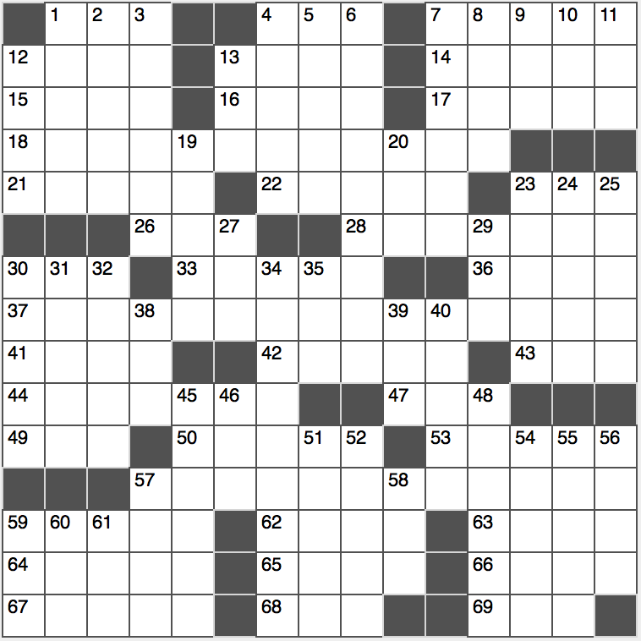**Across**

1. Army bunk

4. Setting for a famous “Forrest Gump” scene, for short

7. Skip the service, say

12. Mauna Loa’s output

13. Drunkard

14. Heavy, inert noble gas

15. Warning

16. The ‘A’ in AD

17. Wordsworth’s works

18. Date when 37-Across may be said in 2016

21. German heavy industry city

22. Gambler’s last words

23. Miniscule work unit

26. The Alps and the Himalayas, for example: Abbr.

28. Like 0 or 1, but nothing in between them

30. Atlanta-based media inits.

33. Tiny tree branch

36. “The ____ Show With Stephen Colbert”

37. Words said at a pop festival?

41. Caribbean map dot

42. Terra-____

43. GRE takers: Abbr.

44. Hard igneous rock

47. Matterhorn, for example

49. Derby or beret

50. OT book and prophet who foretold the fall of Nineveh

53. Dignity of manner

57. European analog of the occasion referenced in 37-Across

59. Lessen in severity

62. “Atlas Shrugged” author

63. Hardly heart-pounding

64. Lyndon B. Johnson or Dwight D. Eisenhower, by birth

65. Bank material?

66. Olympian with a bow

67. Talent broker

68. Music producer Brian

69. Anti-trafficking org.

**Down**

1. “The Stranger” author
2. Pizza-cooking appliances
3. Bicycle made for two
4. Black-clad Japanese warrior
5. Invalidate, as a wedding
6. Lunar illumination
7. Like the 2 of $x^{2}$
8. Resembling a lion
9. Xbox ____
10. When doubled, a cheerleader’s accessory
11. N N N N N
12. Get walloped
13. Route

19. Overly anxious

20. “A” in German class

23. Out-of-date shouts

24. Make road repairs

25. “____ Anatomy”

27. Sunscreen letters

29. Golf champion Ernie

30. Hip-knee link

31. Iraq’s second largest city

32. Bug-smacking sound

34. Animal giving you a run for your money?

35. “What was ___ do?”

38. Word with pig or play

39.

40. “Lord of the Flies” protagonist

45. Very focused

46. ____ Mahal

48. Put online

51. Sprinter Bolt

52. ____ Park (home of Thomas Edison’s laboratory)

54. “Eyes ____ not meet in dreams…” (Eliot)

55. Fiji’s not so close neighbor

56. Things that may twinkle

57. Common country ending

58. Cal. summer hours

59. “I’m ____ loss for words”

60. Request charity

61. Fire-fighting tool