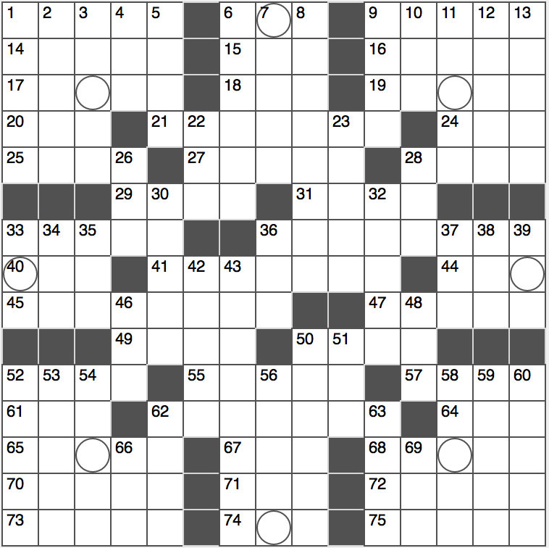**Across**

1. Pusher’s foes
2. Santa ____ winds

9. Great Plains Native American tribe

14. Escape adroitly

15. ____ Ripkin Jr. of “Iron Man”

16. Act part

17. Mutually profitable

18. Article in Oaxaca

19. Kind of algebra

20. Subway transfer loc.

21. Most populous city in Canada

24. “____ was saying…”

25. Stringed toy

27. Homes in Havana

28. Tennis great Arthur

29. Qts. and gals.

31. Young ram

33. Pageant winner’s headgear

36. Sea between Italy and the Balkans

40. “Actually!”

41. Object hinted at by this puzzle’s circled squares

44. Beverage that might be pale

45. Home of the Big House in college football

47. Scouting rank

49. There’s interest in it

50. Former SNL cast member Dunn

52. Balcony safeguard

55. V-8 you can’t drink

57. Adderall target

61. Choose

62. Library user’s aid

64. “Old MacDonald” refrain E-I-____

65. Solution

67. Poem of praise

68. Gone

70. Go

71. “Illmatic” rapper

72. Narrow, steep-walled canyon

73. Showed boldness

74. Windy curve

75. Early bets

**Down**

1. Topical
2. Supreme Court justice nominated by Bush
3. Landing strip
4. Livy’s 401
5. Email folder label
6. Honda luxury cars
7. Small iPods
8. Hawkeye actor of *M*A*S*H*
9. The Nobel Peace Prize is awarded annually in this city
10. Bio or chem, e.g.
11. Ancestor claimed by Julius Caesar
12. Grind teeth together
13. Uncannily strange

22. Halloween mo.

23. Autocrats no more

26. Rowing implement

28. Lawyer’s league

30. Prefix with biotic or economics

32. Tight-fisted sort

33. Pan Am rival of old

34. James Bond author Fleming

35. Big first name in Objectivism

36. Six months before or after 22-Down: Abbr.

37. Childhood game

38. Sick

39. 2.o GPA

42. Romney rival

43. Dull speaker’s delivery

46. Each and every one of

48. Grp. that aids stranded drivers

50. At least as much

51. Gold, to Jose

52. Dahl of children’s literature

53. Sleep lab concern

54. “Dem’s fightin’ words!”

56. Proud cries

58. Oasis locale

59. Window or door joint

60. Shows fondness for

61. Reputation, briefly

62. Lady ____ of pop music

66. Time for preparation

69. “____ appetite!”