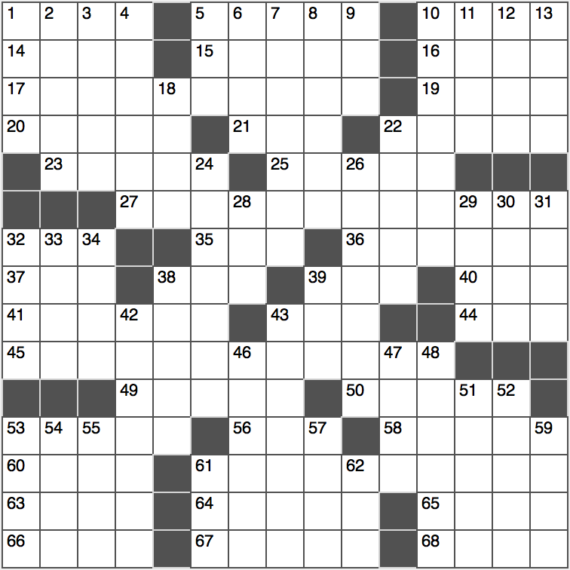**Across**

1. Eyeglasses support

5. Leisurely evening stroll

10. Not imaginary

14. Ottoman general

15. November birthstone

16. Goes astray

17. ***Concealed reptile?***

19. On deck?

20. Company that encourages people to lie?

21. ____-de-France

22. Halloween “trick” alternative

23. Not be a tightwad

25. Ill-gotten dough

27. ***Large mammal going unnoticed?***

32. Texting format, for short

35. Blue

36. Increases

37. Soul producer

38. Perform in a play

39. Severe soreness

40. Off-road letters

41. Like a trait present at birth

43. TV maker of the past

44. Eggs served with sushi

45. ***Primate trapped in between?***

49.Alternative to “bottled”

50. Capital of France

53. Fracas

56. Be regretful about

58. Burglar’s targets

60. ____ Spring (2010-2012 movement)

61. ***Nocturnal mammal is off-kilter?***

63. Dalai ____

64. Work on the lawn, say

65. Auction endings?

66. Suffix denoting “residents of”

67. Hymn closers

68. Swarthmore, informally

**Down**

1. Scolding sorts
2. Fiona and Shrek, for two
3. Stylish
4. Kind of egg or bonnet
5. K-12 grp.
6. Isao in the Golf Hall of Famer
7. Was a bee contestant
8. Relax
9. Pound parts: Abbr.
10. Run into from behind
11. Celtic tongue of the British Isles
12. Zone
13. Test for future attys.

18. “Billionth” prefix

22. Plumbing or carpentry

24. Downward journey

26. Sham

28. Longitude crosser: Abbr.

29. The last one was Nicholas II

30. ____ von Bismarck

31. Leave the neighborhood

32. Read through rapidly

33. Small iPad model

34. Castle building supply

38. Make amends

39. Like frozen winter roads

42. Microscopic blobs

43. Disgust

46. Hoops legend Abdul-Jabbar

47. Inordinate desire

48. Wipes out

51. A man ____ words

52. Missionary Junipero canonized by Pope Francis

53. Timbuktu’s country

54. The “E” of QED

55. Feeble, as an excuse

57. Black, to Shakespeare

59. Circulatory or respiratory: Abbr.

61. Supportive garb

62. Promos for products