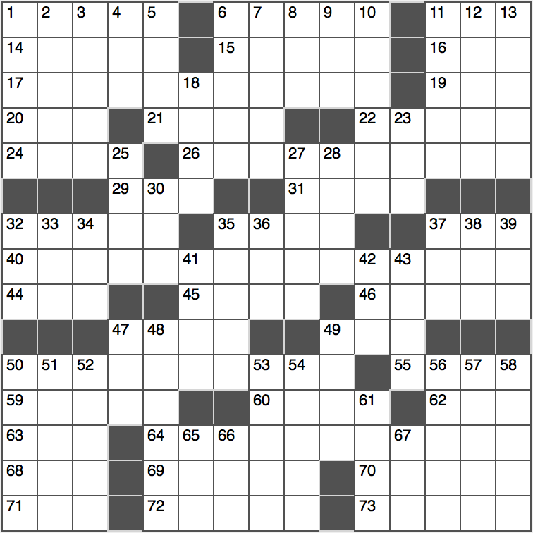**Across**

1. Lil’ ____ (comic strip character)

6. Vegetarian Jack

11. Portion of butter

14. “____ evil, hear…”

15. Brother’s daughter

16. Jackie O’s husband, in headlines

17. “*I dropped the toothpaste,” he said ____*

19. Part of a gym set

20. Iraq War hazard, for short

21. Model Delevingne

22. Duelling needs

24. Very, very small

26. “*They had to amputate them both of my ankles,” he said ____*

29. Praising lines

31. Deteriorate like a pipe

32. Future oak tree, potentially

35. Diploma holder, say

37. Honest guy on a penny

40. *“Oh shoot! I’ve lost all of my flowers,” he said ____*

44. Late Pink Floyd member Barrett

45. Long, thin woodwind

46. Ill will

47. ‘Mission: Impossible’ theme composer Schifrin

49. Sass

50. *“Come walk with me,” he said ____*

55. Crust on a healing wound

59. Old-time announcer

60. Kyrgyzstan’s locale

62. In the style of

63. Fishing implement

64. *“That’s the last time I pet a lion,” he said ____*

68. Mimic

69. Dolt

70. Treetop dwelling

71. By the word of

72. Willows and yews

73. Mix well

**Down**

1. Computer language std.
2. It often goes to a Frenchman’s head
3. Basic requirements
4. Three in a nunnery?
5. Campus cadets’ org.
6. Trap
7. Mideast rice dish
8. Family member: Abbr.
9. Versatile card in Blackjack
10. Religious principles
11. Peeled, as fruit
12. Staggering dizzily
13. Squiffy
14. Lose vibrancy
15. Many a veterinary patient
16. Toronto, originally

27. Desktop command

28. German automaker

whose name is Latin for “Hark!”

30. Type of modern lab

32. Disease that the Ice Bucket Challenge benefitted, for short

33. Low coral island

34. Condition involving repetitive behavior: Abbr.

35. Republic on the west coast of Africa

36. 2016 Olympics locale

37. Boxer born Cassius Clay Jr.

38. Deli order

39. ____ contact

41. Unemployment pay

42. Popular TV crime show

43. Angry Birds and Snapchat, for two

47. Fib

48. Dexterous

49. ____’ Ted (Mr. Cruz to Donald Trump)

50. Piece left over

51. Figurative expression

52. Free ____ problem (economics issue)

53. Lake near Reno, NV

54. Exams for future J.D.s

56. Personnel unit

57. Last-ditch poker bet

58. Howled

61. Not much, as of hair gel

65. HST’s predecessor

66. “Fee, ____, fo, fum!”

67. Sushi’s unagi