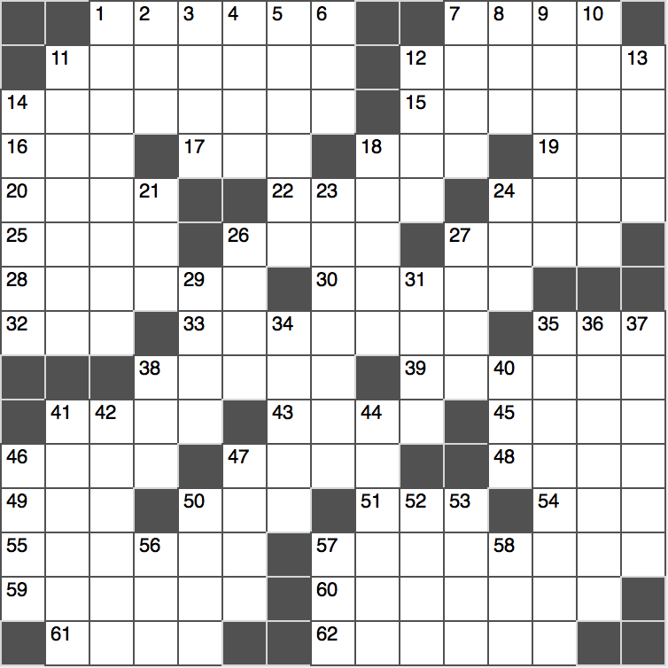**“Across**

1. Eddie who won five Kentucky Derbys

*7. 1976 Summer Olympics site\**

11. Eradicator

12. Coastal inhalation

14. Distinctive patterns

15. Be an informant

16. ____-la-la

17. Like a number less than zero: Abbr.

*18. Steady guys and girls\**

19. Journalist Wells or actor Lupino

20. Bank safety org.

*22. Conclusive evaluation\**

24. Motorbike stuntman Knievel

25. Pakistani’s lingo

*26. Pre-fax message\**

27. Tijuana three

28. In a specific fashion

30. Playwright William et al.

32. “I think,” in chats

33. Convenience store locations, often

35. Go out with

38. Empty window sign

39. Acropolis goddess

41. Place in a schedule

43. Elbow ____

45. Des Moines neighbor

46. Parent teacher groups

47. Come down to earth

48. Viral sensation

49. JFK or LAX letters

50. Subject of sermons

51. Rapping Doctor

54. The ‘S’ of RSVP

55. Roman military unit

57. Raises up

59. Tryster’s request

60. Sculptures that hang above cribs

61. Family chart

62. Not as newsworthy

**Down**

1. “Unfortunately, that is the case”
2. ____ Stadium, home of D.C. United
3. Biblical committer of fratricide
4. Unpopular spots in school?
5. Jamaican musical genre
6. Surgery locales: Abbr.
7. Veal, e.g.
8. It may be steel-cut
9. An original inhabitant
10. Spanish accents?
11. Common name for the tympanic membrane
12. Word meaning ‘town’ in Swedish, Danish, Dutch, Afrikaans and Luxembourgish
13. Non-fictional
14. Japan’s highest peak

18. Compound with two carbon double bonds

*21. Sacrifice quality for speed, or the key to interpreting the starred clues (including this one)\**

23. “I’m With Her” campaigner

24. EMT drop-off sites: Abbr.

*26. Workshop\**

27. Exam

*29. “Braveheart” setting\**

31. One-millionth of a metric ton

34. Aired once again

35. Academic year division

36. Lex Luther and Superman, e.g.

37. Painting class props

*38. Add as a bonus\**

40. Hawaiian pizza topping

41. Sesame ____

42. Bigger than

44. Nonstandard stock buy

*46. Oasis growth\**

47. It may be toed or crossed

50. Just a few

52. Country music singer McEntire

53. Voldemort-like

56. Suffix with Manhattan or Brooklyn

57. Emmy has two and “Mamma Mia!” has four

58. Bitter beverage