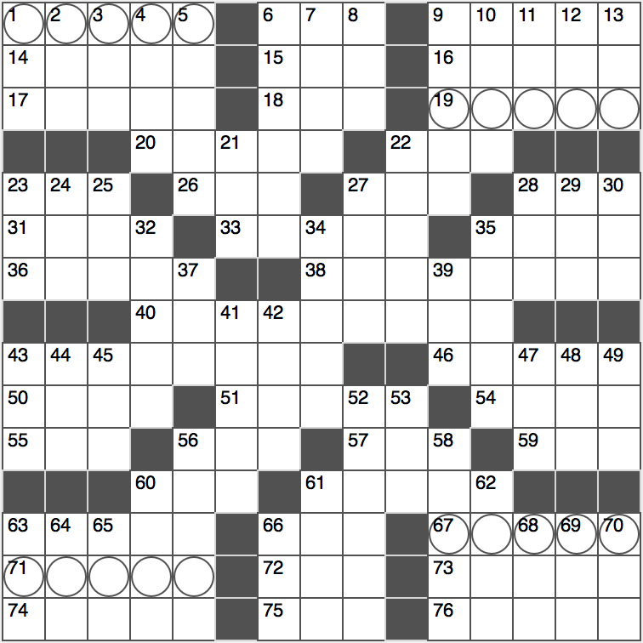**ACROSS**

1. *See 40-Across*

6. Jellyfish abode

9. Protagonist of Kafka’s “The Metamorphosis”

14. School for Sartre

15. Road coating

16. Broadcast again

17. Bishop’s law

18. 24/7 money dispenser

*19. See 40-Across*

20. Features of some sports cars

22. The way of Lao-Tze

23. Wharf denizen

26. ____ Paradise of Jack Kerouac’s “On the Road”

27. It may be noble or ideal

28. Angst-filled rock genre

31. Cleveland’s Great Lake

33. Actor Reeves of “The Matrix”

35. Perceive audiologically

36. Swimming pool figure

38. Foot-drumming showbiz act

40. Spooky holiday… or a time to 1-, 19-, 67- and 71-Across. Note that your answers will depend on the choices you make in the intersecting down clues.

43. Pig based on Joseph Stalin in George Orwell’s Animal Farm

46. MI6 Employee

50. 12/24 and 12/31, e.g.

51. Site of some waves?

54. Promenade of ancient Greece

55. Home of the lions

56. You might trip on it

57. “The Raven” poet’s initials

59. Industrious insect

60. Bit of butter

61. Where one might go after indulging in 56-Across

63. Formed another congress

66. ____ Cruces, NM

*67. See 40-Across*

*71. See 40-Across*

72. “A long time ____ in a galaxy far far away”

73. Gender-neutral pronoun

74. Clear, as a whiteboard

75. Gridiron great Marino

76. Upholsterer’s stock

**DOWN**

1. Detective, in slang
2. Elvis’ longtime label
3. Unfathomably long period OR infinitesimally small charged particle
4. Mass amount OR coagulated mass
5. Vacationers adapted abodes OR Superman’s adopted family
6. Metal clip
7. Isn’t fasting
8. Radius site
9. Misses at a bullfight, for short?
10. In the ____ Plane Over the Sea, 1998 Neutral Milk Hotel album
11. Fannie ____ OR ____ tai
12. Artist with the 2014 hit “Chandelier” OR [their error, not mine]
13. It belongs in a museum OR it belongs in the ocean

21. Acorn’s canopy

22. Mole color

23. Crimson or scarlet

24. Exist in the present

25. Insider’s offering

27. Chew (0n)

28. Suffix with velvet or eight

29. Big ____

30. It needs refining

32. Collective spirit

34. Square things up

35. Dangles

37. Malicious computer in “2001: A Space Odyssey”

39. “Breaking Bad” org.

41. Minimum

42. Byron or Tennyson, e.g.

43. Homer Simpson’s neighbor Flanders

44. One of 17 in Monopoly: Abbr.

45. Confident crossword solver’s instrument

47.

48. Veto in French legislature

49. Bit of ink

52. Liam of “Taken”

53. “Man, that feels good!”

56. Starbucks offering OR Hanukkah offering

58. Forest trails

60. Beef go-with OR Beefcake’s target

61. Music in many a Bollywood movie

62. La ____ Tar Pits

63. GPS calculation: Abbr.

64. Mess things up

65. ____ culpa OR “Mamma ____!”

66. “Wee” fellow

68. Suffix for superlatives OR suffix for believers

69. Hawaiian yellowfin tuna OR “Hawaii Five-0” actor McBride

70. X to Nero OR boyfriend to Barbie