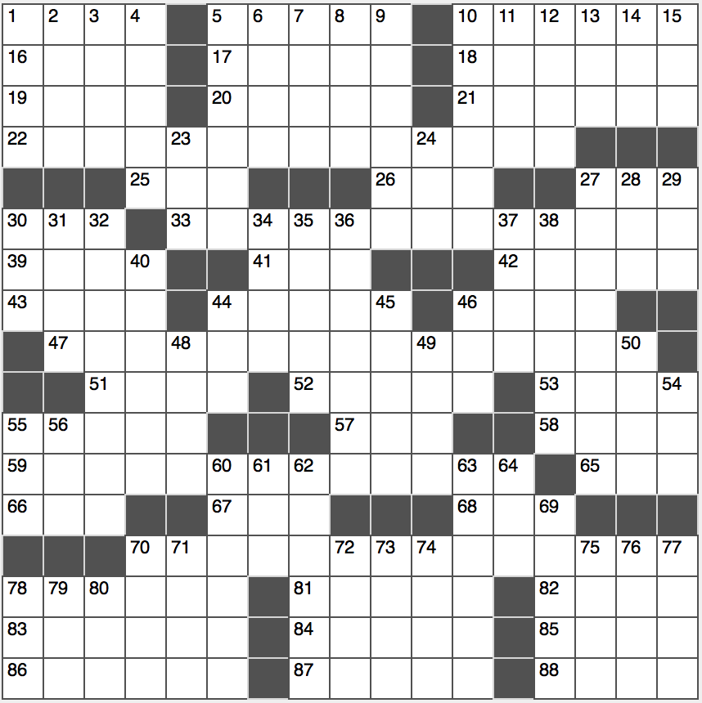**ACROSS**

1. Cake often seen in a dish
2. Parker and Penn, for two
3. Rodeo ropes

16. Italian auto-maker ____ Romeo

17. Assign portions

18. Queuing for tickets

19. What children should be rather than heard, in a saying

20. Starbucks staple

21. Highest-grossing musical in the US to date

22. Phrase from “Sonnet 43”

25. Off-road letters

26. Pavement for parkers

27. New York rail and bus inits.

30. Giant great Mel

33. Phrase from “Moby Dick”

39. Macbeth’s dagger or Groucho’s cigar

41. Thin battery size

42. Artist’s 39-Across

43. “The only critic without ambition,” per John Steinbeck

44. Dull thumps

46. X-ray relatives

47. Phrase from “The Stranger”

51. Fisherman’s gizmo

52. “Narnia” lion

53. Senses of self, to Freud

55. Lose sleep over

57. Suffix with fact or human

58. “Miss Independent” singer

59.Phrase from “Atlas Shrugged”

65. Go rancid

66. Amaze

67. Opposite of WNW

68. Ajaccio agreement

70. Phrase from the Bible... or a description of where each of the phrases from 22-, 33-, 47-, 59- and 70-Across can be found in their respective works

78. “Every dog has his day” for one

81. Former European gold coin

82. Shallowest of the Great Lakes

83. Oscar winning role for Philip Seymour Hoffman

84. Where to learn grammaire

85. Demonstrate fatigue

86. Desire to drink

87. Pharmacist, at times

88. Pekoe and Jasmine, for example

**DOWN**

1. Beauty pageant band
2. Margarine
3. Several
4. Bamboo-eating bear
5. It wets your whistle
6. Airline with no Sabbath flights
7. ____ saxophone
8. Punishment for a grounded child, maybe
9. Remington of ‘80s television
10. Entitlements
11. Concerning, on office reminders
12. Sheltered from the wind
13. Padre’s hermana
14. Part of Q and A: Abbr.
15. Go out with

23. Like nonprescription meds

24. You, to Yvette

27. One rubbing you the right way?

28. Golfer’s accessory

29. Every bit of

30. Drop (out)

31. Lace or ribbons

32. “Learn from yesterday, live for today, hope for ____. The important thing is not to stop questioning.” –Albert Einstein

34. Bert who played a scaredy-cat in a famous 1939 film?

35. Austrian 1984 Formula One winner Niki

36. Fourth US President

37. Grinder or submarine

38. Word before name or voyage

40. “Great” Russian ruler

44. ____ Aviv

45. Bud ____, baseball commissioner during the steroid era

46. Everest or Kilimanjaro: Abbr.

48. Slangy greetings

49. Pop, to a tot

50. Toy used to “walk the dog”

54. Drunkard

55. It follows http:// in a URL

56. “I see what you’re doing!”

60. Globetrotting clique

61. ____ Kosh B’Gosh

62. Listened to, as advice

63. Hang around aimlessly

64. Vineyard cask

69. Prone to bungling

70. “The Firebird” composer Stravinsky

71. Meshed materials

72. Osso ____

73. Writer Umberto et al.

74. Wild windstorm

75. “Dies ____” (requiem hymn)

76. One of a 1492 trio

77. Catches, like a cold

78. “America’s Got Talent” segment

79. T to a telegrapher

80. Prefix meaning bee