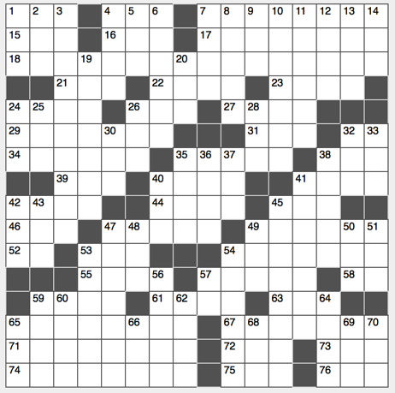**Across**

1. Gridiron grp.

4. Neither’s go-with

7. Feature of 74-Across … or a hint to the starred clues

15. Israeli illusionist Geller

16. “____ quit!”

17. Did a 5k, e.g.

18. Summer hours*

21. Garden implement

22. Ticked (off)

23. Stopping, Sp.

24. NIH part, abbr.

26. Certain distress call*

27. Brewed beverages

29. Advantages

31. Counter letters

32. The past, tomorrow*

34. Green eyes and baldness, e.g.

35. Some daily newspapers, informally

38. “I do,” for one

39. Opposite of ESE

40. Aging aristocratic teetotaler? †

41. Day laborer

42. Flair

44. Like Jeb Bush and Carly Fiorina, now, with “also”

45. JFK info

46. Verbalize

47. “Enjoy the moment!” *

49. Ancient patron of sailors and abdominal pain

52. Like most doctor’s appointments†

53. Sighs of relief

54. 49-Across and others, e.g.

55. Sci-Fi sister of Luke

57. Yellow gemstone

58. Lecture hall helper, abbr.

59. Minute amount

61. Eve on which 2000 pounds of confetti are dropped in Times Square†

63. Confident crossword solver’s tool

65. Doctor deterrent, maybe*

67. Turn in*

71. Hungry wolves or dental patients, often

72. Buckeye’s sch.

73. “Ready or ___ …”

74. Certain quadrennial event … or a hint to the clues marked with daggers

75. Film director Anderson

76. Mousse alternative

**Down**

1. Annul’s ending?
2. Turkey Day follower*
3. Like the Andromeda or Triangulum Galaxy†
4. Part of a chord
5. Hosp. areas
6. Rodeo rope
7. One of the Greats
8. Most common independent variables
9. Star Trek series, abbr.
10. Scalawags
11. Former surname of Metta World Peace
12. Platform
13. Wile E. Coyote corporation
14. “___-haw”

19. Maybe your parents stayed here? *

20. Exclamation of grief, with “oy”

24. Bolt’s partner

25. Earth Day mo.

26. 25-Across, e.g., Sp.

28. Tidal retreat

30. Detroit airport code

32. Also

33. Possess

35. Snare

36. Father of Cartesian coordinates, familiarly

37. They, Fr.

38. Like 8:30AM classes, to most students †

40. Canine warning

41. Knot-shaped snack

42. Immigrant’s course, for short

43. Nonexpert

45. Gillette razor brand

47. Economically

48. “____ Lay Dying” (Faulkner novel)

49. Tree fluid

50. “I pity the fool” speaker

51. She-bear in Seville

53. Genre for The Smith’s or Wilco

54. Site of the 1980 Summer Olympics

56. End of ____

57. Warner Bros. parent company

59. Memo opener

60. Certain “Bora Bora” pattern?

62. Enterprise Air Surveillance Radar, acronymically

64. Deep longing†

65. Anti-Semitism fighting org.

66. Grant foe

68. Common enzyme ending

69. Tic-Tac’s neighbor?

70. Home of the Braves, abbr.

