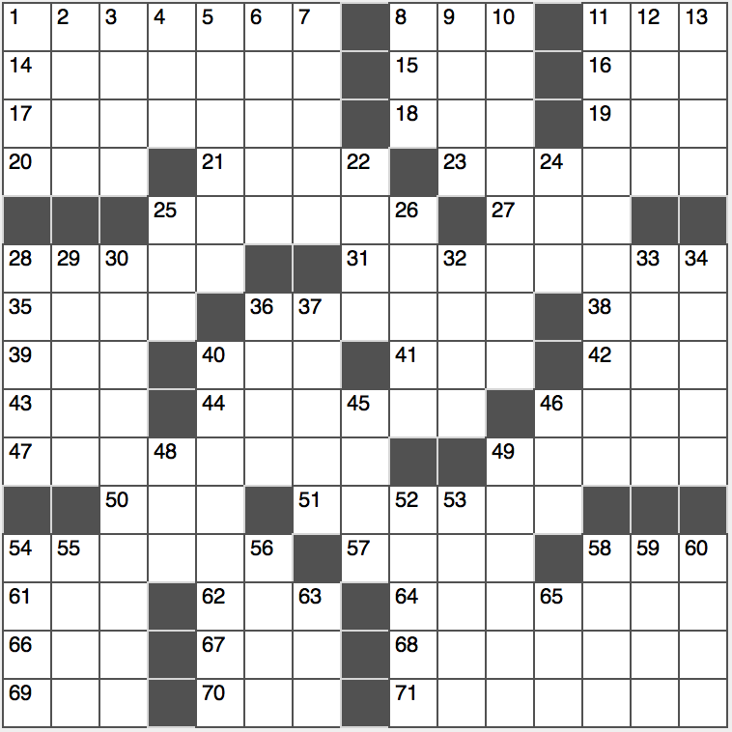**ACROSS**

1. Evaluation for creative types
2. Prefix with systems and friendly

11. Run at a leisurely pace

14. Indonesian capital

15. ____ Paradise of Jack Kerouac’s “On the Road”

16. Livy’s “I love”

17. Best: Lat.

18. Psychedelic drug

19. Where Harry Potter first learned that he could talk to snakes

20. Many undergraduate degrees: Abbr.

21. Dom Pedro’s slain lover

23. World’s longest river

25. Lead-ins

27. Response to a question: Abbr.

28. Grade A…or a word that can either precede or follow 17-, 23-, 31-, 47- and 71-Across… or a description of the numbers of each of these clues

31. Longitude line

35. Pep rally cries

36. Like some rye bread or watermelon

38. Org. for Wizards and Celtics

39. State whose license says “Famous Potatoes,” for short

40. Georgia’s capital: Abbr.

41. Disease for which the Ice Bucket Challenge raised money

42. Mars or Osiris, e.g.

43. Toy-torturing kid in Toy Story

44. “A Series of Unfortunate Events” author Snicket

46. Mani-____ (salon offering)

47. Pastor

49. Bold fellow

50. John Lennon’s “Bed-In for Peace” partner

51. Unit of angular measurement

54. Bird enclosure

57. Ding-a-____ (airhead)

58. Letters you may see in place of the Wi-Fi symbol on a smartphone

61. Eye shutter

62. Big name in email

64. Slow sections of music

66. Cover with frosting

67. The Big Apple

68. Enemy

69. Stereotypical English drink

70. Landscaper’s grass

71. Typical specimen

**DOWN**

1. “This looks like ____ for Superman!”
2. ____ Nui (Easter Island)
3. Box office buys: Abbr.
4. Last half of a rum cocktail?
5. White coated critter
6. Publicity trick
7. Weapon that’s a shocker
8. Lang. course for some US immigrants
9. Home in Honduras
10. Spinsters
11. Ella Fitzgerald or Billie Holiday, e.g.
12. Herman Melville story
13. Thug, slangily

22. A few

24. &

25. Uses WhatsApp, say

26. Spacious kind of auto

28. Object depicted on the cover of Pink Floyd’s “The Dark Side of the Moon”

29. Arm bones

30. “Honestly!?”

32. Lean heavily (0n)

33. “Humble” place of residence

34. Zenith’s antithesis

36. “Leave as is” mark

37. ____ Fudd, gun-toting adversary of Bugs Bunny

40. Bernie Sanders and John Kasich, now

45. Like slander vis-à-vis libel

46. Gold Rush tool

48. Words between one and million

49. Vasco who explored India

52. Veteran telejournalist Sawyer

53. End-of-book reference

54. Came down to earth?

55. Immoral activity

56. Stringed toy

58. Thpeak like Thylvethter

59. Slog away

60. To be: Lat.

63. Portable computer screen material

65. Bit of bling