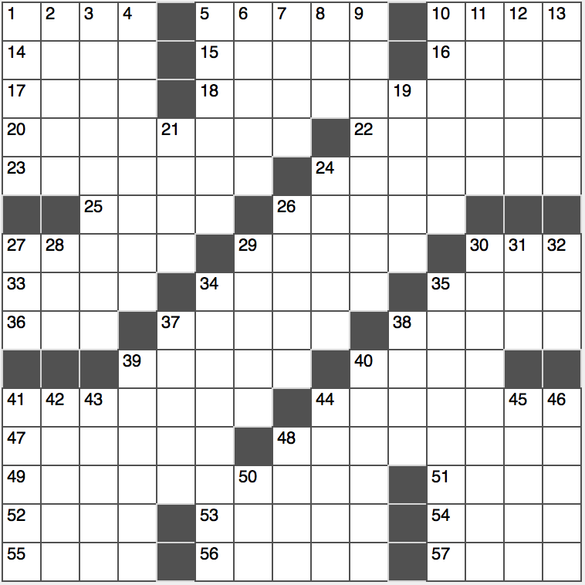**Across**

1. River near Mt. Ararat
2. A bit high?
3. Faucet competitor of Kohler

14. Bistro’s detailer

15. “You are not!” rebuttal

16. Phrase that follows an estimate

17. Answers, on “Jeopardy”

18. Fashionistas

20. Soup accompaniers

22. Noble’s bookselling partner

23. Cardigan, e.g.

24. Orbital low point

25. Gossip

26. Lead-in to Kitchen or Angels

27. Itty-bitty

29. Pitcher for the Yankees?

3o. Natter away

33. Fills with reverence

34. Like much Tex-Mex cuisine

35. Explorer of toondom

36. Single crunch, say

37. Wines’ partner

38. Bookkeeping term

39. Main character in Kafka’s “The Metamorphosis”

40. “____ grip!”

41. Tokyo-based TV pioneer

44. French newspaper that becomes a beverage if you insert an “a” after its fifth letter

47. Chevy model named after an antelope

48. Sendai send-off

49. MLB record holder for most career home runs who also has a Kanye West song named after him

51. Santa ____ (weather phenomena)

52. Heroine in Tennyson’s “Idylls of the King”

53. Alternative to two-percent or skim

54. Only US president who also served as chief justice of the Supreme Court

55. Fixes a fight, say

56. Glowing cookout leftover

57. Superlative suffixes

**Down**

1. Rack up, as wealth
2. Caught a film again
3. Nowhere near in over one’s head?
4. Keeps up
5. Official seal or stamp seen on a ring
6. Stronger and healthier
7. Buddies in Bordeaux
8. Queue after Q
9. Hardly a six-pack
10. Feline of cat food ads or Actor Chestnut
11. Rain forest ape, for short
12. Cosmetics queen Lauder
13. Din

19. Before the usual time

21. Reply that’s a bit of a humblebrag

24. Hides from wild animals?

26. Old Testament book that follows Daniel

27. Harmful cigarette component

28. Sheepish farm animal

29. Brainy bunch?

30. Lose control, in a way

31. Tycoon Onassis who married Jackie Kennedy, familiarly

32. Giant image over Gotham

34. Last UN member alphabetically

35. Go off

37. The New York Times, for one

38. Tear down, in real-estate lingo

39. Slivers of glass

40. Hot water gusher

41. River on whose banks Rome was founded, according to legend

42. Muscat native

43. Bit of parsley, e.g.

44. Serving spoon

45. Blueprint

46. 25% of bridge players

48. Supercilious person

50. Electrical unit of resistance