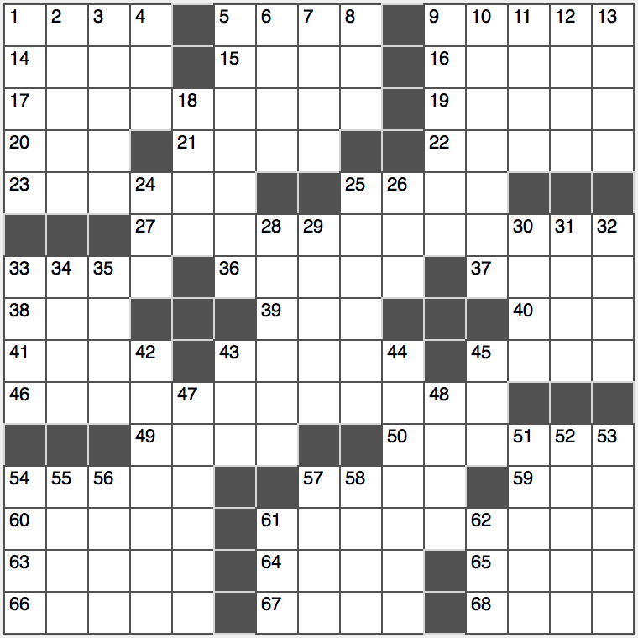*Hint:* You’ll need to be a bit clever to address the **bolded** clues in this puzzle.

**Across**

1. Castle’s watery defense

5. First word of many fairy tales

9. Hayseeds

14. Former US Secretary of Education ____ Duncan who was appointed by President Obama

15. Anjou or bosc, e.g.

16. Wipe clean

17. **“Oh my goodness!”**

19. Crush competitor

20. Impair or damage

21. Srta., on the Seine

22. 2000 NBA MVP with the Lakers

23. Nonspecific person

25. Modern know-it-all

27. **Output from Nas or Nirvana**

33. App prototype

36. Halloween handout

37. Spydom’s ____ Hari

38. Wht this clue is missing

39. Abbr. after many a military name

40. Tennis redo

41. Four-fifths of a 1990s American boy-band?

43. Gobble

45. Brief “how-to” session

46. **Attractive**

49. Only actor to appear in every episode of TV’s *M*A*S*H*

50. Archives

54. Mix together

57. Opposite of fem.

59. Government org. in *Breaking Bad*

60. Treetop dwelling

61. **Take advantage of one’s opportunity**

63. Surprise wartime attacks

64. Hamlet, e.g.

65. Ripped

66. Item in a set of bed linens

67. Suffix with gang or prank

68. Part of A.D.

**Down**

1. Molten underground rock
2. Heart or kidney, for example
3. Irate
4. ____ Aviv
5. Richly luxurious
6. Buzz preceder, famously
7. Sherlock’s assignment
8. Before, to a bard
9. Turn over a new leaf
10. Radioactive metallic element
11. Aptly named Batman villain
12. This, to Picasso
13. Authenticating mark

18. Prefix with science and present

24. ____ roll

25. Lady Liberty, for one

26. *Addams Family* cousin

28. Editorial slip-ups

29. Mouth contents

30. Black Friday event

31. Bulleted list entry

32. Tenacious foe of Julius Caesar

33. Military compound

34. Single-named Celtic singer who’s sold 75 million albums

35. Darkens from light?

42. Deadly poison responsible for the death of Alan Turing

43. Terminus

44. Middle Eastern monetary unit equal to one hundredth of a pound

45. Ado

47. Greatest in age

48. Small part of a foot

51. Extra

52. Get educated

53. Refuse an offer

54. Some candy purchases

55. First wife of Jacob in the Bible

56. Shallowest of the Great Lakes

57. MD-to-be’s exam

58. Adolescent’s issue

61. Musical spinners

62. Flight status info: Abbr.