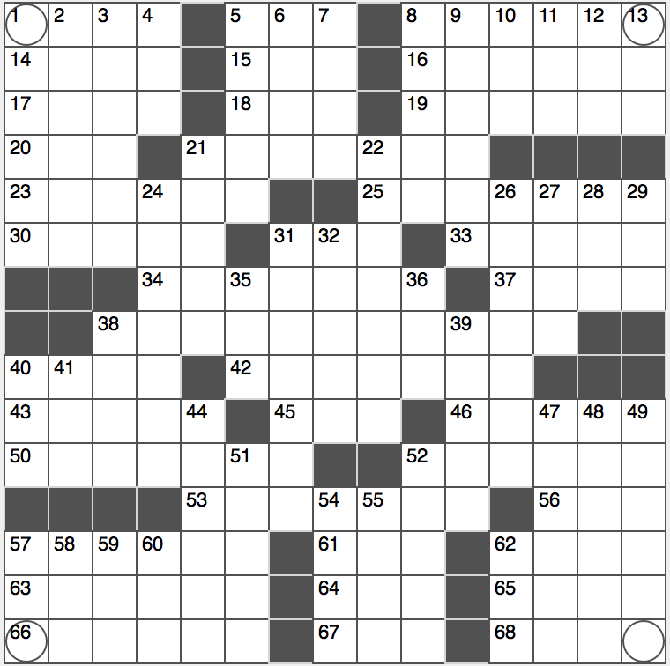**ACROSS**

1. Keep tabs on a tabby

5. Soccer mom’s org.

8. Garfield, for one

14. Prefix with “globin”

15. Hardly rigorous

16. A in physics class?

17. Paris’s ____ Airport

18. Catch a bug

19. Thin coat?

20. Meadow

21. Popular painkiller

23. Entombs

25. Clear plastic material

30. Green with Grammys

31. Got into the swing?

33. Rapper Shakur

34. Mozart’s homeland

37. Dastardly Roman emperor

38. Slanted diagonally…or the key to filling in the circled square

40. Where diners spend dinars

42. Modified

43. “Weeping Willow” painter

45. GI dog tags

46. Relative of a cello

50. Wondrous

52. Hound’s hotel

53. Article accompanier

56. Foreign student’s subj.

57. Coercion

61. Gent’s title

62. Baptism or initiation

63. Phraseologists’ concerns

64. When doubled, a prop for a cheerleader

65. Beatles hit “____ in the Life”

66. Division

67. Code breaking org.

68. Bigwig with big bucks

**DOWN**

1. Like Pope Francis
2. Peaceful
3. Lament from a Disney rabbit
4. Elf’s export
5. Quarterback’s calls
6. Animal’s end
7. Greased part of a car
8. Mayhem
9. Cousin of a frittata
10. “Star Trek: Enterprise” network
11. Employ one’s pupils
12. Before, in verse
13. Supply a spread for

21. Fly fisher’s target

22. Olympic teams

24. Renowned Manhattan eatery

26. Perceptive

27. Copycat

28. Pine goo

29. Lead-in to friendly or tourism

31. Left clueless

32. Moved like a cannon ball

35. BART stop: Abbr.

36. Drunk’s chaser?

38. Citizen of cinema

39. Not once

40. “____ little teapot…”

41. Rank

44. Insomniac, at times

47. Lake near Utica

48. Vampire in “The Vampire Chronicles”

49. Urban scavenger

51. Hip-hopper Elliott

52. Cosmic balance

54. 1979 TV debut

55. Some book blurbs

57. Former European gold coin

58. Employ

59. Old shirt, perhaps

60. Braggart’s overabundance

62. UK defense arm