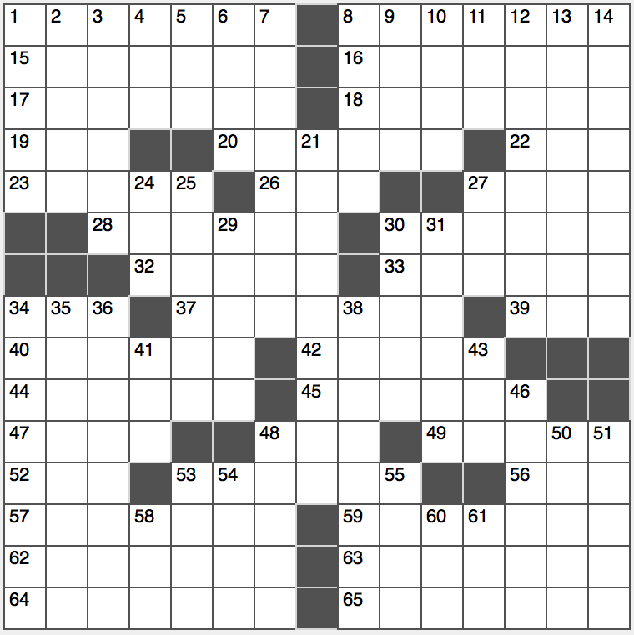**Across**

1. “A poem in our eyes,” per Emerson

8. Brazilian Beach in a 1964 song

15. It may help you get a grip?

16. Cage of “Rage”

17. Witticism

18. Chemical cousins

19. Capital of Romania

20. Impatience indication

22. Contest

23. Die’s dozen

26. Hall figures: Abbr.

27. ‘60s pop band Manfred ____

28. Headbands?

30. Barraged

32. Nearest capital city to Gibraltar

33. “Uncle!”

34. Address in Kingston

37. Sprint, e.g.

39. It was terrific in the ‘90s

40. Dares say

42. Eager, in dialect

44. Poe’s “Raven” lady

45. Kagan and Kampouris, for two

47. Big name in belligerence

48. Animated film F/X

49. Squeals

52. Harden

53. Phraseologists’ concerns

56. UN working standards grp.

57. Purloiner

59. Silver stater

62. Like some truths

63. Rear

64. Winner of eight Grammys in 2000

65. Shade source

**Down**

1. Doctor’s bane?
2. Seriously stuck
3. Word before and after “is”
4. Clerical title, for short
5. Addition to Canaan?
6. Amazon icon
7. Out on a limb?
8. D.D.E and J.F.K.
9. Site of a canted campanile
10. Rent-____
11. Info on un certificate de naissance
12. Brit’s lift
13. Bow tie go-with
14. Acquiesced

21. Object of a spring hunt

24. It has a drum

25. Roof repairer

27. Popular palindromic tat word

29. Quite corpulent

30. Sleep soundly?

31. Basis for grits

34. Metaphor for slowness

35. Lightly scored work?

36. Number opposite one on a standard dartboard

38. Salsa specification

41. Digits, briefly

43. “When pigs fly, laddie!”

46. White Castle fare

48. Server on “Cheers”

50. Geometer’s expanse

51. Atmospheric balloon probe

53. Radius’s comrade-in-arms?

54. “Mercy” rapper Big ____

55. Escutcheon

58. Simon’s Garfunkel

60. Vigor partner

61. Flight stat.