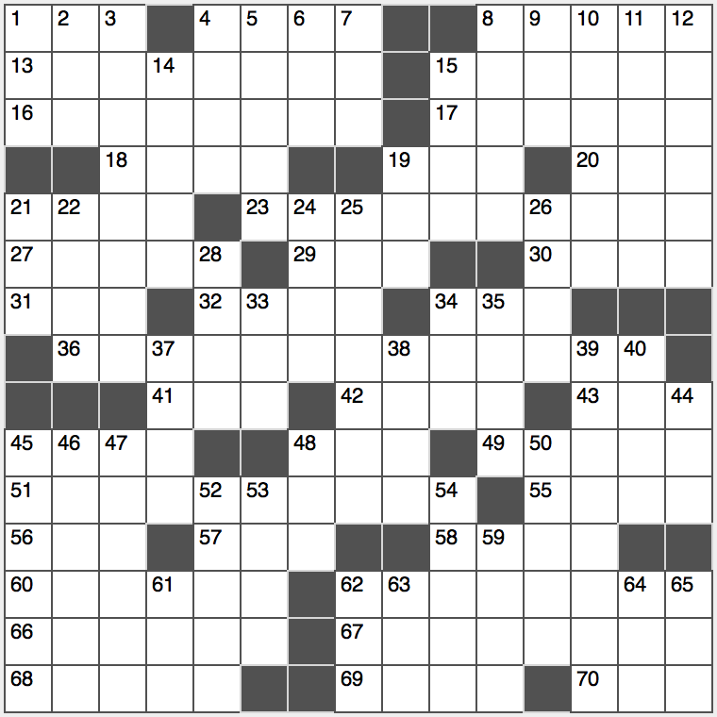**ACROSS**

1. Traditional luau treat

4. ____ fide (bad faith)

8. Is ominous

13. Dosage phrase

15. Seldom

16.

17. Not divisible, as a job

18. Part of DoE: Abbr.

19. Elevation, for short

20. “Am ____ believe that...”

21. Spydom’s Mata

23.

27. Blunt fencing foils

29. Univ. in Cambridge

30. “____ of the d’Urbervilles”

31. Certain House vote

32. Most fit for the draft

34. Locale of Phelps’s last five gold medals

36.

41. PC port type

42. Tag sale condition

43. TV chef Garten

45. Chicago NFLer

48. Half of hexa

49. Ed who voiced Carl Fredrickson in Pixar’s “Up”

51.

55. Actress Amanda of “2012”

56. Airport NW of the Gateway Arch

57. PC’s bailout key

58. To some degree

60. Before this moment, in poetry

62. Oblivious…or a description of and hint to 16-, 23-, 36- and 51-Across

66. Canadian singer Dion

67. Element 99 honoree

68. Cold weather temperature range

69. Permits

70. Base fig.

**DOWN**

1. La ____ (Bolivian capital)
2. Grizzly, in Guaymas
3. Balance regulator
4. Ancient Assyrian foe
5. Add bling to
6. Moldovan currency
7. Home security co.
8. Swahili or Zulu, e.g.
9. Crude copper
10. Termination
11. Brings up?
12. Church gatherings

14. Counting rhyme beginning

15. Sushi plate item

19. Suitable for the job

21. “Watch it, pal!”

22. Did likewise

24. Eerie occurrence

25. Falls for many lovers?

26. Greek covered walk

28. Some oinkers

33. Sharpie tip, e.g.

34. Baseball slugger’s stat: Abbr.

35. Rick’s flame in Casablanca

37. Ambient quality

38. Z ____ zebra

39. Almost a score

40. ACL tear sight

44. Museum attraction

45. Cut the corner?

46. Main course

47. Gene variant

48. R.N.’s special touch

50. Diverge

52. Trotsky and Uris, for two

53. “Even ____ speak…”

54. Dishearten

59. 1940’s first lady

61. Diarist Anais with a palindromic first name

62. Picture frame?

63. Tell tales

64. “This is an exact quote”

65. Wintry-looking, in brand names