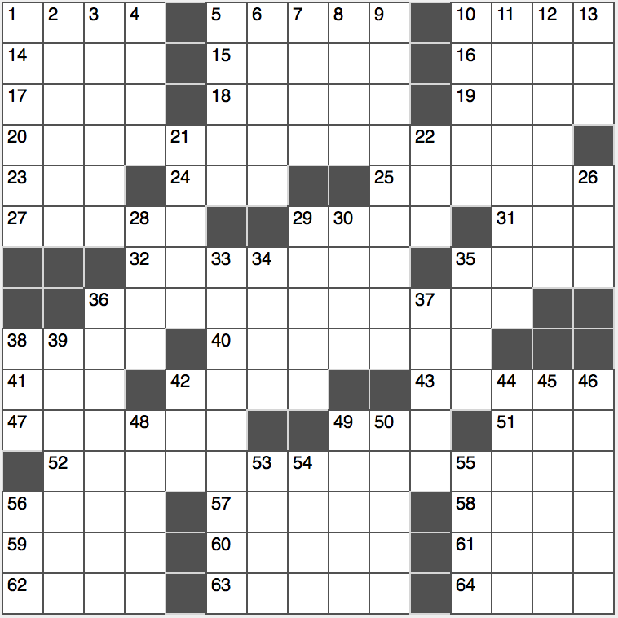**ACROSS**

1. Attack with a sword

5. 32-piece game

10. High-fiving sound

14. Word with cake or lamp

15. Author Bret who wrote with Mark Twain

16. Bee’s milieu

17. “Got it, got it!”

18. Author Poe

19. Several

20. First part of a quote by 36-Across

23. Summer in Evian

24. Ranch suffix

25. Leaf producer

27. Event with lots of horsing around

29. Beer blast purchases

31. Prominent green org.?

32. Thin and graceful

35. Normandy battlefield where William the Conqueror is buried

36. “Leaves of Grass” poet who wrote the quote given in 20- and 52-Across

38. Z ____ zebra

40. Stages a comeback

41. Nada

42. Browns

43. Does some field work?

47. Title character in a Hemingway classic

49. Begin tiring

51. Caviar, essentially

52. Second part of the quote by 36-Across

56. LSD

57. Partner of each

58. Stunned accusation

59. It’s merrier, in a saying

60. Old-time sidewalk show

61. The Titanic, for example

62. Change for a five

63. Loses traction

64. Brady’s bunch, familiarly

**DOWN**

1. Ritardando
2. Hit it off with
3. Self-confessed
4. Make cookies, e.g.
5. Say “hooray,” say
6. Didn’t have a choice
7. “For that reason”
8. Forest buck
9. Tanzanian wildlife reserve
10. Ex-rulers of Iran
11. Time on earth
12. Mean
13. Congregant’s spot

21. Put more lubricant on

22. “____ the season…”

26. Mom’s mom, to the kids

28. Energetic style

29. Macy’s rival

30. Actor Jannings who was the first person to win an Oscar

33. New faces

34. Elegant lake swimmer

35. Violin protector

36. Symbol of success

37. Join

38. Decada division

39. Microchip material

42. Pine goo

44. R&B singer Franklin

45. Sticky square

46. Sting operations

48. Most common numbers

49. ____ throat

50. “Now I remember”

53. Elliptical shape

54. Actresses Garr or Hatcher

55. Reply to, briefly

56. “I love,” to Caesar