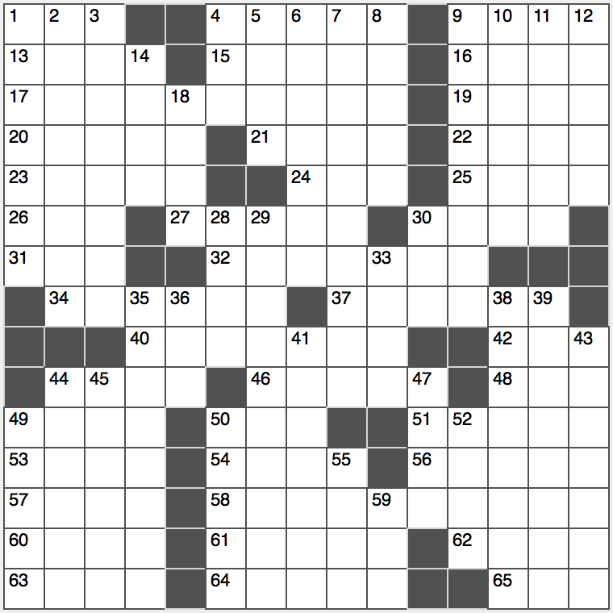**ACROSS**

1. Paperback publisher owned by Penguin: Abbr.

4. Occupied

9. Discipline with planks

13. Purple blossom

15. Impose another levy on

16. Unbox

17. Valuation

19. Produced some pitches

20. Unsettle

21. Surjective

22. 90º from norte

23. “Lend ____” (listen)

24. Jack Kerouac’s Paradise

25. Pell-____

26. Dashed off

27. In simplest form

30. Get out of bed

31. PC key near the space bar

32. Mathematical void

34. Part of USSR

37. Dante saw him in limbo

40. Continent connector

42. Georges, par exemple

44. Bow of the foot

46. Gallery tripod

48. Santa ____ winds

49. Go ____ great length

50. Adolescent leader?

51. Totally wipe out

53. Puerto’s partner

54. “Frozen” queen

56. Rice-____ (Quaker Oats brand)

57. English Boxer Khan

58. Cataracts…or a collective description of 1-, 9-, 12-, 35- and 29-Down

60. Certain bond, in brief

61. 2o02 scandal company with an ironically crooked logo

62. Lack of neutrality

63. Dazed

64. Ritzy Twin Cities suburb

65. Shock and wonder

**DOWN**

1. One of the world’s most famous 58-Across…in Canada

2. Stores of weapons

3. Heed

4. Auditor’s agcy.

5. Lost fish of filmdom

6. Diner’s need

7. Noted list keeper

8. Glorify

9. …in California

10. Numbered musical compositions

11. Tender and mild

12. …in Venezuela

14. “Go ____ Watchman” (Harper E. Lee novel)

18. Tart fruit

28. Dill seed

29. …in New Zealand

30. Kylo ____ (“Star Wars” jedi)

33. Zaire’s Mobutu Seko

35. …in Zambia

36. Estimator’s suffix

38. Asian portion of Turkey

39. Acquired kin

41. Orchestra leaders

43. Henri who painted “The Dance”

44. Jungian part of some personalities

45. Lake Michigan port

47. Nissan hybrid

49. Pan attachment?

50. North American fly-catching bird

52. Many a denizen of Dubai

55. It feels like forever

59. Genetic messenger