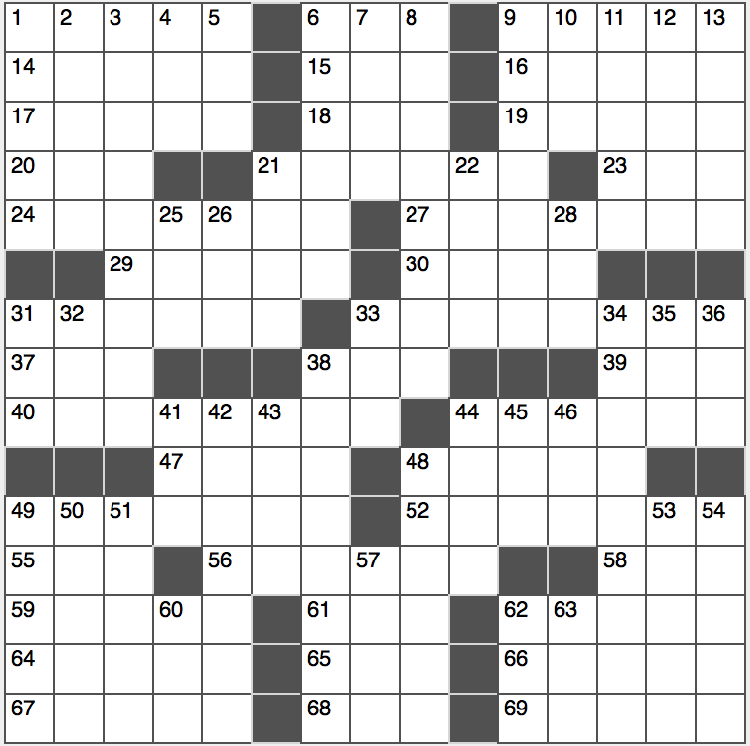**Across**

1. F on a physics exam

6. Fighter who said, “I should be a postage stamp, because that’s the only way I’ll ever get licked”

9. Spiteful

14. Play platform

15. Fleming who was the creator of James Bond

16. The wizard of ____ (nickname for Warren Buffet)

17. Rugby scores

18. Amazon, for one: Abbr.

19. About 55% of American college undergraduates

20. Texas “tea”

21. Tummy settler

23. Be a pesterer

24. One who just came out?

27. Daydreamer’s drawings

29. With 48-Across, the cosmos…or what needs to be added to complete the answers to the starred clues

30. One-named Grammy winner from Donegal

31. Portable warmer*

33. Water east of Dublin

37. Suffix for drunk or tank

38. Not Macs

39. Rapper with the most-viewed YouTube video of all time

40. ____ Tonight, late-night program for comedian John Oliver

44. What one might get more of after a promotion*

47. Bryn ____

48. See 29-Across

49. Venerations

52. They may be pulled or tweaked

55. Ref. for wordsmiths

56. Hoarded treasures

58. Frat address

59. One less than ocho

61. Goalkeeper’s perfect score

62. Rendition that might express 49-Across

64. Summer month in South America

65. Monopolist’s share

66. Below the belt

67. End of a letter

68. Guitar legend Paul

69. Rival of Sparta and Athens

**Down**

1. Lens speed setting
2. Lobbies for light gatherings?
3. Charges for Dagny Taggart in “Atlas Shrugged”
4. Period that began in 1957*
5. From abroad?
6. Not as stuffy
7. Like people in pews
8. Alternative to Asteroids or Pac-Man*
9. 2000 Clint Eastwood film in which a Soviet satellite is repaired*
10. Member of a popular Latin trio?
11. Sri Lankan language
12. Word for pointers
13. Sharp jerks

21. “Suds”

22. Rice-a-____

25. Strike three result

26. Letters in place of the Wi-Fi symbol on a smartphone

28. Dit partner

31. Evil film computer

32. Division of geological time

33. “Oh, yuck!”

34. Steven who directed “Raiders of the Lost Ark” and “Jaws”

35. Bailout key

36. At-sea affirmation

38. Physical comfort zone*

41. “No more deets!”

42. Slang term for a useless person*

43. Wash basin accessory

44. Masterwork, especially in music

45. Notes between mis and sols

46. US TV watchdog

48. Is nosy?

49. Works for a model employer?

50. Roi’s partner

51. “Doe, ____ …”

53. Mythical lyre player

54. Walkmans and Playstations, for two

57. “Slavery is so ____” (first line of John Locke’s “Two Treatises on Government”)

60. Half of hexa

62. Canoodling on the sidewalk, e.g.: Abbr.

63. Pilot’s zone that may be restricted*