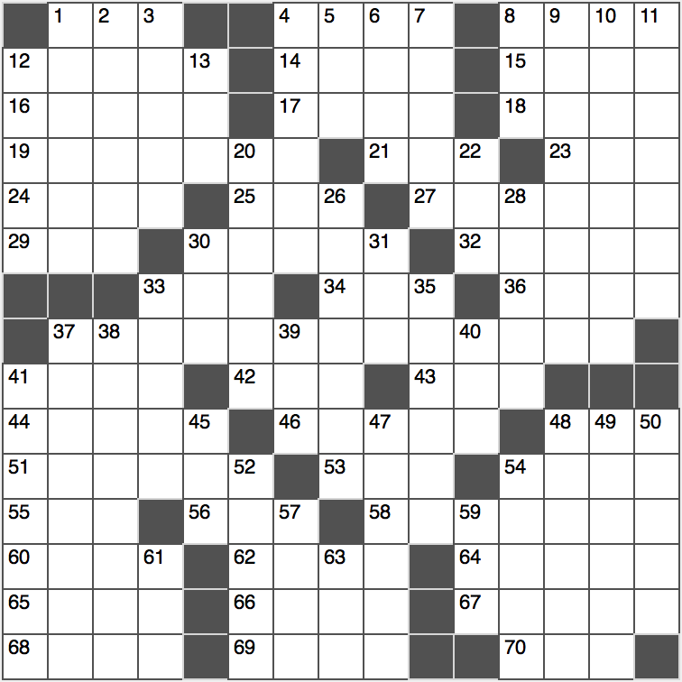**Across**

1. Embassy diplomat: Abbr.

4. Painful-looking soccer shots

8. Looming in the distance

12. Educational octet

14. Greek covered walk

15. Stiffly proper

16. Lucille Ball and Ginny Weasley, for two

17. Broadway honor

18. Fluids with antibodies

19. Literary supplements

21. “Homeland” channel, for short

23. Roads that cross aves.

24. Broke the news to

25. What “washes away from the soul the dust of everyday life,” per Picasso

27. Perceive instinctively

29. Austin-to-Baltimore dir.

30. Star-shaped fall flower

32. French WWI battle site

33. Sauna spot

34. Pull-down target

36. Bucks, but not dollars

37. Religious trophies of many Amazon tribes…or a hint to seven squares in this puzzle

41. Parka or mackinaw

42. Quadrennially prominent grp.

43. Personal conclusion?

44. System in which the number 73 is represented as 111

46. They may be dressed in pads

48. When doubled, a dangerous fly

51. Cry at a magic act

53. Dallas pro, informally

54. Pineapple, to a GI

55. 5 is a high one

56. Day before the big day

58. Peddling drugs

60. Space saving abbr.

62. Able was I ___ saw Elba

64. Fan of Jerry Garcia’s band

65. Start from the top

66. High-end Swiss watchmaker

67. “The Dance Class” painter

68. Operator’s wear

69. How rivals compete

70. ___ Aviv

**Down**

1. Onetime Vogue photographer Richard

2. Word with finger or America

3. Like two of Henry VIII’s wives

4. Racer’s edge

5. WWII theater of operations

6. Director Howard and politician Paul

7. “Send our regards!”

8. FedEx competitor

9. Took for granted

10. TV schedule listings

11. Dumbledore, e.g.

12. Totally ticked

13. Job applicant’s ID

20. Bottled-water brand

22. Add-___ (extras)

26. Fiber optics field

28. Right now, date-wise

30. Kwik-E-Mart clerk on “The Simpsons”

31. Executed, as a program

33. Mlles. in Madrid

35. Pilfer

37. Plato was his disciple

38. “Drink” for the overly critical

39. Some UFC wins

40. “Star Wars” extras

41. Venomous pit viper

45. Network standard for smartphones, for short

47. “In Rainbows” Grammy-winning rockers

48. Area where patients are prioritized

49. Leisure footwear

50. Brainiacs

52. Operating expenses

54. Naval battle group

57. The “E” of QED

59. Come up with sum-thing?

61. Parking area

63. Former name for Tokyo