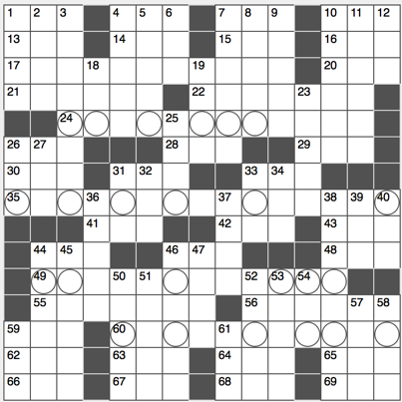**Across**

1. Bulls power forward Gasol
2. Political issues, so to speak

7. Unfortunate result of a college night out, colloquially

10. ____ Newtons

13. Mont Blanc, for one

14. Pique condition

15. Tyrant Amin

16. “Keep me in the loop,” for short

17. Rest period for many college students, or a literal hint to 24-, 35-, 49- and 60-Across

20. It makes a truck stop?

21. “Indeed”

22. Demoralize

24. Item that Dick sells?

26. Bordeaux buddy

28. “Perfect world” prelude?

29. Many GRE takers, for short

30. Autograph hound’s offering

31. No, in New Glasgow

33. Hosp. areas

35. Wicca and nature worshiping, for example

41. Briny expanse

42. IPA part

43. Berkley and Davis, e.g.

44. ____ Kosh B’Gosh

46. Elect (to)

48. Roadside rescue

49. Method that involves chunking and subvocalization

55. Mosque tower

56. It’s often personal

59. Massive amount

60. Elaborate displays or ceremonies

62. Olympics chant

63. Beatle bride

64. Ship pronoun

65. Gross minus expenses

66. Salon stiffener

67. Ages

68. Unwelcome sign for latecomers

69. Video game set in the fictional city of Los Santos, CA

**Down**

1. Gridiron option
2. Rations for Rover
3. Rebellion

4. Certain Sicilian town

5. Insistent one

6. Societal newcomer

7. Capital city on the Danube

8. “My goodness”

9. “Odd Future” rapper whose real name is Michael Anthony Griffin II

10. Any of up, down, strange, charm, top or bottom, quark-wise

11. Establishes

12. Net minders, for short

18. AOL or Verizon, abbr.

19. Mar

23. Martini’s partner

25. Theater ticker price factor

26. Angry Birds, e.g.

27. ____ culpa

31. New Orleans to Detroit dir.

32. ____ glance

33. Lubricant

34. Highway, abbr.

36. Pale

37. Drive filler

38. Extrovert

39. Sgt., for example

40. 180 degrees from 31-Down

44. Move through a membrane

45. Type of cord or column

46. Nike headquarters location

47. Wimbledon great Sampras

50. “The Raven” writer, in footnotes

51. Pipe clog dissolver

52. Restaurant patron

53. Freshman course word

54. ATM giant

57. Entry on a track and field team’s schedule

58. “These,” in Tijuana

59. Yank

61. Sighs of relief

