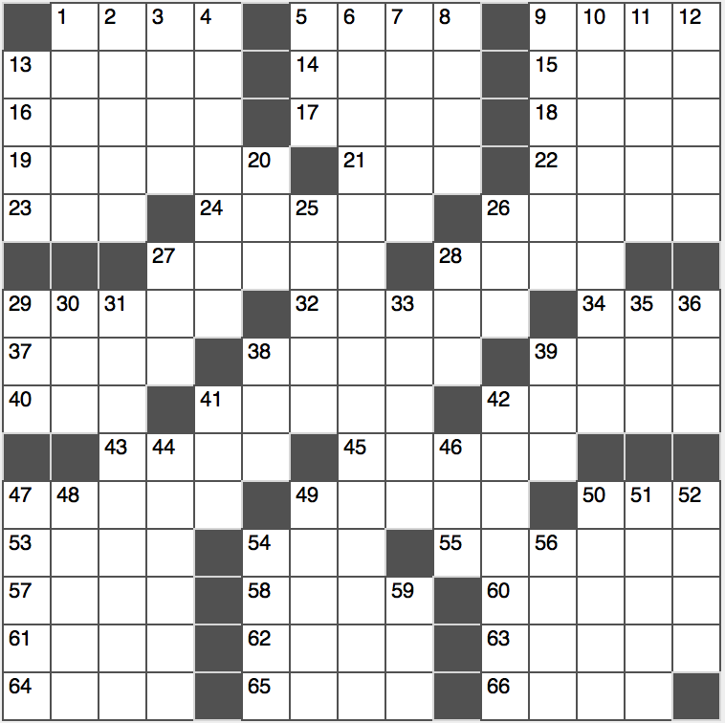**Across**

1. Submerged ridge

5. Ungentlemanly men

9. Gets to the bottom line?

13. Painter Matisse

14. Indistinct recollection

15. Aloe ____

16. Destination for the last flight?

17. Proofer’s mark

18. “The Wealth of Nations” subj.

19. Cancun catnap

21. H, on a 37-Across house

22. Rare bird that might be found on 53-Across

23. Word in Hillary’s campaign slogan

24. Opening words

26. “Fantastic!”

27. Late night’s O’Brien

28. Sharpen a knife

29. Completely joyless

32. Small film role

34. Iraq War weapon: Abbr.

37. Group of brothers

38. Heaps affection (on)

39. 51-Down, south of the border

40. Titter on Twitter

41. Drop by

42. Like many long-limbed people

43. Complete duration

45. Bland and insipid

47. Extract 33-Down from ore

49. Confused, wild fight

50. Athenian X

53. Waikiki Beach’s island

54. Alternative to JPG

55. Loved intensely

57. ____ Hubbard (Scientology founder)

58. Faulkner’s “As ____ Dying”

60. “____ Mio” (classic Italian song)

61. Bug-eyed

62. Curtain fabric, often

63. Entire

64. Traveled by bike

65. Tiny workers on a farm?

66. Thin iPod

**Down**

1. Fix, as shoelaces
2. Wander in
3. Dwarf planet near Pluto
4. Fantasy
5. “60 Minutes” broadcaster
6. Perjury, to Kellyanne Conway

7. Because of

8. Mlle. in Baja

9. Pennsylvania or Park

10. Sophism

11. Surveillance flier

12. Not as daffy

13. Diner side order

20. Fashionable Taylor

25. Tex-Mex staples

26. “Homeland” airer, for short

27. Remove from the roster

28. “The Grand Budapest Hotel” director Anderson

29. Org. for Bears and Panthers

30. Palindromic elemento

31. Whopper

33. Music genre word

35. Yosemite beast

36. Week unit

38. Ado

39. Used to own

41. Wine keg

42. Command to Rover…or a hint to 4-, 6-, 10-, and 31-Down

44. Drop steeply

46. Podded legume

47. Descriptor for some cells

48. Eldest “Despicable Me” sister

49. La Scala location

50. Sing in a soft, low voice

51. “Is anybody home?”

52. De Tocqueville thought

54. Desert monster

56. Work watchdog: Abbr.

59. “Absolutely”