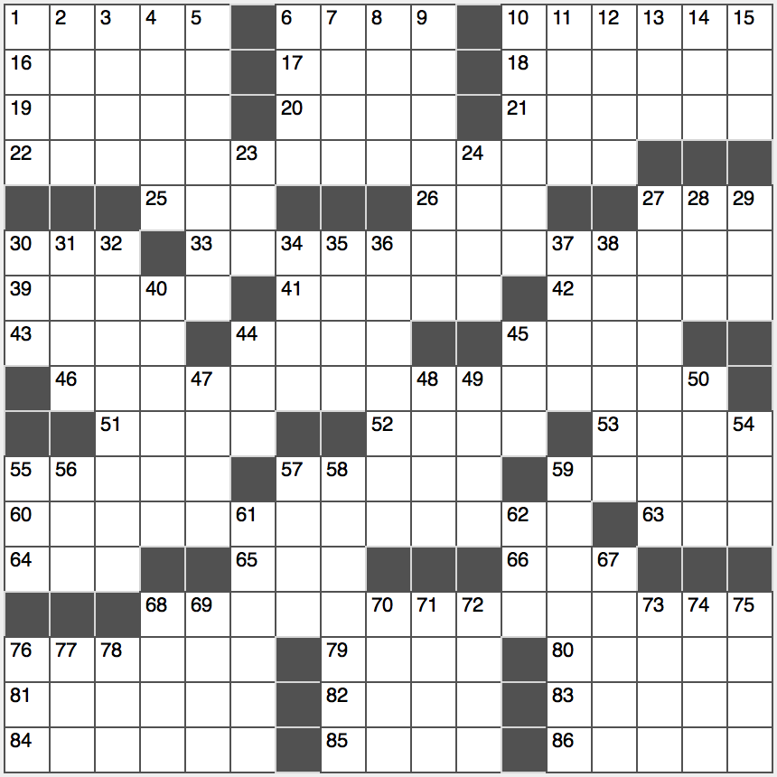**Across**

1. Cornerstone word: Abbr.

6. Terminal specification

10. “Who cares?”

16. “West Side Story” character

17. Hershiser on the mound

18. Copa Mundial cry

19. Roofing worker

20. Copy room package

21. Flat legume

22. SAW

25. Pinch

26. Didn’t just walk

27. Brazilian map word

30. A.A. or AAA

33. BUG

39. Spills over

41. Blunt fencing foils

42. Against property, in law

43. “Will you let me?”

44. Native Celt

45. Until

46. DIG

51. Jack and Jill item

52. One of six Russian tsars

53. Composer Stravinsky

55. Shrek’s girlfriend

57. Stanford-____ test

59. “Mad Men” office worker

60. DOG

63. Taylor Swift’s 2012 album

64. Fam. member

65. Come up with sum-thing?

66. Kidder’s cry

68. LENS

76. Bring into existence

79. Plucky Roman emperor?

80. Chips pile

81. Post-pubescent

82. Luggage markers

83. Online memo

84. Where IKEA was founded

85. “Go away!”

86. Fix, as worn brakes

**Down**

1. Is a consumer?

2. Quick cut

3. Dollar drawer

4. Ordered from Grubhub, for example

5. Things with round numbers?

6. Backpacker’s snack

7. General vicinity

8. Painful muscle injury

9. Graceful street liner

10. “Farewell”

11. Bread spread

12. Proceed circuitously

13. Like some salsas and summer months

14. Boxer who said, “If you even dream of beating me, you’d better wake up and apologize”

15. ____ Aviv

23. Atty’s. group

24. General interests?

27. 2007 Kanye West hit

28. Serving feat

29. Eponymous physicist Georg

30. Sans prescription, in brief

31. Like books and tea leaves

32. Heredity source

34. Liter lead-in

35. Fairy tale word

36. Immediate surroundings

37. Slimming surgery, briefly

38. Perceive instinctively

40. Fashion center of Italia

44. Salt, in Saguenay

45. Mausoleum container

47. Blood vessel?

48. Above

49. Mexican Manx

50. Out of the oven

54. Cone’s partner

55. New Deal prez

56. Great displeasure

57. Gym bunnies work on them

58. Puts right?

59. Pub game

61. Lustrous cotton fabric

62. Homey lodging

67. Packing supply

68. Pour kudos on

69. Bordeaux being

70. Slangy “sure”

71. Thus

72. Just all right

73. Bus map dot

74. Jazzy James

75. Ogled

76. There are 2.54 in an in.

77. Not 50-Down

78. Summer on the Seine