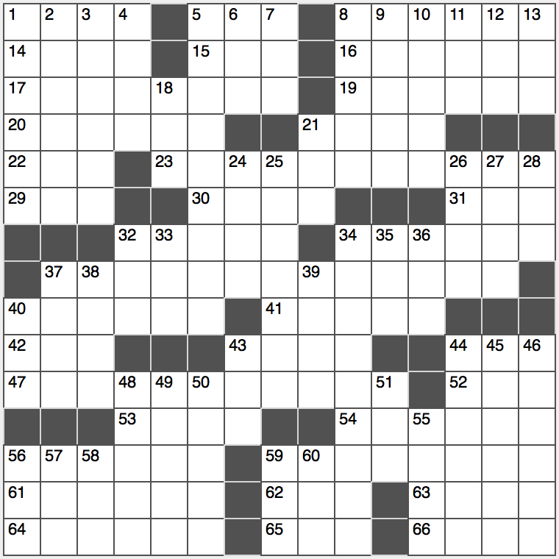**Across**

1. Word before wire or bait

5. Build an extension

8. Walk like a penguin

14. Hard seed husk

15. Signal from offstage

16. Dexterous

17. More frequently than desired*

19. Pulls with a pulley

2o. Instead (of)

21. Sprawl lazily

22. Classy grp.?

23. Each and every kind*

29. Free app annoyances

30. Former Nevada Senator Harry

31. Lipid

32. Like Mongolians or Sri Lankans

34. Nice lady?

37. Like many a boaster*

40. Like some prejudice

41. Recipient of roses

42. Something you can bank on, briefly?

43. Comedic actress Garr

44. “The Little Red Book” chairman

47. They couldn’t put Humpty-Dumpty back together again*

52. Angsty style

53. Yours, in Ypres

54. Sowed, as a lawn

56. Zeroes in on

59. Nevertheless…or where each of the starred clues needs to be put to make sense

61. Remington of 1980s TV

62. Meadow

63. “Would ____ to you?”

64. Actor John of “Full House”

65. Pay-view connector

66. Those, in Barcelona

**Down**

1. Rita Moreno of Jennifer Lopez, e.g.
2. Hard pressed?
3. Violins’ cousins
4. “The Time Machine” race
5. Science that seeks to assess risk using statistical methods
6. Word librarians use
7. Cub’s cave
8. “Yee-haw!”
9. Unpopular baby name
10. Tool for carpenters or dentists
11. Mexican couple?
12. Illuminated
13. “Arrival” creatures

18. Not many

21. Hits from the ‘60s?

24. Opposite of 31-Across

25. E-readers from Amazon

26. “____ first you don’t succeed…”

27. Celebrity

28. Summer, to a 34-Across

32. The D-backs, on scoreboards

33. Reggae predecessor

34. Hollywood headliner

35. U.S. Civil war prez

36. SSW or NE

37. It’s drawn in a lavatory

38. Source of cartoon explosives

39. Conventional pattern

40. Ship stowaway

43. ___ Fridays (dining chain)

44. General’s chestful

45. Legendary aviatrix Earhart

46. Tons

48. Radio legend Casey

49. “Invisible Cities” novelist Calvino

50. Students may pass them

51. Maiden name preceder

55. Canal that runs for over 500 miles in New York State

56. Zebra cousin

57. Cousin of old TV

58. ____ culpa (Latin for “my bad”)

59. Jungfrau, e.g.

60. Payment for professional services