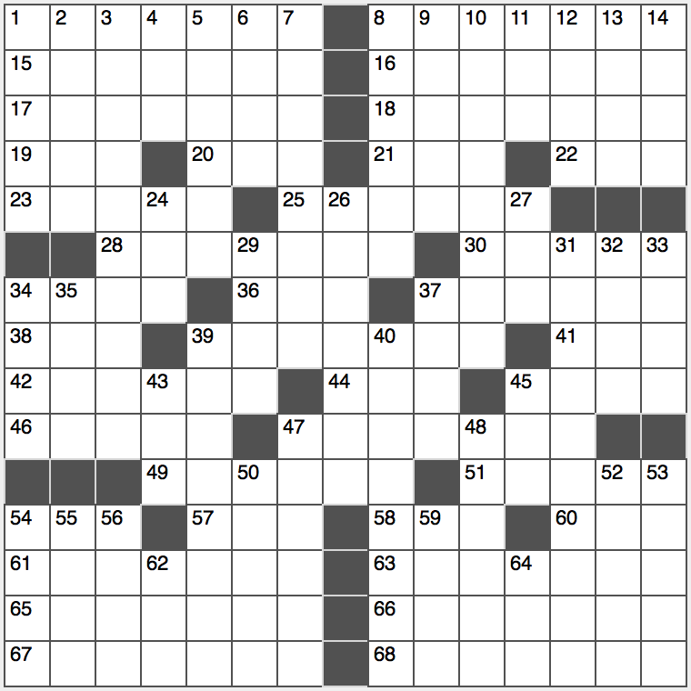**Across**

1. Machine gun syllables

8. Swords of old

15. Unsettle

16. Disappearing Asian body of water

17. University governors

18. Post-box fillers?

19. Opposite of WSW

20. Vocalist ____ King Cole

21. “I think, therefore ____”

22. Distress initials

23. “Beetle Bailey” figure

25. Washes (off)

28. Union, of sorts

30. Rolls with rice

34. Anarchic action

36. Summer hrs. in Philly

37. Evolutionary revolutionary

38. Hubbub

39. Moviedom’s Morgan

41. Key for cancelling

42. Pandemonium

44. Guy’s partner

45. Cheese in spinach pie

46. Tension reliever

47. Olive-green gem

49. Declare as truth

51. Robert of “Vega$’

54. Either way it expressed surprise

57. Superman’s nemesis Luther

58. Defeat time and time again, in slang

60. Ambient musician Brian

61. Machinate

63. Redundant-sounding refreshment

65. Talk of Tijuana

66. Faithful recluse

67. Architects’ works

68. Conical quarters

**Down**

1. Porterhouse orders
2. Project Gemini rocket
3. Youngest Masters champ
4. Munched on lunch
5. Browned at the beach
6. Enthusiastic word before boy or girl
7. Bicycle buyer’s request
8. Oval activity
9. Atlas statistics
10. Spaghetti sprinkle
11. Terre dans la mer
12. Those, en 65-Across

13. Move, in realtor speak

14. Lip

24. Wreak revenge on

26. 1 or 2

27. California’s Big ____

29. Skin suffix

31. Sugar

32. Liberal arts subj.

33. Peruvian’s ancestor, perhaps

34. Broccoli ____

35. Invention, initially

37. “The Persistence of Memory” artist

39. Widespread

40. Long-tailed Latin American monkey

43. Meadow

45. Programming loop type

47. Points of view?

48. Scottish seaport

50. Was sustained by

52. 10 sawbucks

53. Has aspirations

54. Scored well

55. Fire fighter?

56. Yodeler’s home

59. Had on

62. China’s Chou En ____

64. Rock band booster