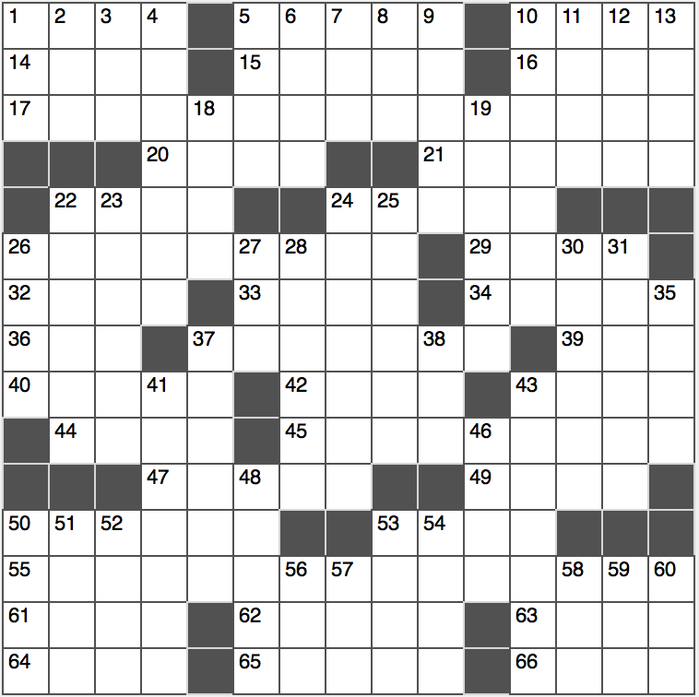**Across**

1. Boot base

5. Not just happen once

10. At any point in history

14. Do as instructed

15. “You are not!” rejoinder

16. Plunge headfirst

17. Powerless

20. Meets, at the poker table

21. Some Monopoly purchases

22. Highbrow, perhaps

24. 1993 Nirvana album “In ___”

26. Science of the nerves

29. Macadamias or pecans, e.g.

32. Looney Tunes supply co.

33. Yosemite runner

34. Prefix with “centrism” or “graphic”

36. Steaming state

37. Achieve equilibrium

39. After dusk, to Shakespeare

40. Far from tame

42. Frivolous fusses

43. “Hang on ___!”

44. “Unbreak My Heart” singer Braxton

45. Arrange haphazardly

47. Its floor is never dry

49. Valentine’s flower

50. Titillating

53. Only artist to have a number-one single on a Billboard chart in each decade from the 1960s to the 2010s

55. Absolutely accurate…or a spatial description of 15-, 22- and 42-Across

61. Homesteader’s measure

62. “Mean Girls” star Lindsay

63. Bear up in the air

64. Tarot expert, maybe

65. Still-life vessels

66. 2-Down, e.g.

**Down**

1. Cover for a bald spot
2. Geisha’s waist tie
3. Guitar legend Paul
4. A sty, or maybe a stye
5. Widespread
6. Locales of canals
7. Nashville awards grp.
8. Admiral’s org.
9. Drug giant that makes Valium
10. Censor, in a way
11. Workbench jaws
12. Canyon jumper Knievel
13. Cabernet and Merlot, for two

18. Mountain Moses climbed

19. Charlotte NBA player

22. Word after top or trade

23. Uno, por ejemplo

24. Kenyan’s neighbor

25. Magnate

26. Innocent sort

27. Actress Tyler of “The Lord of the Rings”

28. 1998 PGA player of the year Mark

30. Dissertation

31. Blessed thing?

35. A unique occasion

37. Draw out, as a response

38. Yank’s currency: Abbr.

41. One way alternative?

43. Romantic

46. Utah city, or an anagram of an Italian city

48. Pierre’s academy

50. Periods in history texts

51. Former US Secretary of State Condoleezza

52. Grimm bully

53. Blacken

54. Fowls on the farm

56. Not later

57. Fill in ___ blank

58. Piece advocate’s org.?

59. Sioux leader?

60. Slangy assent