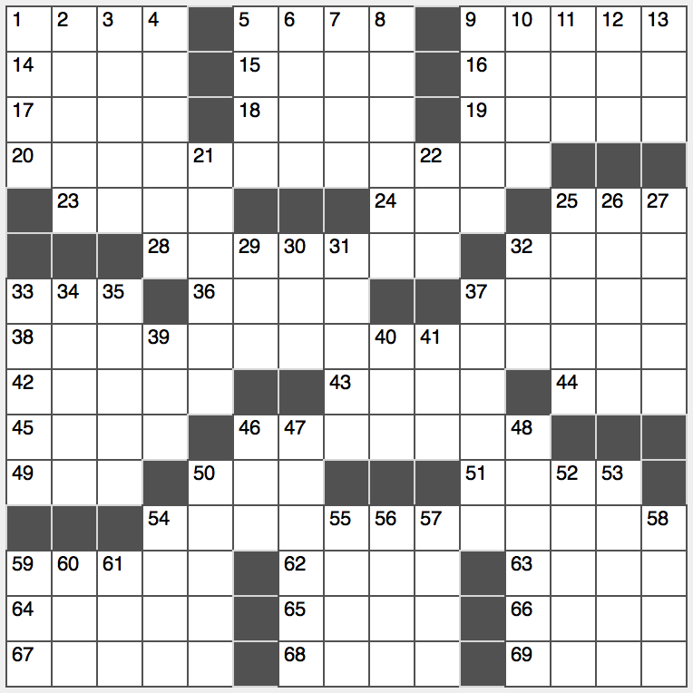**Across**

1. Spot on a radar screen

5. Avoid getting an F in a class

9. Resort isle off the Spanish coast

14. State known for growing corn

15. Leave out

16. Stockings material

17. Lots

18. Kit-lit detective ____ the Great

19. Message to one’s followers, say

20. Date of the holiday referred to in 38-Across

23. Simple canine command

24. Elderly

25. Frat dude

28. Fish often pan-fried

32. Totally blah

33. Dads to Jr.s

36. Saloon servings

37. A neutral tone

38. Words said at a pop festival?

42. Like and then some

43. Pro ____ (in equal share)

44. Suffix for lion or host

45. Primitive helicopter

46. Active chemical substance

49. Use the couch

50. It’s used to pick things up

51. Biz bigs

54. European analog of the occasion referenced in 37-Across

59. Relative of a cello

62. The ‘T’ in TV

63. Script portion

64. Flashy performance

65. Inventor Sikorsky

66. Ski resort near Salt Lake City

67. Spills over

68. Isn’t allowed to

69. Lightly burn, as a steak

**Down**

1. Lack of fairness

2. Type of water lily

3. “Not gonna happen”

4. Bears from China

5. Child’s mount

6. Key of Beethoven’s 7th Symphony: Abbr.

7. In ____ (as first fount)

8. Old office note-takers

9. Spoke without feeling

10. How some veggies are sold

11. Text ending?

12. “Sesame Street” Muppet who wears a tutu

13. Tiny colony insect

21. Sailor’s assent

22. Golfer Ernie

25. Woman getting married

26. Shankar pieces

27. Falls in line

29. Landon who lost to FDR

30. “Don’t ____ stranger”

31. Stars of the Roman Empire?

32. ____ Moines

33. Rough rugs

34. Straight sides of a pizza slice, e.g.

35. Athletic pastime

37. Local bank, e.g.

39. Non-amateur

40. Storybook witch

41. Summer on the Seine

46. Friend of Howard Wolowitz on “The Big Bang Theory”

47. Arousing

48. Some cars at charging stations

50. Californie and others

52. “Swan Lake” villainess

53. He keeps a list

54. Sharply criticize

55. Genesis name?

56. SpaceX head Musk

57. Lively and cheeky

58. 365.25 days

59. Kitty doc

60. Water chiller

61. Bull ring chant