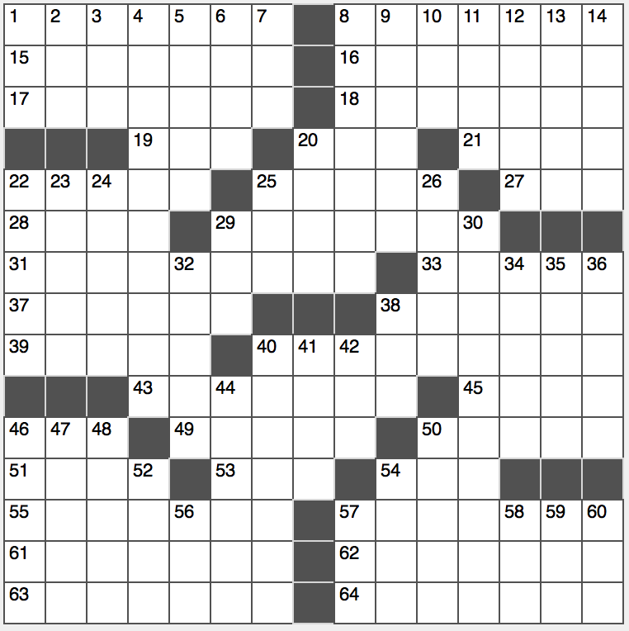**ACROSS**

1. Cubist before Rubik?

8. Ivory tower

15. Ranch rival

16. Seats of power

17. Still on the loose

18. “Hamlet, thou art slain” speaker

19. Bridal bio term

20. Treat a hide

21. Desert plateau

22. Social rung

25. Prepared, as fish fillets or corsets

27. Pop star Lana Del ____

28. “In ____ of flowers…”

29. Pirated product

31. Stuff for a U.S. history buff

33. Surry send-offs

37. Finish the job?

38. Robbed of

39. Capital of Sweden?

40. The most widely spoken constructed language in the world

43. Knotty

45. Adorkable one

46. Rhine tributary near the start of a dictionary

49. Bird brain

50. Cadence, to Keats

51. Endless chore

53. Get an A+ on

54. Assn. of nations founded in Bogota

55. Seasoned sailors have them

57. They’re basic

61. Talk show host Hall who won on “Celebrity Apprentice”

62. Direct route

63. Fussed over, as a grandchild

64. Gist

**DOWN**

1. ____ mater (brain membrane)
2. Cousin of classic TV
3. Berkeley institution, briefly
4. Famed British computer pioneer
5. Emphatic “yes” or “no” follower
6. Wise beyond words
7. First square?
8. Peach State capital
9. Chic Coco
10. Exist
11. Collegian quarters
12. Wide keyboard key
13. Reagan attorney-general Edwin
14. Emersonian offering

20. One in a cel block?

22. First name in superhero lore

23. One using a scope

24. Deal with

25. Breath-taking snake?

26. Discourage

29. Old-time letters?

30. Bargain hunter’s destination

32. “Argo” extra

34. Article of belief

35. In hot pursuit of

36. Add fuel to the fire?

38. Canopy, e.g.

40. Vinland explorer circa 1000 A.D.

41. Member of the plum family

42. Toy one plays with, e.g.?

44. At a fairly slow tempo

46. Putin ally

47. Final Olds

48. Certain comedic tribute

50. Car brands

52. Fox’s drama club hit show

54. Soccer stadium shouts

56. It might be bitter

57. Japanese PM Shinzo

58. “Hamilton” creator ____-Manuel Miranda

59. Business add-on?

60. Poker decision