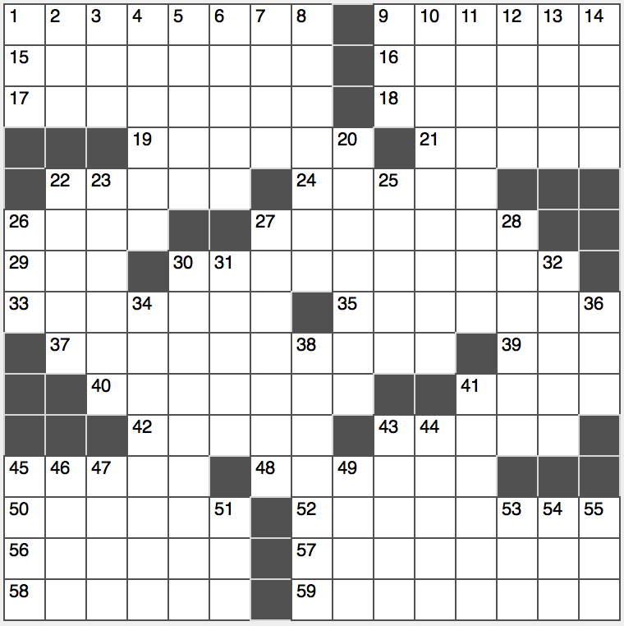**ACROSS**

1. Home of the Big House

9. Ruin, weather-wise

15. “Madam Secretary” actress

16. Insinuate

17. Fiesta food

18. Does the moon walk, e.g.

19. Childish rejoinder

21. Some home furnishing stores

22. Verges

24. Rib

26. Title before Bear or Rabbit

27. Like a romantic evening

29. 2008 recipient of govt. largesse

30. It’s frequently used for dunking

33. Longer

35. Sanctions

37. Alfresco mall

39. Parlor piece, briefly

40. Possible reason for a search party

41. “How unfortunate”

42. Seashore denizens

43. Decorticates

45. 2016 Key and Peele action comedy

48. Exactly

50. Pole position?

52. “That was the last straw!”

56. “The Neighbor’s Wife” author Gay

57. Revealing

58. Piano compositions

59. Like whiteboards

**DOWN**

1. U-verse co.

2. New start?

3. “Illmatic” rapper

4. Brightest star in Aquila

5. Provide new pieces?

6. Augurs

7. Seedy character of the Bible?

8. Ristorante side dish

9. Syncopated musical style

10. Words of total despair

11. Rival campaign phrase to “All the way with Adlai”

12. Like all newborns

13. Ancient concert venues

14. Capone’s enemy

20. Scone alternative

22. Give final instructions to

23. Lavishly entertain

25. Quit lying

26. Shrub with aromatic leaves

27. Spaghetti-western garb

28. Boy adventurer with a faithful dog named Snowy

30. Luxuriating between ports, perhaps

31. Staff anew

32. Nice states?

34. Took umbrage at

­36. Where some mud baths are taken

38. Breather

41. It’s often attacked by bats

43. Inscribed stone marker

44. Target rival

45. Shakespeare’s title shrew

46. Mathematician’s “E”

47. Group of rights-minded people?

49. No longer a fan of

51. Parisian pronoun

53. Dollop’s opposite

54. Unlikely to be chipper

55. It’s right before you?