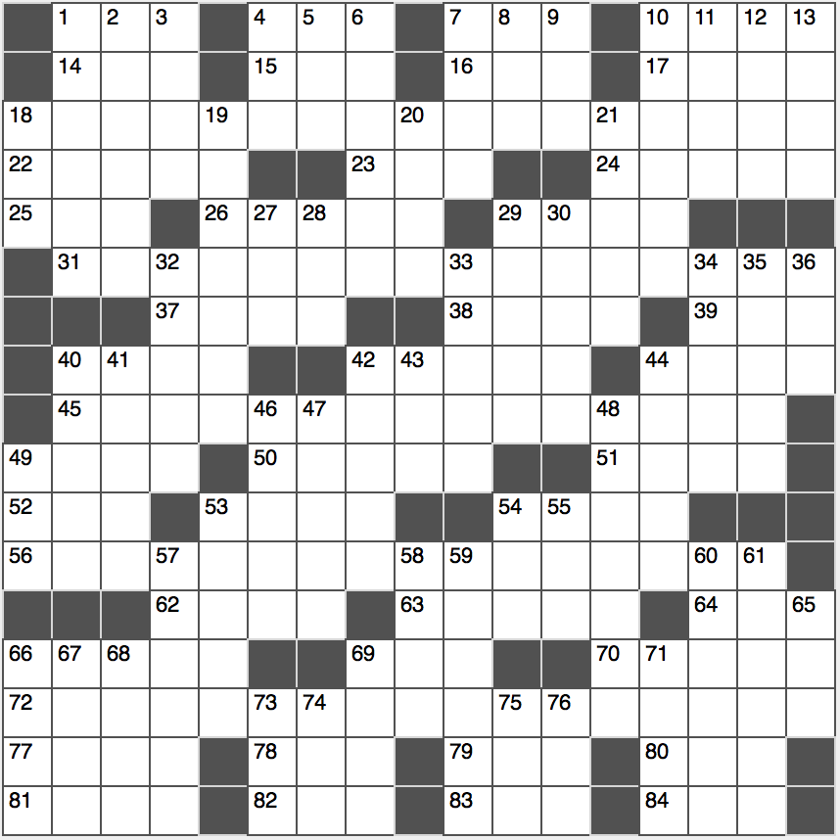**Across**

1. “Let me think…”

4. Apply gently, as cream

7. Scholarship, for example

10. Barley mixture

14. Sheepish cry?

15. Chicken ____ king

16. Reggae forerunner

17. Paradise outcast

18. Keep away game…or a hit to what’s hidden in 31-, 45-, 56- and 72-Across

22. Undercover, informally

23. One way to finish second?

24. Welles who starred in “Citizen Kane”

25. Homeric outburst?

26. Muscat native

29. “Cheerio, old boy!”

31. Rubbish receptacle

37. The munchies, say

38. Neighbor of Myanmar

39. Indigenous Oklahoman

40. Emphatic assent, in Spain

42. Hot Tex-Mex concoction

44. Like some granola bars

45. Technique for approximating definite integrals with quadrilaterals

46. Bread sometimes accompanying vindaloo

50. Bit of bad judgment

51. H H H

52. Approximation: Abbr.

53. Clues in, with “off”

54. It’s water under the bridge

56. Classic 1939 novel depicting rural Oklahoma during the Great Depression

62. Trailblazer Parks

63. Big bettor at the casino

64. “That hits the spot”

66. Arthritis prefix

69. Defense group founded in Bogota

70. Daredevil’s attribute

72. Bestselling 1948 novel about a large family later adapted into a 2000s movie with Steve Martin

77. 7-Across for the stumped

78. Me for Monet

79. Couple’s pronoun

80. D.C. major leaguer

81. Shows decisiveness

82. Booster-seat user

83. Grade-sch. Supporter

84. ____-Caps (cinema candy)

**Down**

1. How to watch “Game of Thrones” on your phone

2. La ____ (region of central Spain)

3. Great white shark kin

4. Night’s successor

5. Aladdin’s alias

6. Split fruit?

7. Messy, as a hearth

8. ‘50s chief exec.

9. Beaver’s barrier

10. Plaid-pattern fabric

11. Tosses into the mix

12. Grammy winner Schifrin

13. Dodgers’ pursuers

18. Western leader?

19. Indulgence for a diva

20. Journey

21. Merest traces

27. “Family Guy” girl voiced by Mila Kunis

28. Word found in each of the clues referenced in 72-Across

29. Sing-song syllables

30. Bubbling away

32. Singing sensation Boyle

33. Skip, as a syllable

34. Outback cutie

35. Kitchen add-ons?

36. What an 82-Across may play with

40. Hidden collection

41. Piqued

42. Dense patch of bushes

43. Starts of many emails

44. “I’m ____ here”

46. Howe who had people in stitches?

47. Guitarist Frank of the “Mothers of Invention”

48. Subject to whiplash, perhaps

49. Income after expenses

53. Brownie group

54. Deg. for a designer

55. Hedwig, e.g.

57. Legendary performers

58. Bend in the breeze

59. “C’mon, quit it!”

60. Jungle hero who befriended many a 28-Across

61. Can’t help but

65. Chicken coop resident

66. Dos + seis

67. Clipper or liner

68. Pitcher’s place?

69. It contains a few last words?

71. Ages and ages

73. Defib user

74. Pooh’s little pal

75. Primitive abode

78. Chapter in history, perhaps